# **Brief description of the application**

What is the application about

The application is designed to improve, automate and shorten the time of manual work. On the basis of individual data, the application should return as much information as possible about a given object.

# **Technologies used and why**

The technologies used for this project are:

1. Microsoft Excel - easily send a set of information for analysis
2. Python Flask Framework - powerful programming language
3. Pandas library - a library used in Python that allows reading and modifying Excel files
4. bs4 library - (import BeautifulSoup) library that enables reading information from the searched website

# **Main functionality**

Description of the main functionality

Using a script, reading out missing data and then suggesting more extensive and possibly correct answers.

# **Other Functionalities**

All of the functionalities

Possibility to download a filling template supported by the script

# **Graphical interfaces (GUI and menu)**

Write down and briefly describe all of the menus

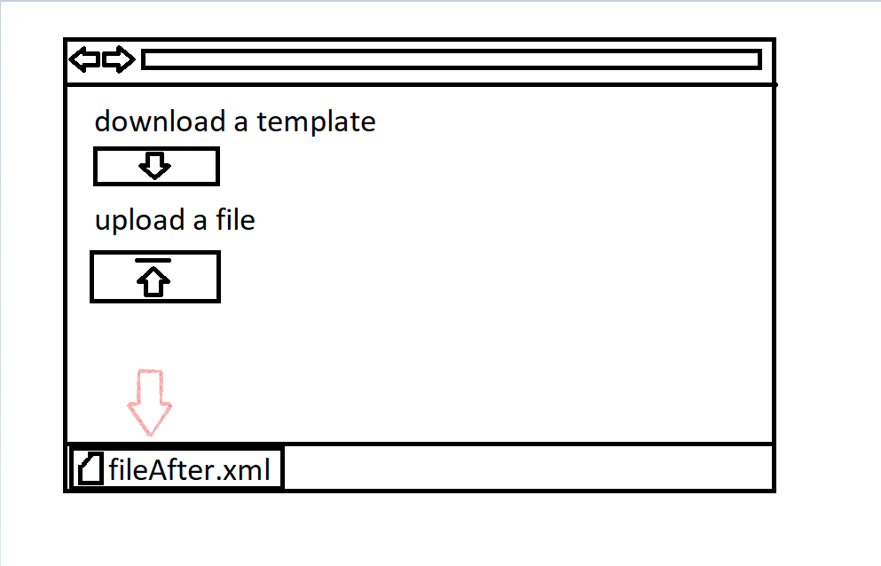

# **Diagrams (use cases etc)**

# **List of assets**

Write down all of the assets you’ll need.

Eg.

* Character 3d model
* 3 types of trees
* Textures for terrain
* Grass terrain