Examen Campusbiker

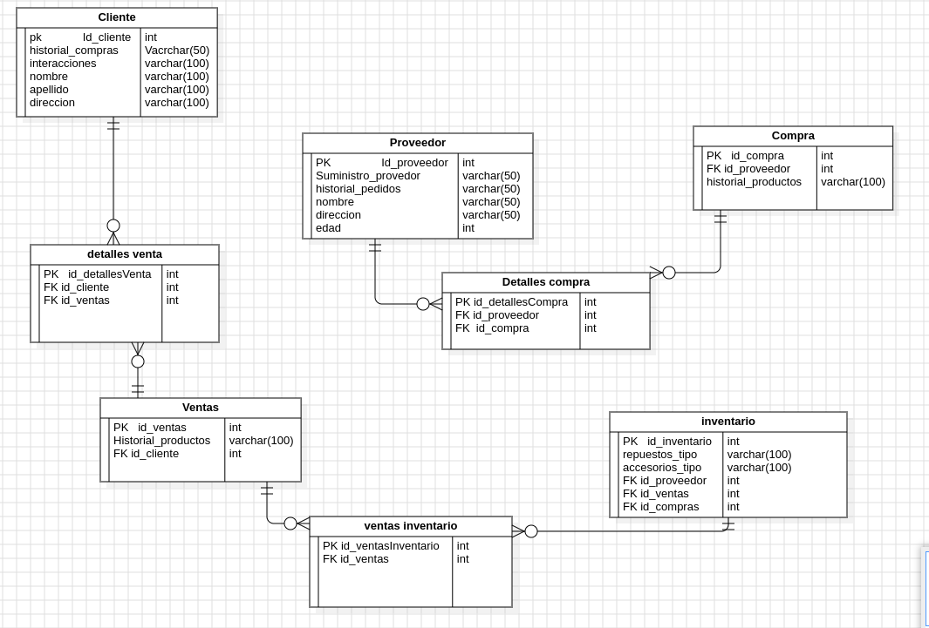

Creación de tablas del modelo ER

Creación tabla cliente

create table cliente (
-> id_cliente int primary key auto_increment,
-> historial_compras varchar(50) not null,
-> interacciones varchar(100) not null,
-> nombre varchar(50) not null,
-> apellido varchar(50) not null,
-> direccion varchar(100) not null);
Query OK, 0 rows affected (0,03 sec)

mysql> describe cliente;
+-------------------+--------------+------+-----+---------+----------------+
| Field | Type | Null | Key | Default | Extra |
+-------------------+--------------+------+-----+---------+----------------+
| id_cliente | int | NO | PRI | NULL | auto_increment |
| historial_compras | varchar(50) | NO | | NULL | |
| interacciones | varchar(100) | NO | | NULL | |
| nombre | varchar(50) | NO | | NULL | |
| apellido | varchar(50) | NO | | NULL | |
| direccion | varchar(100) | NO | | NULL | |
+-------------------+--------------+------+-----+---------+----------------+
6 rows in set (0,01 sec)

Creación tabla Proveedor

create table proveedor(
-> id_proveedor int not null primary key,
-> suministro_provedor varchar(50) not null,
-> historial_pedidos varchar(50) not null,
-> nombre varchar(50) not null,
-> direccion varchar(50) not null,
-> edad int not null);
Query OK, 0 rows affected (0,02 sec)

mysql> describe proveedor;
+---------------------+-------------+------+-----+---------+-------+
| Field | Type | Null | Key | Default | Extra |
+---------------------+-------------+------+-----+---------+-------+
| id_proveedor | int | NO | PRI | NULL | |
| suministro_provedor | varchar(50) | NO | | NULL | |
| historial_pedidos | varchar(50) | NO | | NULL | |
| nombre | varchar(50) | NO | | NULL | |
| direccion | varchar(50) | NO | | NULL | |
| edad | int | NO | | NULL | |
+---------------------+------

creación tabla inventario

create table inventario( id_inventario int not null primary key, repuesto_tipo varchar(50) not null, accesorios_tipo varchar(100) not null, id_proveedor
int not null, id_ventas int not null, id_compras int not null);
Query OK, 0 rows affected (0,02 sec)

mysql> describe inventario;
+-----------------+--------------+------+-----+---------+-------+
| Field | Type | Null | Key | Default | Extra |
+-----------------+--------------+------+-----+---------+-------+
| id_inventario | int | NO | PRI | NULL | |
| repuesto_tipo | varchar(50) | NO | | NULL | |
| accesorios_tipo | varchar(100) | NO | | NULL | |
| id_proveedor | int | NO | FOR | NULL | |
| id_ventas | int | NO | FOR | NULL | |
| id_compras | int | NO | FOR | NULL | |
+-----------------+--------------+------+-----+---------+-------+
6 rows in set (0,00 sec)

creación VENTAS_INVENTARIO

create table ventas_inventario(
-> id_ventasInventario int not null primary key,
-> id_ventas int not null);
Query OK, 0 rows affected (0,03 sec)

creación Tabla ventas

create table ventas(
-> id_ventas int primary key,
-> historial_productos varchar(50) not null,
-> id_cliente int not null);
Query OK, 0 rows affected (0,03 sec)

mysql> describe ventas;
+---------------------+-------------+------+-----+---------+-------+
| Field | Type | Null | Key | Default | Extra |
+---------------------+-------------+------+-----+---------+-------+
| id_ventas | int | NO | PRI | NULL | || historial_productos | varchar(50) | NO | | NULL | |
| id_cliente | int | NO | FOR | NULL | |
+---------------------+-------------+------+-----+---------+-------+
3 rows in set (0,01 sec)

creación de tabla compra

create table compra(
-> id_compra int primary key,
-> id_proveedor int not null,
-> historial_productos varchar(50) not null);
Query OK, 0 rows affected (0,02 sec)

mysql> describe compra;
+---------------------+-------------+------+-----+---------+-------+
| Field | Type | Null | Key | Default | Extra |
+---------------------+-------------+------+-----+---------+-------+
| id_compra | int | NO | PRI | NULL | |
| id_proveedor | int | NO | FOR | NULL | |
| historial_productos | varchar(50) | NO | | NULL | |
+---------------------+-------------+------+-----+---------+-------+
3 rows in set (0,00 sec)

creación tabla detalles_compra

create table detalles_compra(
-> id_detallesCompra int primary key,
-> id_proveedor int not null,
-> id_compra int not null);
Query OK, 0 rows affected (0,02 sec)

mysql> describe detalles_compra;
+-------------------+------+------+-----+---------+-------+
| Field | Type | Null | Key | Default | Extra |
+-------------------+------+------+-----+---------+-------+
| id_detallesCompra | int | NO | PRI | NULL | |
| id_proveedor | int | NO | FOR | NULL | |
| id_compra | int | NO | FOR | NULL | |
+-------------------+------+------+-----+---------+-------+
3 rows in set (0,00 sec)

describe table destalles_venta;
ERROR 1146 (42S02): Table 'campusbike.destalles_venta' doesn't exist
mysql> create table destalles_venta(
-> id_detallesVentas int not null primary key,
-> id_cliente int not null,
-> id_ventas int not null);
Query OK, 0 rows affected (0,02 sec)

mysql> describe detalles_ventas;
ERROR 1146 (42S02): Table 'campusbike.detalles_ventas' doesn't exist
mysql> describe detalles_venta;
+------------------+------+------+-----+---------+----------------+
| Field | Type | Null | Key | Default | Extra |
+------------------+------+------+-----+---------+----------------+
| id_detallesVenta | int | NO | PRI | NULL | auto_increment |
| id_cliente | int | NO | FOR | NULL | |
| id_ventas | int | NO | FOR | NULL | |
+------------------+------+------+-----+---------+----------------+
3 rows in set (0,00 sec)

