**1、Responsive Web Design**

**(1)Basic HTML and HTML5**

HTML is a markup language that uses a special syntax or notation to describe the structure of a webpage to the browser.

1.Most HTML elements have an opening tag and a closing tag.

Opening tags look like this:

Closing tags look like this:

The only difference between opening and closing tags is the forward slash after the opening bracket of a closing tag.

There’s also <title>

2.<p> is for a paragraph to begin with.

Lorem ipsum text is used as placeholder text???



3.HTML5 introduces more descriptive HTML tags. These include main, header, footer, nav, video, article, section and others.

(1)main:

The main HTML5 tag helps search engines and other developers find the main content of your page.

Example usage, a main element with two child elements nested inside it:

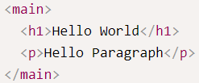

(2)

4.image with alt attribute

All img elements must have an alt attribute. The text inside an alt attribute is used for screen readers to improve accessibility and is displayed if the image fails to load.

<img src=”url.com” alt=”cannot access”>

5.anchor element

use a (anchor) elements to link to content outside of your web page.

a elements need a destination web address called an href attribute. They also need anchor text.

<a href="https://www.freecodecamp.org">this links to freecodecamp.org</a>

Also used for create internal links:

<a href="#new_id" >Jump to Bottom</a>

<footer id="new_id">Copyright Cat Photo App</footer>

6.insert <a> inside <p>

<p>This is a link <a href=”#” target="_blank">this links to freecodecamp.org</a></p>

#:use a hash symbol to turn links to dead links

target="_blank":open links in a new tab

7.turn an image into a link

<a href=”#”><img src=”” alt=””></a>

8.create list using HTML

(1)Create a Bulleted Unordered List  
 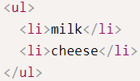

(2)Create an Ordered List

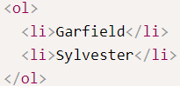

9.Create a Text Field

<input type=”text”>

1. Add Placeholder Text to a Text Field

<input type=”text” placeholder=”text showed before anyone input anything”>

10.build web forms

(1)build web forms that actually submit data to a server using nothing more than pure HTML.

Input a data and submit,then automatically returns the link that action attribute contains.

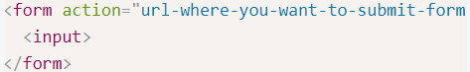

(2)Add a Submit Button to a Form

Insert <button type=”submit”>submit</button> inside the from tags.

(3)use HTML5 to require a form filed

require specific form fields so that your user will not be able to submit your form until he or she has filled them out.

Add required attribute in input element:<input type="text" required>

11.create a series of radio buttons

By wrapping an input element inside of a label element it will automatically associate the radio button input with the label element surrounding it.

All related radio buttons should have the same name attribute to create a radio button group.selecting any single radio button will automatically deselect the other buttons within the same group ensuring only one answer is provided by the user.

**All related radio buttons should have the same name attribute to create a radio button group.**

(1)one type

<label for="indoor"> (for has the same value of id attribute,each button should has its own label)

<input id="indoor" type="radio" name="indoor-outdoor">Indoor

</label>

(2)second type

<input id="indoor" type="radio" name="indoor-outdoor">

<label for="indoor">**Indoor**</label>

12.Create a Set of Checkboxes

Forms commonly use checkboxes for questions that may have more than one answer.

By wrapping an input element inside of a label element it will automatically associate the checkbox input with the label element surrounding it.

**All related checkbox inputs should have the same name attribute.**

It is considered best practice to explicitly define the relationship between a checkbox input and its corresponding label by setting the for attribute on the label element to match the id attribute of the associated input element.

<label for="loving"><input id="loving" type="checkbox" name="personality"> Loving</label>

13.Use the value attribute with Radio Buttons and Checkboxes

When a form gets submitted, the data is sent to the server and includes entries for the options selected. Inputs of type radio and checkbox report their values from the value attribute.

eg:

<label for="indoor">

<input id="indoor" value="indoor" type="radio" name="indoor-outdoor">Indoor

</label>

<label for="outdoor">

<input id="outdoor" value="outdoor" type="radio" name="indoor-outdoor">Outdoor

</label>

When the user submits the form with the indoor option selected, the form data will include the line: indoor-outdoor=indoor. This is from the name and value attributes of the "indoor" input.

However,if omit the value attribute, the submitted form data uses the default value, which is on:indoor-outdoor=on,which has no meanings.

14.Check Radio Buttons and Checkboxes by Default

Add the checked attribute to the inside of an input element.

Automatically choose the option before user choose.



15.Nest Many Elements within a Single div Element

The div element, also known as a division element, is a general purpose container for other elements.

Just like any other non-self-closing element, you can open a div element with <div> and close it on another line with </div>.Divide into different parts I guess.

16.Declare the Doctype of an HTML Document

However, there are a few elements that give overall structure to your page, and should be included in every HTML document.

At the top of your document, you need to tell the browser which version of HTML your page is using.

You tell the browser this information by adding the <!DOCTYPE ...> tag on the first line, where the ... part is the version of HTML. For HTML5, you use <!DOCTYPE html>.

Next, the rest of your HTML code needs to be wrapped in html tags. The opening <html> goes directly below the <!DOCTYPE html> line, and the closing </html> goes at the end of the page.Your HTML code would go in the space between the two html tags.

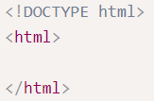

16.Define the Head and Body of an HTML Document

You can add another level of organization in your HTML document within the html tags with the head and body elements. Any markup with information about your page would go into the head tag. Then any markup with the content of the page (what displays for a user) would go into the body tag.

Metadata elements, such as link, meta, title, and style, typically go inside the head element.

Here's an example of a page's layout:

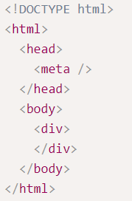

**(2)Basic CSS**

CSS, or Cascading Style Sheets, tell the browser how to display the text and other content that you write in HTML. With CSS, you can control the color, font, size, spacing, and many other aspects of HTML elements.

1.change color of text

Styling that individual h2 element with inline CSS, which stands for Cascading Style Sheets.

Look out “;” to end inline style declarations with a ; .



2.Use CSS Selectors to Style Elements

Method above is one way to specify the style of an element, but there's a better way to apply CSS:

Inside that style block, you can create a CSS selector for all h2 elements.

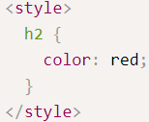

3.