GPEC 443 – GIS – McCord [SP19]

**Final Paper Data Description**

Xinyu Huang

May 13, 2019

**Research question** (1-2 sentences)**:** Is there a significant increase in the financial investment of China to the Belt and Road Initiative participants in 2014, when the Initiative was launched, comparing to that in 2012? Where are hot spots of Chinese financial investments across years? Where are the significant differences of investments between 2014 and 2012 on the map? Are these areas close to the Belt and Road drawn on the map?

**Contribution(s) to the literature** (2-3 sentences): The project unveils the pattern of Chinese government’s financial investments in the primitive stage of the Belt and Road Initiative. It might also illustrate how China developed its own grand strategy. Projects covered by the Initiative may have historical roots, reflecting patterns of China’s investment before. Also, significant increases of investments shown on maps may confirm that Chinese governmental investment strategy was not developed around the Initiative in its first stage, but in later years.

**Independent variable(s)** (list each variable): distance to the Belt and Road; binary variable indicating whether or not the country is along the Belt and Road

Operationalization (list each variable): 1. Use Cost and Distance tool in ArcGIS to calculate the distance to China but weight the Belt and Road differently (Or calculate distance to the Belt and Road directly) 2. Add binary variable into the table with all financed projects.

Data source(s): Belt and Road shapefile

(<https://www.arcgis.com/home/item.html?id=bb9d0a627ee944c7a7edaa5e6d0f6d68>)

Countries along Belt and Road

(https://www.imsilkroad.com/news/p/76186.html)

Unit of analysis: One degree (depending on projection); country

Make a map of the independent variable

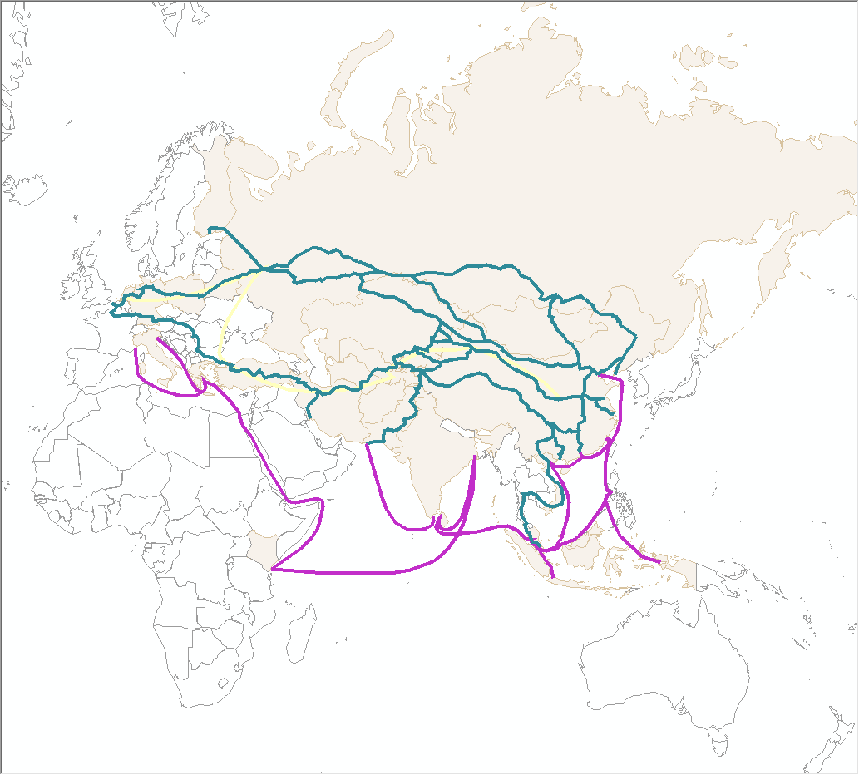

**Dependent variable(s): China-invested projects (geo-located)**

Operationalization: 1. Project each project on the map (check disproportionally heavily-financed projects and justify their locations) 2. Make raster of investment (by summing total amount of investments within an administrative region and the number of investments within)

Data source(s): AidData's Geocoded Global Chinese Official Finance, Version 1.1.1 (<https://www.aiddata.org/data/geocoded-chinese-global-official-finance-dataset>)

World administrative divisions

(<https://www.arcgis.com/home/item.html?id=f0ceb8af000a4ffbae75d742538c548b>)

Unit of analysis: projects & country or administrative divisions within a country

Map of dependent variable

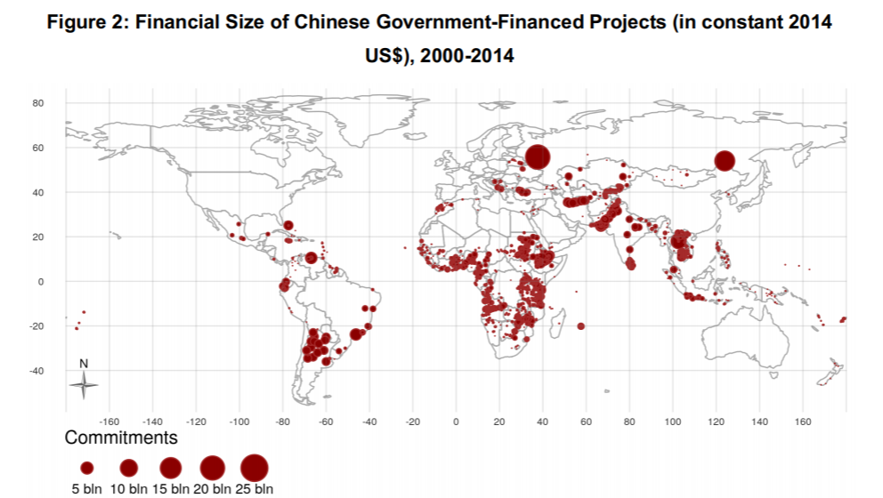

From: Bluhm, R., Dreher, A., Fuchs, A., Parks, B., Strange, A., & Tierney, M. J. (2018). *Connective financing: Chinese infrastructure projects and the diffusion of economic activity in developing countries*.

**Control variable(s): Ports & railroads (still undecided)**

Operationalization: 1. Adding number of ports / whether or not near major railroads into OLS and GWR

Data source(s):Ports along the Belt and Road (<https://www.arcgis.com/home/item.html?id=406f1936fd2240ea83d58712d7663aa9>)

Major railroads along the Belt and Road

(<https://www.arcgis.com/home/item.html?id=0759bc373e534a8080ed19e39eaef1ca>)

Unit of analysis: Country or administrative divisions within a country

**Time span: 2000 – 2014 (mainly focus on 2012 and 2014)**