HINO WARRANTY CLAIM NOTIFICATION
Hino Motors Manufacturing (Thailand) Ltd.
(Accounting)
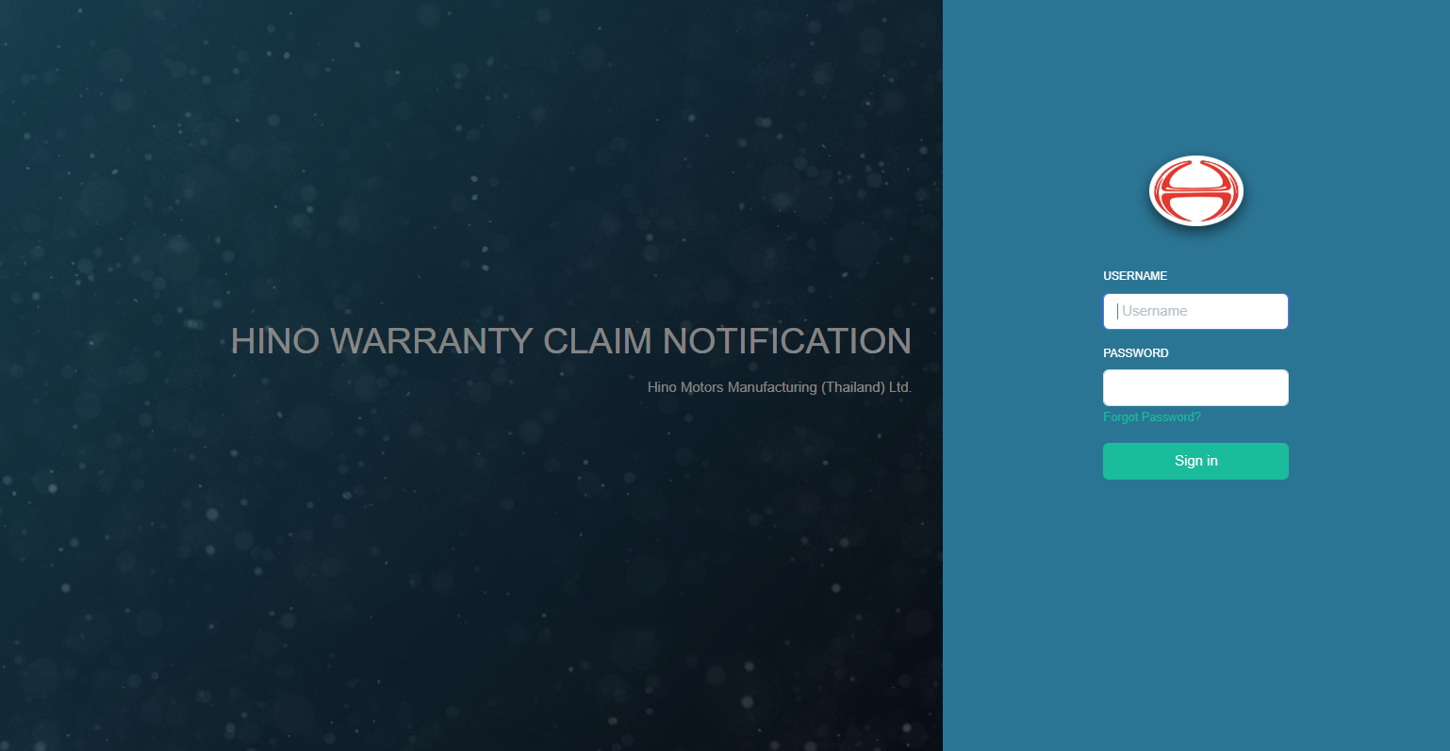
Index Page
Login 3
Change your profile 4
Change password 5
Upload Receipt 7

Login
- Open browser, go to website https://warranty.hinommt.com/Login/HIno and press [Sign in].
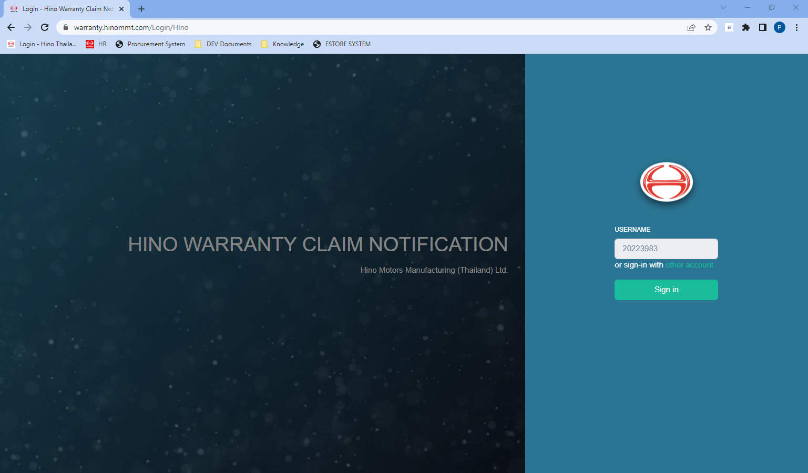

- Default Page is Home.
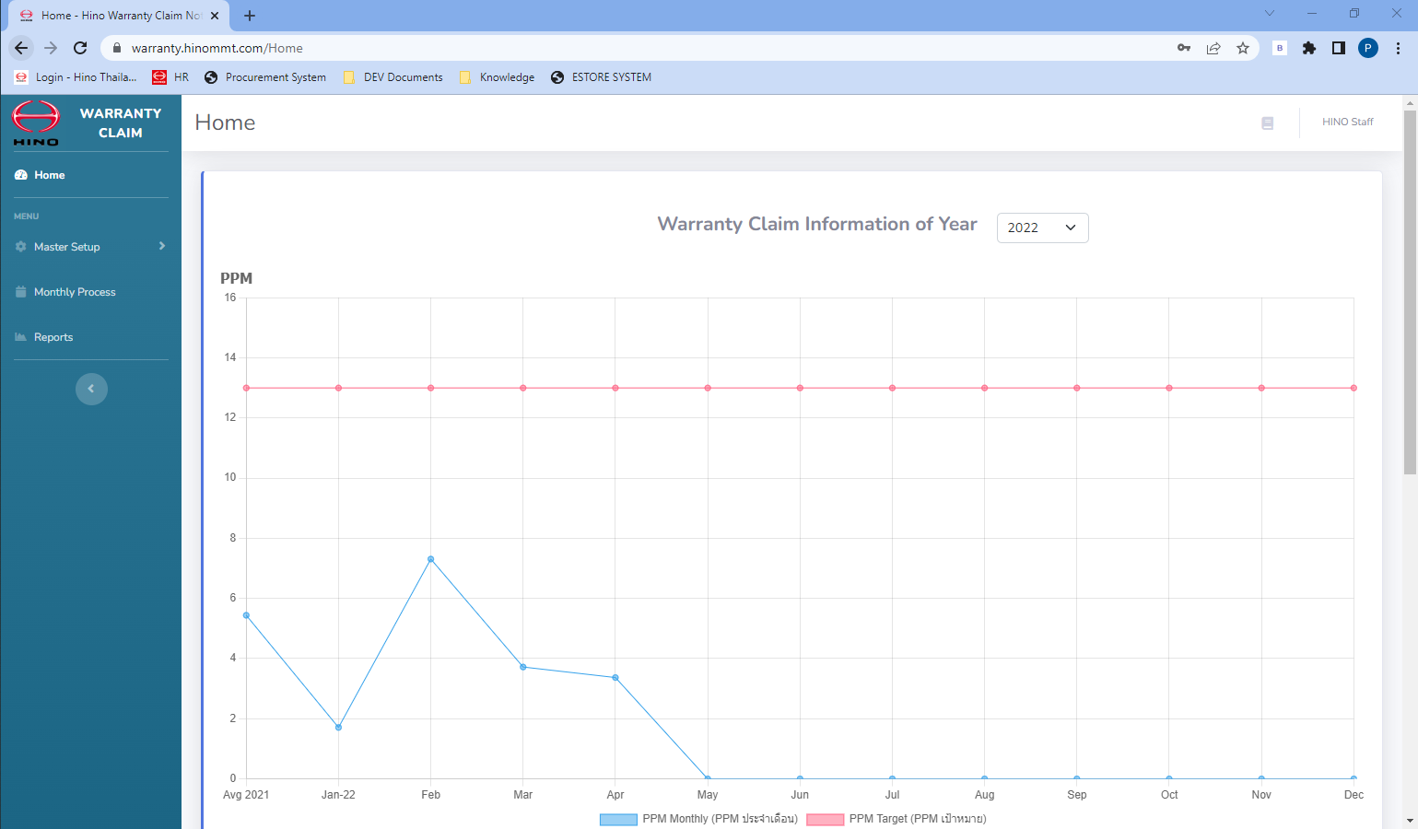

Change your profile
- Click you name (in the top-right), select [Profile].
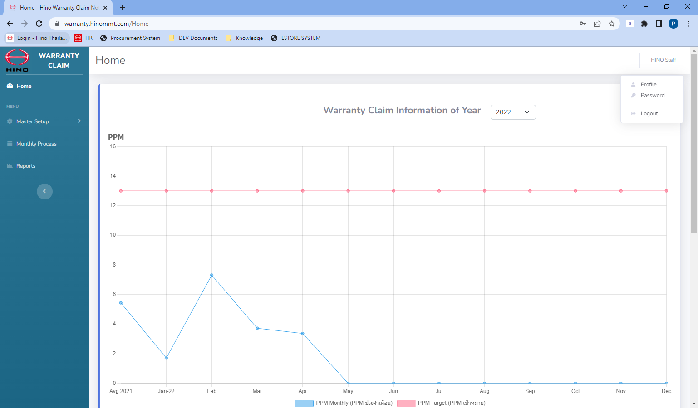
1
2

- Change your profile etc. Name, Surname, Email, Language.
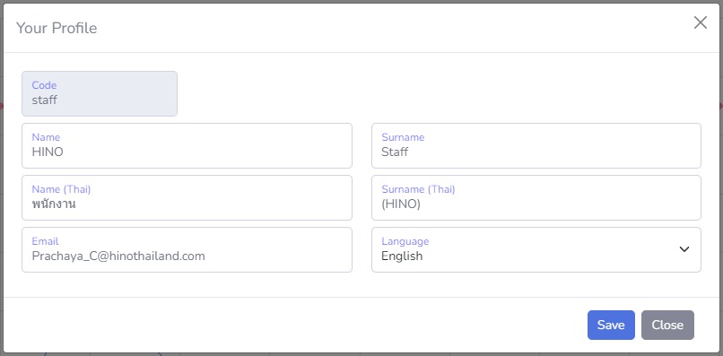
3

- Click [Save].

Change password
- Click you name (in the top-right), select [Password].

1
2

- Click [Send], mail for reset password will be send to your email.
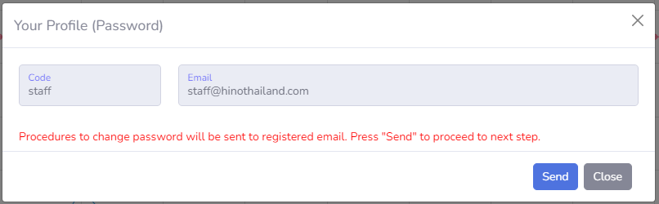
3
- Click reset link from email.
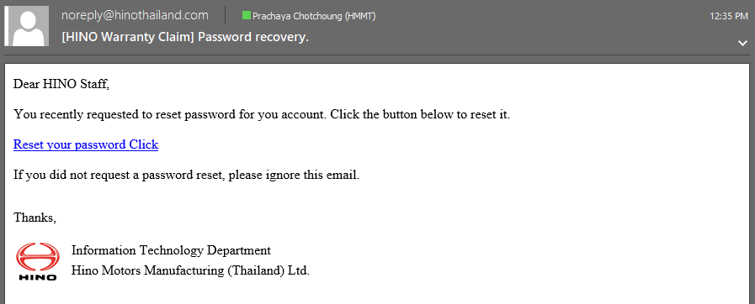
4

- Enter a new password, click [Change Password].
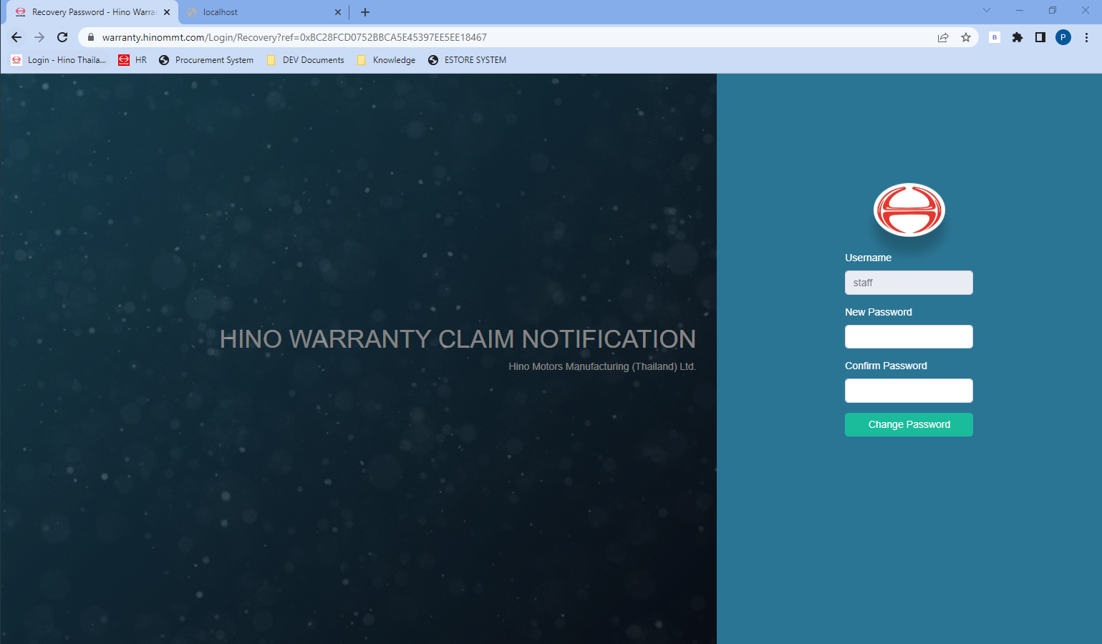
6
5

- And login with a new password.

Upload Receipt
Click “Upload Receipt”
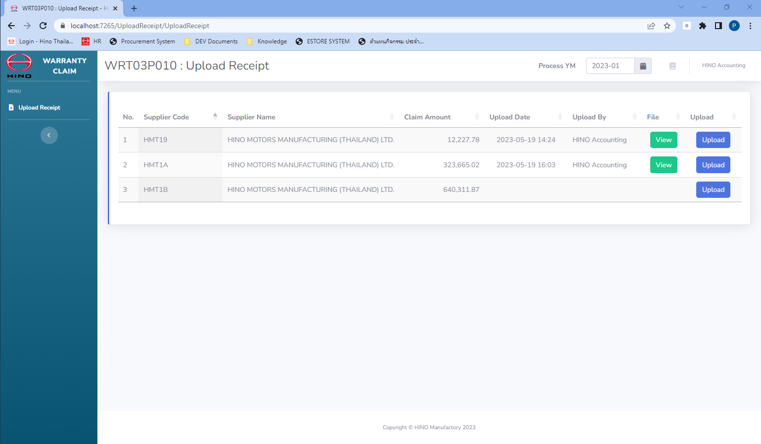
Upload Receipt
B: Upload
A: View

Step A: View
- Click [View] (green button) for view uploaded invoice.
Step B: Upload
- Click [Choose File] for select file in your computer.
- Click [Upload] for upload file to server.
- Click [View] (green button) for view uploaded invoice.
- Click [Delete] for remove a receipt file of this record.

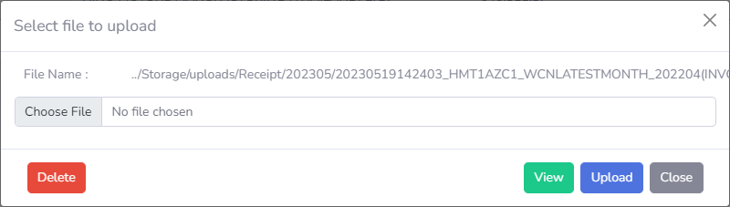
B-4
B-3

B-1
B-2

C-3

