HINO WARRANTY CLAIM NOTIFICATION
Hino Motors Manufacturing (Thailand) Ltd.
(Supplier)
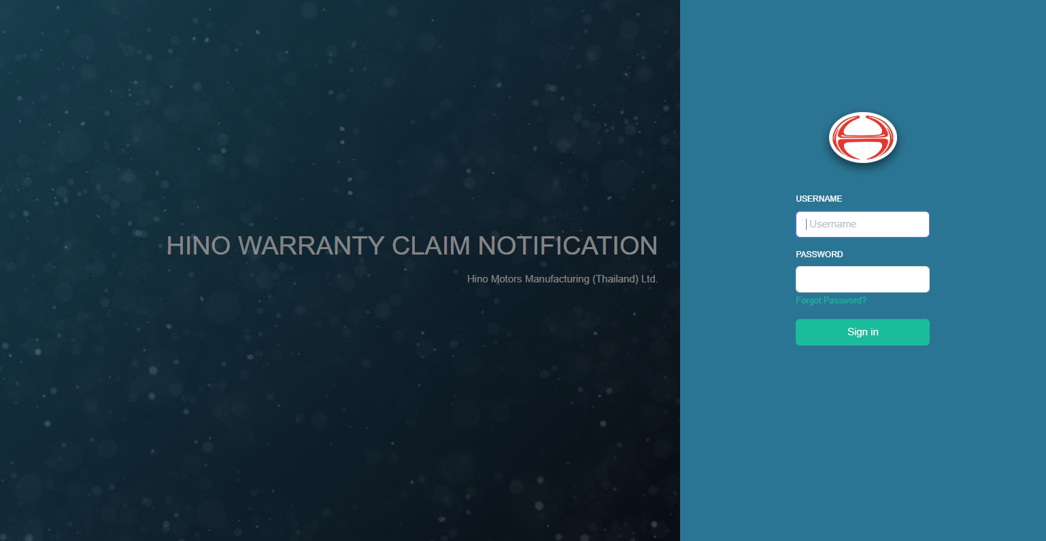
Index Page
Login 3
Change your profile 4
Change password 5
Claim Information 7
Reports 8

Login
- Open browser, go to website https://warranty.hinommt.com/Login and press [Sign in].
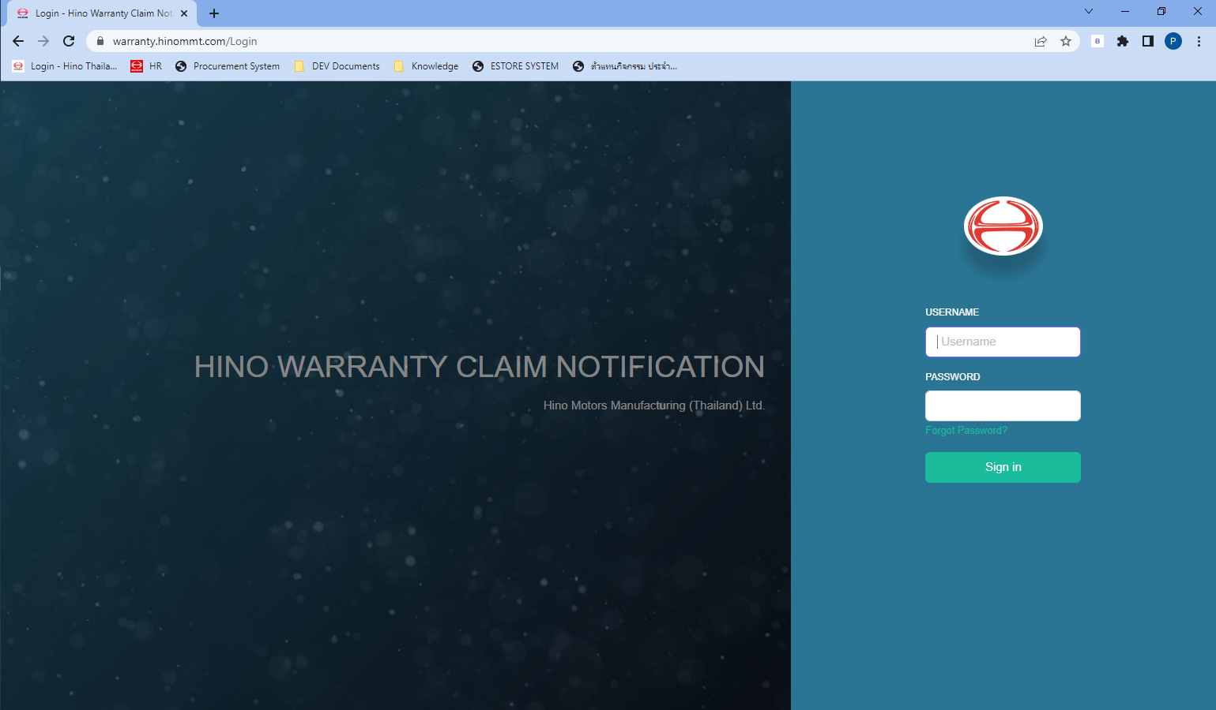

- Default Page is Claim Information
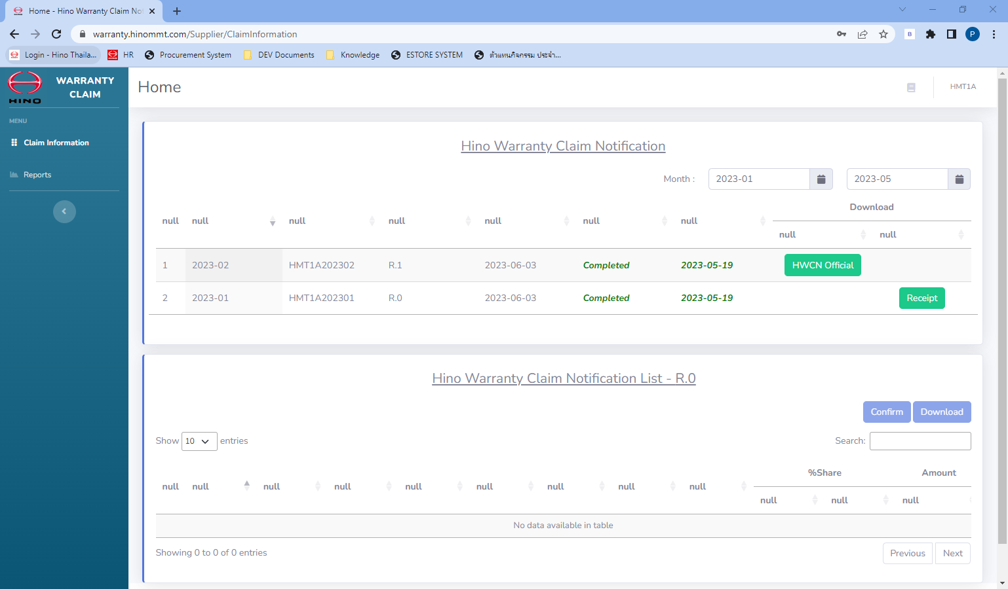

Change your profile
- Click you name (in the top-right), select [Profile].
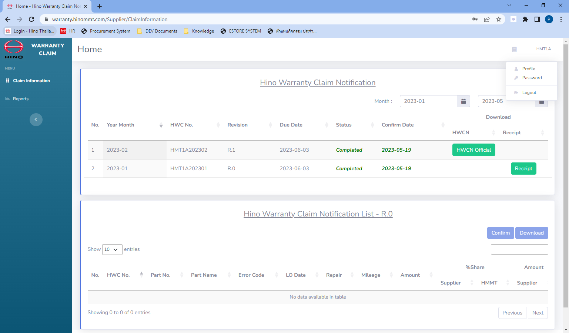
1
2

- Change your profile etc. Name, Surname, Email, Language.
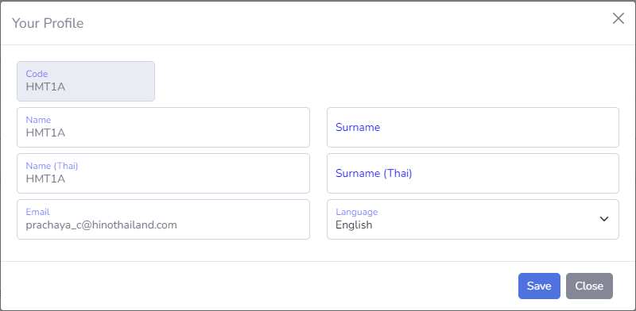
3

- Click [Save].

Change password
- Click you name (in the top-right), select [Password].

1
2

- Click [Send], mail for reset password will be send to your email.
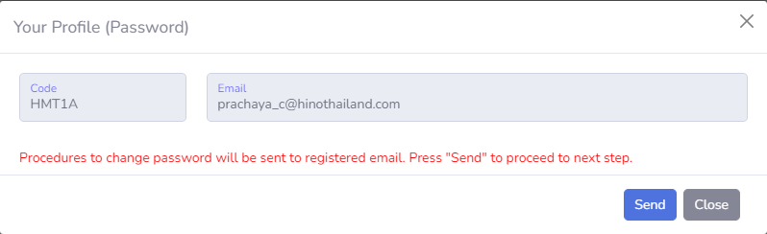
3
- Click reset link from email.
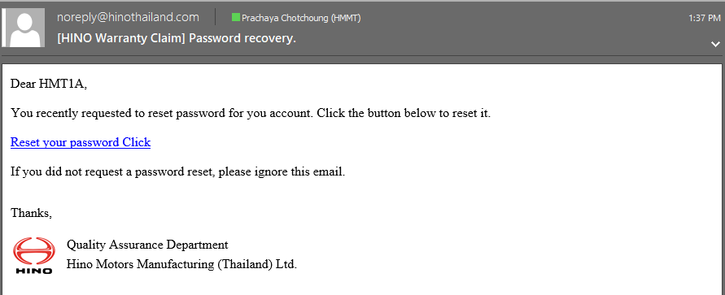
4

- Enter a new password, click [Change Password].
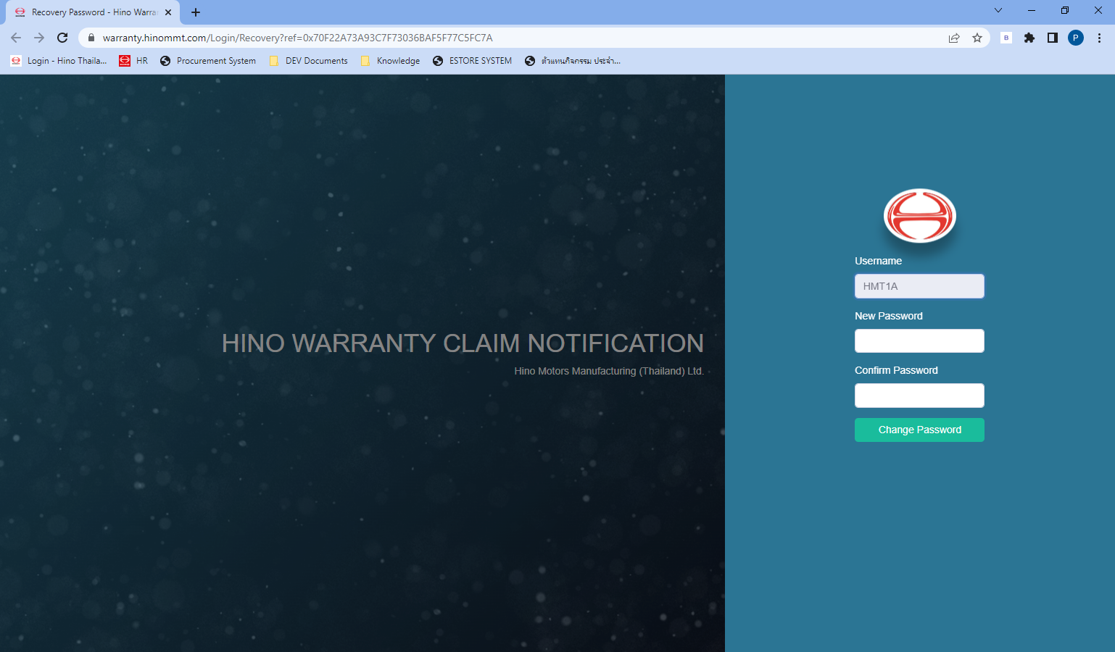
6
5

- And login with a new password.

Claim Information
Click “Claim Information”
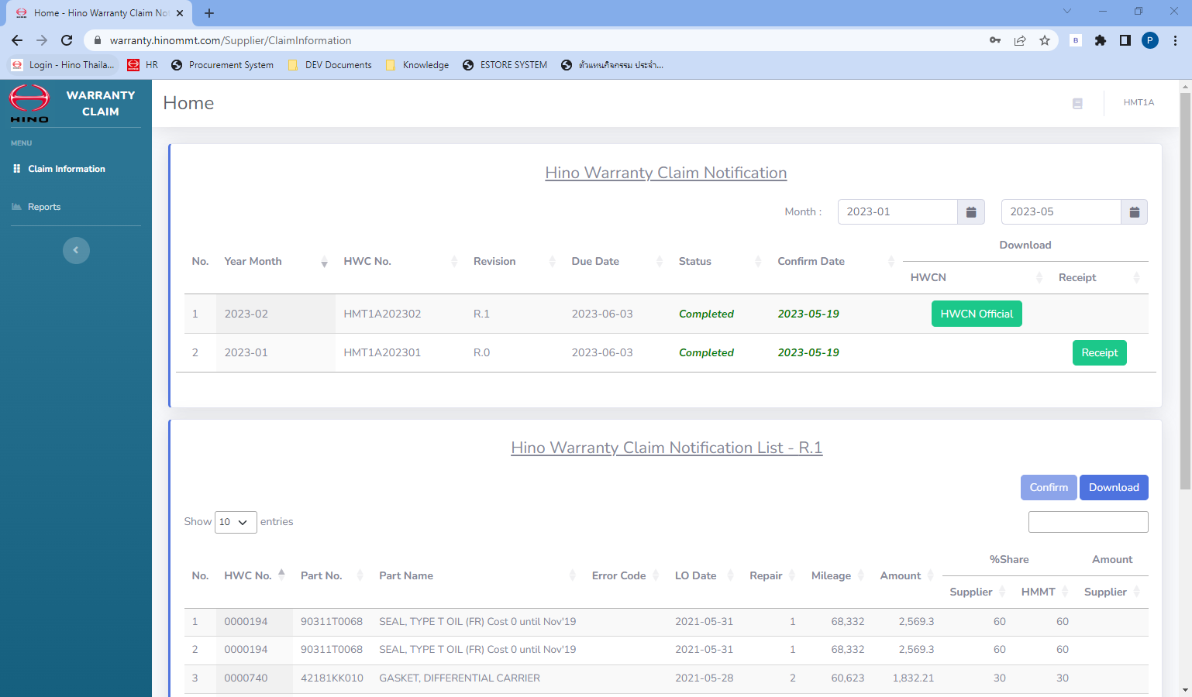
C: Confirm
B: Download
A-1: HWCN Official Report
A-2: Receipt Document
Claim Information

Step A: View Report
- Click [HWCN Official] for view HINO Warranty Claim Notification Official Report.
- Click [Receipt] for view receipt from accounting department.

Step B: Download data
- Click [Download] for download of HWCN data and raw data.

Step C: Confirm data
- In case of completely data, click [Confirm] for confirm data and return to HINO Staff.

Reports
- Select Process YM.
- Click [Preview] for preview a report.
