Order Verification Procedure:
For a given time integrator order x:
- Start with relatively large time step Δ t.
- Each sub-sequential value for  is halved.
- For each compute the relative L2 norm as follows:
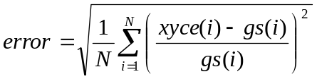
- Consider at least six values for.
- Once the L2 error is calculated for each , the errors calculations are fitted to power low as 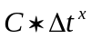 (via least squares), where C is to be determined by the fit and x is the order of the time integrator

