Assignment #3 NextJS Web Page – Due Friday Feb 20th – 25 marks total
Submit a github link to your repo in the dropbox
In this assignment you will create a NextJS Web Page which displays data related to the show Rick and Morty. You will use the https://rickandmortyapi.com/api/ to fetch data about characters on the show.
Initial Setup:
Create a starter nextjs project
npx create-next-app@latest trivia-assignment
when selecting options, go with:
Would you like to use TypeScript? No
Would you like to use ESLint? Yes
Would you like to use Tailwind CSS? Yes
Would you like to use App Router? Yes
Would you like to customize the default import alias? No

Alternatively I have a clean template starter project at https://github.com/EricStockTeacher/nextjs-trivia-assignment . You may fork this repo to begin the assignment. This avoid issues initializing and picking the correct options for your next js project.

Step 1: ( 5 marks)
Setup the Home page:
Edit the page.js file in the /app directory to display a simple message welcoming people to your webpage. Display an image on the page.
Ignore the top nav bar in screenshot below as this is added later (“HomeCharacters”)
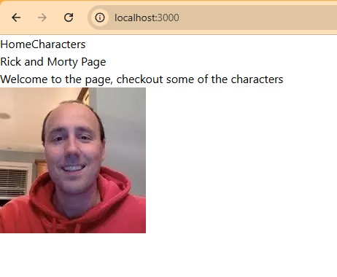
Step 2: ( 5 marks)
Setup the Characters Page:
Using app routing, add a folder characters and place a page.jsx file in it. In this file, add a component which perform a fetch to grab character data from https://rickandmortyapi.com/api/character
This component should then map over all the characters and provide a link that displays the name of the character. (You will use the “next/link” component)

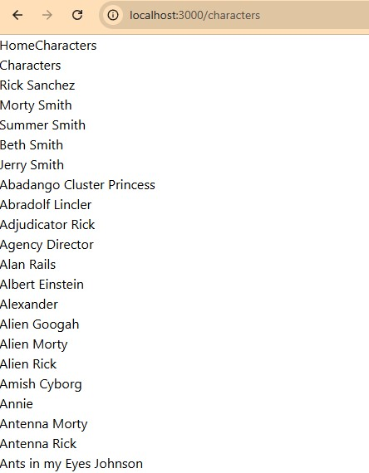

The url for each link should be /characters/ + character.id ex// “/characters/2” ( right now this won’t work, it will get setup in the next step.

Step 3: ( 5 marks)
Setup the individual Character page
Using route parameters ( https://www.linkedin.com/learning/next-js-creating-and-hosting-a-full-stack-site/customizing-content-with-route-parameters?resume=false&u=27766394) , add a folder “[id] inside the characters folder. In the [id] folder, add a file page.jsx.

In the page.jsx, there is a property of the props object named params. It will contain the route param part of the url. Ex// in “characters/2”, the value params.id will be “2”. You can use the following code to access the id.
Then inside the CharacterDetail component, you will use the id to make another fetch request to get information about the specific character. For example https://rickandmortyapi.com/api/character/1
Display the name, species and image for each character.
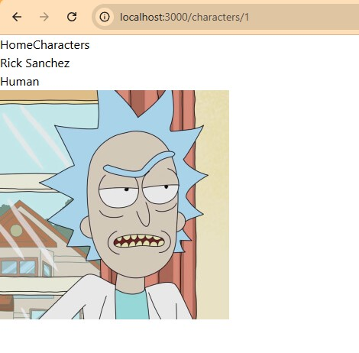

Step 4: ( 5 marks)
Create a nav bar. In the components folder, add a file “Header.jsx”. In this file, create a component which contains a Link to both the Home and Character pages. Import and add this component to the layout.js file.

Step 5: ( 5 marks )
Add another file in the components folder named Character.jsx. In this file create a component which displays the name, species and image for a character. Then in the CharacterDetail page, import and use the Character component to render the character. This will require you to pass the name, species and image as props to the Character component.
Here is what the final file structure should look like:
