Exercise1:

* **Perform one-hot encoding on the data**

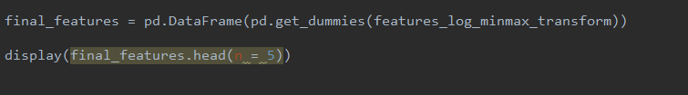

运行结果：

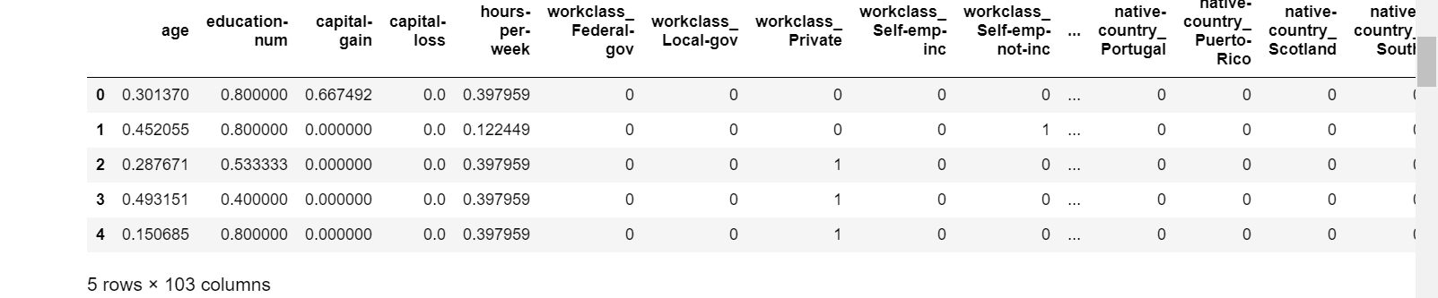

* **Convert the target label ‘income_raw’ to numerical entries (set records with “<=50k” to 0 and records with “>50k” to 1).**

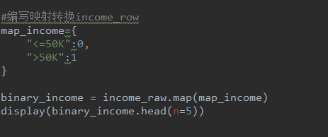

运行结果：



Exercise2:

使用五种算法计算TN，FN,F1-Score

Gaussian:

