Music classification using CNN

Tung Tze Lung Xavier
DAAA
Diploma in Applied Artifical Intelligence and Analytics
Singapore Polytechnic
Singapore

This technical paper aims to use a classification neural network
Keywords—image, compression, KMeans, clustering, pixels, RGB, Color quantization, size

Introduction
With the modernization of the world, data now comes in many different forms. But taken at its most minuscule form, we can change individual parts therefore affecting the big picture. What we would be trying to accomplish would be similar to the artistry of such that can be seen in photographs with camera effects such as film grain, exposure etc. But how is this performed? Through clustering, Clustering is the process of grouping data based on its similarity.
In this technical paper I will be demonstrating Unsupervised learning clustering to achieve different coloring results by reducing distinct colors through clustering similar RGB values together recreating the image and producing colored compressions of premade images. Henceforth reducing file sizes of the pictured image and creating a new visual effect.

Related works
Based on work from the earliest published paper for improvement on k-means for color quantization by M. Emre Celebi [1] Published in 2011 it is dictated through multiple values of K for color quantization. They used KMeans with k going up to k=255 to cluster data points using various KM variants with different initialization schemes on a multitude of images to show the effectiveness of accelerated KM algorithms compared to the usual KMean.
Another implementation is from Xing Wan. Published in 2019 [2] Using Binary classification through KMeans. By determining the number of centroids and selecting a variant of k to cluster by. All this done using an elbow K value from the plotting of inertia. Image compression is then performed to produce varying results, in effort to find the most cost functioning image compression method.

image methology
Here’s an image that will be used for testing.
Fig 1. Image taken from the depths of my hard drive
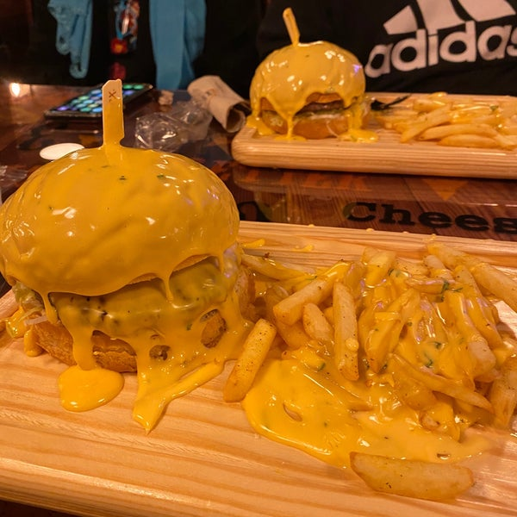
It is in the form of JPEG and will be read using matplotlib pyplot imread. After initializing with a simple type, size and shape check using numpy modules. We can see that the image is actually consisting of a numpy array of size (600, 600, 3) and a size of 1080000 and a file size of 69kb
The 3 in the size indicates the type of color channel (RGB) used in the shape. RGB (RED, GREEN, BLUE) consists of unsigned integers in the range of 0 to 255, this is the maximum that a single 8-bit byte can offer. The value of which is computed to form various light intensities. Theoretically there is 16,777,216 possible colors within an image.
Since the pixel intensity is always between 0 to 255 inclusively, we will first divide it by 255 to in a way “Standardize” the pixel values. Practically, we can visualize only a few colors in an image very less than the above number. So, the k-Means Clustering algorithm takes advantage of the visual perception of the human eye and uses few colors to represent the image.[3]
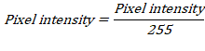
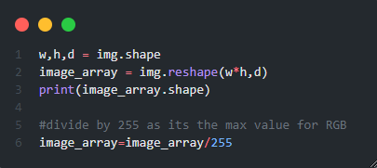
We then change the dimensions of the array to a 2D array by taking the width and height multiplied together and leaving the dimension as it is, this results in a 2D shape and then we can proceed to creating a K-Means algorithm.
Fig. 2. Implementation of changing dimensions

kmeans clustering
The K-Means algorithm solves the clustering problem of data in multidimensional space. In this case we are using it to compress images through grouping of RGB values using a compression ratio. The larger the compression ratio, the larger the difference between the compressed image and the original image. So to ensure we’re on the right track there are some guidelines to follow
• 𝐾 must be less than the number of image pixels.
• Using each pixel of the image as a data point to perform K-means and obtain centroids
• Storing the centroid and the index of the centroid of each pixel, so it doesn’t need to use all the original data.
An interesting fact about KMeans clustering is that it locates the at the centroids using the Euclidean Distance or “straight-line distance”. By using K-Means, the algorithm could effectively locate and replace the cluster region with the centroid RGB values.

This is done using this equation below where For each pixel of an image, calculate the Euclidean distance d, between the center and each pixel of an image. Where p(x, y) be an input pixels to be cluster and be the cluster centers.

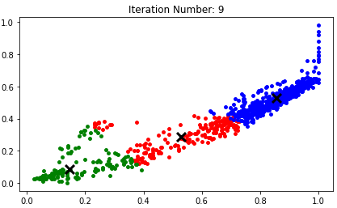
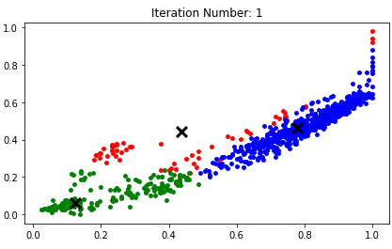

Fig. 3. K-Means centroid finding on 1st iteration Fig. 4. K-Means centroid finding on 9th iteration

From Fig. 3 and Fig.4 We can see that with more iterations of K-Means (At k=3) the algorithm can create more distinct segregation for different values of RGB and the centroids become much more centered within the points. Using this theory, we can create our K-Means model to perform color compression on the RGB values of images.

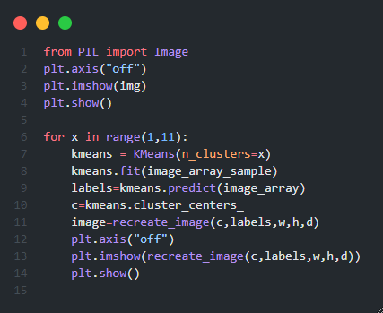
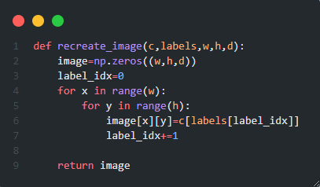

Fig. 4. Code to recreate the image Fig. 5. Code to make images by K clusters

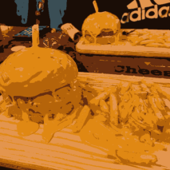
By implementing K-means of range 0-11. I produced new images from the prexisting image by shuffling the data array and performing clustering and then recreating the image using the dimension and outputing it using matplotlib for visualisation

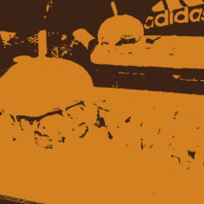
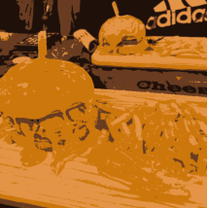
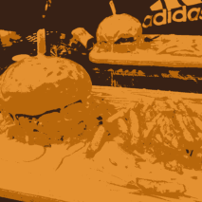
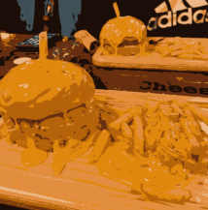
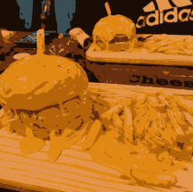
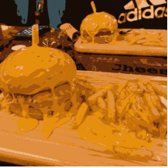
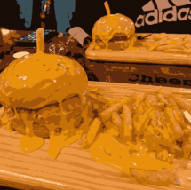
Results output
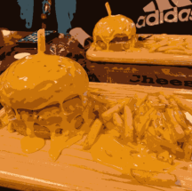
Fig. 6. Recreated images by order of K-Means (2-9)
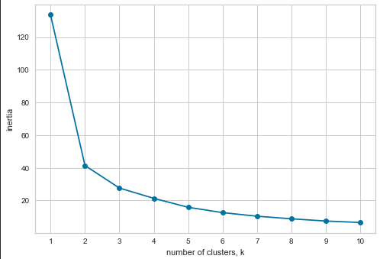
In Fig. 6 we can see that as k increases the image becomes less and less compressed and less distorted the image effect becomes more visible. With the result being that the image quality becomes significantly diminished due to the lack of colors present due to the clustering
WCSS (Within Cluster Sum of Squares) or also known as inertia score [4] is then performed for each initiation of k and from this we can see that based on elbow score k=2 would be the best clustering for the image however since we are not carrying out an unsupervised model but merely creating image effects inertia is irrelevant to what we can visibly determine with the naked eye.
Fig.7 Inertia score by cluster k

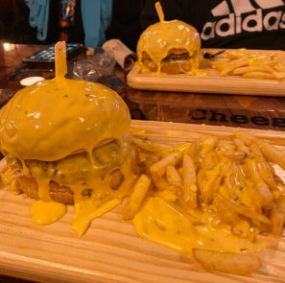
We then determine that after k=4 the image looks relatively the same as the distribution of colors simply cannot be perceived with the human eye and small details of each cluster are unable to be perceived in the grand scheme of the image if we were doing color compression for an image, the cluster of k=4 would be sufficient to produce an effect of image compression to give it an effect similar to modern day distortion filters.
However if we up the clustering all the way up to 255, the largest pixel size that is available we would have an image that is similar to Fig. 1 as we can see in Fig. 8 as the K clustered exactly the number of pixel values that is available in a normal image after standardization.

Fig. 8. Recreated image of K-Mean = 255

Conclusion
In this technical paper, We have performed color compression using K-means clustering using different values of K to varying effects on the image provided. We realize at some point that the color compression becomes almost unnoticeable to the human eye due to the colors and gives us a distortion effect similar to what many filters produce.

Acknowledgment
Thank you to the person reading this and Dr Wilson for implementing the technical paper
and making me to try out new things
😊

References
[1] Celebi, M. E. 2011. Improving the performance of k-means for color quantization. Image and Vision Computing.[Online]. https://faculty.uca.edu. Available at: https://faculty.uca.edu/ecelebi/documents/IMAVIS_2011.pdf [Accessed 8 August 2022].
[2] Xing.W 2019 IOP Conf. Ser.: Mater. Sci. Eng. 563 052042. Application of K-means Algorithm in Image Compression. [Online]. https://iopscience.iop.org/. Available at: https://iopscience.iop.org/article/10.1088/1757-899X/563/5/052042/pdf [Accessed 8 August 2022].
[3] Satyam. K. 2020. Image Compression using K-Means Clustering. [Online]. Available at: https://towardsdatascience.com/image-compression-using-k-means-clustering-aa0c91bb0eeb [Accessed 8 August 2022].
[4] Nameirakpam. D. 2015. Image Segmentation using K -means Clustering Algorithm and Subtractive Clustering Algorithm. [Online]. Available at: www.sciencedirect.com [Accessed 11 August 2022].

