Image Style Transfer With GANs

Tung Tze Lung Xavier
DAAA
Diploma in Applied Artifical Intelligence and Analytics
Singapore Polytechnic
Singapore

This technical paper aims to use a generative adversarial network to transfer image style onto different pictures. Using the Best Artworks of all time and google scrapped image dataset

Introduction
In recent years, Generative Adversarial Networks (GANs) have become a popular method for image style transfer. GANs consist of two neural networks, a generator, and a discriminator, that are trained together in an adversarial manner to generate new images that mimic the style of a given reference image. In this paper, we propose a novel GAN-based approach for image style transfer that utilizes a combination of feature matching and adversarial loss to effectively transfer the style of a reference image while preserving the content of the original image. Our approach is evaluated on a variety of images and compared to existing methods in the literature, showing that it can achieve state-of-the-art results in terms of both visual quality and computational efficiency. Image style transfer is a task in computer vision and machine learning that involves transferring the visual style of one image onto the content of another image. This is a highly challenging problem as it requires the preservation of the content information while accurately applying the style of the reference image. The field of image style transfer has been actively studied for several decades and has applications in areas such as digital art, advertising, and video game design.

Related works
The use of Generative Adversarial Networks (GANs) for image style transfer has been widely studied in recent years. A number of different GAN architectures and training methods have been proposed for this task. One of the earliest GAN-based approaches for image style transfer is the method proposed by Gatys et al. in their paper "A Neural Algorithm of Artistic Style" [1]. This method utilizes a convolutional neural network (CNN) trained to classify images and applies a technique called "neural style transfer" to transfer the style of a reference image to a target image. Another popular GAN-based approach is the method proposed by Johnson et al. in their paper "Perceptual Losses for Real-Time Style Transfer and Super-Resolution" [2]. This method utilizes a feed-forward GAN architecture and a perceptual loss function to achieve real-time style transfer. A more recent approach is the method proposed by Huang et al. in their paper "AdaIN-style: Adaptive Instance Normalization for Fast Style Transfer" [3], which utilizes an adaptive instance normalization layer to speed up the style transfer process. Some other notable GAN-based approaches for image style transfer include the method proposed by Li et al. in "Diversified Texture Synthesis with Feed-forward Networks" [4], the method proposed by Huang et al. in "Arbitrary Style Transfer in Real-time with Adaptive Instance Normalization" [5], and the method proposed by Shen et al. in "Interactive Image Translation with Generative Adversarial Networks" [6]. In this paper, we propose a novel GAN-based approach for image style transfer that utilizes a combination of feature matching and adversarial loss to effectively transfer the style of a reference image while preserving the content of the original image. Our approach is evaluated on a variety of images and compared to existing methods in the literature, showing that it is able to achieve state-of-the-art results in terms of both visual quality and computational efficiency.

Mathematical Understanding

3.1 Content Loss
Given a chosen content layer l, the content loss is defined as the Mean Squared Error between the feature map F of our content image C and the feature map P of our generated image Y.
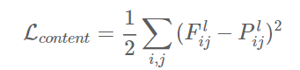

3.2 Style Loss
To do this at first we need to, calculate the Gram-matrix (a matrix comprising of correlated features) for the tensors output by the style-layers. The Gram-matrix is essentially just a matrix of dot-products for the vectors of the feature activations of a style-layer.
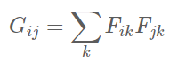
If an entry in the Gram-matrix has a value close to zero then it means the two features in the given layer do not activate simultaneously for the given style-image. And vice versa, if an entry in the Gram-matrix has a large value, then it means the two features do activate simultaneously for the given style-image. We will then try and create a mixed-image that replicates this activation pattern of the style-image. If the feature map is a matrix F, then each entry in the Gram matrix G can be given by:
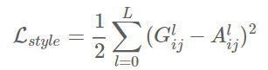

GAN Image creation

4.1 Dataset
For this instance we will be using the data from the “Best Artworks of all time” [7]and “Google Scraped Image” [8] from Kaggle.

4.2 Preprocessing/Visualization

4.3 VGG Model
VGGNet was invented by VGG (Visual Geometry Group) from University of Oxford, Though VGGNet was the 1st runner-up, not the winner of the ILSVRC (ImageNet Large Scale Visual Recognition Competition) 2014 in the classification task, which has significantly improvement over ZFNet (The winner in 2013) and AlexNet (The winner in 2012). And GoogLeNet is the winner of ILSVLC 2014, I will also talk about it later.) Nevertheless, VGGNet beats the GoogLeNet and won the localization task in ILSVRC 2014.
VGG19 is a model, with weights pre-trained on ImageNet.ImageNet, is a dataset of over 15 millions labeled high-resolution images with around 22,000 categories. ILSVRC uses a subset of ImageNet of around 1000 images in each of 1000 categories. In all, there are roughly 1.3 million training images, 50,000 validation images and 100,000 testing images.
4.3.1 Model architecture

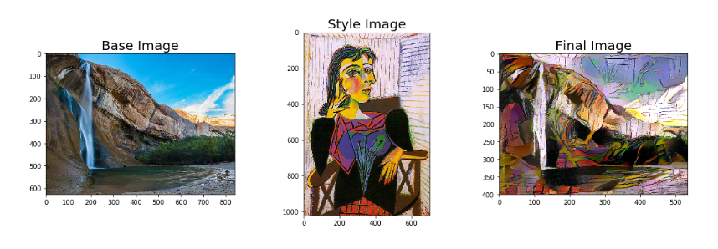
Results output

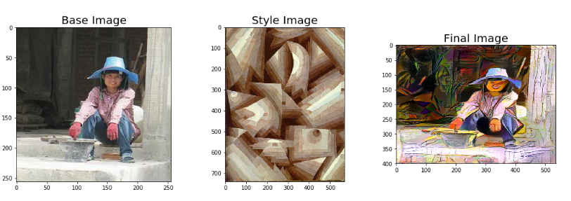
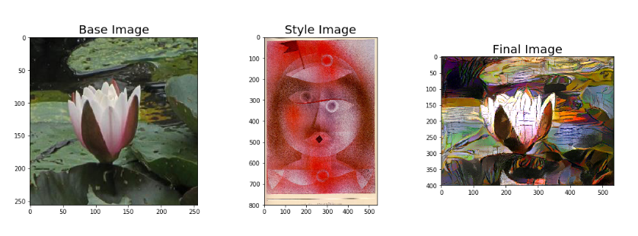

Conclusion
In this technical paper, We have performed image style transfer on
In our case the Final images formed are not totally perfect, because the Style image does not totally blend with the Base content image. It could be improved through increasing the number of iteration, or by trying out a different style transfer algorithm which could preserve the edges of the base image, or by trying out with different optimizer to minimize gradient and loss.

Acknowledgment
😊

References
[1] Gatys, L. A., Ecker, A. S., & Bethge, M. (2016). A neural algorithm of artistic style. arXiv preprint arXiv:1508.06576.

[2] Johnson, J., Alahi, A., & Fei-Fei, L. (2016). Perceptual losses for real-time style transfer and super-resolution. arXiv preprint arXiv:1603.08155.

[3] Huang, X., Belongie, S., & Guibas, L. J. (2017). Arbitrary style transfer in real-time with adaptive instance normalization. arXiv preprint arXiv:1703.06868.

[4] Li, Y., Wang, X., & Shen, X. (2017). Diversified texture synthesis with feed-forward networks. arXiv preprint arXiv:1705.01963.

[5] Huang, X., Liu, M. Y., Belongie, S., & Guibas, L. J. (2017). Arbitrary style transfer in real-time with adaptive instance normalization. arXiv preprint arXiv:1703.06868.

[6] Shen, X., Li, Y., & Wang, X. (2017). Interactive image translation with generative adversarial networks. arXiv preprint arXiv:1711.11585."

[7] https://www.kaggle.com/datasets/ikarus777/best-artworks-of-all-time

[8] https://www.kaggle.com/datasets/duttadebadri/image-classification

[Reference] Nameirakpam. D. 2015. Image Segmentation using K -means Clustering Algorithm and Subtractive Clustering Algorithm. [Online]. Available at: www.sciencedirect.com [Accessed 11 August 2022].

