Sam Ford

Global Illumination (CSCI-711)

Joe Giegel

Final Project Report

What I set out to do:  
I set out to render caustics at the start of the semester. I later figured out that I could do this via photon mapping, which was an advanced checkpoint for the course so I decided to make it an extension of my raytracer in the end. I simply added caustics to my photon mapping assignment.   
As stretch goals, I wanted to try to simulate swimming pool caustics in different ways: water made via normal mapping, water as generated triangles or a model, water as a cube, and water as a transparent blue plane. I was able to accomplish the last one.

What I managed to finish:  
I have a kdtree that handles triangles well (spheres currently give it issues), a working version of photon mapping with caustics (some details need some ironing out but it works generally well), and a Cornell swimming pool scene to expand as a side project in a separate repository from my current raytracer code.

Caustics in Cornell Box Results:

The following scenes were meant to be illustrative thus the following parameters:

* 10-watt light source (center of the box)
* Box dims are 3x3x3
* search radius^2 used = .15.
* 250 nearest photons gathered from both maps at intersection points
* Walls = .75 diffuse 0 specular
* Spheres = .65spec and .35diffuse, .35 transmissive and .65 reflective
* Left sphere IOR = .995’
* Right sphere IOR = 1.33 (water’s IOR)

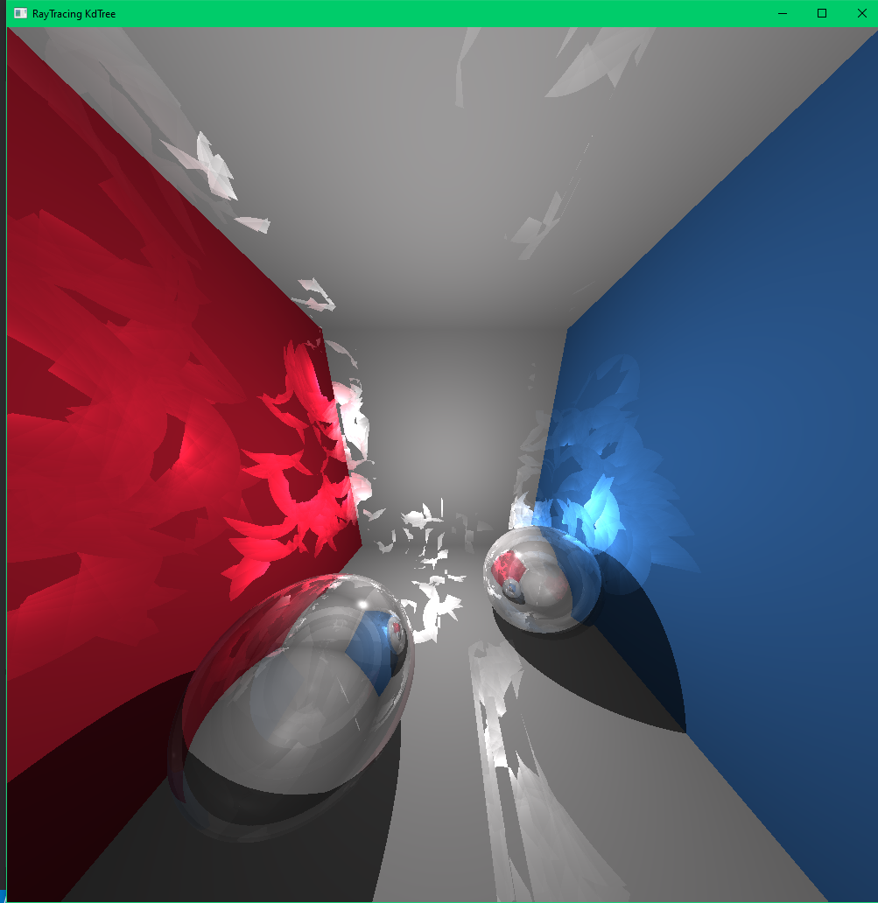  
Global&Caustics 1k global and 2k caustic photons

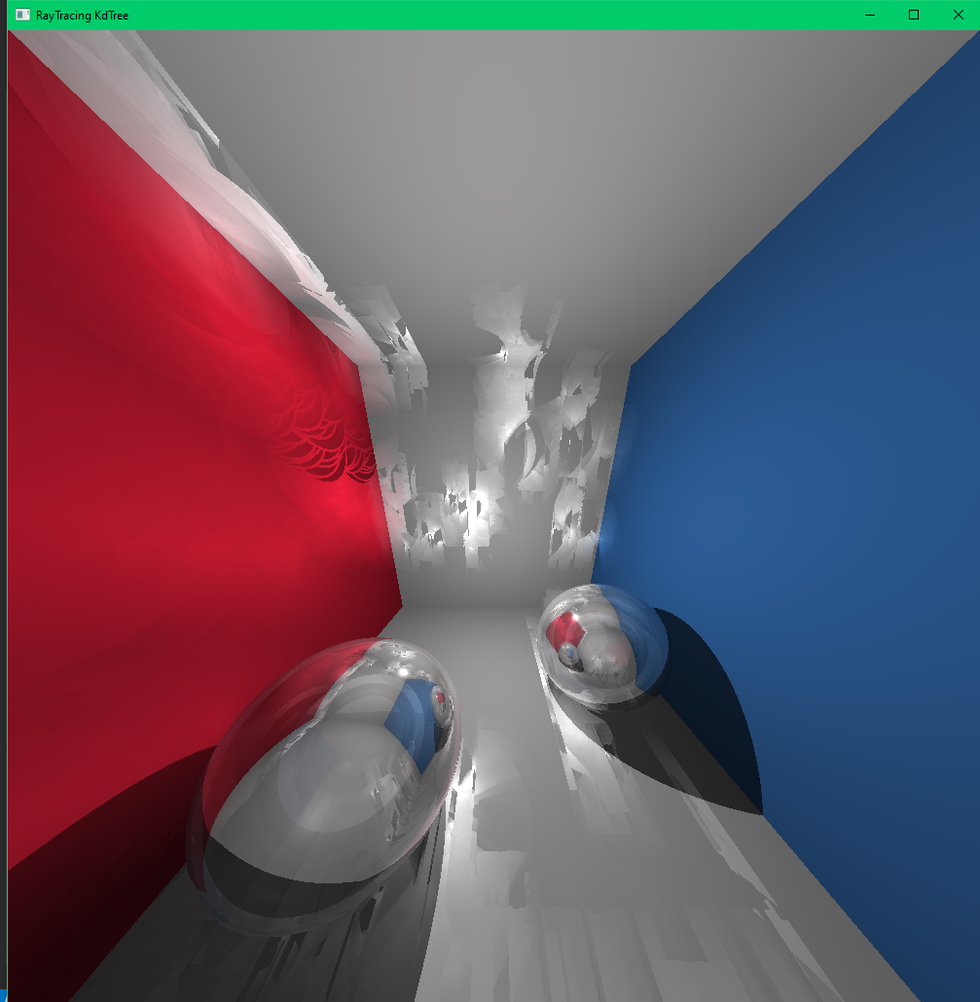

Global&Caustics 10k global and 20k caustic photons

Swimming Pool Scene Results:

* The light source is in the center but slightly below the ceiling.
* The box dims are 3x3 for the length and width. The depth is 3.5 .
* The two cyan transparent triangles used to represent the water are .95 transmissive and .05 reflective. IORs are 1.33.
* Swimming pool borders, floors, and walls are still .75 diffuse

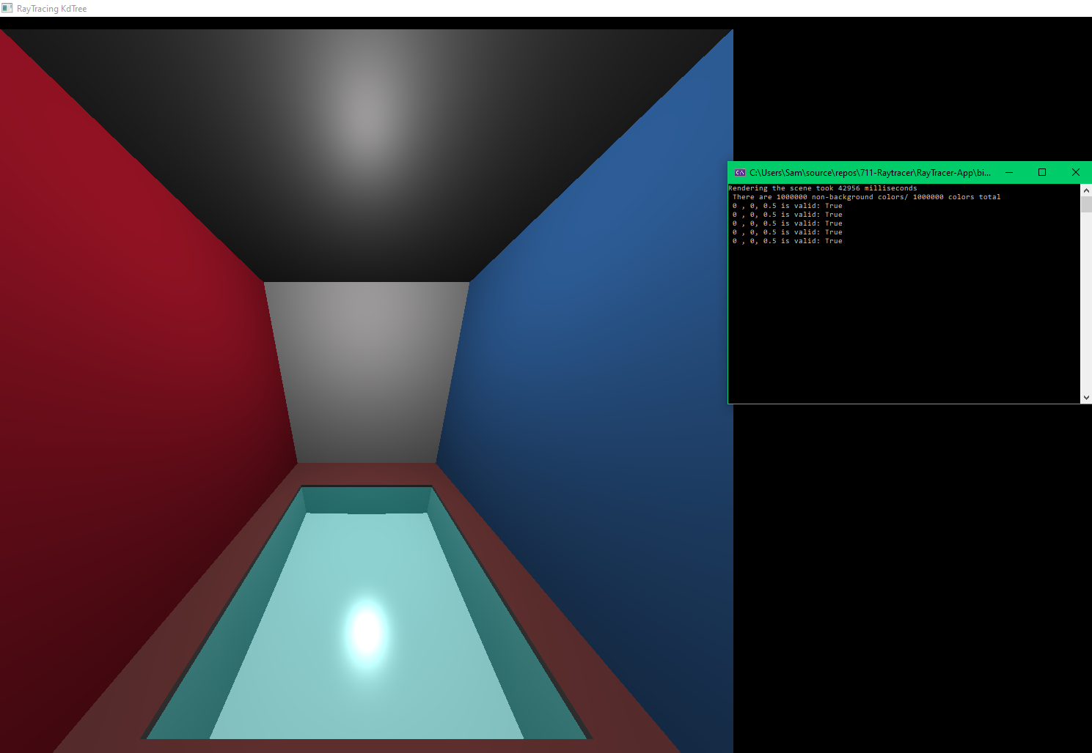

No caustics/ photon mapping

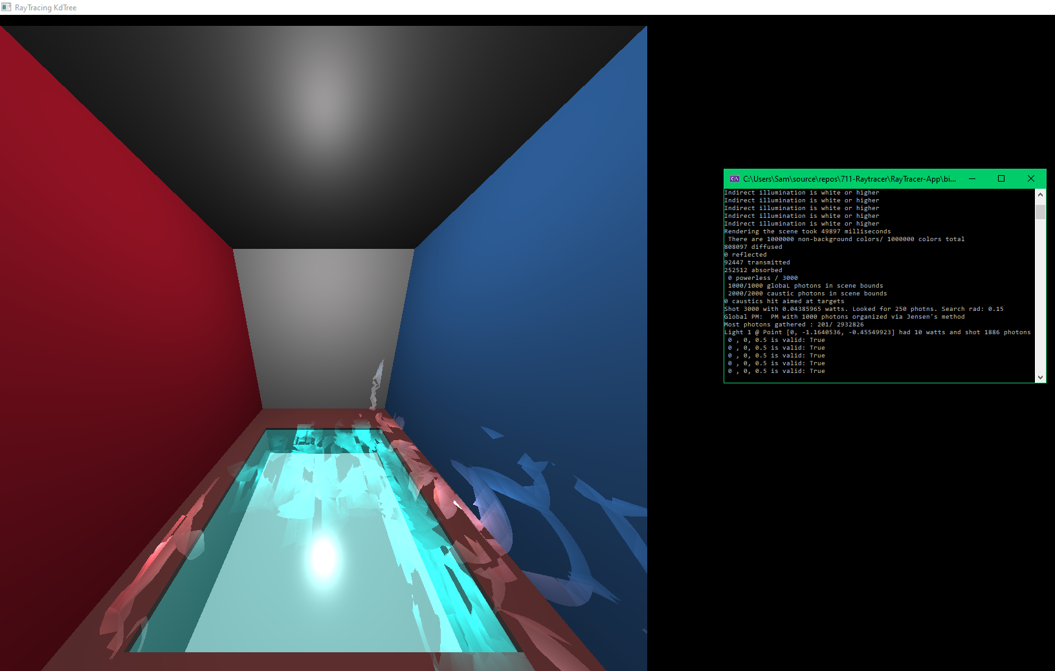

1k global photons and 2k caustics

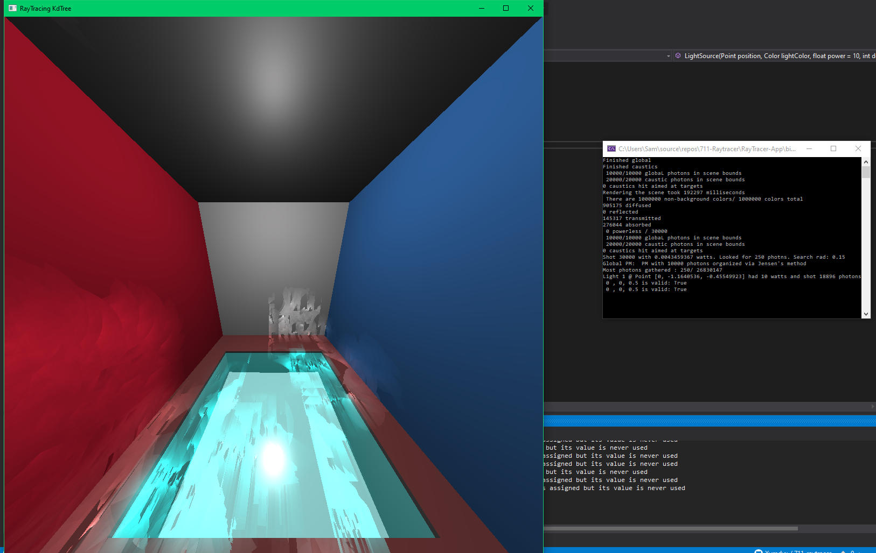

10k global and 20k caustics

What went Wrong:

* Heaviest workload for a semester yet.
* KdTree bad at handling spheres at the moment
* Photon Mapping took 2 weeks longer than expected and I suspect that there may be a hidden issue or two.
* Spent lots of time researching how to do the later water effects rather than just focusing on doing Photon Mapping earlier.
* I used OpenGL and C#, both of which I have little experience in and had insufficient time to become fluent in this semester.

What Went Right:

* I have a solid project to expand outside of this course in a separate repository away from the submitted version.
* I have plenty of graphics resources to read through.
* I learned about Fresnel Equations which is needed for realistic water.
* Know of progressive photon mapping and its stochastic variant
* Learned about TBN matrices for transforming to/from a surface normal’s defined space

Future Work:

* Migrate and refactor current raytracer code
* Double-check photon mapping code over summer. Expand to have volume support once I verify global and caustic photons.
* Implement Fresnel effects and other BRDFS.
* Learn Blender and how to read their obj files into my raytracer.
* Implement texture and normal mapping. Make water differently.
* Make area lights.