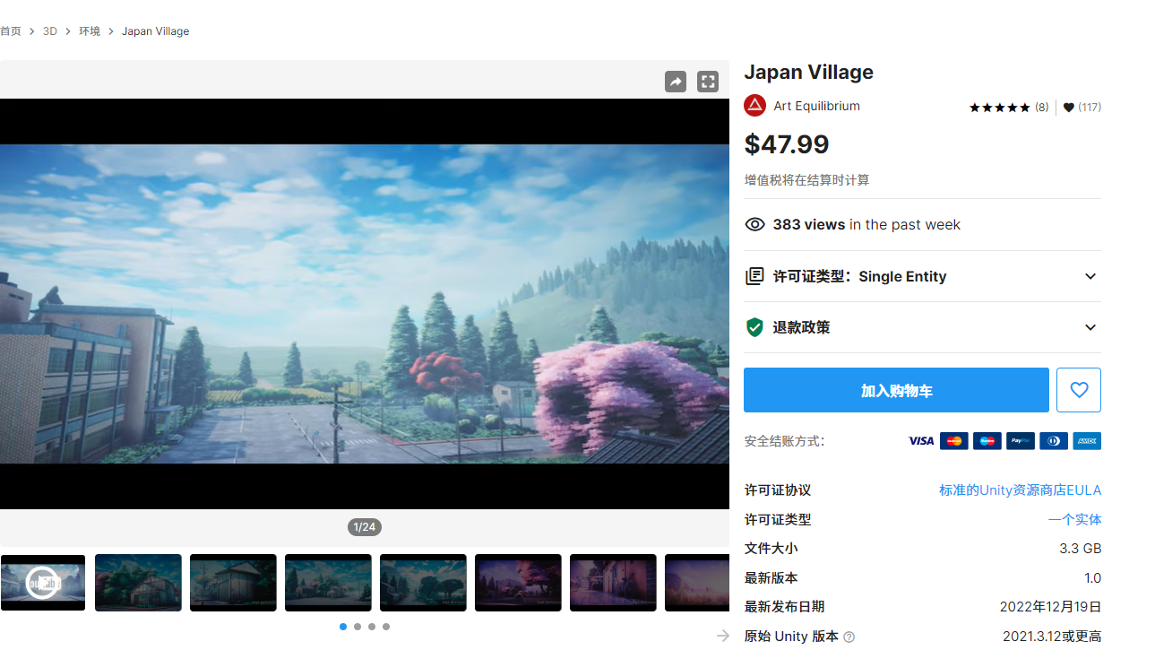

<https://assetstore.unity.com/packages/3d/environments/japan-village-241986>

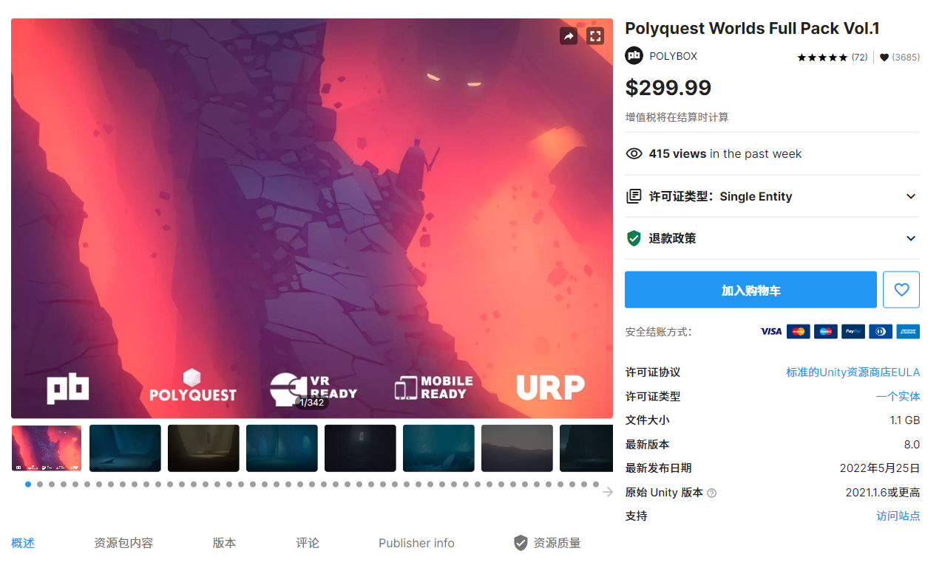

<https://assetstore.unity.com/packages/3d/environments/polyquest-worlds-full-pack-vol-1-74631>

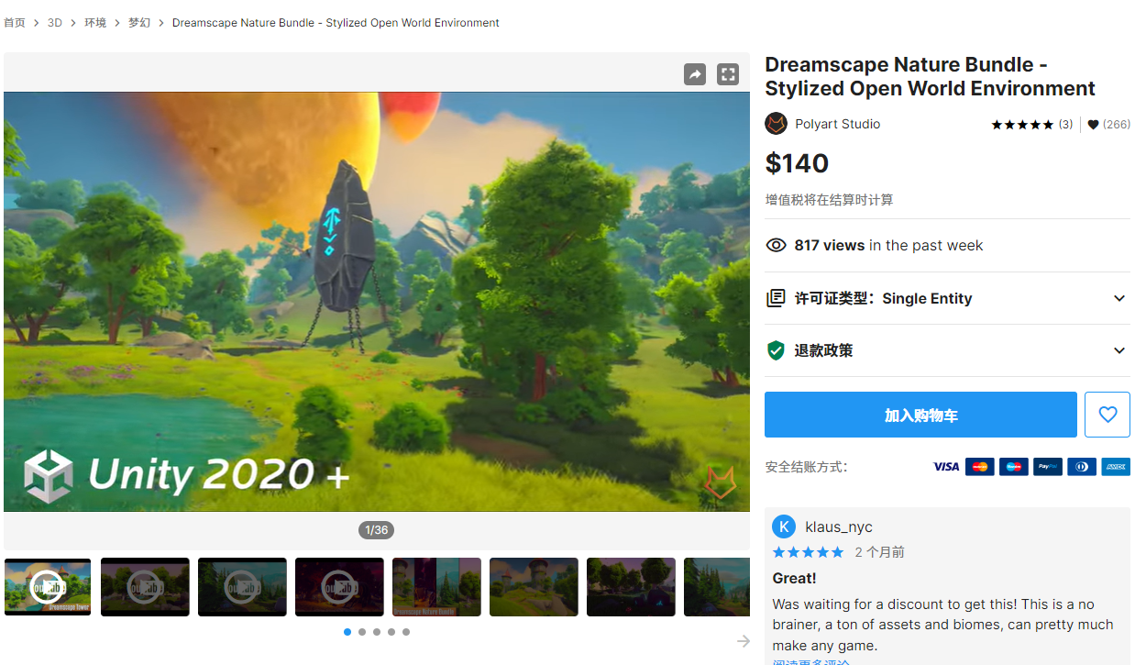

<https://assetstore.unity.com/packages/3d/environments/fantasy/dreamscape-nature-bundle-stylized-open-world-environment-232630>

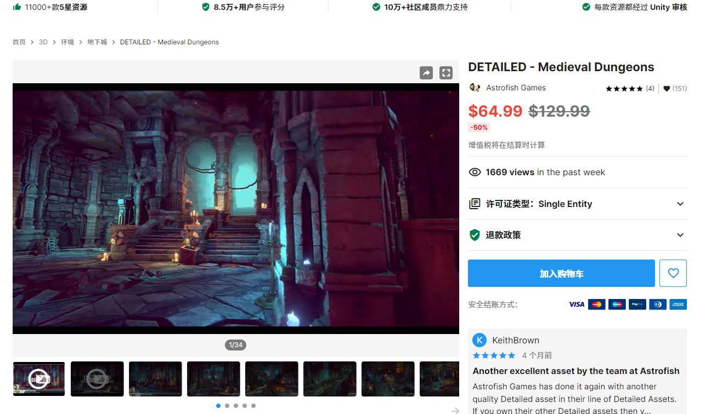

<https://assetstore.unity.com/packages/3d/environments/dungeons/detailed-medieval-dungeons-230973>

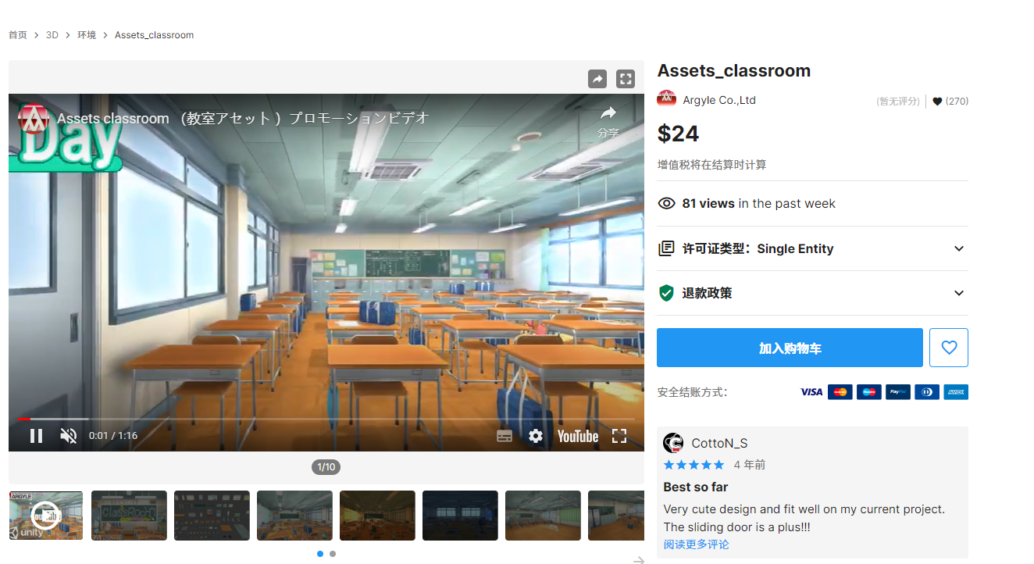

<https://assetstore.unity.com/packages/3d/environments/assets-classroom-98134>

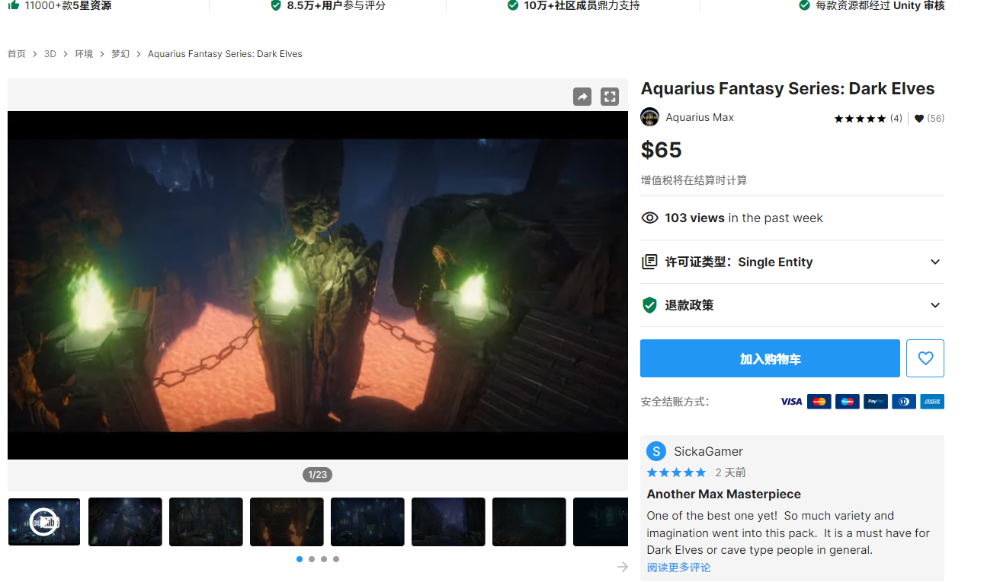

<https://assetstore.unity.com/packages/3d/environments/fantasy/aquarius-fantasy-series-dark-elves-237879>

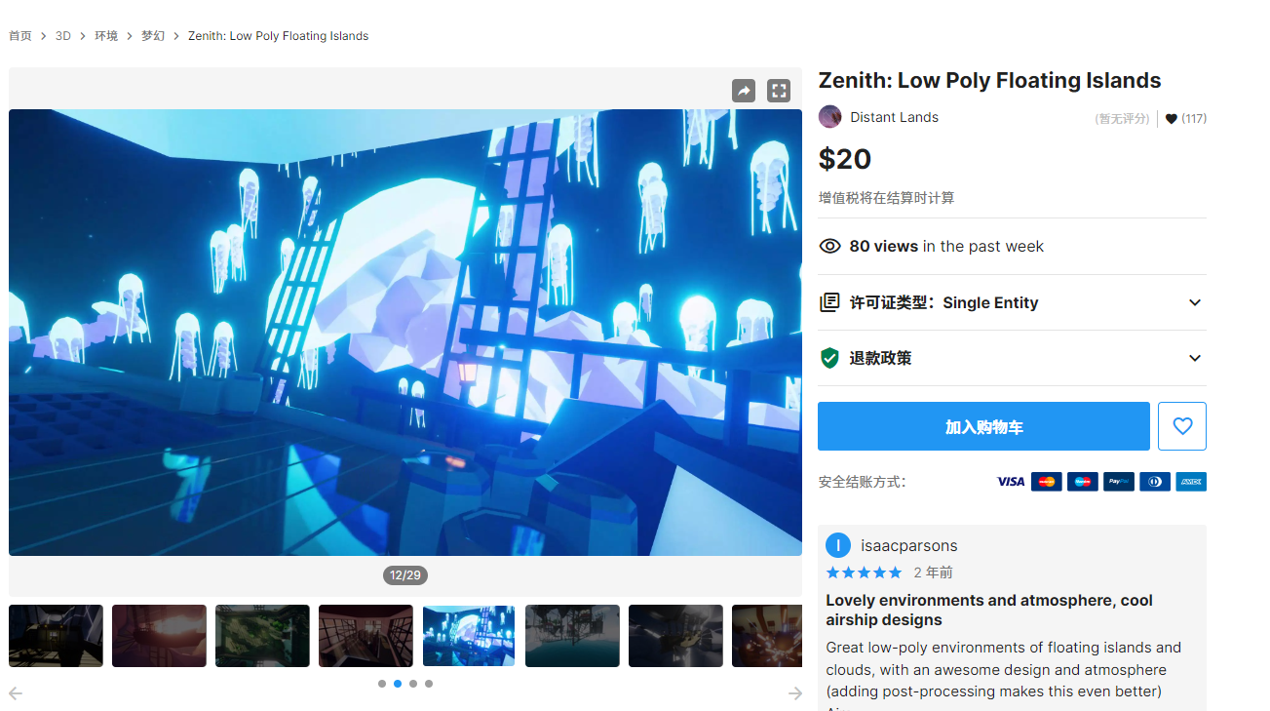

<https://assetstore.unity.com/packages/3d/environments/fantasy/zenith-low-poly-floating-islands-179683>

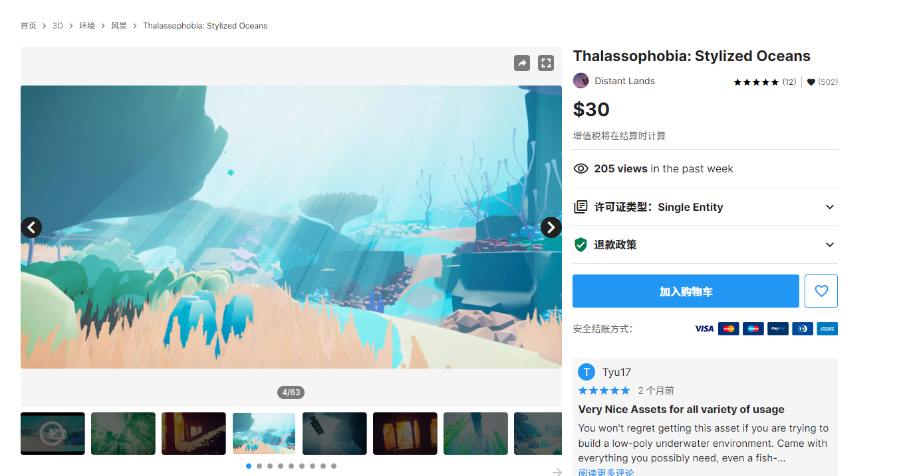

<https://assetstore.unity.com/packages/3d/environments/landscapes/thalassophobia-stylized-oceans-192227>