1 interaction design ： Designing interactive products to support the way people communicate and interact in their everyday and working lives.
2 Core characteristics of interaction design ：Users / usability and user experience goals / Iteration
3 Usability and user experience goals ：Usability is more objective: how useful or productive a system is from its own perspective / User experience is more subjective: how users experience an interactive product from their own perspective
4 The Process of Interaction Design：Discovering requirements / Designing alternatives / Prototyping/ Evaluating
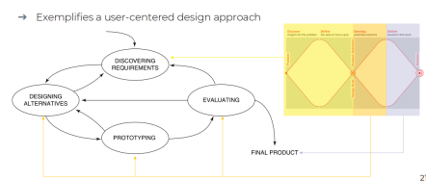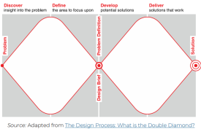
5 Practical Issues in Interaction Design : What are the users needs?/ How to generate alternative designs? / How to choose among alternatives?
6 User-centered approach 3 principles : Early focus / Empirical measurement / Iterative design
Discovering Requirements
1 Describe requirement : Atomic requirement shell / User stories
2 Six most common types of requirements : Functional requirements/ Data requirements / Environment requirements / Users characteristics / Usability goals / User experience goals
3 Data gathering for requirements : Interviews, observations, and questionnaires / Studying documentation / Researching similar products
4 Bringing requirements to life : Personas / Scenario
Prototype
1 Feature : Cheaper & Faster! / Easier to communicate! / Direct feel!
2 Why prototype ：Understanding / Communication / test and reflection
3 The fidelity of a prototype refers to how it conveys the look-and-feel of the final product (basically, its level of detail and realism).
4 Prototyping tools : Storyboards / ‘Wizard-of-Oz’prototyping ---The user thinks they are interacting with a computer, but a developer is responding to output rather than the system. / User journey map / Empathy map
5 Five dimensions in prototyping : Visual: / Interaction: / Breadth: / Depth/ Content:
6 What Type of Prototyping? throw-away / incremental (product built as separate components ) / evolutionary
Design
1 Accessibility and inclusiveness : the extent to which an interactive product is accessible by as many people as possible / making products and services that accommodate the widest possible number of people
2 Design Principles: Visibility 可见性 / Feedback / Constraints防止用户使用错误选项/ Consistency / Keypad numbers layout 键盘布局符合用户使用场景 / Affordances ：Refers to an attribute of an object that allows people to know how to use it. For example, a mouse button invites pushing, a door handle affords pulling / Mapping ： Relationship between controls and their effects
3 Shneiderman's Eight Golden Rules of Interface Design ： 1. Strive for consistency / 2. Enable frequent users to use shortcuts 允许频繁使用的用户使用快捷方式 / 3. Offer informative feedback/ 4. Design dialog to yield closure 设计对话以实现闭环/ 5. Offer simple error handling / 6. Permit easy traversal of actions / 7. Support internal locus of control / 8. Reduce short-term memory load
4 How to choose among alternatives ： A/B Testing / Quality thresholds （Different stakeholder groups have different quality thresholds (think of photo taking on the phone)
5 physical design : Menu design / Icon design / Screen design / Information display
6 Interface metaphors 界面隐喻 ： Exploit user’s familiar knowledge, helping them to understand ‘the unfamiliar’/ 让学习新系统变得更容易，帮助用户理解底层概念模型，用户更加易于访问/ 打破常规和文化规则，与设计原则相冲突，设计师可能无意中采用不良的设计元素并将其转移，限制了设计师在创造新概念模型时的想象力
7 Interaction types ： Instructing 教 / Conversing对话/ Manipulating 用户在物理世界的操纵/ Exploring 用户探索/ Responding系统主动提醒
8 20 interface types covered ： Command / Graphical / Multimedia / Virtual reality / Web / Mobile / Appliance 器具/ Voice / Pen / Touch /
Gesture / . Haptic 触觉 / Multimodal 多模态 / Shareable 可共享 / Tangible 可触知 / Augmented reality / Wearables / Robots and drones 无人机
Brain–computer interaction / . Smart 智能接口
Evaluation
1 Running the interview ： Introduction: Introduce yourself, explain the goals of the interview, reassure about the ethical issues, ask to record, and present the informed consent form. / Warm-up: Make first questions easy and non-threatening. / Main body: Present questions in a logical order/ A cool-off period: Include a few easy questions to defuse tension at the end /. Closure: Thank interviewee, signal the end, for example, switch recorder off.
2 Choosing and combining techniques
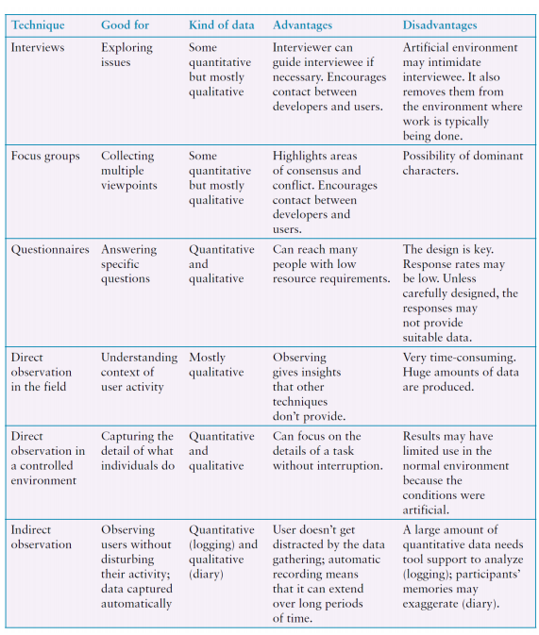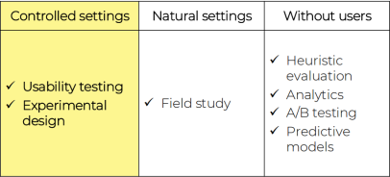
3 Five key issues: Setting goals / Identifying participants / Relationship with participants / Triangulation / Pilot studies
4 Why, what, where and when to evaluate : Why: To check users’ requirements and confirm that users can utilize the product and that they like it/ What: A conceptual model, early and subsequent prototypes of a new system, more complete prototypes, and a prototype to compare with competitors’ products / Where: In natural, in-the-wild, and laboratory settings / When: Throughout design; finished products can be evaluated to collect information to inform new products
5 observation : 直接实地观察收集数据 处理敏感话题 / 间接跟踪用户活动⇾日记⇾交互日志⇾网络分析
6 Practical challenges of evaluation : Participants’ consent 参与者的同意 / Interpreting data 可解释的数据
7 Without users ： More precisely, without direct involvement of users.： Heuristic evaluation / Walkthroughs/ Analytics/ A/B testing/ Predictive modeling
8 Nielsen’s heuristics : Visibility of system status/ Match between system and real world / User control and freedom/ Consistency and standards/ Error prevention/ Recognition rather than recall (The user should not have to remember information from one part of the interface to another)/ Flexibility and efficiency of use/ . Aesthetic and minimalist design 美学与极简主义设计/ Help users recognize, diagnose, recover from errors/. Help and documentation
9 Doing heuristic evaluation: Briefing session to tell experts what to do / Evaluation period of 1-2 hours in which: Each expert works separately Take one pass to get a feel for the product Take a second pass to focus on specific features / Debriefing session in which experts work together to prioritize problems
Disadvantages : Can be difficult and expensive to find experts / Experts have biases
10 walkthrough 3 questions : Users know what to do / Users know how to do it / Users understand the feedback
12 Analytics 自动记录活动的优势⇾如果不影响系统性能，这种做法不会引起注意⇾可以自动记录大量数据，并通过可视化工具等进行探索和分析。➔缺点⇾如果在参与者不知情的情况下进行，可能会引发伦理上的担忧
13 A/B Testing 大规模实验（涉及数千名或更多参与者）➔提供了一种评估网站、移动设备上运行的应用程序的方法➔常用于评估社交媒体应用设计的变化➔比较两组用户在两个不同设计版本上的表现➔如果用户不知情，可能会引发伦理问题
14 Predictive Modeling 提供一种无需直接涉及用户即可评估产品或设计的方法，且成本低于用户测试➔使用公式推导出各种用户性能指标➔仅适用于具有可预测任务的系统，例如语音邮件系统、智能手机和专用移动设备
15 Usability testing ：Users are observed and timed / Data is recorded on video, and key presses are logged/ The data is used to calculate performance times and to identify and explain errors / User satisfaction is evaluated using questionnaires and interviews / Quantitative performance measures 定量绩效指标
16 Experimental design ：Predict the relationship between two or more variables / Independent variable is manipulated by the researcher/ Dependent variable influenced by the independent variable/ Typical experimental designs have one or two independent variables/ Validated statistically and replicable 17 Null hypothesis: typically states that there is no difference between experimental treatments / Alternative hypothesis: a statement that is mutually exclusive with the null hypothesis / The goal of an experiment is to find statistical evidence to reject the null hypothesis in order to support the alternative hypothesis
18 Experimental designs type : Between subjects design ( Different participants , Single group of participants is allocated randomly to the experimental conditions ) / Within subjects design ( Same participants , All participants appear in both conditions )
2 Field study 实地研究Field studies are done in natural settings “In the wild” is a term for prototypes being used freely in natural settings

