Converge GDD
Andrew Perrault – June 20, 2015
Table of Contents
1 Overview 1
1.1 Setting/Theme 1
1.2 Platform 1
2 Game Rules 2
2.1 The Board 2
2.2 Your Turn 2
2.3 Capturing Bits 2
2.4 Winning 3
3 Controls 3
4 Screens 3
4.1 Game Screen 3
4.2 AI Difficulty Selection 3
4.3 Title Screen 4
4.4 Main Menu 4
4.5 Options 4
4.6 About Screen 4
5 Technical Design 4
5.1 The Game Board 4
6 Appendix A - Options for the Future 4
6.1 Monetization 4

Overview
Converge is an iPhone game board game. The game is similar to traditional Central Asian and African games like Mancala, Oware and Bohnenspiel but with modern styling and slightly different rules to make the game faster. The original game is intended for two players but in this version you will always play against an AI opponent. The game is intended to be quick to learn and quick to play but deep enough to be played many times over.

Setting/Theme
The game board will have a very simple, clean design. The game board will take up most of the screen. There will not be any numerical UI or score. You will be able to tell who is winning by the pool of captured game pieces on each side of the board.

Platform
The primary platform will be iOS. It will target iPhone 6, 5 and 4 as well as iPad.

Game Rules
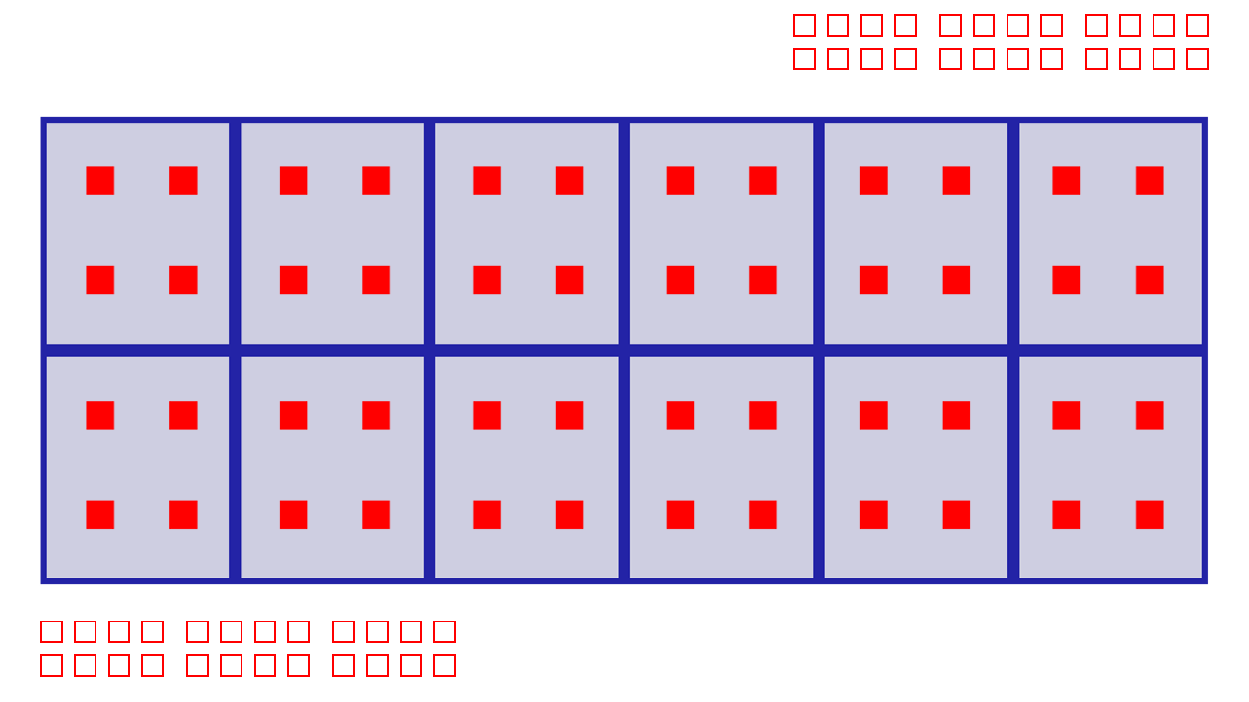Illustration 1: The game board

The Board
The board will consist of twelve pools arranged in two rows. You control the pools at the bottom and your opponent controls the pools at the top. At the beginning of the game there are four bits in each pool.

Your Turn
You turn consists of selecting one of the pools you control that contains at least one bit. The bits are removed and added one at a time to each pool in a counter-clockwise direction. Continue adding bits to the pools until all of the bits are distributed. If you have twelve or more bits then you skip the original pool.

Capturing Bits
When you finished distributing bits if the last pool you added a bit to is on your opponents side and now contains 2, 4, 8 or 16 bits then you capture those bits and remove them from play. If the next to last pool you added bits to also has 2, 4, 8 or 16 bits you can also capture those bits. You can continue capturing to the right and capturing as long as you only capture your opponents bits and the pool contains exactly 2, 4, 8 or 16 bits. If the last distributed bit is on you side of the board then you capture nothing. If the last distributed bit is in a pool that finishes with any number other than 2, 4, 8 or 16 then you capture nothing even if other pool contains those numbers.

Winning
As soon as one player captures at least half of the bits – 24 – then then the game is over and that player wins.

Controls
The game controls are very simple. When it is your turn tap the pool you want to distribute.

Screens
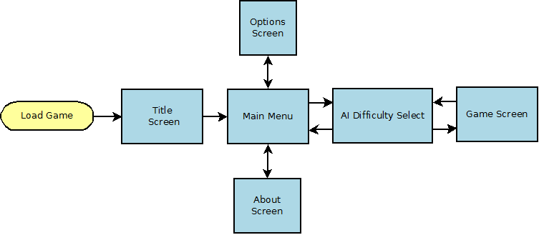Illustration 2: Game Screens

Game Screen
The game screen will mostly be filled with the game board. There will be a small icon at the top to return to the main menu.

AI Difficulty Selection
This screen will let you select easy, normal or hard AI. This screen depend on making the AI difficult enough to make easier levels relevent. Multilevel AI will be low priority for the prototype and this screen may get cut.

Title Screen
Title screen will be displayed as the game is loading.

Main Menu
Main menu will have options to play the game, view the options menu or view the about screen.

Options
Options for sound on/off and music on/off.

About Screen
This lists information about me and about the licenced libraries used in the game.

Technical Design
The game will be written in Swift using the Sprite Kit framework. The main menu and options screen will use UIKit.

The Game Board
Each pool will be represented by a class. The game class will have a doubly linked list shaped like a ring linking the last element to the first. Distributing the bits will be a simple as iterating through the list starting at selectedPool.Next().

Appendix A - Options for the Future

Monetization
To be competitive this game should be free. The simplest way to monetize the game would be ads. If ads on the game screen seem to obtrusive then they could be added to a loading screen before the game starts. Also the main menu could provide a link to a paid version of the game with no ads.

