The Right to Bear Arms GDD
Written by: Andrew Perrault November 7 2014
Table of Contents
1 Introduction 3
2 Background 3
3 Platforms 3
3.1 Google Play 3
3.1.1 Minimum System Requirements 3
3.2 Windows Store 3
3.2.1 Minimum System Requirements 3
3.3 IOS 3
3.3.1 Minimum System Requirements 4
4 Win/Loss Conditions 4
5 Levels 4
5.1 Intro Level - Zoo 4
5.1.1 Enemies 4
5.2 Zoo 2 4
5.2.1 Enemies 4
5.3 Space Ship 5
5.3.1 Enemies 5
5.4 Alien Space Station 5
5.4.1 Enemies 5
5.5 End Boss 5
5.5.1 Enemies 5
6 Cuddles 5
7 Enemies 6
7.1 Robot drones 6
7.2 Spider mines 6
7.3 Energy beam drones 6
7.4 Little green men 6
7.5 Tiny Flying Saucer 7
8 Pregame Upgrades 7
8.1 Weapon 7
8.2 Armour 7
9 In-Game App Purchase 8
10 Interface 8
10.1 Menu Outline 8
10.1.1 Title Screen 8
10.1.2 Option Screen 8
10.1.3 Upgrade Screen 8
10.1.4 Shop 8
10.1.5 Title Screen 9
10.1.6 End Game Screen 9
10.2 Player Interaction 9
10.3 Meters and Icons 10
10.3.1 Health Meter 10
10.3.2 Armour and Weapon Icons 10
10.3.3 Point Meter 10
11 Appendix A. Estimated Schedule 11

Introduction
The Right to Bear Arms is a fast paced action game where you play as Cuddles the bear and must fight an alien invasion. The game is a twitch based action game with simple controls intended for mobile phones. Mechanically the game is a side scrolling beat-em-up. The revenue model will be based on in app purchases of game currency.

Background
Alien trophy hunters are attacking the earth. The aliens are collecting tiger tails, elephant ears, cow lips and bear arm…
Cuddles wakes up one day in his comfy cave at the zoo to the sounds of panic. He tries to go see what is happening and immediately falls on his face. What happened to his arms? Looking around Cuddles sees a little green man with a huge head running out of his enclosure carrying a pair of bear arms. Cuddles stands up onto his back legs and walks over to the nearest maintenance building to get something to fight the aliens with. He sticks a pair of chainsaws on his stumps and goes looking for little green men.

Platforms

Google Play
Android will be the first platform to ship because it is the simplest platform qualification process. The in game currency will be stored in the cloud and attached to the end users Google Play account.

Minimum System Requirements
TBD

Windows Store
The windows port will be the exact same game as the Google Play version. The in game app purchase portion of the game will need to be rewritten.

Minimum System Requirements
TBD

IOS
The iOS port will be the exact same game as the Google Play version. The in game app purchase portion of the game will need to be rewritten.

Minimum System Requirements
TBD

Win/Loss Conditions
- The game will consist of four levels and one end boss level
- Enemies will constantly spawn off screen and run at you
- Enemies do damage when they touch you
- You begin each level at one end and run all the way to the other end to win the level
- If you get through all five level without dying then you win
When the game ends you will always be presented with screen congratulating you and displaying the number of enemies you have killed and the amount of currency you have collected.

Levels

Intro Level - Zoo
The first level is primarily to let a new player get used to the controls. The first third of the level will only have a few drones. After the first third the level will ramp in difficulty. The end boss of level one will be a Tiny Flying Saucer.

Enemies
Enemy | How Many | Notes
Drones | Lots in groups of 2-4 | Start level with small groups
Energy Beam Drones | 3-4 | From middle of level on
Tiny Flying Saucer | 1 | End Boss

Zoo 2
The second level is similar to the first except harder. The player will see spider-mines for the first time on this level. At the end of the level you will come to the huge alien space ship.

Enemies
Enemy | How Many | Notes
Drones | Lots in groups of 2-4 | Start level with small groups
Energy Beam Drones | 4-5 | Groups of 1 to 2
Spidermines | 5-6
Tiny Flying Saucer | 2

Space Ship
The third level is inside the alien space ship. The player will see little green men for the first time on this level. At the end of the level you will get to a control room and fly to the alien space station.

Enemies
Enemy | How Many | Notes
Drones | Few | Groups of 3-5
Energy Beam Drones | 4-5 | Groups of 2
Spidermines | 5-6
Little Green Men | 5 | Groups of 1-2

Alien Space Station
The forth level is inside the alien space ship. You will be able to see the trophies that the aliens have stolen from earth in the background in this level. There will be lots of enemies and traps. This level will be much more difficult than the previous three.

Enemies
Enemy | How Many | Notes
Energy Beam Drones | Lots | Groups of 2
Spidermines | Lots
Little Green Men | Lots | Groups of 1-2
Other Traps |  | ??? TBD

End Boss
The end boss will be a huge brain in a tank of goo. He will attack you with electricity and chainsaws on mechanical arms. The whole level will take place in one large room. Enemies will spawn in waves and attack you.

Enemies
Enemy | How Many | Notes
Energy Beam Drones | Lots | Groups of 2
Spidermines | Lots
Little Green Men | Lots | Groups of 1-2
Other Traps |  | ??? TBD

Cuddles
Cuddles the bear is the main character in the game.
- Starts with 100 hp that will be refilled at the end of each level
- Attack do 10 damage to enemies
- Multiple attacks in quick succession will add 5 damage to each attack (10, 15, 20, ...)
- Duck attacks will always do 10 damage
- Jump attacks will do +10 damage and can still continue a combo after you land
- When drones grab on to him he will be unable to move or attack and will need to tap the button to break free

Enemies

Robot drones
These are the normal enemies that will take one hit to kill. They will run right at you and do damage as long as they are touching you.
Hit Points | 10
Damage | 10 dps while touching

Spider mines
Run right at the player and explode. The player can jump over them to avoid or duck and attack them.
Hit Points | 12
Damage | 30 damage AOE – hits enemies

Energy beam drones
Similar to robot drones except the will also shoot energy beam that you must duck to avoid. They are also tougher to kill than standard drones.
Hit Points | 20
Damage | 10 dps while touching
Beam Damage | 20

Little green men
These are the actual aliens behind the invasion. They will run onto the screen - shoot- and run away. They are not difficult to kill but they are very difficult to catch.
Hit Points | 12
Beam Damage | 20

Tiny Flying Saucer
These are little green men in miniature flying saucers. They will move around the screen and try to zap you with electricity. The will be a mini boss early in the game but in the last few levels they may spawn as regular enemies. They are much tougher to kill than other enemies.
Hit Points | 120
Damage | 10 dps while touching
Beam Damage | 20

Pregame Upgrades
Before the start of the game players will be given the option of buying temporary upgrades. The can spend money collected in previous play or the can go to the store and spend real money to buy in game currency.

Weapon
Weapon upgrades will add damage to your base damage as well as bonus damage for multiple attacks.
E.g. Three quick attacks
No upgrade -- 10 + 10(+5bonus) + 10(+10bonus) = 45 damage
+1 damage – 11 + 11(+6bonus) + 11(+11bonus) = 50 damage
+5 damage – 15 + 15(+10bonus) + 15(+15bonus) = 70 damage

Armour
Armour upgrades will subtract from each instance of damage taken from enemies.
E.g. Taking one energy blast for 20 and two drones for one second each at 10 dps.
No upgrade – 20 + 10 + 10 = 40 damage taken
+1 armour = 19 + 9 + 9 = 37 damage taken
+5 armour = 15 + 5 + 5 = 25 damage taken

Upgrade | Value | Cost in Game Money
Armour 1 | +1 | 1,000
Armour 2 | +3 | 5,000
Armour 3 | +5 | 10,000
Weapon 1 | +1 | 1,000
Weapon 2 | +3 | 5,000
Weapon 3 | +5 | 10,000

In-Game App Purchase
Real Money | Game Money
$1.00 | 50,000
$2.00 | 120,000
$5.00 | 450,000
$20.00 | 2,000,000
$100.00 | 12,000,000

Interface

Menu Outline
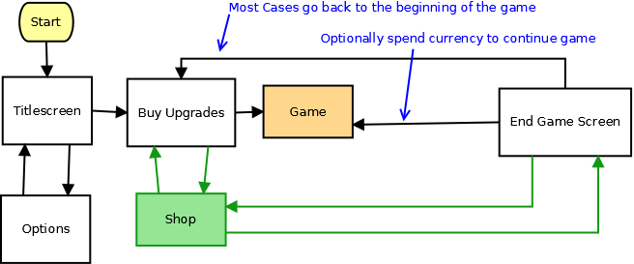

Title Screen
The title screen will be a simple picture and background music. There will be a menu to start the game or go to the options screen.

Option Screen
The options screen will allow you to adjust sound effects and music volume. You also have the option of switching the controls backwards so that the controller and buttons are on opposite sides.

Upgrade Screen
You can use this screen to purchase upgrades for your next play through of the game and you can also enter the shop buy currency from here.

Shop
Buy fake money with real money.

Title Screen
The title screen is just a picture and a menu with play the game or go to the options screen.

End Game Screen
When the game ends you will be congratulated for the number of enemies you have killed and given bonus currency based on your point total. You will have the option of going back to the title screen or playing again. You will also be given the option of continuing the game from the beginning of the last level you played by spending some of your collected currency.

Player Interaction
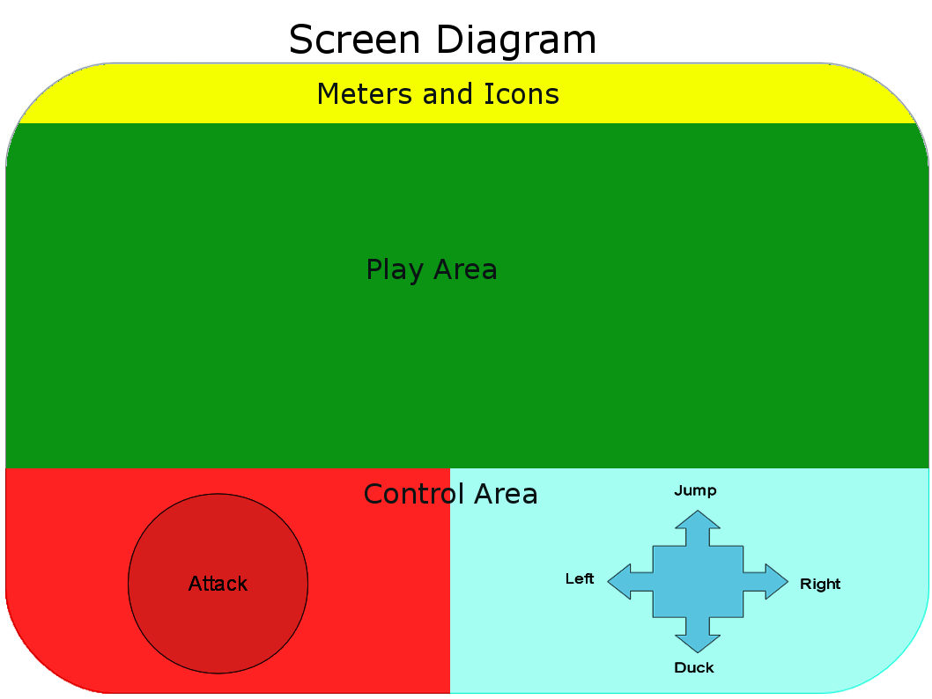
The game controls are designed to be usable from a phone touch screen are very simple.

- Pressing the attack button will cause Cuddles to do an attack animation
- If an enemy is in range then the enemy will be hit
- Many enemies will die from a single hit
- Enemies that do not die will generally be knocked back
- Attacking while in the air will be required to hit some enemies
- Attacking while ducked will be required to hit some enemies

Meters and Icons

Health Meter
The health meter will be a large bar representing player health. The bar will shrink and gradually fade from green to red as the player takes damage. The bar will disappear when [player health reaches zero and the game will end.

Armour and Weapon Icons
Small symbols representing your current upgrades will be displayed in the icon bar.

Point Meter
Your total accumulated points will be displayed in the icon bar also. At the end of each level your remaining health will be converted to bonus points and your health will be fully restored for the next level.

Appendix A. Estimated Schedule
Task | Time | Budget
Main Game Play Mechanics | 1.5 Weeks
Main Character Art and Animation | 2 Weeks
Enemy Art and Animations | 3 Weeks
Enemy Mechanics | 1 Week
Background Art | 1 Week
Particle Effects and Animation Polish | 1 Week
Sound and Music | 1.5 Weeks
Title and Option Screens | 0.5 Weeks
High Score and Currency System | 1 Week
Google Play In-App Purchase Integration | 3 Weeks | $25
Google Play Packaging and Launch | 1 Week | $25
Incidental Time | 2 Week
Total | 18.5 Weeks | $50
Post Launch
Emergency Bug Fixes | 1 Week
Windows App Store In-App Purchase Integration | 3 Weeks | $25
Windows App Store Packaging and Launch | 1 Week | $20
iOS App Store In-App Purchase Integration | 3 Weeks | $25
iOS App Store Packaging and Launch | 1 Week | $99
Incidental Time | 2 Week
Total | 11 Weeks | $169
Grand Total | 7 Months | $219

