The Right to Bear Arms Proposal

Introduction
The Right to Bear Arms is a fast paced action game where you play as Cuddles the bear and must fight an alien invasion. The game is a twitch based action game with simple controls intended for mobile phones. Mechanically the game is a side scrolling beat-em-up game. The revenue model will be based on in app purchases of game currency.

Background
Alien trophy hunters are attacking the earth. The aliens are collecting tiger tails, elephant ears, cow lips and bear arm…
Cuddles wakes up one day in his comfy cave at the zoo to the sounds of panic. He tries to go see what is happening and immediately falls on his face. What happened to his arms? Looking around Cuddles sees a little green man with a huge head running out of his enclosure carrying a pair of bear arms. Cuddles stands up onto his back legs and walks over to the nearest maintenance building to get something to fight the aliens with. He sticks a pair of chainsaws on his stumps and goes looking for little green men.

Win/Loss Conditions
- The game will consist of four levels and one end boss level
- Enemies will constantly spawn off screen and run at you
- Enemies do damage when they touch you
- You begin each level at one end and run all the way to the other end to win the level
- If you get through all five level without dying then you win
When the game ends you will always be presented with screen congratulating you and displaying the number of enemies you have killed and the amount of currency you have collected.

Enemies
- Robot drones
  - These are the normal enemies that will take one hit to kill
  - Spawn constantly on every level
  - Run right at you and do damage as long as they are touching you
- Spider mines
  - Run right at the player and explode
  - Jump over them to avoid
- Energy beam drones
  - Shoot energy beam that you must duck to avoid
  - Few attacks to kill
- Little green men
  - Run onto the screen. Shoot. Run away.
  - Difficult but rewarding and satisfying to kill
- Tiny Flying Saucer
  - Move around the screen and try to zap you with electricity
  - Much more difficult to kill than other enemies
  - Boss of level 1 but regular enemies of levels 3-4

Pregame Upgrades
- At the start of each match you can spend your currency on temporary upgrades
- Upgrade damage or armour or both
- Upgrades are disposable and only work on the next play through
- Money is easy to acquire and with even basic skills you will be able to buy basic upgrades each game
- To max out armour and damage you will need to play a few games to save up or buy currency through in app purchase.

Player Interaction
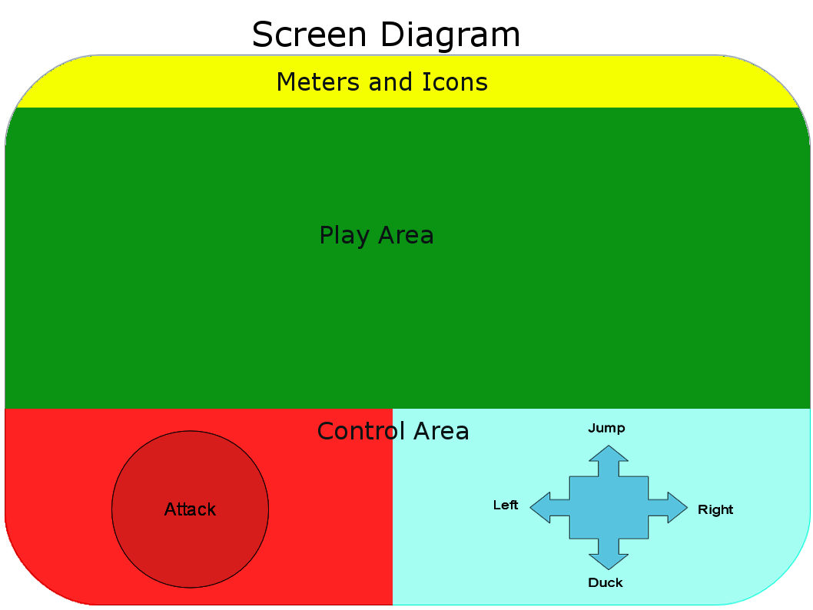
The game controls are designed to be usable from a phone touch screen are very simple.

- Pressing the attack button will cause Cuddles to do an attack animation
- If an enemy is in range then the enemy will be hit
- Many enemies will die from a single hit
- Enemies that do not die will generally be knocked back
- Attacking while in the air will be required to hit some enemies
- Attacking while ducked will be required to hit some enemies

Development and Distribution
- Built in Unity
  - Quick development time
  - Easy to build for multiple platforms
  - C#
  - Plug-ins for in-app purchases available
- Distributed through mobile app stores
  - Windows App store
  - Google play
  - iTunes

Market Research/Revenue
Distributing a game through app stores is relatively easy but discoverability is hard. With a marketing budget of zero and an unknown studio getting people to buy the game is difficult even with the price of one dollar. These difficulties make an in-app purchase model much better for this game then a purchase price. When the game is free we can expect ten to twenty times the number of downloads then we could get even with a cheap price.
Revenue will be based on players purchasing in-game currency that make the game easier. No part of the game will be behind a pay wall and in game currency can be obtained just by playing.
Most players will never spend any money on a free but we would only need to get five to ten cents average per player to make more money on in app purchases then we would make charging a dollar for the game. When the game is in front of players there are a number of factors that may lead a player to invest money.
- People will happily pay a dollar or two for a game they know is fun
- A few people could spend twenty dollars or even more on a game they like
- Players that have played the game for free for a while and are stuck at a level or cannot quite beat the game will be driven to spend a few dollars in upgrades to push them over that edge
The memorable characters, simple to learn controls and addictive gameplay should make word of mouth marketing possible.
Right to Bear Arms is already a common Google search term and even if it obviously taken out of context random Google searches could lead to some sales.

Art Specs
The art will be bright, cartoony and not to be taken seriously. Some countries have issues with violence and the violence in this game will always be cartoon violence. No blood.
The main character animation is critical to this game. Pleasing animation is the key to out word of mouth marketing strategy and a main component of the game being fun and needs resources allocated accordingly.
The characters in the game will be 3D models even though the game perspective will be a fixed view from the side. The advantage of 3D is that we can use simple rag-doll physics to make hitting aliens fun. Tapping a button is not that fun but tapping a button and watching an alien rag-doll down a flight of stairs is fun.
Game backgrounds will be simple 2D cartoon scenes.

Estimated Schedule
Task | Time | Budget
Main Game Play Mechanics | 1.5 Weeks
Main Character Art and Animation | 2 Weeks
Enemy Art and Animations | 3 Weeks
Enemy Mechanics | 1 Week
Background Art | 1 Week
Particle Effects and Animation Polish | 1 Week
Sound and Music | 1.5 Weeks
Title and Option Screens | 0.5 Weeks
High Score and Currency System | 1 Week
Google Play In-App Purchase Integration | 3 Weeks | $25
Google Play Packaging and Launch | 1 Week | $25
Incidental Time | 2 Week
Total | 18.5 Weeks | $50
Post Launch
Emergency Bug Fixes | 1 Week
Windows App Store In-App Purchase Integration | 3 Weeks | $25
Windows App Store Packaging and Launch | 1 Week | $20
iOS App Store In-App Purchase Integration | 3 Weeks | $25
iOS App Store Packaging and Launch | 1 Week | $99
Incidental Time | 2 Week
Total | 11 Weeks | $169
Grand Total | 7 Months | $219

