Stunt Nugget GDD
Andrew Perrault – May 13, 2015
Table of Contents
1 Overview 1
1.1 Setting/Theme 1
1.2 Player End-Goals 2
1.3 Platforms 2
2 Mechanics 2
3 Controls 2
4 Screens 2
4.1 Game Screen 3
4.1.1 Gameplay Layer 3
4.1.2 UI 3
4.1.3 Background Layer 3
4.1.4 Camera System 3
4.2 Level Selection Screen 3
4.3 Title Screen 4
4.4 Main Menu 4
4.5 Options 4
4.6 About Screen 4
5 Game Objects 4
5.1 Fire 4
5.2 Barrels 4
5.3 Fans 4
6 Technical Design 4
6.1 Particle System 5
6.2 Ragdoll System 5
7 Appendix A Options for the Future 5
7.1 Monetization 5
7.2 Ragdoll poses 5

Overview
Stunt Nugget is a simple 2D puzzle game for phones. The object is to get a perfect run through a series of stunts. Each stunt is a different level. The actual gameplay will consist of lining up your initial trajectory and power for a shot and letting it go. After your initial setup the player will watch the stunt play out and get stars based on their performance.

Setting/Theme
The player controls Nugget the rocket powered stunt chicken. The art will be simple and cartoony. Backgrounds will be abstract with little detail.

Player End-Goals
The game consists of a number of levels. If you successfully complete a level the next level will be unlocked. The player can earn one, two or three stars depending on how well they do. When a new game is started the player can start at any previously unlocked level. Unlocked levels, maximum stars achieved on each level and total stars will be saved. The ultimate goal is to complete every level with a three star rating.

Platforms
The primary platform will be Android. Porting to iOS and Windows phone may be possible in the future.

Mechanics
Mechanically the gameplay is essentially shoot once and wait. The outcome will be based on the physics engine. Nugget will bounce around the screen in a cartoony and completely unrealistic but fun to watch way.

Controls
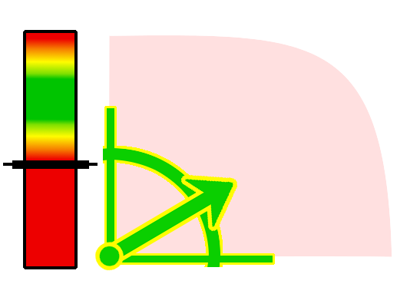Illustration 1: Targeting Controls
Nugget begins each level with on a ramp. The player touches the screen to control the angle of the ramp. When the player touches the screen and arrow will point from Nugget to the players finger and a marker on the power meter will start moving up and down on the power meter. The green area of the meter is full power and the power scales down to only 25% in the red area. The shot is launched when the player removes their finger from the screen.

Screens
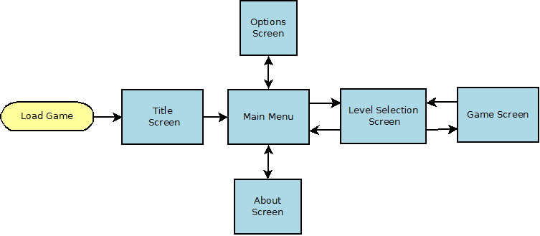Illustration 2: High level game flow

Game Screen

Gameplay Layer
The gameplay layer will contain the physics simulation and the game renderer.

UI
The UI for this game is extremely simple. The ramp targeting widget will be flashing to get the players attention. When they touch the screen the controls will become solid and start moving. The rest of the screen will just be the view of the level.

Background Layer
Backgrounds will be simple, static and abstract colours.

Camera System
The camera system is important in this game. The camera must show the goal and the whole level before zooming in a bit to show the player. The camera will pan and zoom dynamically as Nugget flies around the level.

Level Selection Screen

The level selection screen will display a grid of levels. Stars will be displayed to let the player know the highest score they have achieved on previous plays through the level. The play can just click any level that has previously been unlocked to play again. The number of stars achieved will never decrease. To unlock the next level they must complete the last unlocked level with a minimum score of one star.

Title Screen
Title screen will be displayed as the game is loading.

Main Menu
Main menu will have options to play the game, view the options menu or view the about screen.

Options
Options for sound on/off and music on/off.

About Screen
This lists information about me and about the licenced libraries used in the game.

Game Objects

Fire
Fire will be an obstacle for Nugget to avoid. It will be made from a particle effect and a Box2D trigger.

Barrels
Barrels will be dynamic Box2D bodies.

Fans
Fans will blow the player off course. They will be built using a Box2D trigger are placed in front of the fan sprite.

Technical Design
The game will be written in Java using the LibGDX library. Physics simulation will use the Box2D library and call into the C++ code using JNI.

Particle System
Particles will be built using the LibGDX particle editor. Fire, feathers and fireworks for when you win a level will all be particle effects.

Ragdoll System
The Nugget character will be made of individual component sprites attached to a 2D ragdoll system. The ragdoll will be built using a tool called R.U.B.E. and imported at runtime. The main physical body of the character will be a circle collider that bounces around the level. The ragdoll is just cosmetic and will make it funny to watch Nugget bounce around the level.

Appendix A Options for the Future

Monetization
The simplest way to monetize this game would be ads on the title screen. If the prototype looks promising selling hats and characters in an online store could also work well.

Ragdoll poses
In the initial prototype the arms and legs will mostly just flap around. It would be worth it to design specific poses based on the game state for the ragdoll to perform. This probably will not fit into the prototype schedule but should be in a commercial version.

