Storyboard
TITLE: Harbour Hope Charity Events Website SCREEN ID: 01 Home DATE: 05/10/2026
element cards x 3-6, countdown pill, Free tag, progress bar, gold Donate button, 3 impact tiles, SVG faviconELEMENTS:
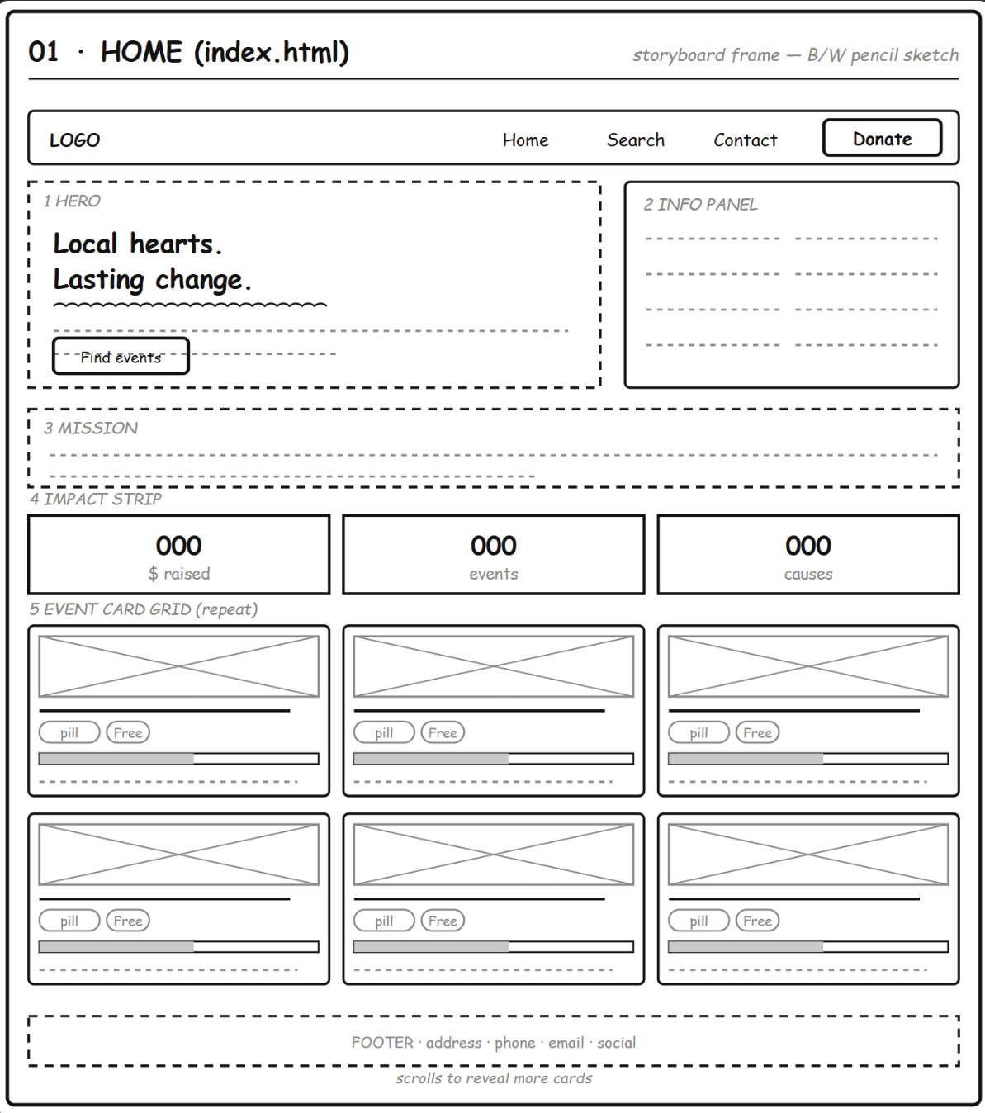
Elements:

①
Header nav (logo · Home/Search/Contact · Donate button) · Hero:
headline "Local hearts. Lasting change." + "Find events" button, info panel on
right · Mission strip · Impact strip (3 numbers: $ raised / events / causes) ·
Event card grid 3×2, each card = image + title + category & price pills +
progress bar + date/venue · Footer.
hero banner, 3-tile impact strip, responsive card grid (CSS Grid), teal #0f6b5c + gold #c9a227 paletteGRAPHICS:

"Local hearts. Lasting change." / mission paragraph / event names / "$X,XXX raised" / "NN% of goal" / "In N days" / "Free"TEXT:

autoplay media - a quiet, low-bandwidth page. Event photos load lazily as the visitor scrolls, so the page stays fast on mobile connections.

NOTES - Landing page and the entry point of the site. On load it calls the events and charity-profile APIs and renders the impact numbers and the event card grid from the JSON response; everything except the static copy is data-driven. Each card links through to the event details page.

Description: | Home page of the Harbour Hope Foundation charity events site. Loads the charity profile and the list of upcoming events, then renders them as a hero, an impact strip, and an event card grid. Screen ID 01 — index.html.
Content: | Header navigation (Home / Search / Contact / Donate). Hero tagline "Local hearts. Lasting change." Mission paragraph. Impact strip: total raised, number of upcoming events, causes supported. Event card grid: image, name, countdown badge (Today / Tomorrow / In N days), Free tag, progress bar with % of goal and amount raised. Footer with address, phone, email.
Interactions: | User can click a nav item (Home / Search / Contact) or the gold Donate button. Hovering a card lifts it. Clicking any event card opens the event details page. Skip-to-content link is reachable by keyboard Tab before the navigation.
Media Creation: | Charity-event photos (event-1.jpg to event-11.jpg) loaded lazily; SVG favicon; system font stack in Arial; data pulled live from the API (no placeholder text).
Navigation: | Entry point of the site. Connects to Search (nav link or filter link), to Event Details (click an event card), and to Contact (nav link or Donate button).

TITLE: Harbour Hope Charity Events Website SCREEN ID: 02 Search DATE: 05/10/2026
filter panel (3 fields + Search and Clear buttons), status banner, result card list, each card = thumbnail, title, category pill, progress bar, SVG faviconELEMENTS:
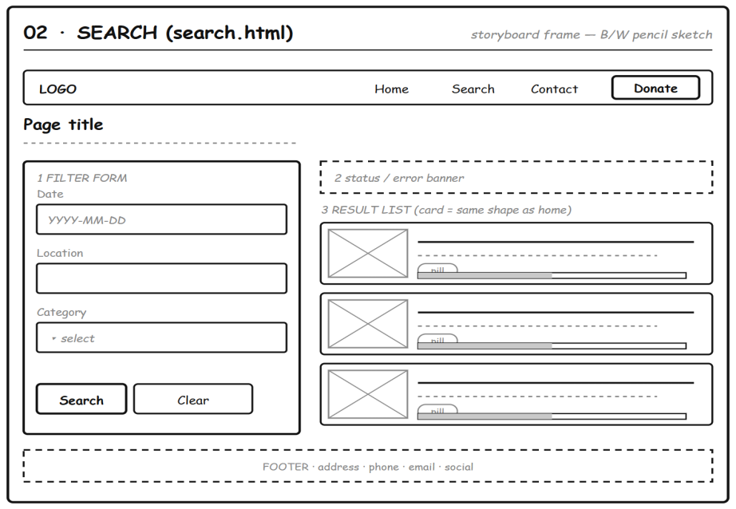
Elements:

①
Elements: Header nav (Search active) · Page title "Find an event" · Left filter
panel: Date / Location / Category + Search & Clear buttons · Right: status
banner (result count or error) · Result list with 3 stacked cards, same shape
as the Home cards · Footer.

Two-column filter-and-results layout (CSS Grid), filter panel styled as a raised card, result cards matching the home grid, teal #0f6b5c + gold #c9a227 palette, dashed status bannerGRAPHICS:

"Find an event" / filter labels (Date, Location, Category) / button labels (Search, Clear) / event titles / "12 events found" / "No events match your filters" / category and price tagsTEXT:

autoplay media. Only the small thumbnails inside each result card load, and they load lazily as the visitor scrolls down the list.

NOTES - Filtering happens on the server through GET /api/events with date, location and category query parameters. Those three fields map directly onto the indexed columns in the database, which is what keeps the search fast. The filter panel stacks above the results on mobile.

Description: | Search page that lets a visitor filter the event programme by date, location, and category. Screen ID 02 - search.html.
Content: | Filter row: date input (YYYY-MM-DD), location text input, category dropdown populated from GET /api/categories, and a gold Search button. A status banner shows e  ither an error or "N events found". Below it, one result card per matching event: image, name, date, venue and suburb, price, progress bar.
Interactions: | Filters combine with AND. Submitting with no filter shows a clear message instead of failing silently. An impossible date (for example 2026-99-99) returns a 400 and the page explains the expected format. Clicking a result card opens the event details page.
Media Creation: | Event photos reused from the same image set; category options come from the database, not hard-coded HTML, so the list never drifts out of step with the data.
Navigation: | Reached from the nav bar or from the home page. Leads to Event Details on click; nav returns to Home or Contact at any time.
TITLE: Harbour Hope Charity Events Website SCREEN ID: 03 Event Details DATE: 05/10/2026
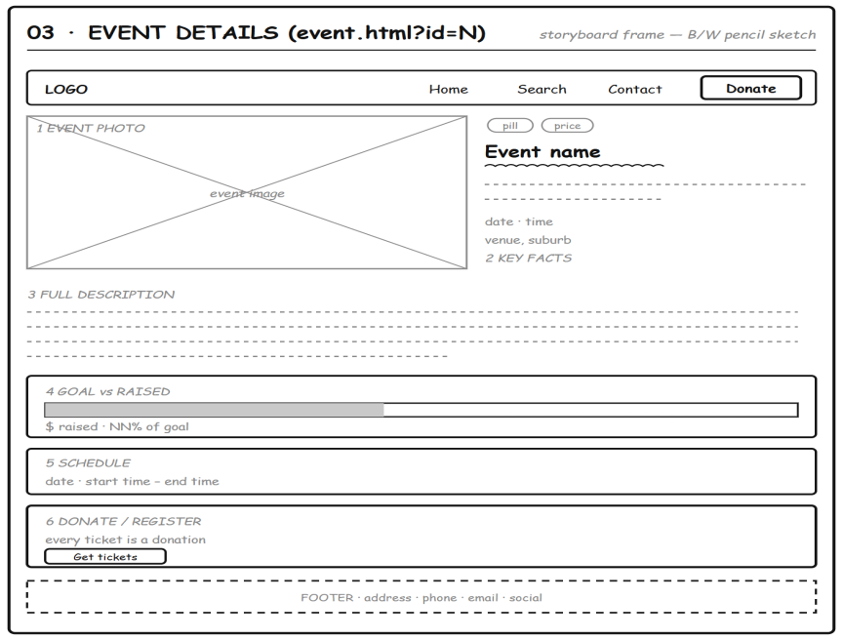

Elements:
①
Elements: Header nav · Hero: large event photo left; category & price pills,
event name, summary, date/time and venue on the right · About this event (long
description) · Goal vs raised progress bar · Schedule (date · start–end time) ·
Donate / Register box with "Get tickets" button · Footer.

Split hero (large photo left, key facts right), full-width information blocks stacked below, progress bar for goal vs raised, heavy border on the donate box, teal #0f6b5c + gold #c9a227 paletteGRAPHICS:

event name / short summary / "About this event" / long description / "$X,XXX raised" / "NN% of goal" / date and time / venue and suburb / "Get tickets"TEXT:

autoplay media. The single large hero photo is the only heavy asset here, and it is loaded lazily so the written details appear first.

NOTES - The only page that reads the query string (?id=N) and calls the single-event API. If the id is missing or invalid the error banner replaces the event block. The donate/register box sits last so the call to action is the final thing the visitor sees.

Description: | Full detail view for a single public event, reached by clicking any event card. Screen ID 03 - event.html?id=N. Reads the id from the query string and renders one event.
Content: | Large event image, event name, category and status, full  description, schedule (date, start and end time), venue name with suburb, city and address, ticket price or a Free badge, and the fundraising goal against funds raised with a progress bar.
Interactions: | An unknown or suspended id returns 404 and the page shows a friendly "event not available" message rather than a blank screen. The detail payload is the only response that includes fullDescription, so list pages stay small.
Media Creation: | High-resolution event photography with descriptive alt text; the progress bar reflects live figures from the database.
Navigation: | Return to Search or Home through the nav bar; the Donate button jumps to Contact. This is the deepest page in the site.
TITLE: Harbour Hope Charity Events Website SCREEN ID: 04 Contact & Donate DATE: 05/10/2026
donate box with anchor target and Donate now button, organisation details panel, contact form (Name, Email, Message fields plus Send button), gold Donate button in the nav bar, SVG faviconELEMENTS:
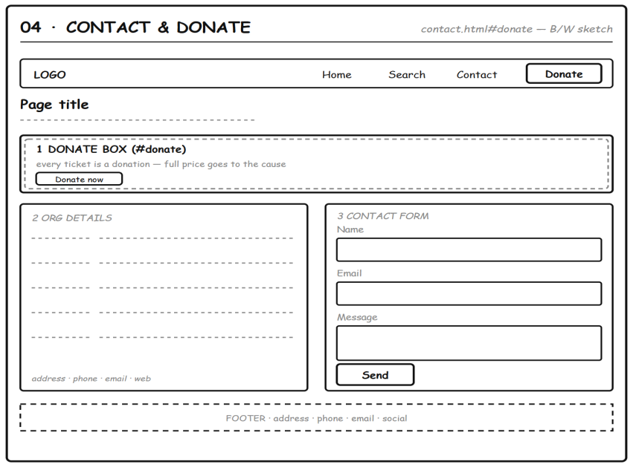
Elements:

①
Elements: Header nav (Contact active) · Page title "Get in touch" · Donate box
with "Donate now" button (double border = #donate anchor) · Two columns below:
left Org details (address/phone/email/website), right Contact form (Name, Email,
Message + Send button) · Footer.
Full-width donate box with a double border marking the #donate anchor, two-column layout below (organisation details left, contact form right), gold Donate button, teal #0f6b5c + gold #c9a227 paletteGRAPHICS:

"Get in touch" / "Donate to Harbour Hope" / "every ticket is a donation" / "Donate now" / form field labels (Name, Email, Message) / "Send" / organisation address, phone, email and websiteTEXT:

audio or video. This page is silent - no autoplay media at all, and no images either, so it renders instantly on any connection.

NOTES - The nav Donate button lands on this box via the #donate anchor, so the call to action is seen straight away. The contact form is a client-side validation demo only; nothing is stored on the server.

Description: | Contact page and the donation call-to-action. Screen ID 04 - contact.html. The Donate button in the navigation bar on every page lands directly on the donate box here.
Content: | Organisation contact details from GET /api/organisation (address, phone, email), a short message about how funds are used, and a donation box that explains that every ticket price goes to the cause it supports.
Interactions: | The gold Donate button anywhere in the site jumps to contact.html#donate and the anchor scrolls straight to the donation box. All contact values are live from the database, so updating them needs no HTML edit.
Media Creation: | Reuses the site palette and typography; the organisation profile text is the same record served by the API, so the page can never contradict the rest of the site.
Navigation: | End of the visitor journey. Returns to Home, Search, or Event Details through the nav bar. Collects the donation ask that every other page points towards.

