Report

Exercise 01:
Computing of Matrix Multiplication using C++

Group: ex01_group02
- Eibl, Sebastian
- Schottenhamml, Julia
- Sen, Karnajit

Contents
1. Objectives: 3
2. Description of the task: 3
3. Design/Flowchart: 3
4. Methodologies: 5
5. Source Code: 5
6. Discussion on the Result and Graphical Representations: 6

Objectives:
Objective of this report is to implement a matrix-matrix multiplication C = A X B, where A is a
M X K matrix, B is a K X N matrix, and C is a M X N matrix.

Description of the task:
Refer to the attached document here.

Design/Flowchart:
Following diagram is the flow chart of the implemented C++ program.

Start Process

Read Input file of Matrix A and B
Load Matrix B
Size of Row of A > 600?
Start LIKWID, Timer
Load Matrix A and B to memory
Checking the matrix dimension and using Padding

No Yes
Apply Strassen algorithm

Apply Naïve Algorithm

Free memories

Stop Likwid and Timer

Stop Process

Methodologies:
These are the key points used in the implementation.
- A separate header class Matrix.hpp is used for all the basic operation and properties of a Matrix.
- Block size of 128 and padding of 64 are used.
- Blocking and loop unrolling are used while transposing a matrix.
- Advanced Vector Extensions (AVX) Instruction set (a new 256 bit Instruction set features provided by Intel processor) is used while fetching data from memory in matrix multiplication operation both in naïve and Strassen modules.
- In naïve multiplication, block size of 4 X 4 is considered.
- AVX methodologies like _mm256_blend_pd(), _mm256_hadd_pd(),
_mm256_permute2f128_pd() and _mm256_add_pd() are used for the addition of multiplied components of A with B.
- More optimized recursive Strassen algorithm is implemented to measure the multiplication of matrix size more than 600.
- Compare.cpp is written to compare the output matrix of the program to the standard outpu files. It will confirm us about the correctness of the result.
- The program is compiled with a Makefile.
- Double precision floating-point operations are used for the multiplication.
- 5 stages of optimization techniques as opt1, opt2, opt3, opt4, opt5 has been done. Opt5 is the final version.

Source Code:

Find the attached files below for the matmult.cpp and Matrix.hpp.

Discussion on the Result and Graphical Representations:

Performance and result of the implementation has been measured in all the optXX versions. And the results attached in the Package.

Following is the table for the final opt5 version which will give the different likwid measurement of time taken by the program. It is taking only 0.781054 sec for 2048 X 2048 matrix multiplication. All the time measurements are lesser than the tutor implementation except for 32 X 32 implementation.

Opt 5 Results:

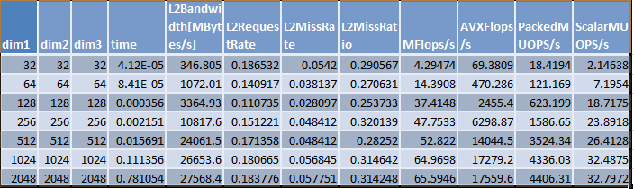
Opt 4 Results:
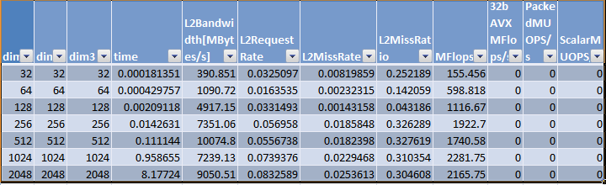

Opt 3 Results:
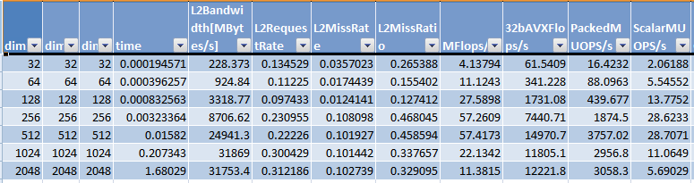
Opt2 Result:
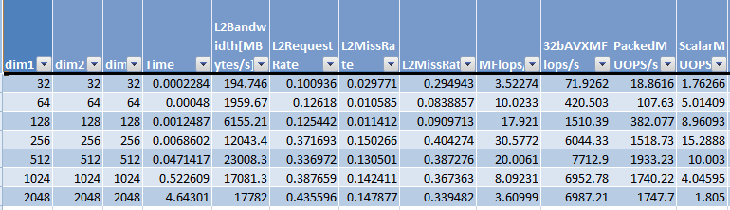
Opt 1 Result:
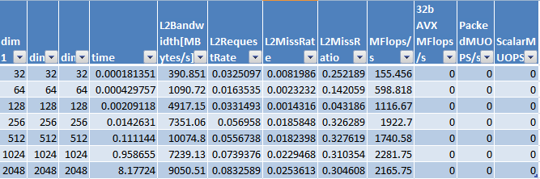

Naïve Result:

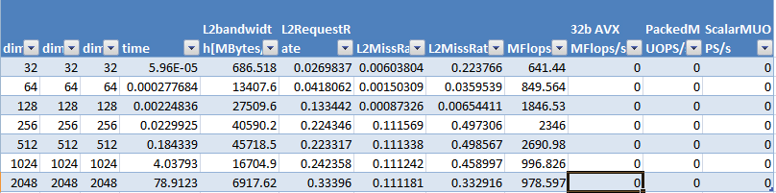

Plot: Time Performance:
From the above diagram it is clear that for the final opt5 version, time taken is always lesser than BLAS irrespective of the matrix size.

Plot of AVXMFlops/

Plot: L2 Bandwidth:
Plot: L2 Miss Rate:
Plot: L2 Miss Ratio:

Plot: L2RequestRate:

Plot: MFlops:

Plot: PackedMUOPSs:

