# Session 2 🡪 Task 1:

Source Code: https://github.com/Y-Baker/.NET_InnoTech/Session#2

1. Home Page:  
   A screenshot of a computer

   Description automatically generated
2. Student Service Page  
   A screenshot of a computer

   Description automatically generated
3. Events & Activities Page  
   A screenshot of a computer

   Description automatically generated
4. Contact Page  
   A screenshot of a computer

   Description automatically generated
5. Login Page  
   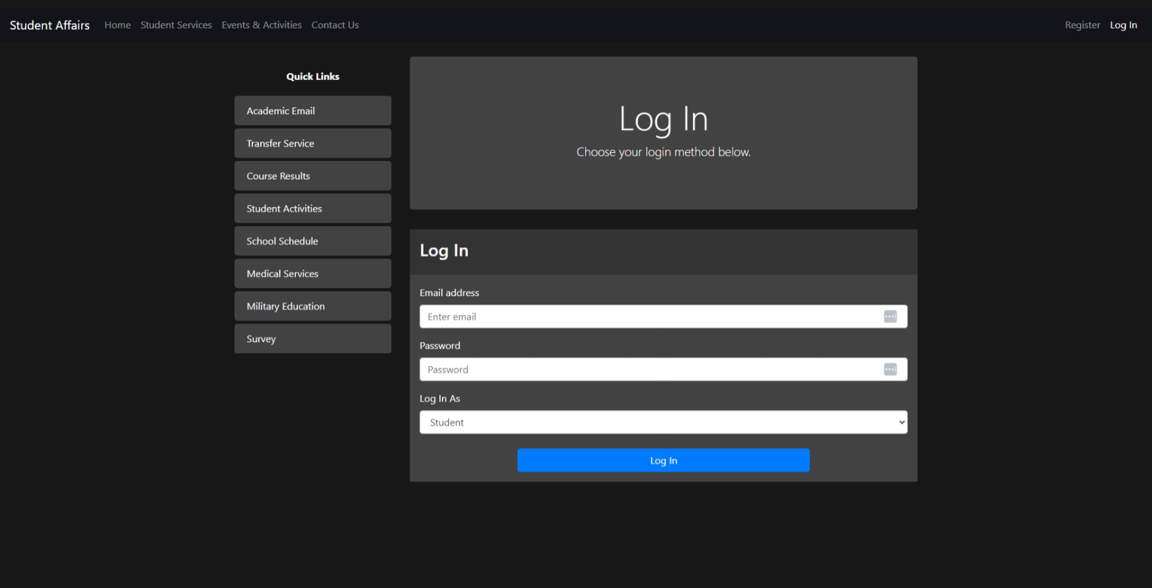

# Session 2 🡪 Task 2:

1. CPU usage if the case of for loop will increase with increasing the input. On the other hand, CPU usage will be constant whatever the input is.
2. Validation   
   A screenshot of a computer program

   Description automatically generated

# Session 2 🡪 Task 3:

1. Remove the last comma  
   A computer screen with text

   Description automatically generated
2. Complexity of string (array) method:  
   As strings are immutable so at each iterate we need to create a new string which take time and process. In the first iteration we no more time as empty string O(1), in the second iteration we need one to copy the string and one to append O(2) and so on   
     
   The Complexity will be O(n * (n+1) / 2) which can simplified to O(n^2)
3. How to know about how string builder work under the hood:  
   - Take a look at Microsoft documentation.  
   - Search about it you can find your answer on stack overflow or any blogs like this  
    https://www.stevejgordon.co.uk/how-does-the-stringbuilder-work-in-dotnet-part-2-understanding-the-overhead.