1. Please keep your eyes on fixation cross.

The Words/Pictures will be presented in the screen in a rapid succession.

1. Look at the at the Words/Pictures without moving your eyes.

Once in a while a question will come up.

1. In a question trial **identify the picture/word associated with the word/picture shown directly before**. Press the left (index finger) or right (middle finger) button depending on the location of the chosen picture.

Only the wrong answer will be identified during experiment. If you answer correctly, the experiment will continue.

+

Question:



**LAMP**

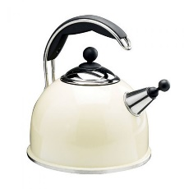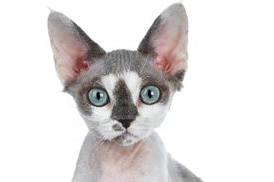

+



**CAT**

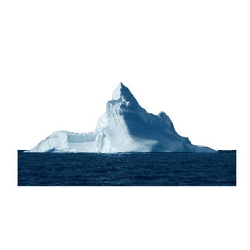

1. Please try not to move during the pictures/words presented. There will be breaks. (Anyway move as little as possible)
2. Blink when the question is presented.

+

+

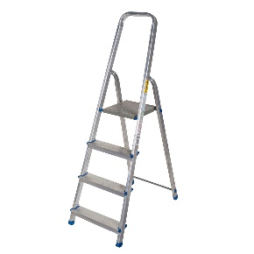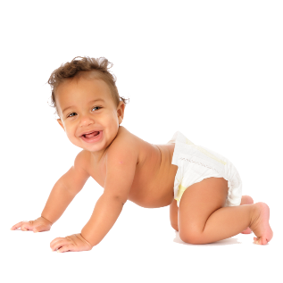

**SUN**

**LADDER**