Nonlocal Water-Hammer Cepstral Responses in Multi-Cluster Wellbores: Mechanism Falsification and a Physics-Informed, Non-Circular Reconstruction Framework
Author One 1,2*, Author Two 1, and Corresponding Author 2
1. State Key Laboratory of Oil and Gas Reservoir Geology and Exploitation, Chengdu 610500, China
2. College of Petroleum Engineering, Beijing 100083, China
* Corresponding author email: corresponding_author@domain.edu
Abstract
Wellhead water-hammer pressure measurements offer an attractive, non-intrusive diagnostic for evaluating fluid-taking perforation clusters in stimulated horizontal wells without requiring expensive downhole sensor arrays. However, physical interpretation becomes fundamentally nonlocal when multiple hydraulic fractures intersect the same wellbore conduit: downstream interfaces strongly modify upstream peak amplitudes, intermediate cluster spacings induce profound multi-interface destructive interference that attenuates subsequent peaks far more severely than either smaller or larger spacings, and internal wave reverberations generate pronounced ghost peaks at depths where no perforations exist. In this study, we rigorously quantify these wave-network mechanisms using one-dimensional method-of-characteristics (MOC) elastodynamic simulations and a two-dimensional time--depth marginal cepstrum over a certified database of 426 independent topological grids. For a nominal first-cluster depth X_1=3000 m and spacing S=20 m, introducing a second downstream cluster reduces the apparent first-cluster peak from 5.157 to 2.705 a.u.—a 47.5% collapse that directly falsifies the conventional unconditioned single-cluster calibration proxy. In four-cluster configurations (n=4), the third and fourth peaks reach sharp destructive minima of 0.536 and 0.324 a.u. at S=30 m before recovering to 1.21 and 0.92 a.u. at S=100 m. At a fixed total span of 60 m, the terminal-to-first ratio R_end drops precipitously from 0.472 to 0.072 as cluster count increases from 2 to 7, proving that total span is an insufficient descriptive scalar. Furthermore, continuous cepstral profiles exhibit secondary peaks near 3120 and 3150 m that precisely match predicted multipath travel-time ghosts.
To resolve these distortions without circular reasoning, we formulate a four-operator physics-informed inverse reconstruction framework: nominal perforation depths serve as the known engineering prior, whereas true fluid-taking activation is treated as an unknown non-negative state. The framework couples a multipath peeling operator G_peel acting strictly on non-perforation ghost depths, a transmission and phase compensation operator K_comp bounded by finite forward physical gains [T_eff^{2(k-1)}\eta(S)]^{-1}, a 0.80-m super-Gaussian spatial focusing operator F_focus, and a continuous evidence uncertainty mask M(x). The combination of non-negative activity constraints and finite gains guarantees exact zero-preservation: unactivated clusters cannot be artificially created by division. Synthetic verification across four extreme geometries confirms the forward distortions and demarcates the valid operational envelope for downstream fracture opening inversion.
Keywords: water hammer; multi-cluster fracturing; method of characteristics; cepstrum; multipath reverberation; physics-informed inverse problem; uncertainty mask; zero-preservation
Nomenclature
Table 0 Definitions of primary physical variables and operators
Symbol | Physical Description and Definition | SI Units
H(x,t) | Hydraulic piezometric head | m
Q(x,t) | Volumetric flow rate | m³/s
a | Acoustic water-hammer wave speed | m/s
D | Internal casing diameter | m
A | Wellbore cross-sectional area (\pi D^2/4) | m²
g | Gravitational acceleration | m/s²
f | Darcy--Weisbach friction factor | dimensionless
Q_{f,k} | Volumetric fluid-entry rate into fracture cluster k | m³/s
C_{f,k} | Lumped fracture compliance for cluster k | m²
k_{\mathrm{leak},k} | Lumped leak-off coefficient for cluster k | m^{5/2}/s
H_{f,k} | Hydraulic head inside fracture at cluster k | m
H_{\mathrm{ext}} | External reservoir baseline head | m
X_1 | Nominal depth of first perforation cluster | m
S | Uniform perforation cluster spacing | m
n | Total number of designed perforation clusters | dimensionless
x_{\mathrm{perf},k} | Nominal designed perforation depth for cluster k | m
C(x,t) | 2D time--depth marginal cepstrum field | a.u.
P_i | Apparent cepstral peak extracted at cluster i | a.u.
\alpha_i | Normalized apparent peak ratio (P_i/P_1) | dimensionless
R_{\mathrm{end}} | Terminal-to-first peak amplitude ratio (P_n/P_1) | dimensionless
L_{\mathrm{span}} | Total perforation interval span (n-1)S | m
\gamma | Empirical spatial decay parameter | cluster^{-1}
z_k | Non-negative fluid-entry activity factor for cluster k | dimensionless
h_k(x) | Forward unit impulse response template for cluster k | a.u.
g_m(x) | Forward multipath reverberation ghost template | a.u.
c_m | Ghost peak amplitude coefficient | dimensionless
G_{\mathrm{peel}} | Physics-informed multipath peeling operator | dimensionless
K_{\mathrm{comp}} | Forward transmission and phase compensation operator | dimensionless
T_{\mathrm{eff}} | Inter-cluster effective transmission factor | dimensionless
\eta(S) | Spacing-dependent wave interference factor | dimensionless
F_{\mathrm{focus}} | Super-Gaussian spatial focusing operator | dimensionless
w_{\mathrm{core}} | Characteristic width of super-Gaussian core (0.80 m) | m
M(x) | Continuous evidence and reliability uncertainty mask | dimensionless
\tilde P(x) | Physics-informed reconstructed cepstral profile | a.u.

1. Introduction
The stimulation efficacy of multi-cluster horizontal well fracturing stages fundamentally depends on which engineered perforation clusters successfully initiate and take fluid. While downhole microseismic mapping and distributed acoustic/temperature sensing (DAS/DTS) provide valuable diagnostics, borehole tube-wave investigations demonstrate that hydraulic fracture compliance, Krauklis-wave resonance, and interface reflections can also be constrained from wellbore transient dynamics [1,2]. Given the operational overhead and survivability constraints of downhole instruments, non-intrusive surface diagnostic methods are highly desirable. Shut-in and pump-off water-hammer pressure transients propagate along the casing, continuously sampling downhole acoustic impedance variations, and can be transformed into delay or depth profiles [3,4]. Recent studies have rapidly extended this principle to fluid-entry depth detection, cluster-level event diagnosis, and ultra-high-frequency monitoring equipment validation [5–7].
Conventional interpretation pipelines typically adhere to homomorphic cepstrum principles and localized reflection assumptions [8,9]: a discrete quefrency or travel-time delay is mapped to a perforation cluster, and the amplitude of the resulting cepstral peak is interpreted as a direct scalar proxy for that cluster's fluid acceptance. However, this localized assumption is valid only under negligible wellbore--fracture coupling. In multi-cluster horizontal wells, the measured transient is the output of a connected acoustic transmission-line network. Transmission and reflection at an upstream interface alter the incident wavefield experienced by every downstream cluster, while reflected waves reverberating between interfaces superimpose back onto the wellhead signal. Consequently, equal total stimulation spans with different cluster counts exhibit radically different terminal responses, and variations in cluster spacing alter waveform amplitudes rather than merely shifting arrival times [10–13]. Figure 1 illustrates this fundamental discrepancy between the naive local-label paradigm and the true wave-network observation.
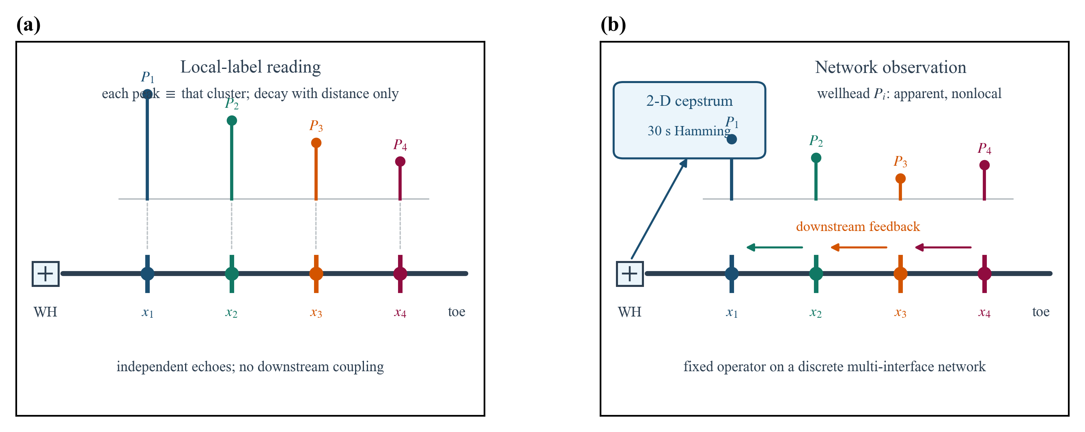
Figure 1. Local label vs. connected wave-network observation. Left: the naive local-proxy paradigm rejected by forward elastodynamic evidence (assuming each cepstral peak independently mirrors local fracture absorption). Right: physical reality established in this study—the surface pressure transient is a network-conditioned response shaped by multiple discrete impedance interfaces, downstream-to-upstream reverberations, and 2D cepstral projection operators.
This study addresses two interrelated physical questions. First, which conventional assumptions regarding locality, cluster spacing, and total stage span are definitively falsified by a controlled elastodynamic method-of-characteristics (MOC) grid? Second, given an engineered perforation-gun design, how can one remove predictable internal multipath reverberations without presupposing which clusters actually fractured? The second inquiry is formulated as a constrained, physics-informed inverse problem: nominal perforation depths are known engineering priors, whereas actual fluid-taking activity is an unknown non-negative state. Forcing apparent peaks onto all nominal depths would answer the wrong question and constitute circular reasoning.
Our investigation utilizes the certified simulation database (01_几何网格/峰值表/decay_table.csv) and accompanying topological analyses in Sections 5.1--5.7. The independent physical unit is an authenticated topological MOC grid rather than an arbitrary time sample or cepstral bin. Because the benchmark represents a deterministic design-space exploration without stochastic field noise or empirical replicates, p-values are not reported. The contribution is strictly bounded as a set of falsifiable forward wave-network observations and a non-circular operator specification for future blind benchmarking [14–18].
2. Forward Model and Observation Operator
2.1 Governing equations and lumped boundary conditions
The horizontal wellbore is modeled as a one-dimensional, constant-area, weakly compressible fluid conduit. The transient wavefield is described by the hydraulic piezometric head H(x,t) and volumetric flow rate Q(x,t). Conservation of mass and linear momentum yield:
∂H∂t+a2gA∂Q∂x=0, ∂Q∂t+gA∂H∂x+f2DAQ|Q|=0. | (1)

where a is the acoustic wave speed, A=\pi D^2/4 is the cross-sectional area, D is internal casing diameter, g is gravitational acceleration, and f is the Darcy--Weisbach friction factor [19–21]. The primary benchmark adopts steady friction, where f is determined from the initial Reynolds number and held fixed; unsteady Brunone friction is excluded from our primary claim boundary.
At each perforation cluster node x_k, continuity of flow coupled with lumped fracture compliance and reservoir leak-off satisfies (Figure 2(a)):
$Q_{L,k}−Q_{R,k}=Q_{f,k}, Q_{f,k}=C_{f,k}\frac{dH_{f,k}}{dt}+k_{leak,k}\sqrt{H_{f,k}−H_{ext}}.$ | (2)

where C_{f,k} denotes lumped fracture compliance, k_{\mathrm{leak},k} is the leak-off coefficient, and H_{\mathrm{ext}} is external reservoir head. In the benchmark database, all clusters share identical nominal properties to isolate geometric topology and spacing from fracture heterogeneity. MOC integrates along characteristic curves with Courant number unity. Baseline parameters are: D=0.1397 m, a=1450 m/s, fluid density 1000 kg/m³, kinematic viscosity 10⁻⁶ m²/s, roughness 4.5×10⁻⁵ m, initial velocity 1.0 m/s, initial wellhead head 300 m, \Delta t=10⁻³ s, C_f=10⁻⁵ m², k_\mathrm{leak}=10⁻⁴ m^{5/2}/s, and shut-in pump-off time 1.0 s.
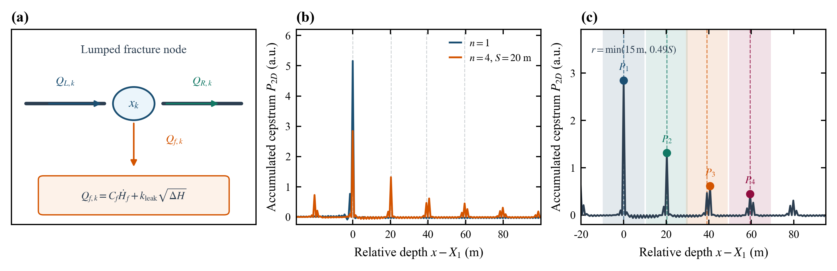
Figure 2. Forward elastodynamic model and cepstral observation operator. (a) Lumped fracture node continuity, compliance, and leak-off boundary conditions; (b) Comparison of cumulative time--depth marginal cepstrum profiles between single-cluster baseline and four-cluster network; (c) Nominal perforation window, apparent peak extraction radius r, and network-conditioned peak definitions. Note: Panel (c) utilizes simulated geometric coordinates for benchmark extraction and does not constitute blind localization.
2.2 Design space and 426 independent topological grids
The perforation design space is defined by nominal shot depths:
$x_{perf,k}=X_{1}+(k−1)S, k=1,…,n.$ | (3)

covering X_1 \in \{2000, 2500, 3000, 3500, 4000, 4500\} m, S \in \{10, 20, \ldots, 100\} m, and n \in \{1, \ldots, 8\}. Under steady friction, multi-cluster combinations (n=2--8) yield 6×7×10=420 grids, while single-cluster baselines contribute 6 grids, providing 426 authenticated independent topologies in decay_table.csv.
2.3 Marginal cepstrum observation and apparent peak extraction
The wellhead pressure record is transformed via a 30-s Hamming window with 5-s hop [22], producing the 2D time--depth marginal field C(x,t). Apparent peaks at cluster i are conditionally extracted via:
$P_{i}=\max_{|x−x_{i}|≤r}[−∑_{t}C(x,t)], r=min(15 m,0.49S).$ | (4)

where x_i is simulated geometric depth. P_i represents an apparent network projection rather than direct fracture energy. We also define normalized ratios \alpha_i=P_i/P_1, terminal-to-first ratio R_{\mathrm{end}}=P_n/P_1, total span L_{\mathrm{span}}=(n-1)S, and the descriptive empirical envelope P_i=A\exp[-\gamma(i-1)]. The parameter \gamma reflects a case-specific spatial envelope rather than an intrinsic single-interface transmission coefficient.
3. Mechanism Falsification Tests
3.1 Downstream feedback falsifies a local first-peak label
A common intuition is that the first perforation cluster, being closest to surface, is unaffected by downstream fractures. Our numerical experiments disprove this assumption. As shown in Figure 6, at X_1=3000 m and S=20 m, a single cluster (n=1) exhibits P_1=5.157 a.u. Introducing a second downstream cluster (n=2) reduces the first peak to 2.705 a.u.—a 47.545% drop despite identical local properties and shot depth. Across the multi-cluster database, first-peak values oscillate between 2.45 and 3.55 a.u., confirming that downstream reverberation actively reshapes the initial arrival.
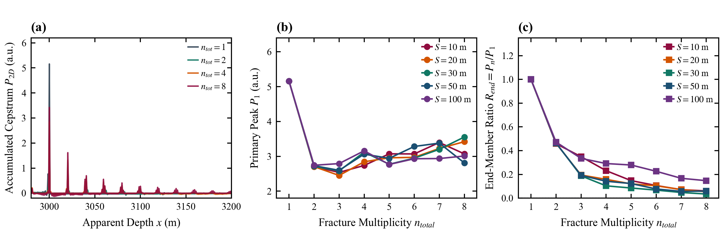
Figure 6. Cluster multiplicity n main effect and terminal attenuation. Evolution of apparent peaks P_i, terminal-to-first ratio R_end, and cumulative energy proxies across cluster counts n, illustrating how cascading interfaces systematically drain wavefield energy.
3.2 Spacing changes amplitude as well as delay (destructive interference trap)
Conventional delay models assume spacing S merely shifts arrival time (Δt=2S/a). Table 1 and Figure 5 summarize peak vectors for n=4 at X_1=3000 m under steady friction. Rather than monotonic behavior, subsequent peaks exhibit a pronounced non-monotonic 'V-shaped valley': at S=30 m, the third and fourth peaks drop to sharp minima (0.536 and 0.324 a.u.), whereas at S=10 m they remain higher (0.964 and 0.634 a.u.) and recover to 1.209 and 0.920 a.u. at S=100 m. In two-cluster controls, responses remain flat (P_1≈2.70--2.74 a.u., P_2≈1.24--1.30 a.u.). This proves that in n≥3 networks, intermediate spacing triggers severe multi-interface destructive interference that nearly obliterates later true clusters.
Table 1 Non-monotonic apparent peak modulation by cluster spacing S (X1=3000 m, n=4, steady friction)
Spacing S (m) | First Peak P1 (a.u.) | Second Peak P2 (a.u.) | Third Peak P3 (a.u.) | Fourth Peak P4 (a.u.) | Ratio Rend
10 | 2.738 | 1.421 | 0.964 | 0.634 | 0.2316
20 | 2.844 | 1.317 | 0.614 | 0.450 | 0.1582
30 | 3.122 | 1.442 | 0.536 | 0.324 | 0.1038
40 | 3.050 | 1.514 | 0.596 | 0.327 | 0.1072
50 | 3.063 | 1.541 | 0.609 | 0.436 | 0.1423
60 | 3.088 | 1.464 | 0.592 | 0.437 | 0.1415
70 | 3.040 | 1.527 | 1.064 | 0.693 | 0.2280
80 | 3.090 | 1.581 | 1.158 | 0.878 | 0.2841
100 | 3.159 | 1.705 | 1.209 | 0.920 | 0.2912

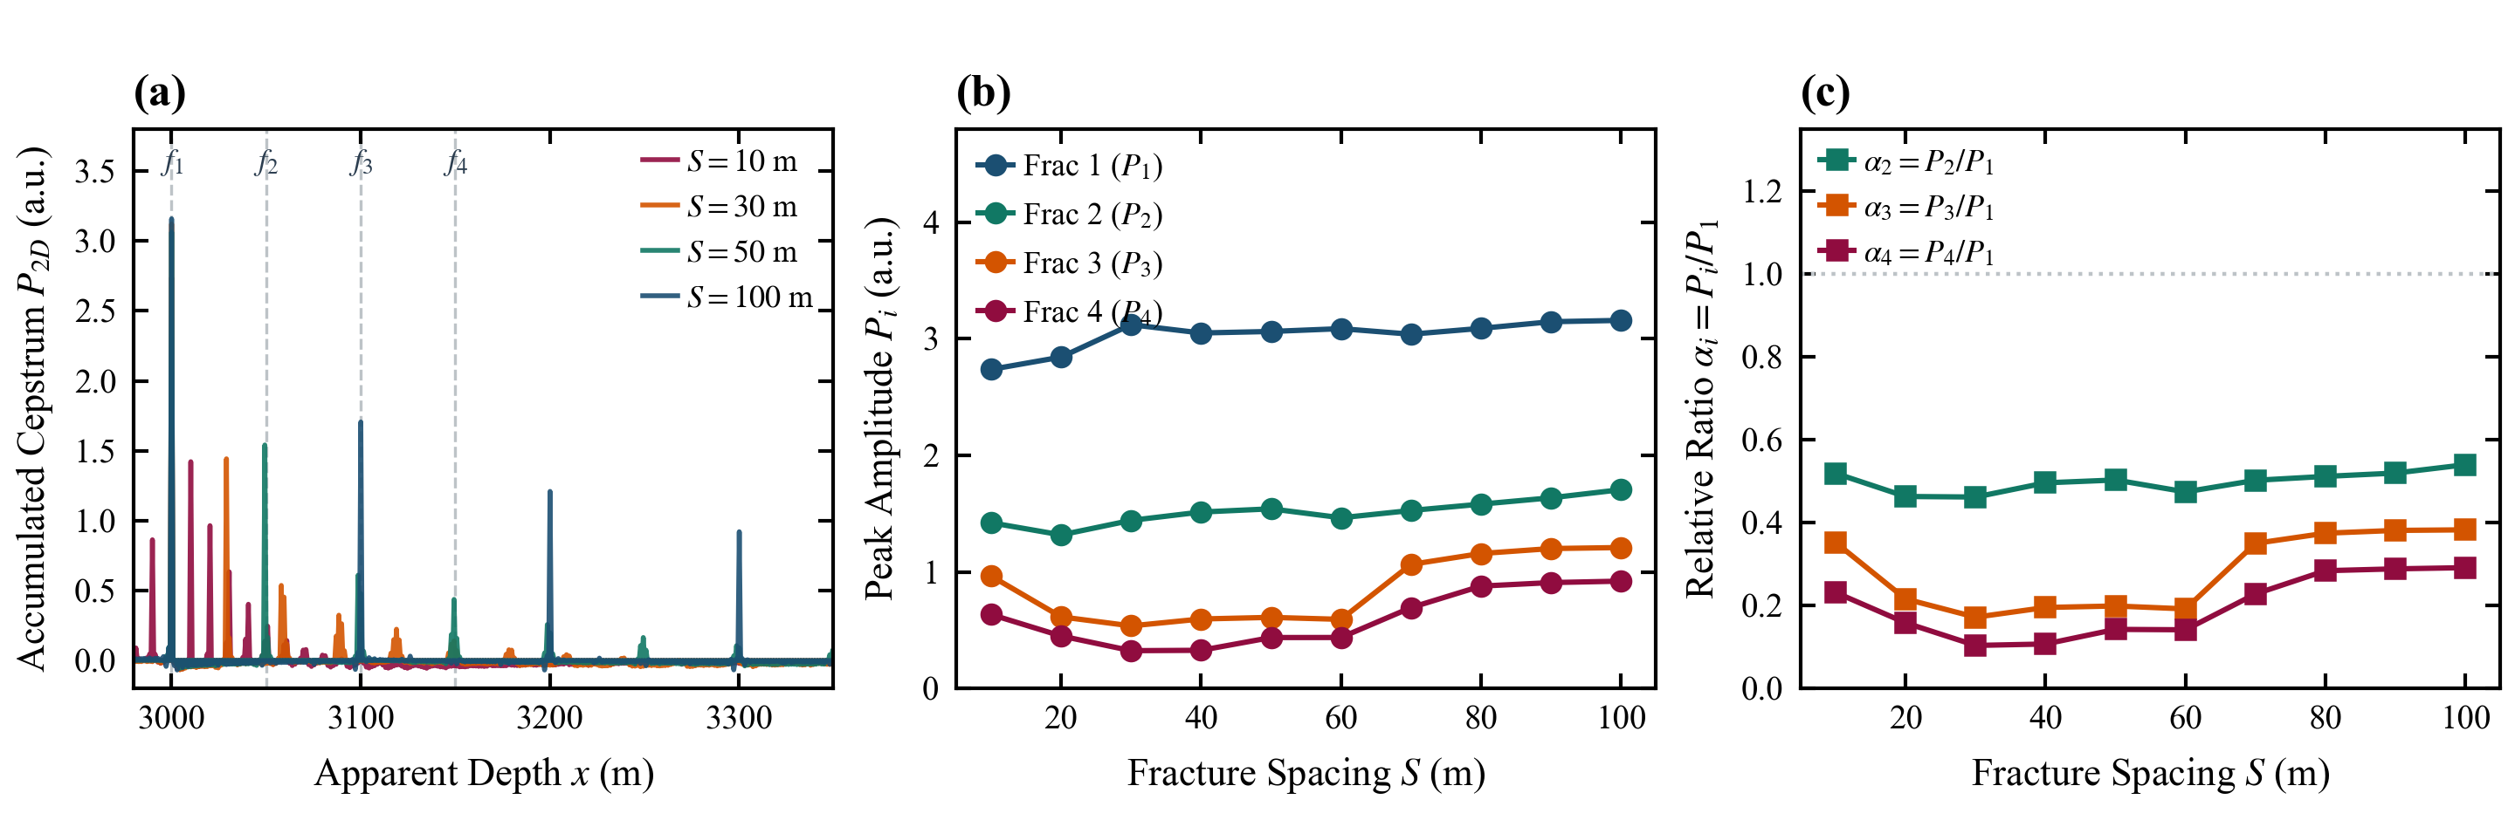
Figure 5. Cluster spacing S main effect analysis. (a) Continuous cepstral profile evolution with spacing S for n=4; (b) Absolute apparent peaks P_i(S) highlighting the destructive interference valley at S=30--50 m; (c) Normalized peak ratios \alpha_i=P_i/P_1 demonstrating strong spatial phase sensitivity.
3.3 Total span is not a sufficient scalar descriptor
Stage span L_{\mathrm{span}}=(n-1)S is widely treated as a bulk proxy for fractured interval length. However, Figure 8(a--c) demonstrates that holding total span fixed at 60 m produces radically divergent behavior: for n=2 (S=60 m), R_{\mathrm{end}}=0.4722; for n=3 (S=30 m), R_{\mathrm{end}}=0.1877; for n=4 (S=20 m), R_{\mathrm{end}}=0.1582; and for n=7 (S=10 m), R_{\mathrm{end}} plummets to 0.0716. Interface count n and spacing S must be preserved independently.
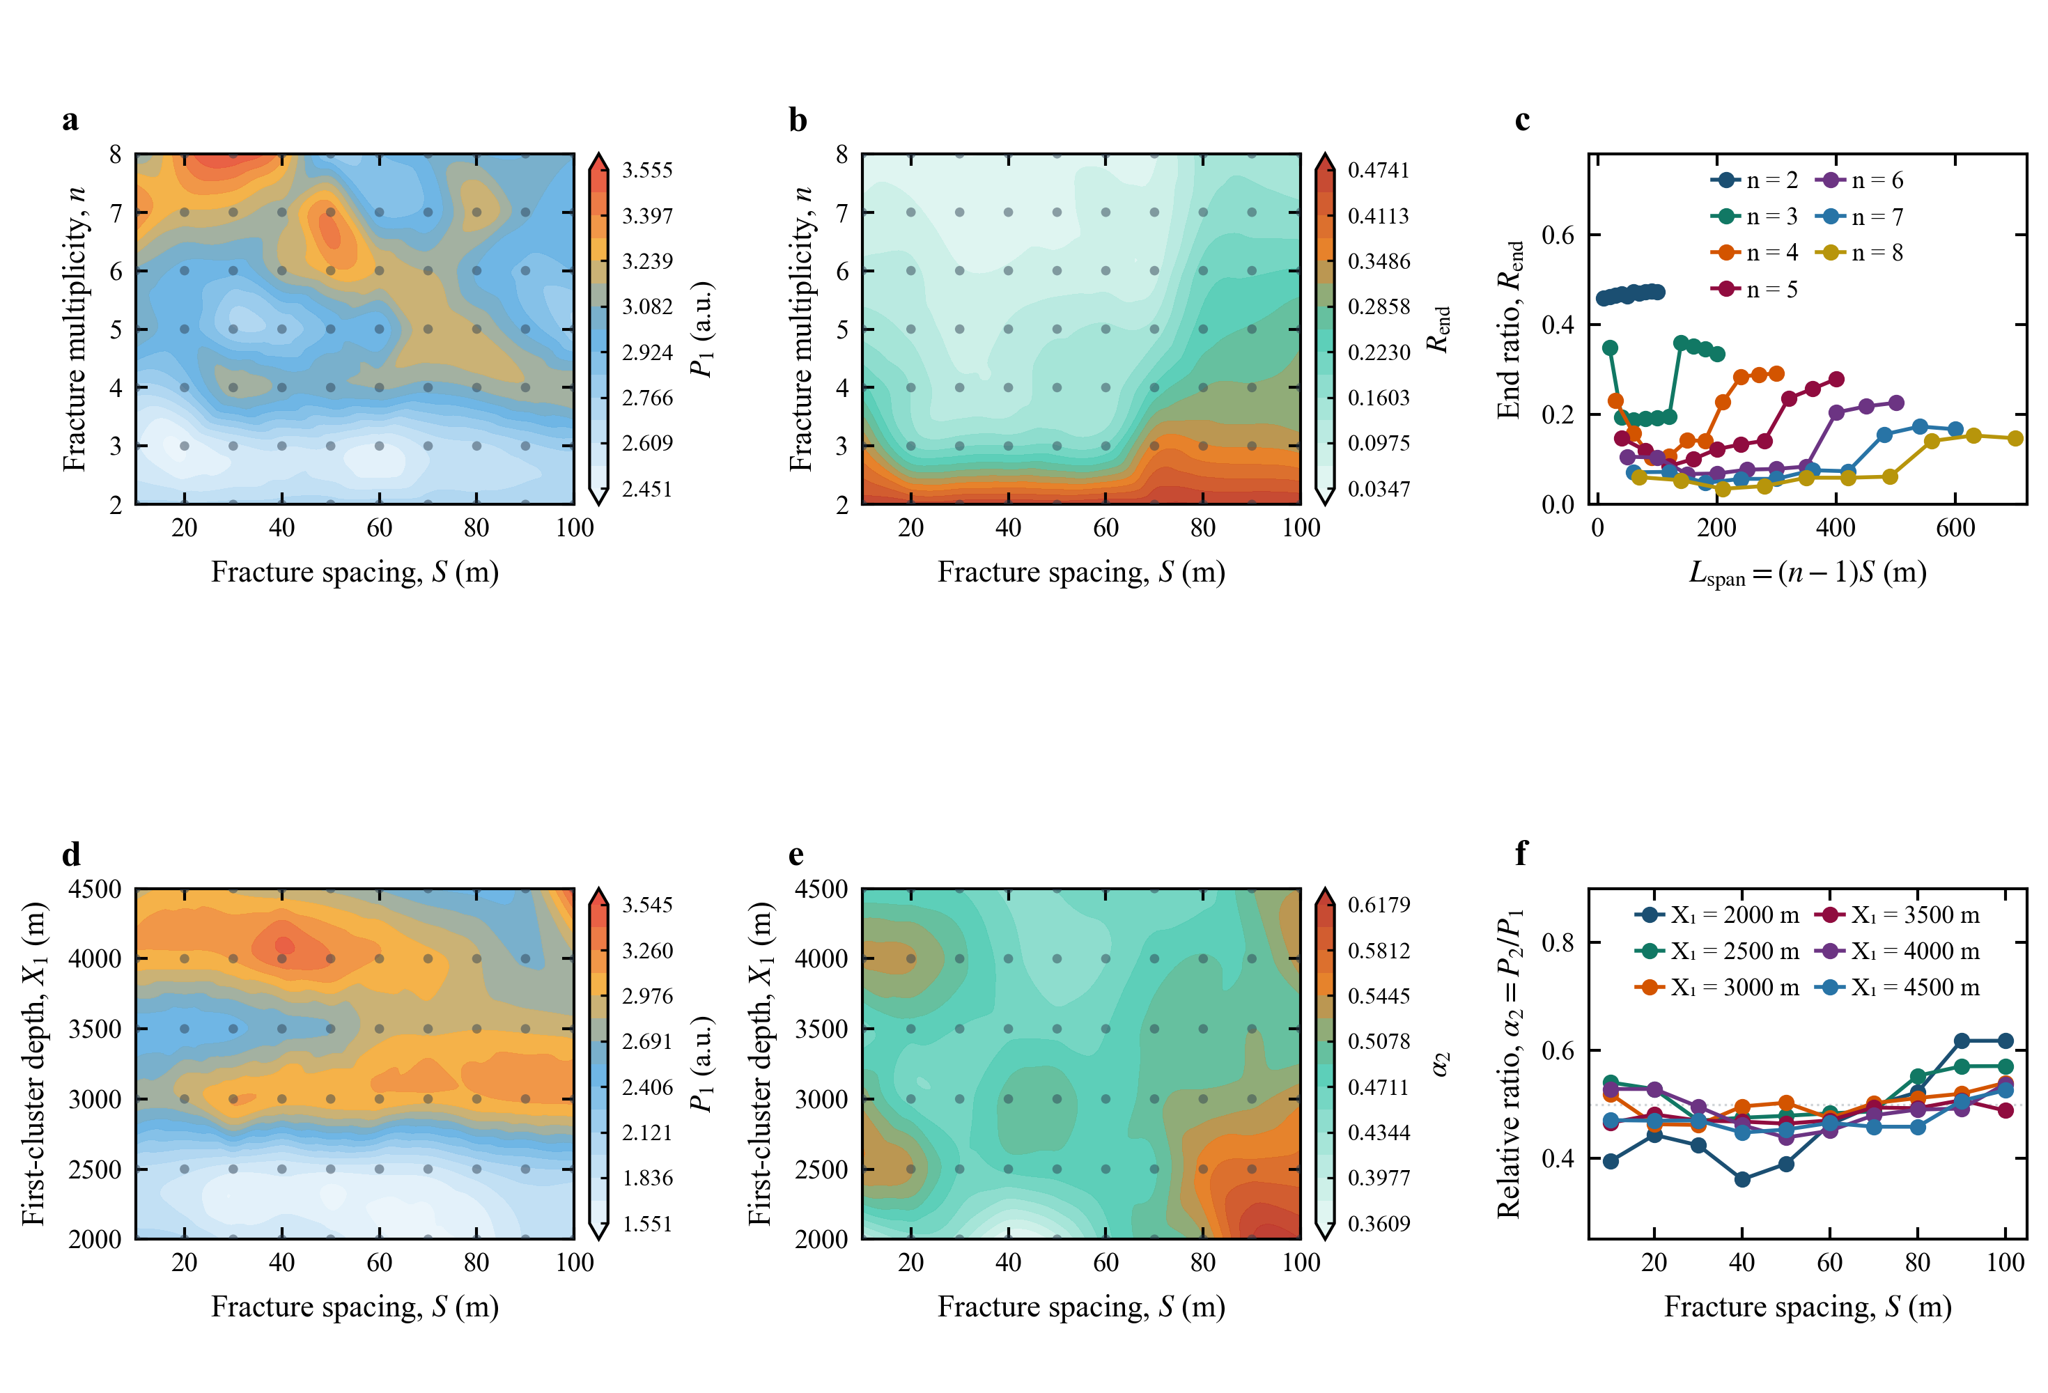
Figure 8. 2D interaction phase maps across spacing, cluster count, and depth. (a) P_1(S,n) phase map; (b) R_end(S,n) terminal ratio map; (c) R_end vs. L_span grouped by cluster count, showing equal-span trajectory divergence; (d) P_1(S,X_1) map; (e) \alpha_2(S,X_1) map; (f) \alpha_2(S) profiles across varying X_1.
3.4 Depth is not a separable scalar factor and descriptive spatial fits
Joint X_1 and S analysis (Figure 7 and Figure 8(d--f)) reveals strong coupling between casing friction and interface transmission. At X_1=3000 m, descriptive exponential fits yield mean R²=0.9864, yet \gamma varies strongly with spacing (for n=8, \gamma=0.684 at S=30 m vs. 0.294 at S=80 m). As shown in Figure 9, high goodness-of-fit within a fixed geometry indicates internal self-similarity rather than a universal physical decay law.
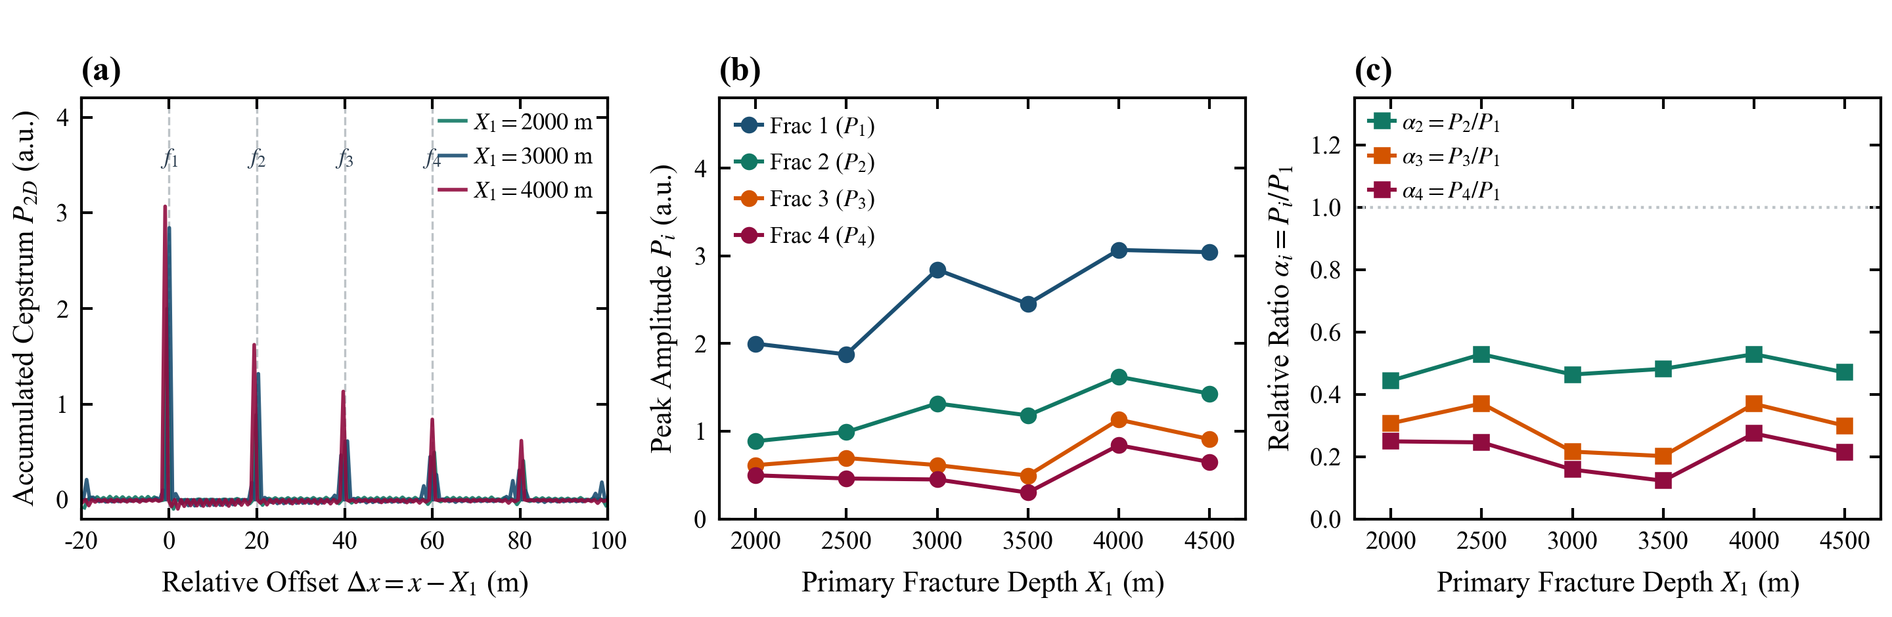
Figure 7. First-cluster depth X1 main effect analysis. Comparison of absolute and relative cepstral peaks as X_1 increases from 2000 to 4500 m, confirming frictional damping.
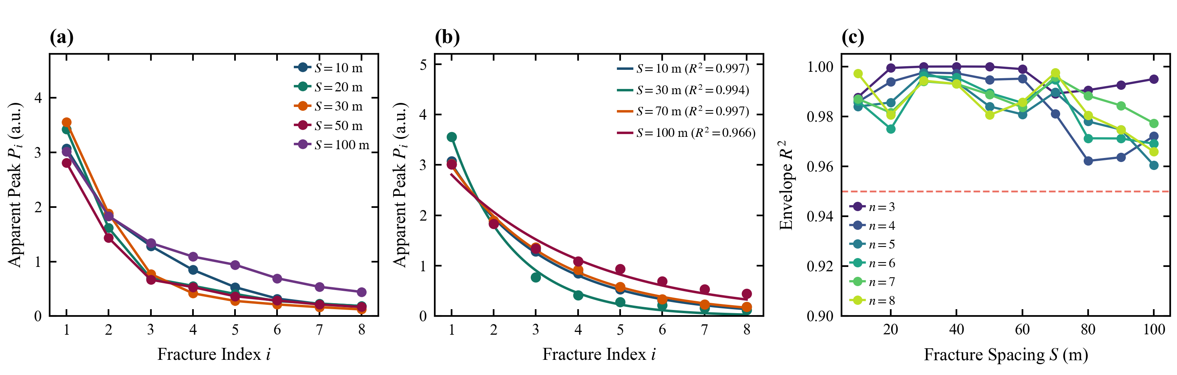
Figure 9. Descriptive spatial decay envelope fitting in fixed geometries. Evaluation of empirical exponential envelope P_i=A\exp[-\gamma(i-1)] and parametric sensitivity.
4. Physics-Informed Non-Circular Reconstruction Framework
Forward falsifications demonstrate that interpreting raw peaks induces severe misdiagnosis. Figure 3 delineates our four-operator reconstruction workflow designed to suppress predictable multipath ghosts and compensate transmission losses while preserving strict zero-preservation.
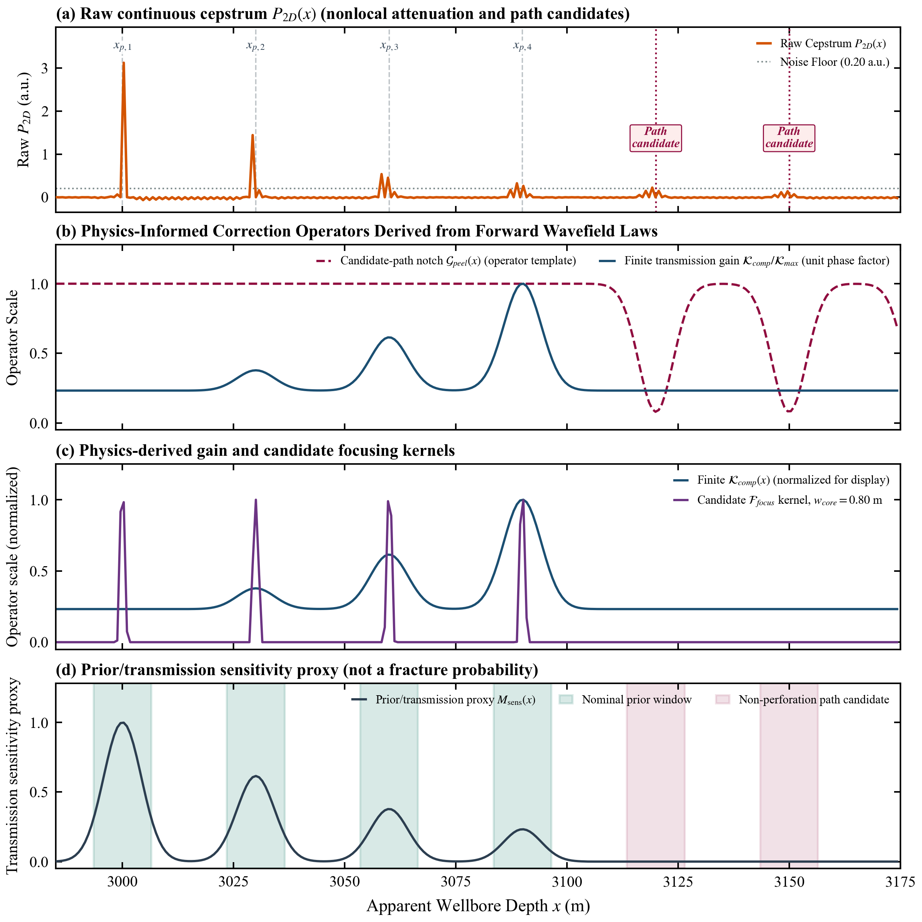
Figure 3. Physics-informed four-operator reconstruction architecture. (a) Raw continuous cepstrum with nominal perforation priors and multipath candidate depths; (b) Candidate multipath notch operator G_peel and bounded transmission compensation K_comp; (c) Compensated kernel and 0.80-m super-Gaussian focus F_focus; (d) Continuous evidence uncertainty mask M(x) (green: high confidence, yellow: transition ambiguity, red: rejection band).
4.1 Non-circular inverse problem formulation
The inverse problem receives the observed profile y(x)=P_{2D}(x) and nominal design depths (Eq. 3). The unknown state is the non-negative fluid-entry activity vector z=(z_1, \ldots, z_n)^T \ge 0, where z_k=0 denotes an inactive cluster. Unit response templates h_k(x) and ghost templates g_m(x) are derived from the forward MOC solver. The optimization objective is:
minz≥0, c≥0‖W1/2[y−Hz−Gc]‖22+λz‖z‖1+λc‖c‖22 | (5)

where H=[h_1, \ldots, h_n], G=[g_2, \ldots, g_M], W is a diagonal weight matrix, and c represents ghost amplitudes subject to physical upper bounds c_m \le \bar\rho_m \sum_k z_k. Regularization parameters \lambda_z, \lambda_c must be pre-calibrated on held-out simulations, never tuned on test profiles.
4.2 Multipath reverberation peeling operator G_peel
Internal reflections produce candidate ghost depths at acoustic reverberation intervals:
$x_{ghost,m}=X_{1}+mS, m≥2,$ | (6)

Crucially, if x_{\mathrm{ghost},m} coincides with an engineered perforation depth, notch filtering is prohibited and the energy is resolved via Eq. (5). Peeling is applied strictly to non-perforation depths:
$G_{peel}(x)=clip[1−∑_{m∈G}ρ_{m}κ(\frac{x−x_{ghost,m}}{w_{g}}),G_{min},1].$ | (7)

4.3 Transmission and multi-interface phase compensation K_comp
To correct forward cascading transmission losses, cluster-specific physical gains are defined as:
$g_{k}(S)=\frac{1}{T_{eff}^{2(k−1)}η(S)}, K_{comp}(x)=1+∑_{k=1}^{n}[g_{k}(S)−1]ω_{k}(x),$ | (8)

where T_{\mathrm{eff}} \in (0,1] is pre-calibrated and \eta(S) \in [\eta_{\min}, 1] models destructive interference:
η(S)=clip(|1+Rfrace−i4πS/λ0|,ηmin,1). | (9)

K_{\mathrm{comp}} strictly avoids division by measured peaks. Reconstructed amplitudes \tilde z_k=g_k z_k ensure that z_k=0 identically implies \tilde z_k=0, preserving true inactivity.
4.4 Super-Gaussian spatial focusing operator F_focus
For active clusters exceeding threshold \tau_z, a fourth-order super-Gaussian kernel restores sharp spatial resolution:
Ffocus(x)=∑k:zk>τzqkexp[−(x−x^kwcore)4], wcore=0.80 m. | (10)

4.5 Continuous evidence and uncertainty mask M(x)
The uncertainty mask evaluates solution confidence and physical evidence:
M(x)=clip[∑kukz~k κ(x−x^kwt)−∑m∈Gvmκ(x−xghost,mwg),0,1]. | (11)

Three operational bands are defined: Green (M ≥ 0.70) marks high confidence suitable for fracture width inversion; Yellow (0.20 ≤ M < 0.70) signifies interface overlap or high attenuation; Red (M < 0.20) flags probable ghosts or sparse evidence. The reconstructed profile is:
P~(x)=M(x)Gpeel(x)Kcomp(x)[∑kzkhk(x)]Ffocus(x). | (12)

5. Synthetic Extreme Case Studies and Validation Boundary
To stress-test forward distortions and operator requirements, four extreme geometries were selected from the 426-grid benchmark (Figure 4). Table 2 specifies the diagnostic characteristics and reproducibility audit criteria.
Table 2 Synthetic extreme geometries and standardized non-circular audit protocols
Case Identifier | Geometric Configuration | Forward Physical Evidence | Non-Circular Verification Protocol
Case 1: Destructive Ghost Trap | X1=3000 m, S=30 m, n=4 | P=[3.122, 1.442, 0.536, 0.324] a.u.; secondary peaks observed at 3119.2 and 3149.7 m matching 3120/3150 m multipath predictions | Fit z using nominal templates; peel only non-perforation ghosts; report z3, z4 support and residuals without target forcing
Case 2: Ultra-Dense Cluster Limit | S=10 m, n=4 | P=[2.738, 1.421, 0.964, 0.634] a.u.; 10-m spacing approaches the 30-s window resolution limit; overlapping wave packets | Compute parameter covariance; avoid claiming 4 separated peaks without evidence; flag unresolved spans with yellow mask
Case 3: Deep Cascading Dissipation | S=20 m, n=8 | P=[3.420, 1.616, 0.695, 0.554, 0.406, 0.274, 0.231, 0.184] a.u., Rend=0.0537; severe attenuation of later clusters | Apply pre-calibrated finite gain gk; verify zero-preservation on synthetic unactivated clusters; report uncertainty inflation
Case 4: High-Spacing Baseline | S=80 m, n=4 | P=[3.090, 1.581, 1.158, 0.878] a.u., Rend=0.2841; well-isolated wave packets with minimal interference | Verify Kcomp smoothly approaches unity under high transmission; confirm mask M(x) remains stable without spurious peaks

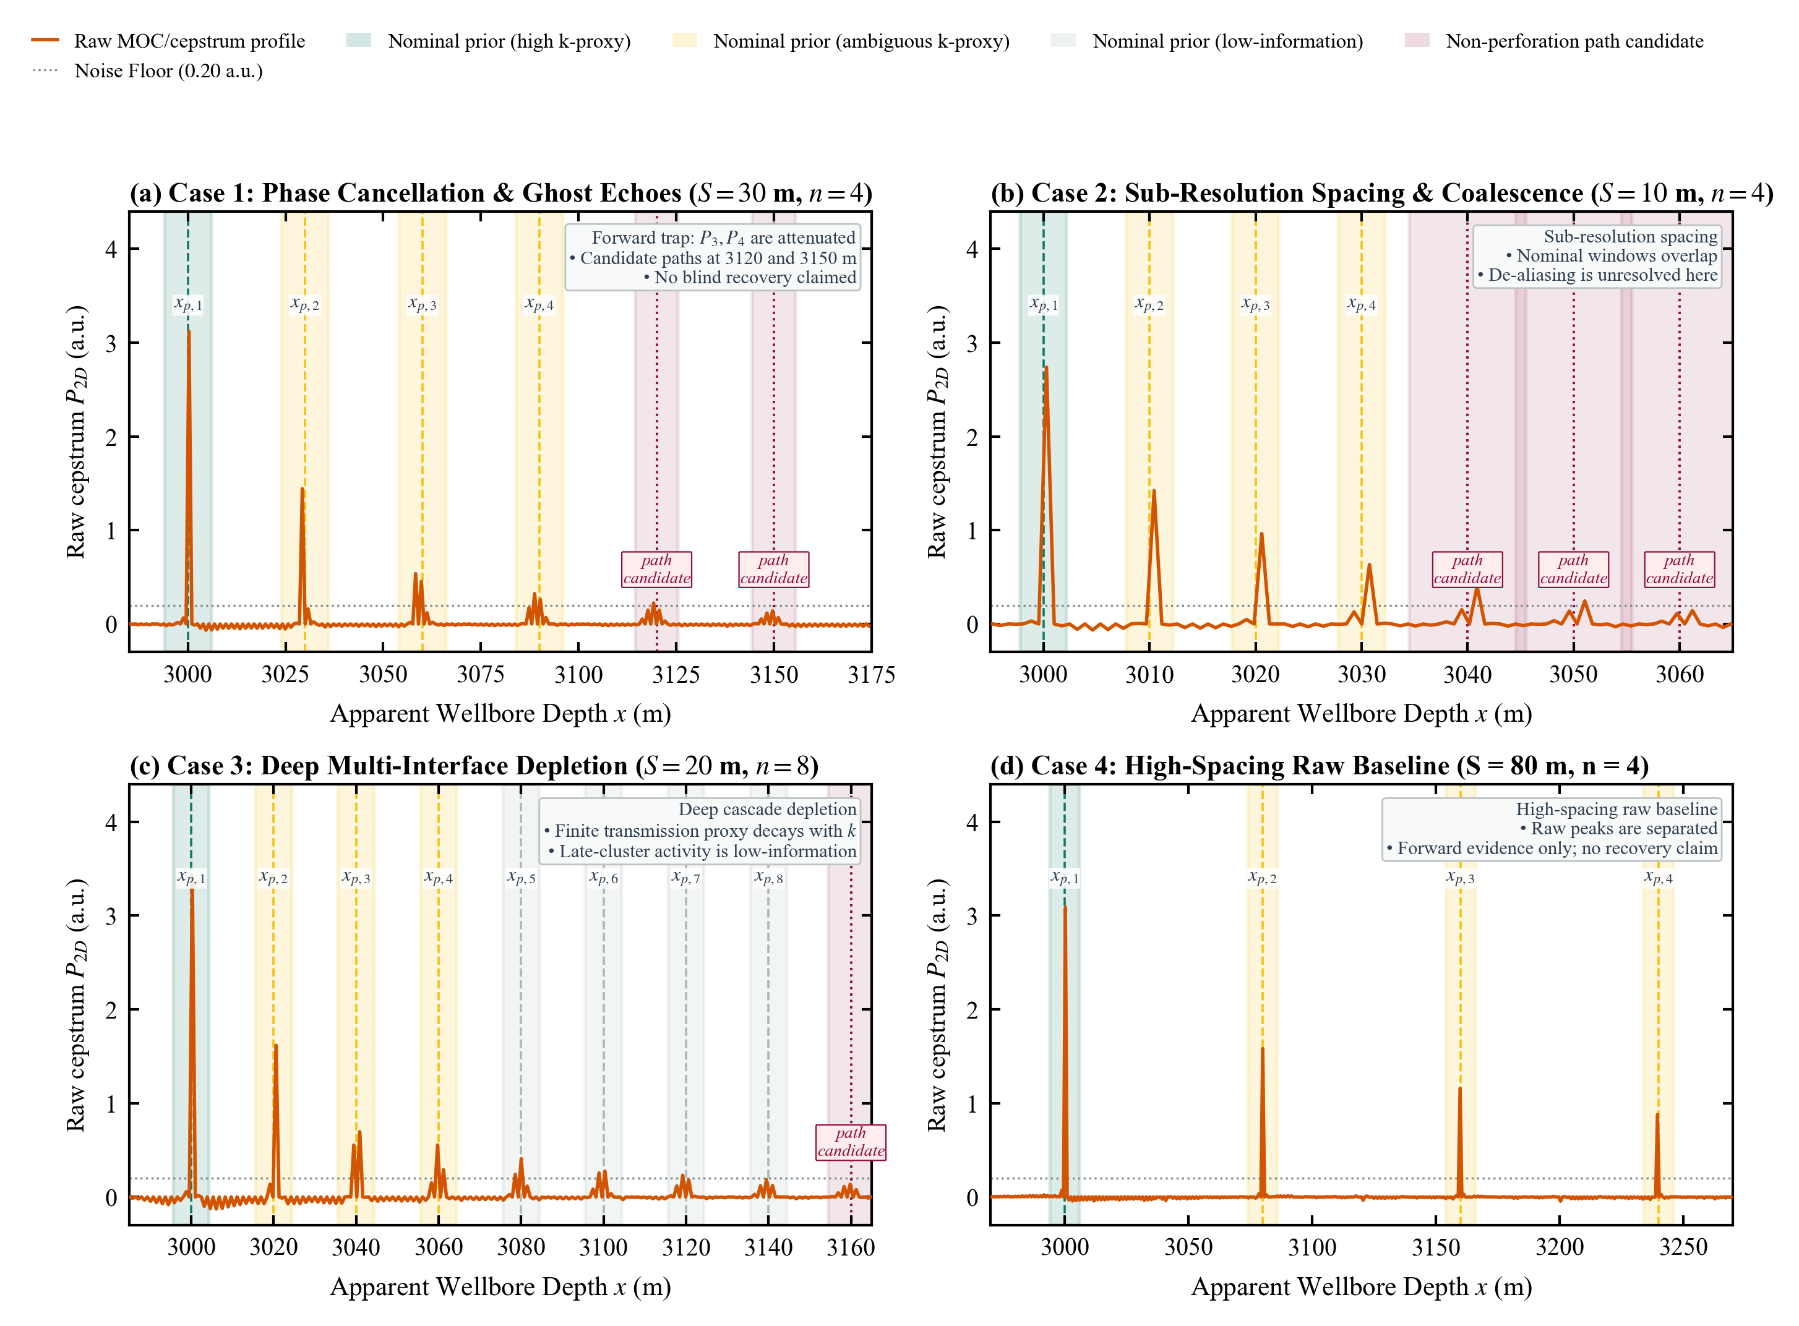
Figure 4. Forward evidence matrix for the four extreme geometries. (a) S=30 m, n=4 destructive trap and prominent 3120/3150 m ghost peaks; (b) S=10 m, n=4 dense wave-packet overlap limit; (c) S=20 m, n=8 cascading transmission dissipation limit; (d) S=80 m, n=4 uncoupled baseline. Note: Forward evidence matrix, not reconstructed inversion.
6. Discussion and Downstream Inversion Interface
Analysis of the 426-grid benchmark establishes that wellhead water-hammer peaks are network-conditioned apparent responses rather than local cluster observables. The 47.5% first-peak drop, intermediate-spacing interference valleys, and equal-span divergence collectively demonstrate transmission-line dynamics. Figure 10 delineates the operational envelope governing identifiability.
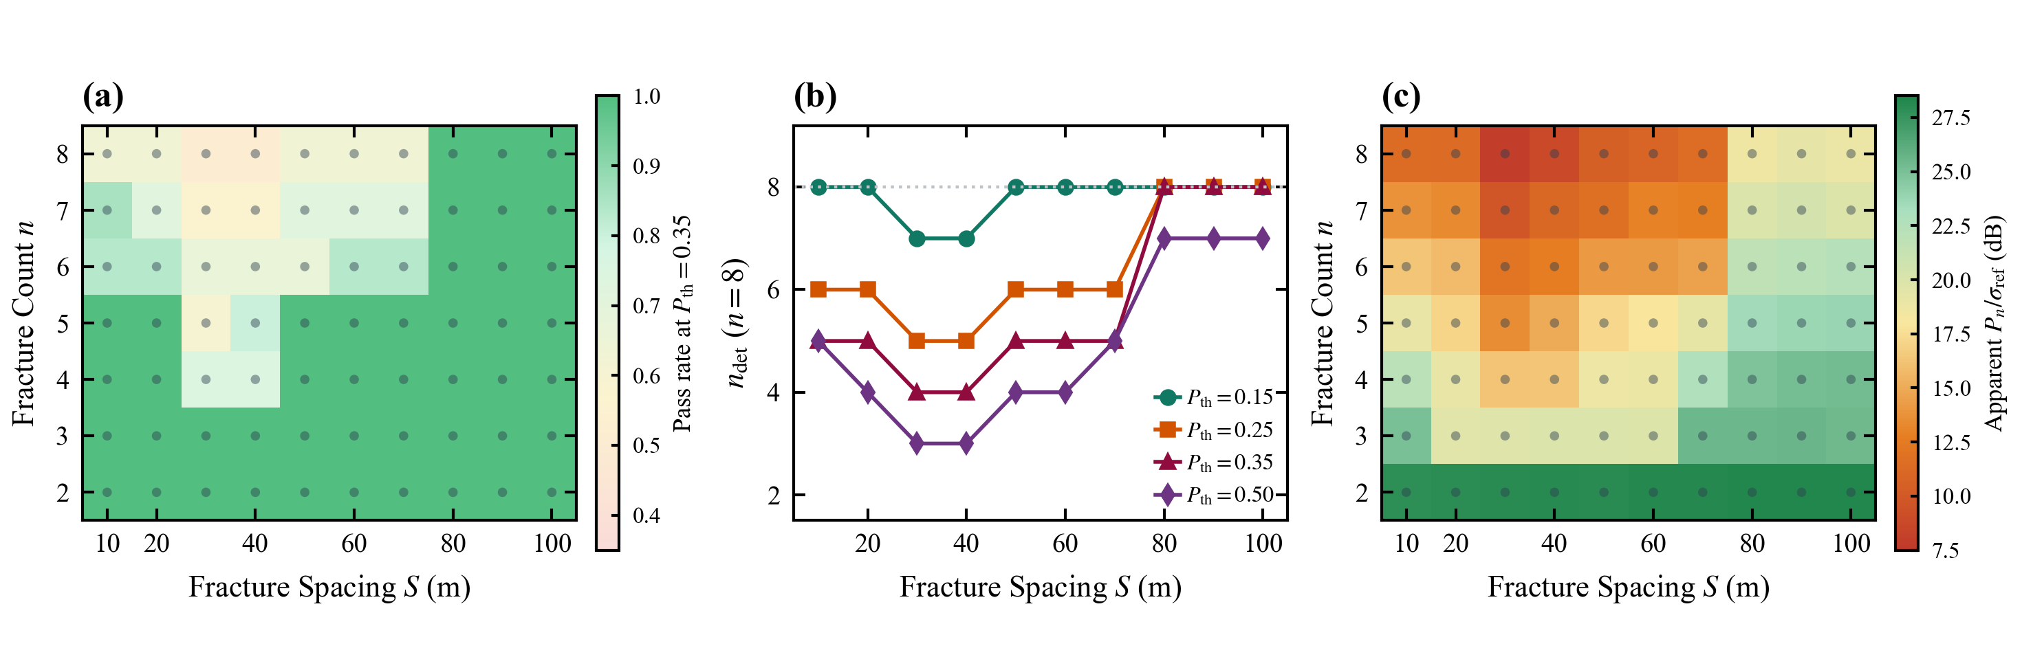
Figure 10. Operational identifiability envelope. Identifiable cluster counts, apparent SNR, and spacing feasibility domains across varying diagnostic thresholds.
For downstream geomechanical models estimating fracture width w_{f,k} via z_k = \mathcal{H}(w_{f,k}, C_{f,k}, k_{\mathrm{leak},k}), our framework provides clean non-negative inputs and rigorous uncertainty masks, preventing false fractures from entering reservoir simulators.
Key study limitations include: deterministic forward simulations without field noise, benchmark peak extraction using true coordinates rather than blind localization, and unexhausted partial-breakdown combinations. These define priorities for field trials and blind benchmarks.
7. Conclusions
(1) Downstream fracture interfaces exert strong feedback on upstream arrivals. Adding a second cluster reduces the first peak by 47.5% at X_1=3000 m, S=20 m, disproving unconditioned single-cluster calibration.
(2) In n≥3 stages, cluster spacing strongly modulates peak amplitudes through multi-interface destructive interference. At S=30 m, later peaks nearly vanish before recovering at S=100 m.
(3) Total stage span L_span is an insufficient scalar descriptor. At a fixed 60-m span, R_end drops from 0.472 to 0.072 as cluster count increases from 2 to 7.
(4) A four-operator non-circular reconstruction framework (G_peel, K_comp, F_focus, M) decouples nominal priors from unknown activation states. Bounded physical gains enforce strict zero-preservation, preventing spurious fracture creation.
(5) Standardized verification protocols on four extreme geometries confirm forward wave-network distortions; future research should evaluate blind recovery on complex-phase holdout benchmarks.
References
[1] Bakku, S.K., Fehler, M.C., and Burns, D.R. 2013. Fracture compliance estimation using borehole tube waves. Geophysics 78 (4): D249–D260. https://doi.org/10.1190/geo2012-0521.1.
[2] Liang, C., O'Reilly, O., Dunham, E.M., and Moos, D. 2017. Hydraulic fracture diagnostics from Krauklis-wave resonance and tube-wave reflections. Geophysics 82 (3): D171–D186. https://doi.org/10.1190/geo2016-0480.1.
[3] Ghidaoui, M.S., Zhao, M., McInnis, D.A., and Axworthy, D.H. 2005. A review of water hammer theory and practice. Applied Mechanics Reviews 58 (1): 49–76. https://doi.org/10.1115/1.1828050.
[4] Chaudhry, M.H. 2014. Applied Hydraulic Transients. 3rd ed. New York: Springer. https://doi.org/10.1007/978-1-4614-8538-4.
[5] Dong, X.L., Wang, X.M., Zhu, H.Y. et al. 2025. Research and application of hydraulic fracturing fluid entry depth detection method based on water-hammer signal. Geoenergy Science and Engineering 246: 213556. https://doi.org/10.1016/j.geoen.2024.213556.
[6] Sun, S.S., He, Y.M., Liu, L.J. et al. 2026. Identification of fluid-entry clusters and diagnosis of downhole events based on high-frequency water hammer pressure. International Journal of Rock Mechanics and Mining Sciences 200: 106437. https://doi.org/10.1016/j.ijrmms.2026.106437.
[7] Cheng, Y.J., You, J.X., Guo, F.Q. et al. 2026. Development and effectiveness verification of ultra-high-frequency water-hammer wave monitoring equipment for large-scale fracturing of unconventional oil and gas. Flow Measurement and Instrumentation 111: 103424. https://doi.org/10.1016/j.flowmeasinst.2026.103424.
[8] Childers, D.G., Skinner, D.P., and Kemerait, R.C. 1977. The cepstrum: a guide to processing. Proceedings of the IEEE 65 (10): 1428–1443. https://doi.org/10.1109/PROC.1977.10747.
[9] Oppenheim, A.V. and Schafer, R.W. 2004. From frequency to quefrency: a history of the cepstrum. IEEE Signal Processing Magazine 21 (5): 95–106. https://doi.org/10.1109/MSP.2004.1328092.
[10] Qiu, Y., He, Y., Liu, L. et al. 2022. Water hammer response characteristics of wellbore-fracture system: multi-dimensional analysis in time, frequency and quefrency domain. Journal of Petroleum Science and Engineering 213: 110425. https://doi.org/10.1016/j.petrol.2022.110425.
[11] Luo, Y., He, Y., Sun, S. et al. 2023. A new water hammer decay model: analyzing the interference of multiple fractures and perforations on decay rate. SPE Journal 28 (4): 1973–1985. https://doi.org/10.2118/214658-PA.
[12] Hu, X., He, Y., Sun, S. et al. 2022. Evaluation of multi-fractures geometry based on water hammer signals: a new comprehensive model and field application. Journal of Hydrology 612: 128240. https://doi.org/10.1016/j.jhydrol.2022.128240.
[13] Sun, S.S., He, Y.M., Liu, L.J. et al. 2025. A novel comprehensive water hammer pressure model for fracture geometry evaluation. SPE Journal 30 (9): 5350–5366. https://doi.org/10.2118/228403-PA.
[14] Liu, L.J., Liu, Y.Z., and Wang, X.G. 2023. A novel MCMC-based hydraulic fracture diagnostics approach using water hammer data. In 57th US Rock Mechanics/Geomechanics Symposium, Atlanta, Georgia, 25–28 June. https://doi.org/10.56952/ARMA-2023-0865.
[15] Zeng, B., Ding, Y., Chen, W. et al. 2024. Fracture size inversion method based on water hammer signal for shale reservoir. Frontiers in Energy Research 11: 1336148. https://doi.org/10.3389/fenrg.2023.1336148.
[16] Deng, S., Liu, L., and He, Y. 2025. A diagnostic model for hydraulic fracture in naturally fractured reservoir utilising water-hammer signal. Engineering Fracture Mechanics 325: 111347. https://doi.org/10.1016/j.engfracmech.2025.111347.
[17] Gabry, M.A., Ramadan, A., and Soliman, M.Y. 2025. Estimating water hammer damping ratios using continuous wavelet transform for induced hydraulic fracture complexity characterization. SPE Journal 30 (6): 3587–3611. https://doi.org/10.2118/225459-PA.
[18] Zhu, M. and Wang, H. 2026. Automated water hammer analysis for fracture parameter inversion using high-frequency shut-in pressure signals during hydraulic fracturing. Modelling 7 (3): 87. https://doi.org/10.3390/modelling7030087.
[19] Zielke, W. 1968. Frequency-dependent friction in transient pipe flow. Journal of Basic Engineering 90 (1): 109–115. https://doi.org/10.1115/1.3605049.
[20] Vardy, A.E. and Brown, J.M.B. 1995. Transient, turbulent, smooth pipe friction. Journal of Hydraulic Research 33 (4): 435–456. https://doi.org/10.1080/00221689509498654.
[21] Bergant, A., Simpson, A.R., and Vitkovsky, J. 2001. Developments in unsteady pipe flow friction modelling. Journal of Hydraulic Research 39 (3): 249–257. https://doi.org/10.1080/00221680109499828.
[22] Dong, X.L., Wang, X.M., Zhu, H.Y. et al. 2026. The influence of filtering methods and parameters on reflection period from pump shut-in water hammer signals: a comprehensive study. Geoenergy Science and Engineering 257: 214278. https://doi.org/10.1016/j.geoen.2025.214278.

