Chi Matcha Project Documentation
Members :
- Yonathan Eivan Riyadi (2402805900)
- Bryan Imanuel Simangunsong (2802444896)

1. Application Overview
App Name Chi Matcha

Description
Chi Matcha is a mobile app for browsing and ordering matcha drinks and desserts. Users can filter products by category, see details of each item, customize their order (ice level, sugar level, quantity), and check available store locations. The app is built for Android using Java.

Technology Stack
Android Studio Meerkat Feature Drop 2024.3.2 Patch 1
Java — Android SDK API 35 — Material Components 3

Figma File
- https://lnkd.in/gr4NYMrR (Prototype)
- https://lnkd.in/gqxF7Dtm (Figma file)

2. Module Documentation
Below is the documentation for each page in Chi Matcha. Each section explains what the page is for, what components are used, and how navigation works from that page.

2.1 Login Page
Files LoginActivity.java — activity_login.xml

Description
This is the first screen when the app opens. The user types their username and password to get into the app. If something is wrong with the input, an error message appears under the field. When login is successful, the username is saved and the app goes to the Home page.

Components
ImageView — app logo
TextInputLayout + TextInputEditText — username field with placeholder
TextInputLayout + TextInputEditText — password field with placeholder
TextView — link to Register page, styled with colored span
MaterialButton — Sign In button, changes color when pressed

Navigation
Sign In button (if validation passes) — HomeActivity
Register link — RegisterActivity

Notes
Username must be more than 6 characters. Both fields are required. The username is saved using SharedPreferences with key 'chi_matcha'. The button changes to a darker color on ACTION_DOWN and returns to the original color on ACTION_UP.

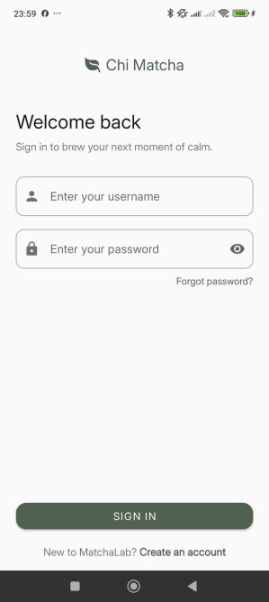

2.2 Register Page
Files RegisterActivity.java — activity_register.xml

Description
This page is for new users who want to make an account. It has three input fields: username, password, and confirm password. Validation fires on button press (ACTION_DOWN), not on release, to match the MouseDown interaction from the Figma prototype.

Components
ImageView — app logo
TextInputLayout + TextInputEditText — username, password, confirm password fields
TextView — link back to Login page
MaterialButton — Create Account button, uses MouseDown behavior

Navigation
Create Account button (if valid) — HomeActivity
Sign in link — LoginActivity

Notes
Password and confirm password must be exactly the same. All fields are required and username must be more than 6 characters. Button uses ACTION_DOWN to fire validation on press, not release.

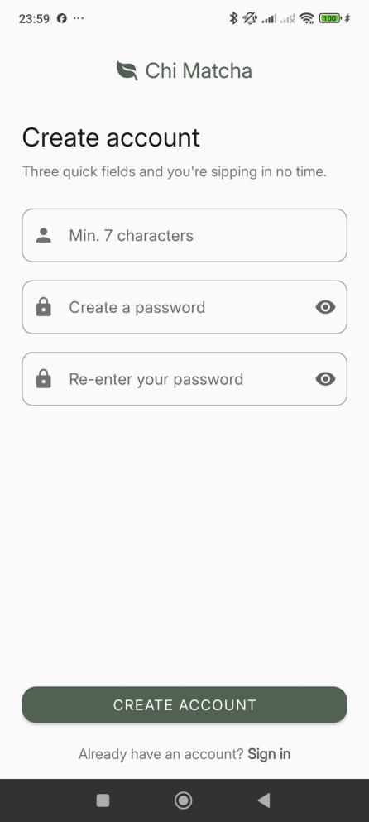

2.3 Home Page
Files HomeActivity.java — activity_home.xml — BannerAdapter.java

Description
This is the main screen after logging in. It shows a greeting with the saved username, a banner carousel at the top that advances automatically every 3 seconds, a quick access menu, and a Today's Pick section at the bottom with two featured products.

Components
TextView — 'Welcome, [username]' greeting and time-based message
ViewPager2 + BannerAdapter — image carousel with 3 banners
ImageButton — previous/next banner controls + dot indicators
DrawerLayout + NavigationView — side drawer menu
CardView x3 — Quick Menu: Items, Branches, Log Out
CardView x2 — Today's Pick: Ceremonial Matcha and Iced Matcha Latte

Navigation
Items card or side drawer — ItemActivity
Branches card or side drawer — BranchActivity
Log Out card or side drawer — LoginActivity (clears back stack)
Today's Pick cards — ItemDetailActivity with product data as extras
'See all' link — ItemActivity

Notes
Time-based greeting: 'Good morning' before 12:00, 'Good afternoon' before 17:00, 'Good evening' after 17:00. The carousel auto-advance pauses in onPause() and resumes in onResume() to avoid background callbacks when the user leaves the screen.

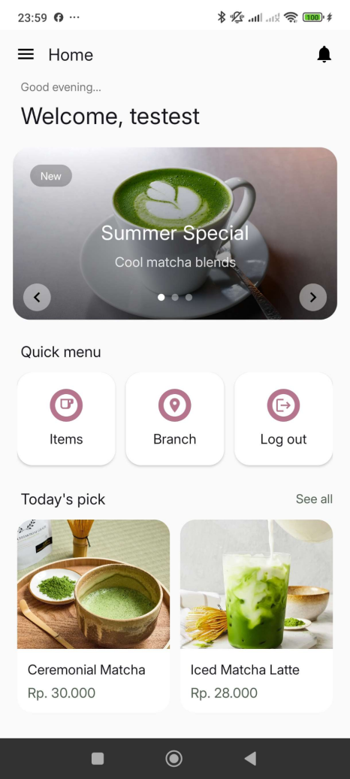

2.4 Item Page
Files ItemActivity.java — activity_item.xml — item_product_card.xml — ItemAdapter.java

Description
This page shows all available matcha products in a 2-column grid. At the top there are category filter chips (All, Hot, Iced, Desserts, Beans). When a chip is selected, the list updates immediately to show only the items in that category without reloading the page.

Components
DrawerLayout + NavigationView — side drawer menu
ChipGroup — filter chips: All, Hot, Iced, Desserts, Beans
RecyclerView with GridLayoutManager (2 columns)
ItemAdapter — handles product cards and navigation on click
Each card: ImageView, product name, short description, price, plus button

Navigation
Each product card — ItemDetailActivity with item data as Intent extras
Drawer Home — HomeActivity
Drawer Branches — BranchActivity
Drawer Log Out — LoginActivity (clears back stack)

Notes
The chip filter checks the tag field on each item. The 'All' chip shows every item regardless of category. There are 7 items total across 4 categories: Hot, Iced, Desserts, Beans.

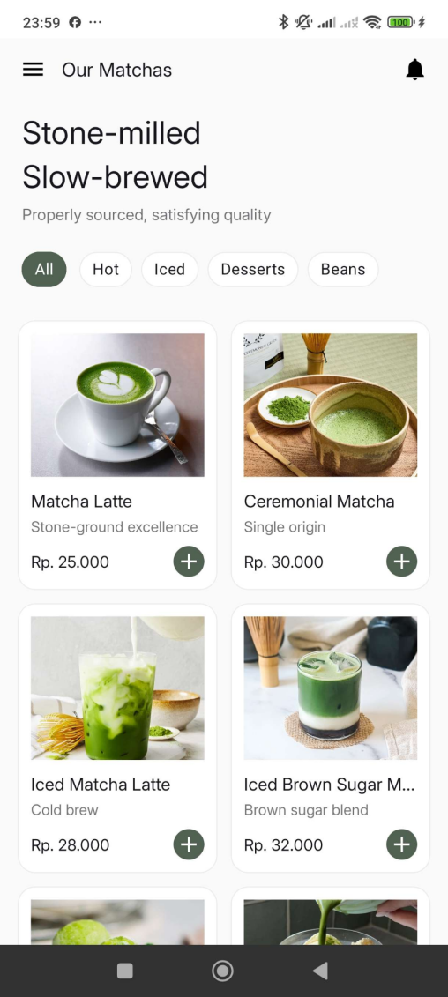

2.5 Item Detail Page
Files ItemDetailActivity.java — activity_item_detail.xml

Description
This page shows the full details of a product the user tapped. Users can pick their ice level and sugar level from dropdowns, set the quantity using plus and minus buttons, and add optional notes. The Order button shows the running total price based on the quantity selected.

Components
ImageView — product cover photo as hero image at the top
TextView — category tag, product name, price, full description
AutoCompleteTextView — ice level dropdown: Full Ice, Less Ice, Half Ice, No Ice
AutoCompleteTextView — sugar level dropdown: Full Sugar, Less Sugar, Half Sugar, No Sugar
ImageButton x2 — minus and plus buttons for quantity stepper
EditText — quantity field, also accepts direct typing
TextInputLayout — optional notes text box with placeholder
MaterialButton — Order button, shows running total e.g. 'Order (Rp. 30.000)'

Navigation
Back button — finish(), returns to previous page
Order button (if quantity > 0) — success dialog, then OK goes to ItemActivity
Order button (if quantity = 0) — error dialog, stays on current page

Notes
The Order button text updates in real time when quantity changes. If quantity is 0 or empty, the stepper field border turns red and an error dialog appears. The success dialog says a confirmation email was sent.

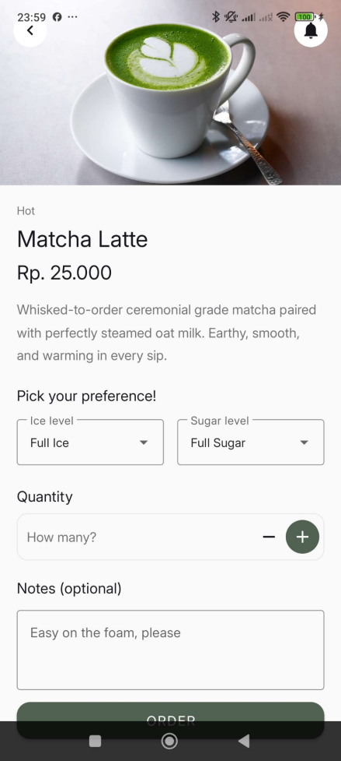

2.6 Branch Page
Files BranchActivity.java — activity_branch.xml — item_branch.xml — BranchAdapter.java

Description
This page shows all Chi Matcha store locations. Each card shows the branch name, address, and opening hours. Users can get here from the quick menu on the home page or from the side drawer on any page.

Components
DrawerLayout + NavigationView — side drawer menu
RecyclerView with LinearLayoutManager — vertical list of branch cards
BranchAdapter — handles branch card layout and data binding
Each card: branch name, address, opening hours

Navigation
Drawer Home — HomeActivity with finish()
Drawer Items — ItemActivity
Drawer Log Out — LoginActivity (clears back stack)
Tapping Branches in drawer while already on this page — just closes the drawer

Notes
Three branches: Chi Matcha Alam Sutera (07:00–22:00), Chi Matcha Jakarta Pusat (08:00–21:00), Chi Matcha Medan (09:00–22:00).

