SpoJeDy
Music Streaming Web Application
Multimedia System and Programming Foundation - Project 1

1. Project Overview
SpoJeDy is a music streaming website built with VueJS 3, Vue Router, and TailwindCSS. It lets users browse a catalog of songs, listen to music, watch music videos, and manage a personal profile with theme preferences. All multimedia is loaded from a CDN (ImageKit for cover images, SoundHelix for sample audio, Google sample bucket for video).

2. How to Run the Application
- Open a terminal in the project root.
- Run: npm install
- Run: npm run dev
- Open the URL printed by Vite (default http://localhost:5173) in Google Chrome.

3. Project Structure
- src/main.js - app entry, loads saved theme before mount.
- src/App.vue - root layout, owns the shared audio player state.
- src/router/index.js - 5-page route table (Vue Router).
- src/data/media.js - dummy song/music video data + CDN URLs.
- src/components/NavBar.vue - top navigation with username + avatar.
- src/components/MiniPlayer.vue - persistent bottom mini player.
- src/components/MediaCard.vue - reusable card (song or MV variant).
- src/views/HomePage.vue - featured song + rows of song cards.
- src/views/SongDetailPage.vue - audio player + fullscreen cover image.
- src/views/MusicVideoPage.vue - featured MV + rows of video cards.
- src/views/MusicVideoDetailPage.vue - HTML5 video player.
- src/views/ProfilePage.vue - username, image upload, theme switch.

4. Page-by-Page Description

4.1 Home Page (/)
- Hero / Featured section: shows the first song with cover, title, artist, genre, and a Play button.
- Listen On Repeat row: horizontally scrolling list of song cards.
- Pop Music row: another horizontal row of song cards.
- Clicking any song card navigates to /song/:id (Song Detail).
- All cover images are loaded from ImageKit CDN as required by the spec.

4.2 Song Detail Page (/song/:id)
- Back to Home link returns to /.
- Square song cover image on the left - click to enter fullscreen overlay.
- Custom audio player on the right with seekable progress bar, Play / Pause, Next, Previous, and a Volume slider.
- Audio file is loaded from a CDN (SoundHelix sample audio).
- Fullscreen overlay shows the cover at full size with Zoom In, Zoom Out, mouse-wheel zoom, and an Exit button. ESC also exits fullscreen.
- Watch Music Video button redirects to the matching MV detail page.
- Spacebar toggles play/pause as a keyboard shortcut.

4.3 Music Video Page (/music-videos)
- Same featured + two rows layout as Home, but for music videos.
- Cards use landscape thumbnails (16:9 aspect) instead of square covers.
- Clicking a card navigates to /music-video/:id.

4.4 Music Video Detail Page (/music-video/:id)
- Back to Music Videos link.
- HTML5 <video> element with custom controls: Play/Pause, Next, Previous, seek bar, Volume slider, Fullscreen.
- Fullscreen uses the native Fullscreen API (requestFullscreen).
- Video file is loaded from Google sample bucket CDN.
- Listen button navigates to the matching Song Detail page.
- Keyboard shortcuts: Space toggles play, F toggles fullscreen.

4.5 Profile Page (/profile)
- Profile image preview (circular, dashed border to match wireframe).
- Upload Image button - opens file picker, then the image is compressed on a canvas (max 512px side, JPEG quality 85%). If still > 1 MB it re-encodes at 60% quality.
- Progressive loading: a progress bar animates from 0 to 100% during read and compress; the image itself uses a blur-to-sharp transition while loading.
- Username input + Save button - stores in localStorage and updates the NavBar in real time via a custom window event.
- Theme Preference (Dark / Light) - toggles the `dark` class on <html> and writes to localStorage. The choice applies instantly across every page.
- All profile data is stored in localStorage under the key spojedy-profile, theme under spojedy-theme.

5. Multimedia Features Mapped to Class Sessions
- Session 1 - basic Vue syntax, v-for, v-if, v-bind, SFC: used everywhere (HomePage, MediaCard, NavBar).
- Session 2 - Vue Router, multi-page navigation: src/router/index.js, all <router-link> uses.
- Session 3 - text rendering, image gallery, Google Fonts: Poppins font, song/MV card grids, dynamic interpolation.
- Session 4 - canvas + image manipulation: profile image compressed via <canvas> drawImage/toBlob in ProfilePage.vue.
- Session 5 - audio playback, volume, seek, metadata: custom audio controls in App.vue + SongDetailPage.vue.
- Session 6 - video player, Fullscreen API, transitions: MusicVideoDetailPage.vue + <transition name="fade"> in App.vue.
- Session 7 - parent-child via props + events, reusable components: MediaCard, MiniPlayer, NavBar all use props/emits.
- Session 8 - keyboard/mouse events + responsive Tailwind classes: spacebar play, ESC exit fullscreen, hover overlays, mobile-first grids.
- Session 9 - localStorage, synchronized multimedia: profile + theme stored in localStorage, MiniPlayer persists across pages.
- Session 10 - client-side image compression, progressive loading, file upload: ProfilePage.vue upload flow.
- Session 11 - CDN integration: ImageKit for cover images, SoundHelix for audio, Google sample bucket for video.

6. Reference Links for Media Assets
Cover images (ImageKit CDN):
https://ik.imagekit.io/demo/img/plant.jpeg
https://ik.imagekit.io/demo/img/woman.jpeg
https://ik.imagekit.io/demo/img/medium_cafe_B1iTdD0C.jpg
https://ik.imagekit.io/demo/img/default-image.jpg
https://ik.imagekit.io/demo/img/sample-folder/four_girls.jpg
https://ik.imagekit.io/demo/img/sample.jpg

Audio (SoundHelix public sample MP3):
https://www.soundhelix.com/examples/mp3/SoundHelix-Song-1.mp3
https://www.soundhelix.com/examples/mp3/SoundHelix-Song-2.mp3
https://www.soundhelix.com/examples/mp3/SoundHelix-Song-3.mp3
https://www.soundhelix.com/examples/mp3/SoundHelix-Song-4.mp3
https://www.soundhelix.com/examples/mp3/SoundHelix-Song-5.mp3
https://www.soundhelix.com/examples/mp3/SoundHelix-Song-6.mp3

Video (Google sample bucket):
https://commondatastorage.googleapis.com/gtv-videos-bucket/sample/BigBuckBunny.mp4
https://commondatastorage.googleapis.com/gtv-videos-bucket/sample/ElephantsDream.mp4
https://commondatastorage.googleapis.com/gtv-videos-bucket/sample/ForBiggerBlazes.mp4
https://commondatastorage.googleapis.com/gtv-videos-bucket/sample/ForBiggerEscapes.mp4
https://commondatastorage.googleapis.com/gtv-videos-bucket/sample/ForBiggerFun.mp4
https://commondatastorage.googleapis.com/gtv-videos-bucket/sample/ForBiggerJoyrides.mp4

Fonts (Google Fonts):
https://fonts.googleapis.com/css2?family=Poppins

7. Wireframe References
The interface design follows the supplied Figma wireframes. Each page is implemented to match the layout of the corresponding wireframe.
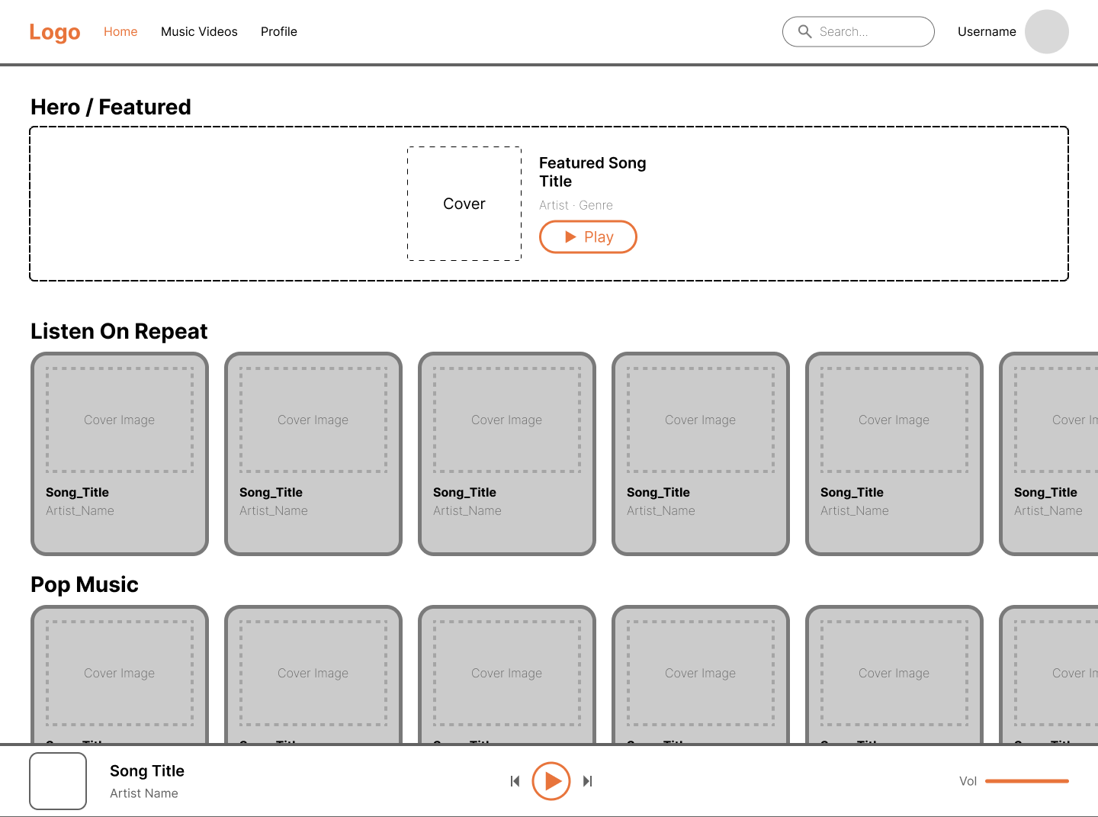
Figure 1 - Home Page wireframe reference

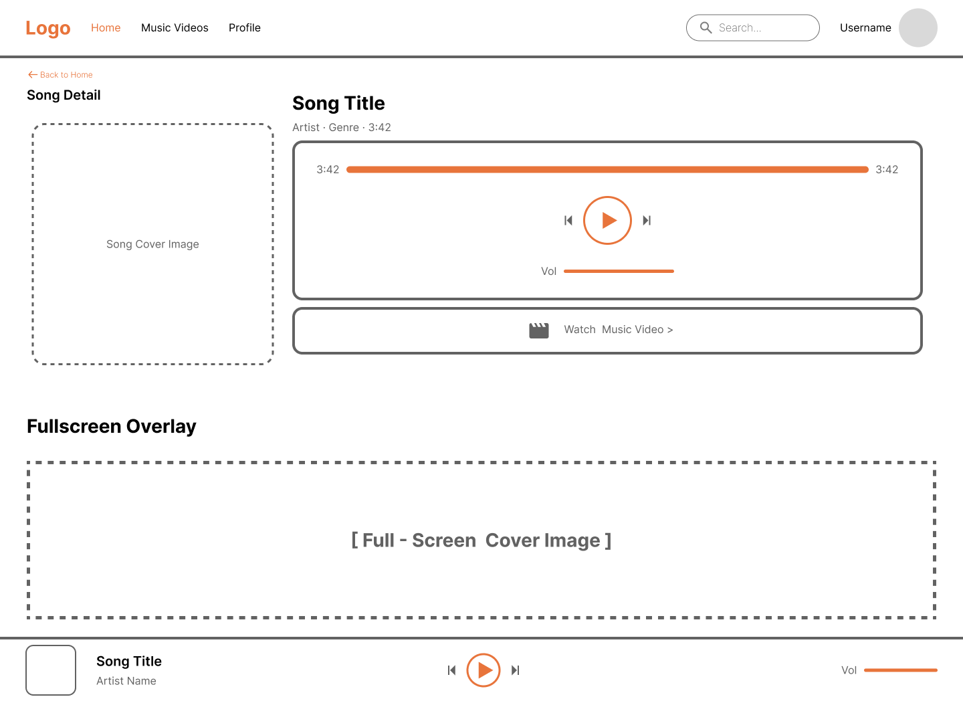
Figure 2 - Song Detail page wireframe reference

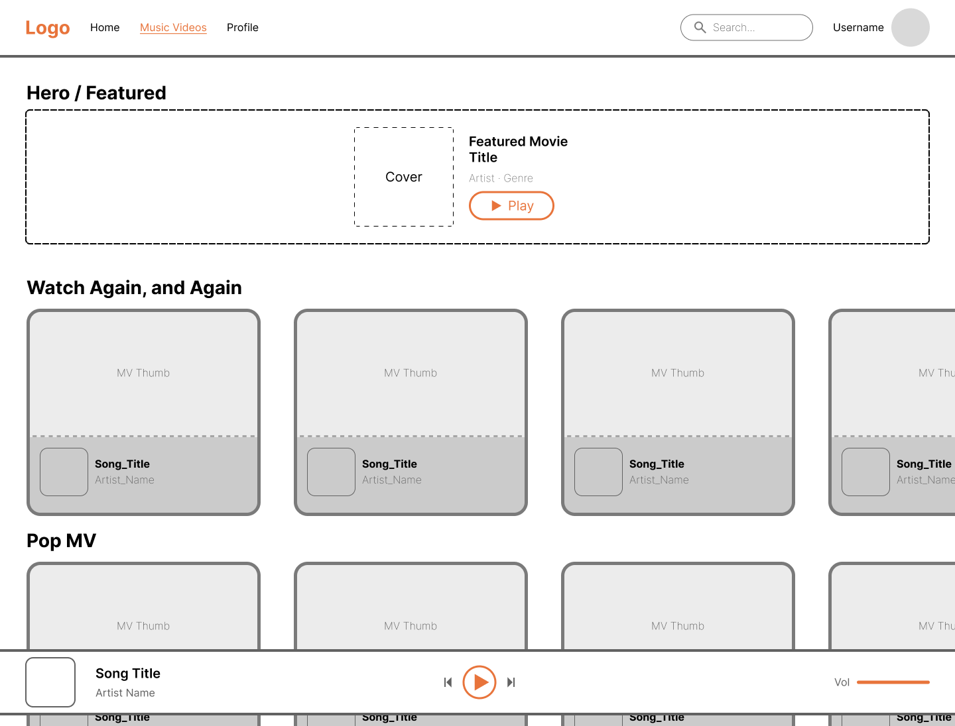
Figure 3 - Music Video page wireframe reference

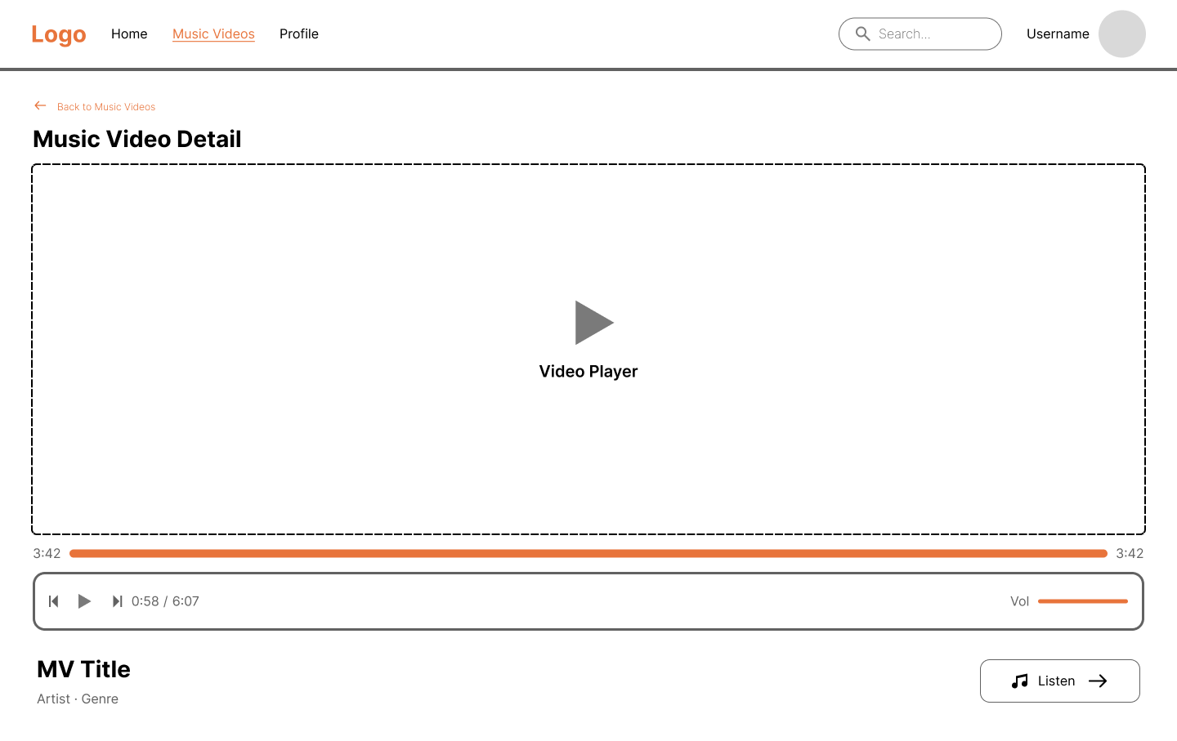
Figure 4 - Music Video Detail wireframe reference

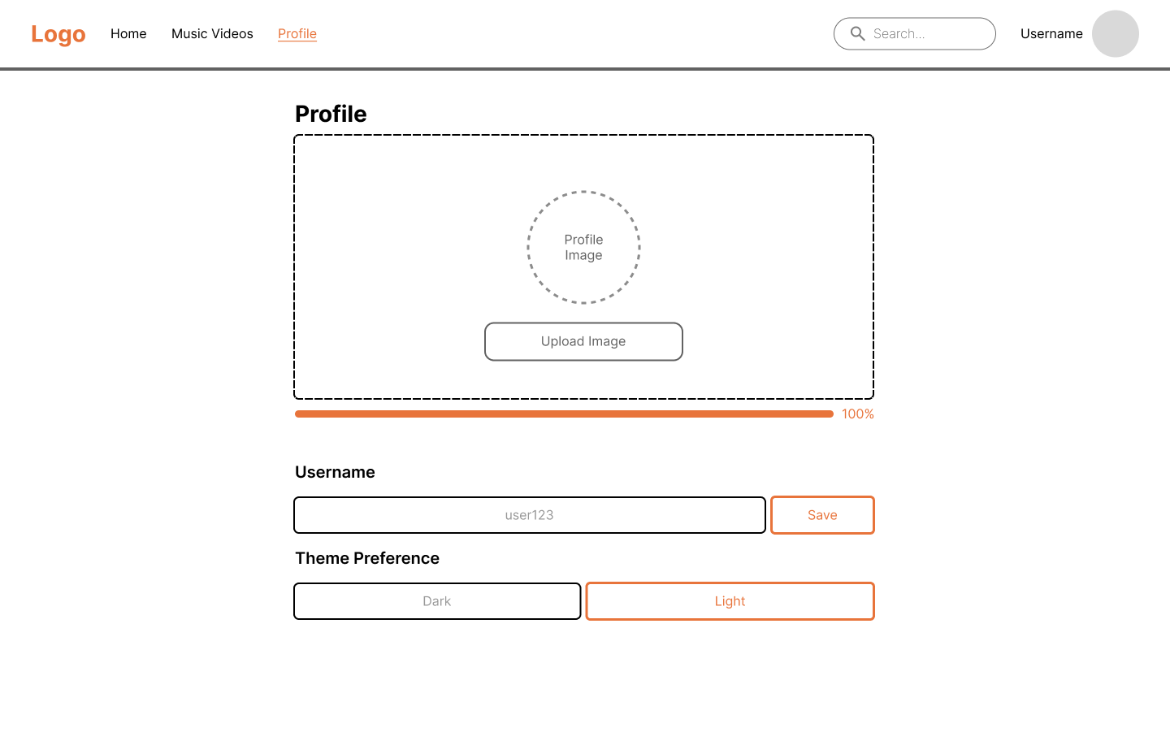
Figure 5 - Profile Page wireframe reference

8. How to Use the Application
- Open the website. You land on the Home Page showing featured + recommended songs.
- Click any song card to open Song Detail. Use the central Play button to start the audio.
- Click the cover image to view it fullscreen, use + / - or scroll wheel to zoom.
- Click "Watch Music Video" to jump to the matching MV detail page.
- Use the top nav to switch to Music Videos or Profile at any time.
- On the Profile page, type a new username and click Save, or click Upload Image to set a profile picture. Toggle Dark/Light to change the theme - it applies everywhere instantly.
- The mini player at the bottom remains visible on every page and keeps controls available.

9. Submission Notes
Before submitting:
- Delete the node_modules folder inside spojedy/.
- Zip the entire spojedy/ folder.
- Submit this documentation file alongside the zip.

