./output/Graph01: test1
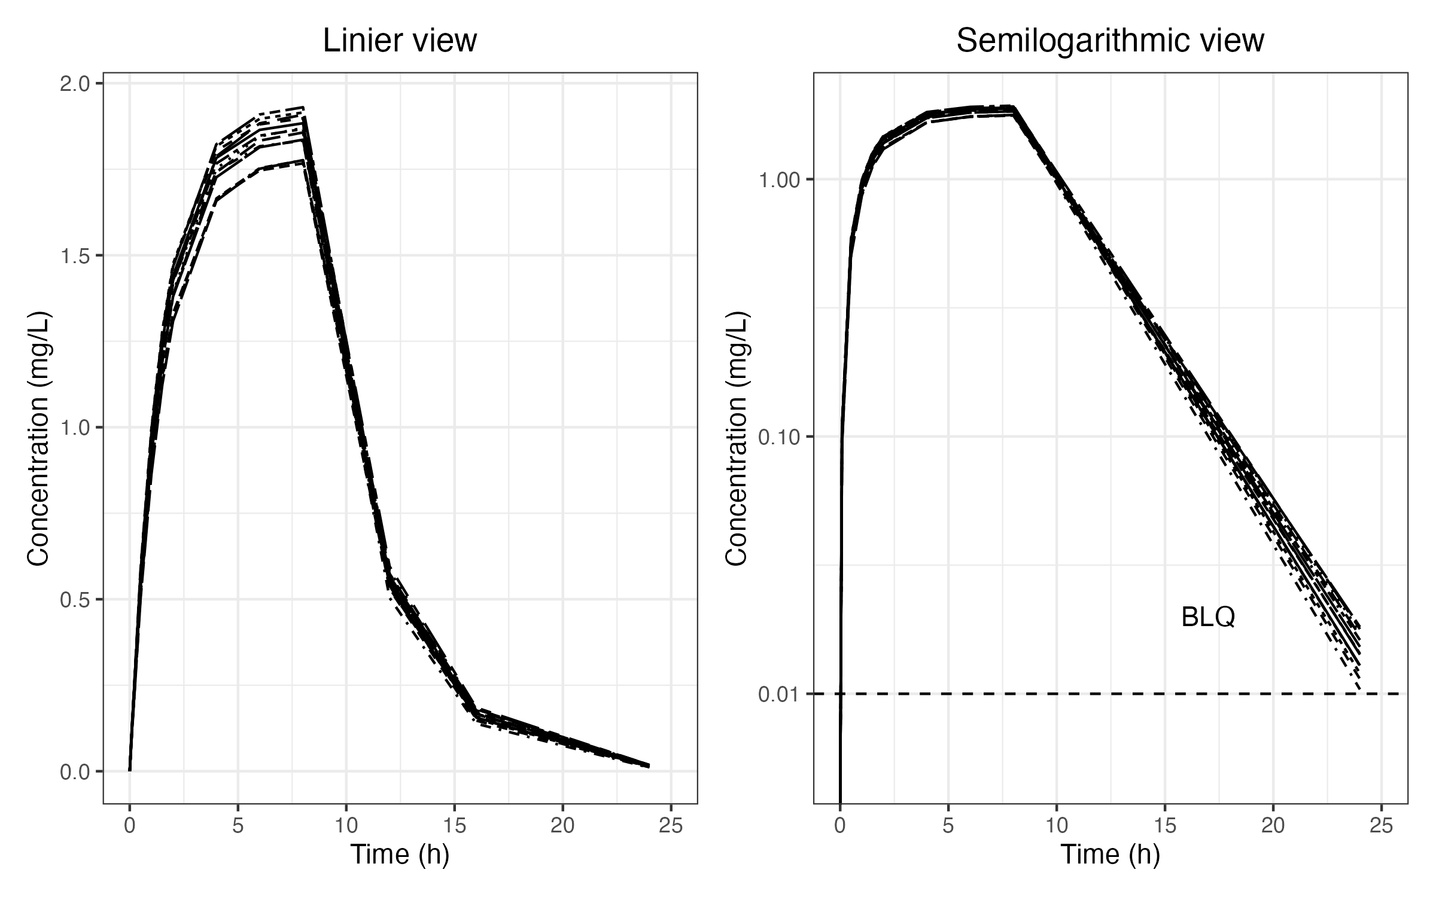
[./output/graph01.rtf][/Applications/quarto/share/rmd/rmd.R] 06FEB2024, 10:13

