Exercise2

Ping tests

Ping test 1:
10 packets transmitted, 10 received, 0% packet loss, time 1840ms
rtt min/avg/max/mdev = 0.316/0.455/0.562/0.064 ms

Ping test 2:
10 packets transmitted, 10 received, 0% packet loss, time 1837ms
rtt min/avg/max/mdev = 0.432/0.517/0.618/0.053 ms

Ping test 3:
100 packets transmitted, 100 received, 0% packet loss, time 100ms
rtt min/avg/max/mdev = 0.347/0.469/0.620/0.047 ms

Ping test 4:
10000 packets transmitted, 10000 received, 0% packet loss, time 4410ms
rtt min/avg/max/mdev = 0.169/0.406/1.992/0.061 ms,
ipg/ewma 0.441/0.406 ms

Ping test 5.1:
1000 packets transmitted, 1000 received, 0% packet loss, time 16062ms
rtt min/avg/max/mdev = 0.321/0.480/0.620/0.045 ms
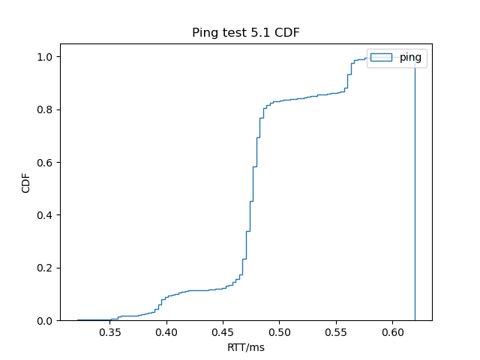
Ping test 5.2:
1000 packets transmitted, 1000 received, 0% packet loss, time 1002ms
rtt min/avg/max/mdev = 0.337/0.466/0.603/0.039 ms

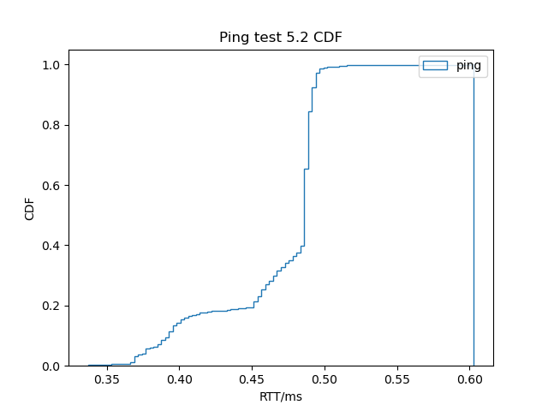
Ping test 5.3:
1000 packets transmitted, 1000 received, 0% packet loss, time 450ms
rtt min/avg/max/mdev = 0.297/0.418/0.613/0.056 ms, ipg/ewma 0.450/0.455 ms

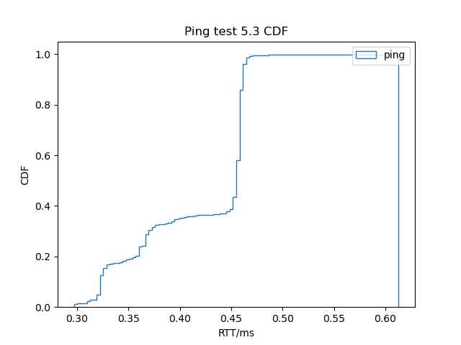
The mean value could be the most accurate parameter.

iperf tests:

test 1:
Transfer: 1.10 Gbytes
Bandwidth: 943 Mbits/sec

test 2:
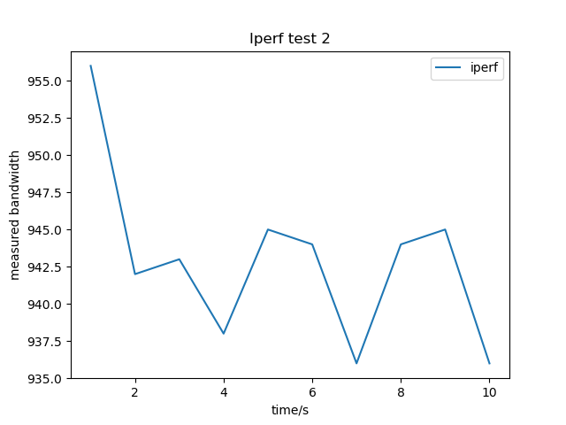

test 3:
The bi-directional iperf test gives:

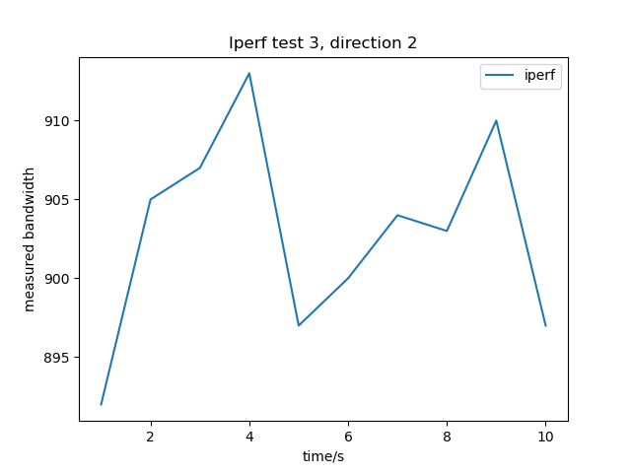

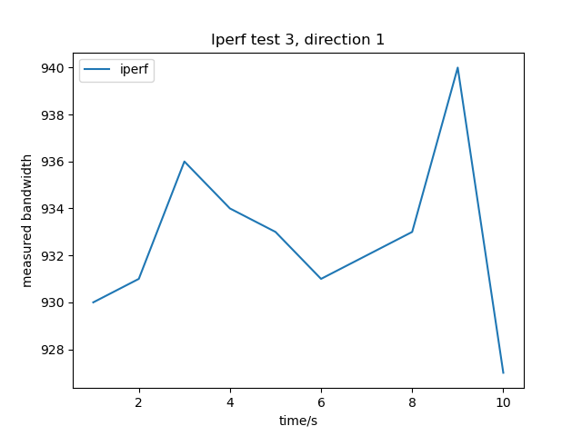

test 4:

For 100Kb/s,
Bandwidth = 102 Kbits/sec
packets dropped: 0%

For 1Mb/s,
Bandwidth = 1.00 Mbits/sec
packets dropped: 0%

For 100Mb/s,
Bandwidth = 100 Mbits/sec
packets dropped: 0%

iperf3 test:

test 1:
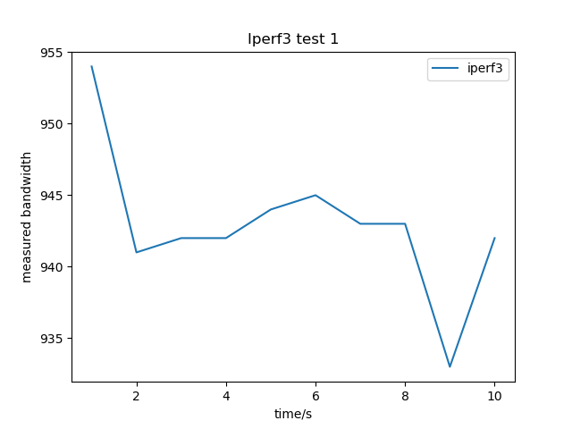

For 100Kb/s,
Bandwidth = 102 Kbits/sec
packets dropped: 0%

For 1Mb/s,
Bandwidth = 1.00 Mbits/sec
packets dropped: 0%

For 100Mb/s,
Bandwidth = 100 Mbits/sec
packets dropped: 0%

link to repo:
https://github.com/Y-J-Xue/CWM-ProgNets

