Assignment 4

The packet 210 is sent from the local machine to the Raspberry Pi, as shown below.
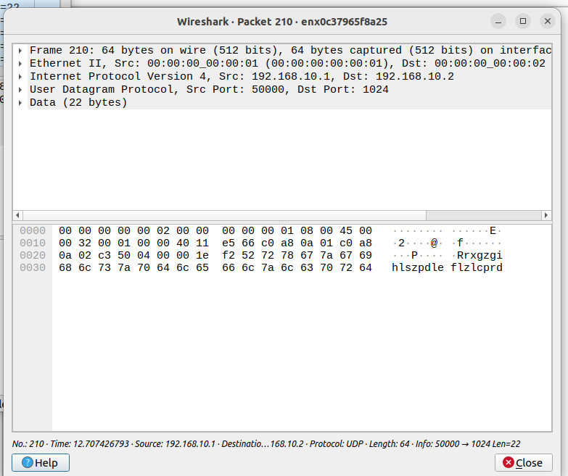

The packet 211 is returned from the Raspberry Pi to the local machine, as shown.
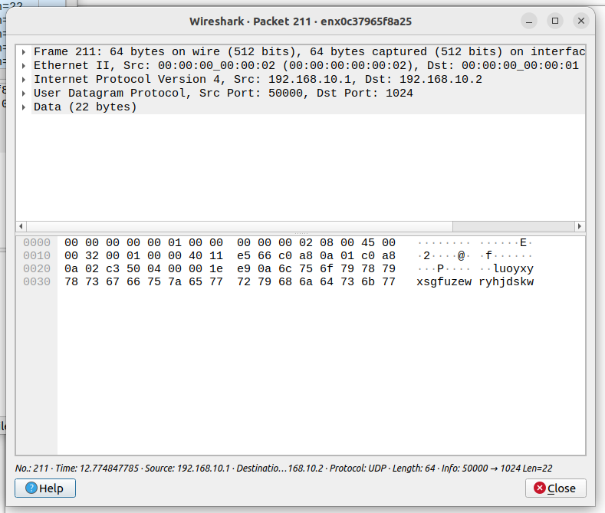

We can add to the table:

table_add MyIngress.src_mac_drop MyIngress.drop 00:00:00:00:00:01 =>

to drop the packets sent from the local machine whose MAC address is 00:00:00:00:00:01.

Link to repo:
https://github.com/Y-J-Xue/CWM-ProgNets

