Segment-wise detection: ground truth vs predicted
Each figure shows the first 25 s of a test recording: its constant-Q spectrogram (top), the ground-truth ornament segments (middle) and the segments predicted by the model (bottom).

1. Before: baseline U-Net (7 classes)
Predictions of the original model, trained on all 7 classes (including Mu and An).

ROD test recordings
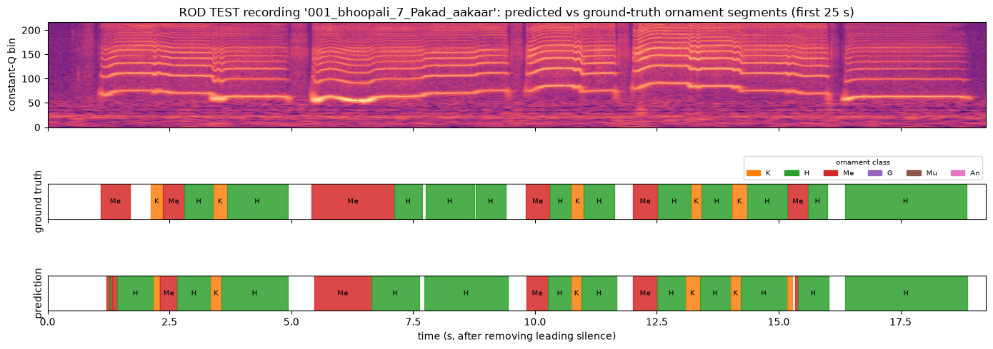
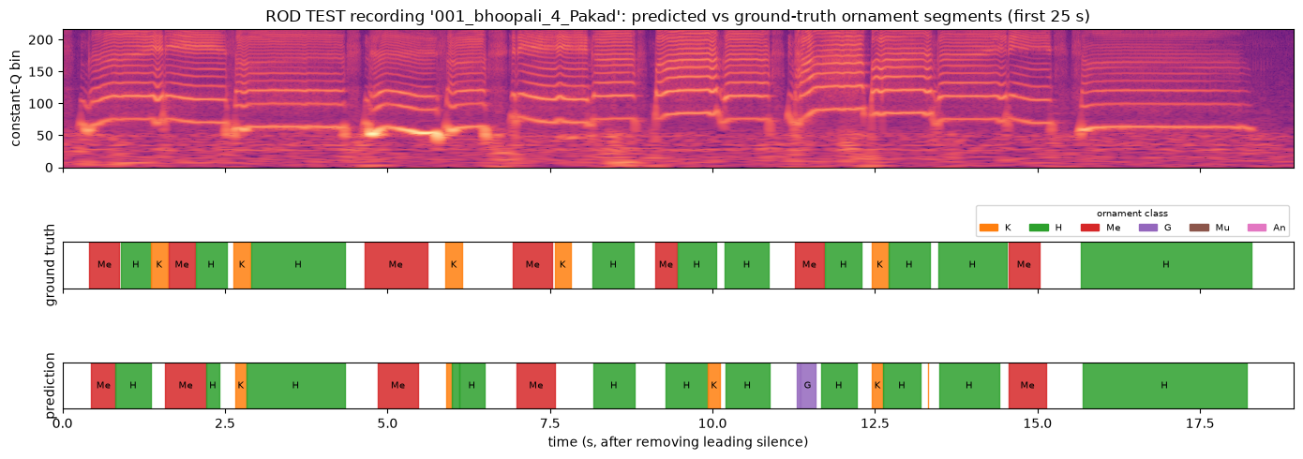
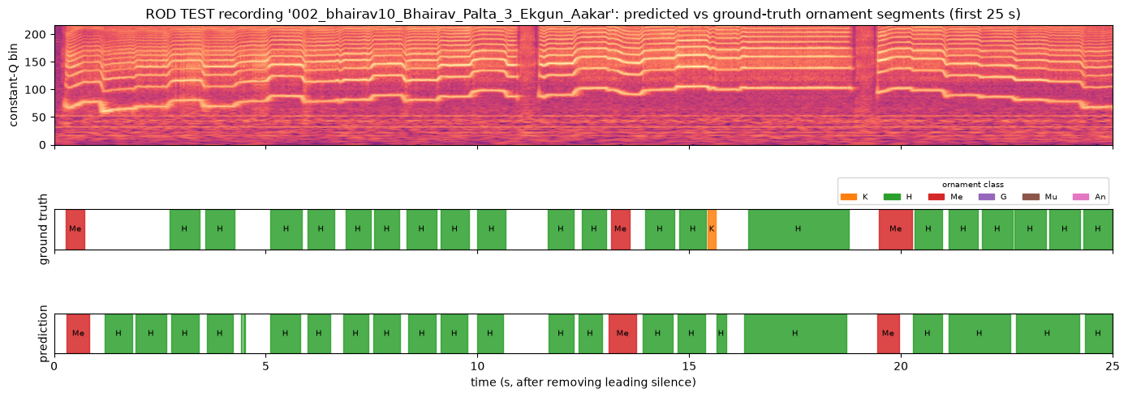

ROD validation recordings
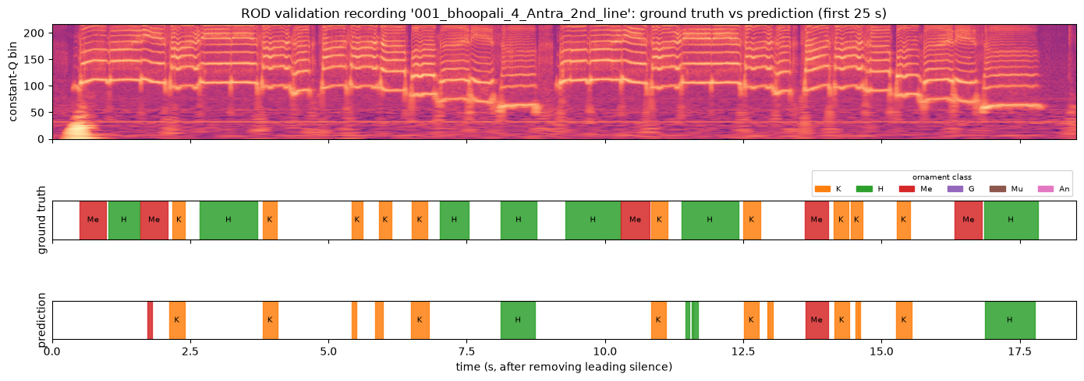
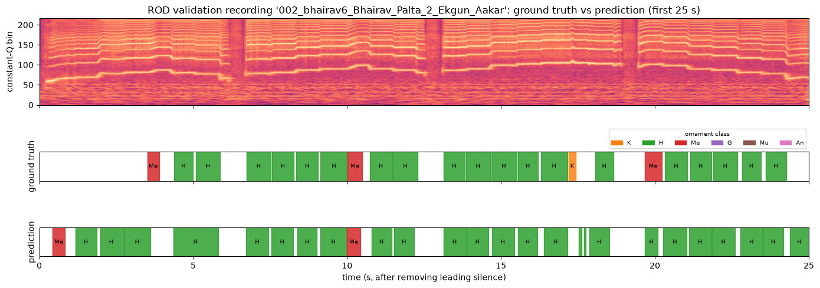

2. After: U-Net + TCN, Mu and An removed
Predictions of the new model on the same test recordings, trained with Mu and An relabelled as none (5 classes).
We wanted the model to see a larger context, so we used dilated convolutions for that: a TCN layer was added at the end of the U-Net.

ROD test recordings
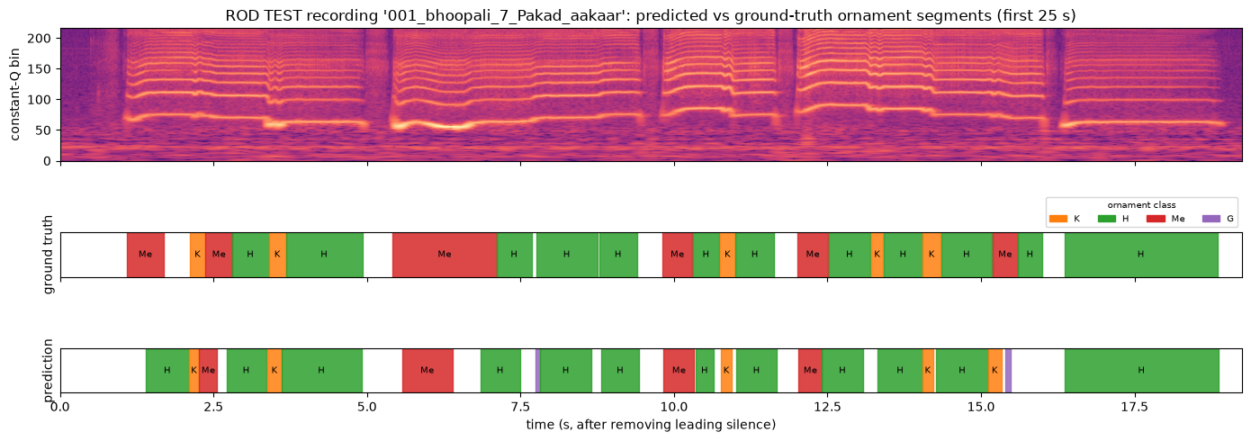
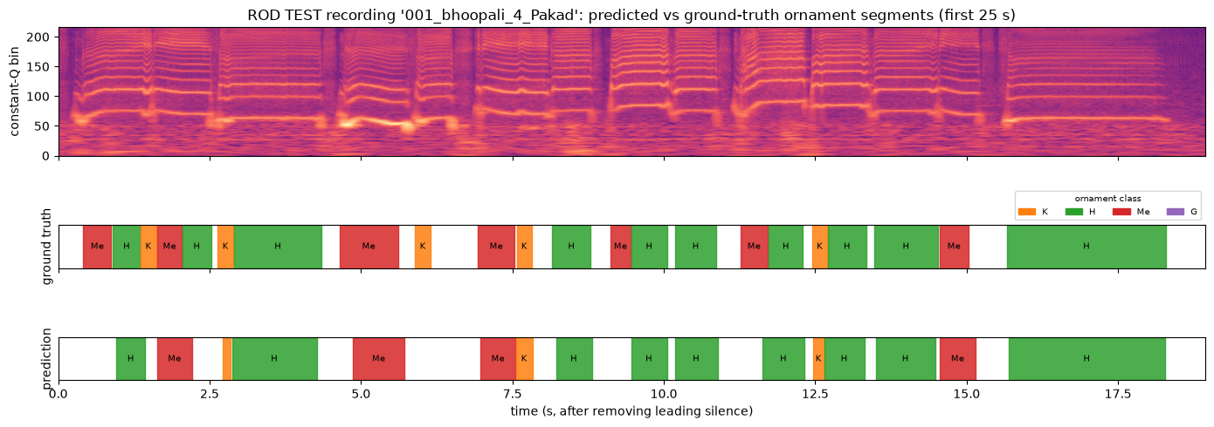
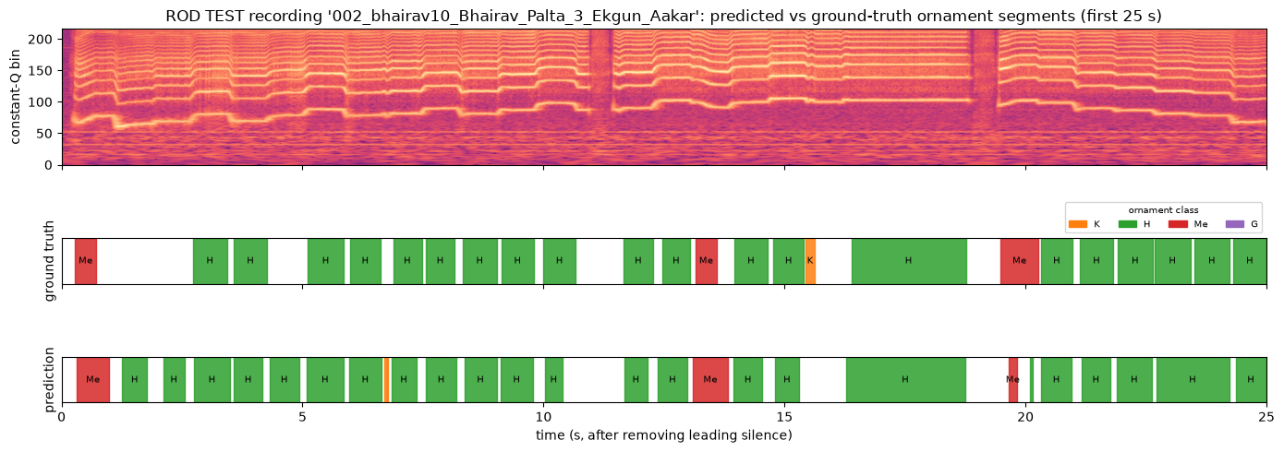

ROD validation recordings


