上海天文馆 · 场馆管理中心
大屏数据可视化平台
UI/UX 设计 · 作品集案例

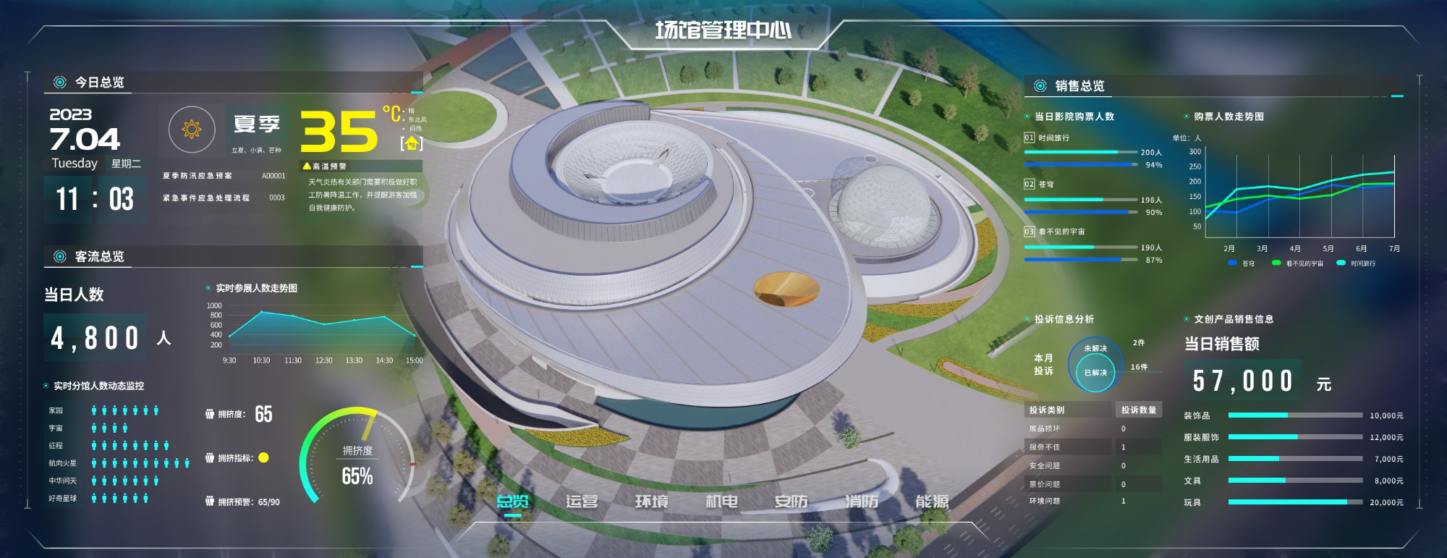
总览页 — 场馆管理中心首页
场馆的运营数据分散在 7 个不同的系统中。这个项目的核心是把它们整合进一个以空间为锚点的统一界面，让管理者快速定位问题。

项目概述
为上海天文馆（上海科技馆分馆）设计的一套大屏数据可视化平台，部署在场馆管理控制中心。系统分为 7 个模块——总览、运营、环境、机电、安防、消防、能源——覆盖了大型场馆日常运营需要关注的主要数据。

角色：UI/UX 设计师
年份：2023

设计思路

用 3D 模型锚定空间，而不是平面地图
场馆有 B1、F1、F2 三个楼层，摄像头、消防设备、机电系统都按楼层和区域分布。平面地图无法同时表达楼层关系和空间位置，而 3D 模型配合左侧的楼层切换控件，可以让每个数据点对应到建筑中的实际位置——让“哪里出了问题”变成一个可以直观看到的事。

为不同数据匹配不同的可视化方式
运营页是客流趋势和票务，环境页是温湿度、噪音等传感器读数，安防页是报警事件和巡逻路线，能源页是能耗的环比同比——每个模块的数据性质差异很大。我为不同类型匹配了对应的可视化方式：趋势用折线图，占比用环形图，状态用色标表格，空间分布标注在 3D 模型上。

大屏场景下的视觉层级
大屏的观看距离远，无法像电脑屏幕一样逐行阅读。关键数字（如当日人数 4,800、本月耗电 138 万 kw.h）需要大字号和高对比度，确保第一时间被捕捉到。设备列表、事件日志等明细信息用较小字号和低对比色退到第二层级。深色背景下的图表配色也需要专门调整，保证颜色之间有足够的辨识度。

左右对称布局，适配大屏的阅读习惯
大屏上的视线路径和手机、电脑不同——先看中间，再往两边扫。对称布局利用了这一点：中间始终是空间概览，两侧始终是数据面板，切换模块时不需要重新适应。左右两侧也天然适合承载不同维度的数据，比如能源页左边是电、右边是水，安防页左边是设备统计、右边是人员和事件。

7 个独立模块，平衡信息量与认知负荷
运营、环境、安防、机电、消防、能源——这些领域之间几乎没有交集，全部放在一个页面信息密度会远超可读极限。拆成 7 个模块后，每个模块只聚焦一个维度，底部导航栏按需切换。总览页作为汇总入口，提供全局快照。

各模块设计详情

总览 — 全局运营状态的快速入口
汇总客流、票务、销售、投诉等核心指标。左侧聚焦人流数据与分馆拥挤度，右侧覆盖票务和商业数据，顶部提供天气信息和应急预案入口。


运营 — 客流、票务与商业数据的交叉呈现
数据类型最丰富的模块，包含实时客流、游客画像、设备租借、投诉分析和文创销售。3D 模型上叠加了热力图，展示各展区的人流密度分布。
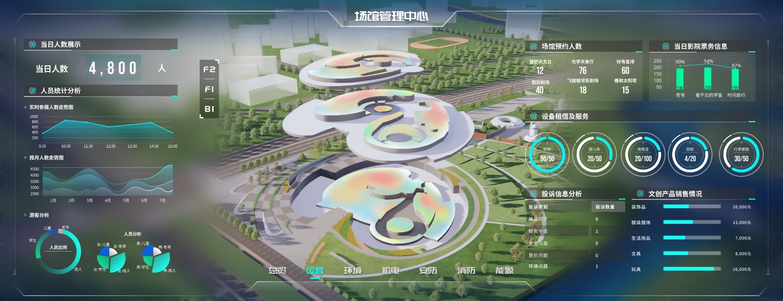

环境 — 按区域监测温湿度、空气与噪音
展示各分区的空气质量、噪音、光照、新风量和温湿度。3D 模型用色块标识不同区域，右侧用大字号突出当前温湿度与预警阈值。
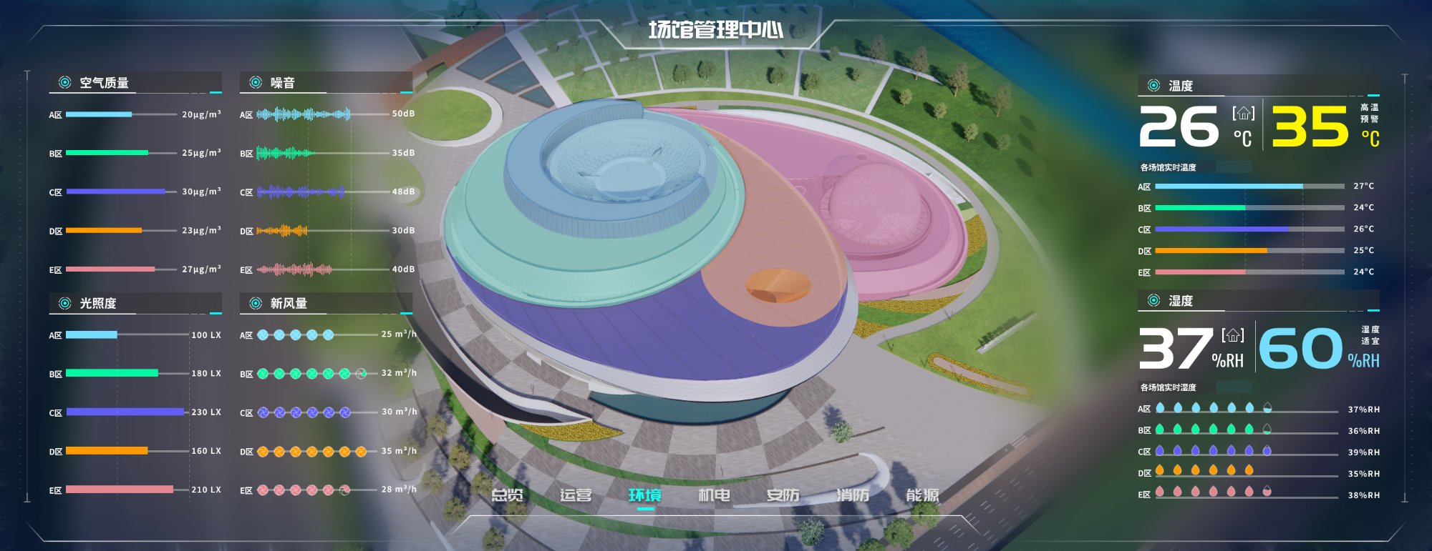

安防 — 设备、空间、人员的三层信息结构
左侧展示停车管理与电子围栏状态，中间 3D 模型标注摄像头和栏杆的空间分布，右侧是巡逻路线、异常事件和安保人员分配。
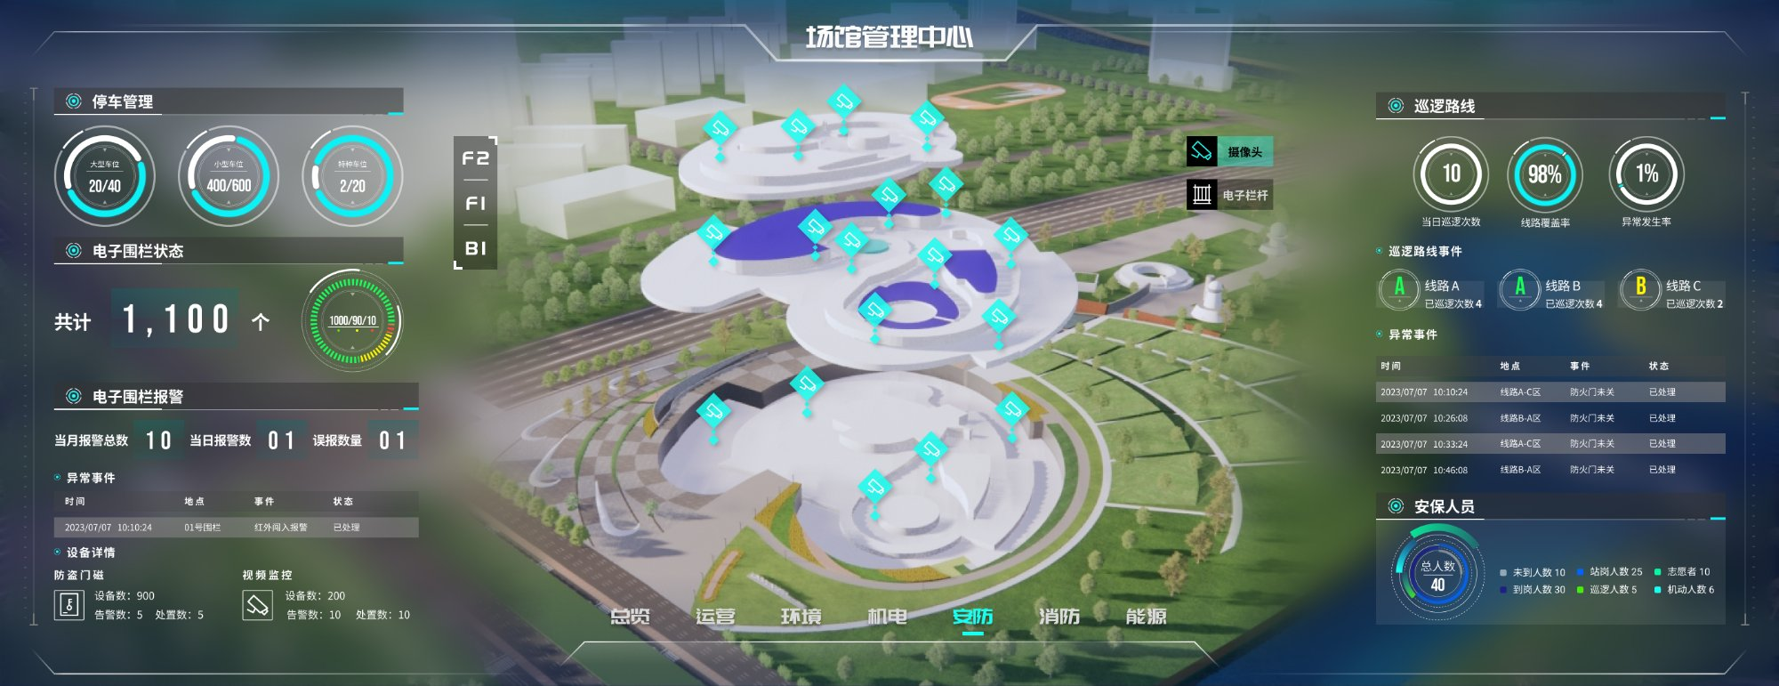

机电 — 五大系统的设备运行状态
给排水、通风、照明、电梯、空调五大系统，按楼层列出设备的运行、检修和年检状态，异常项以红色高亮标记。
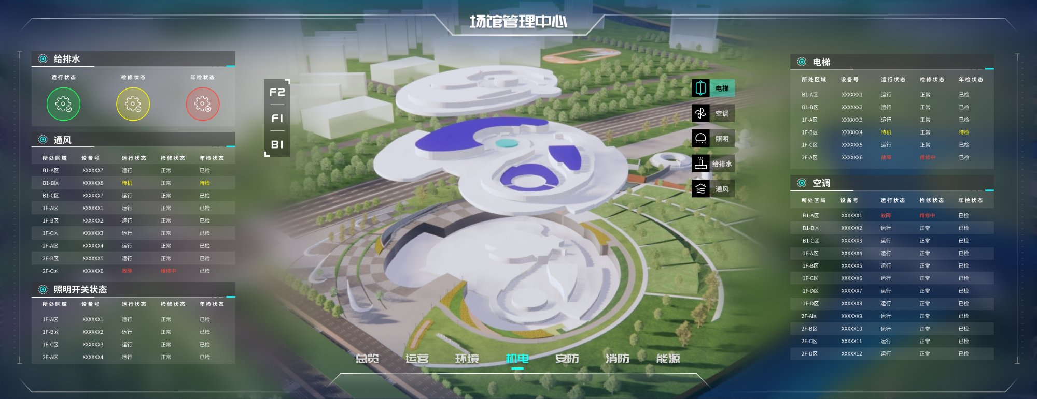

消防 — 警情统计与系统健康监测
左侧展示火警警情统计与消防设施状态，右侧覆盖可燃气体检测和电气线路健康度。系统健康率以仪表盘形式突出显示。
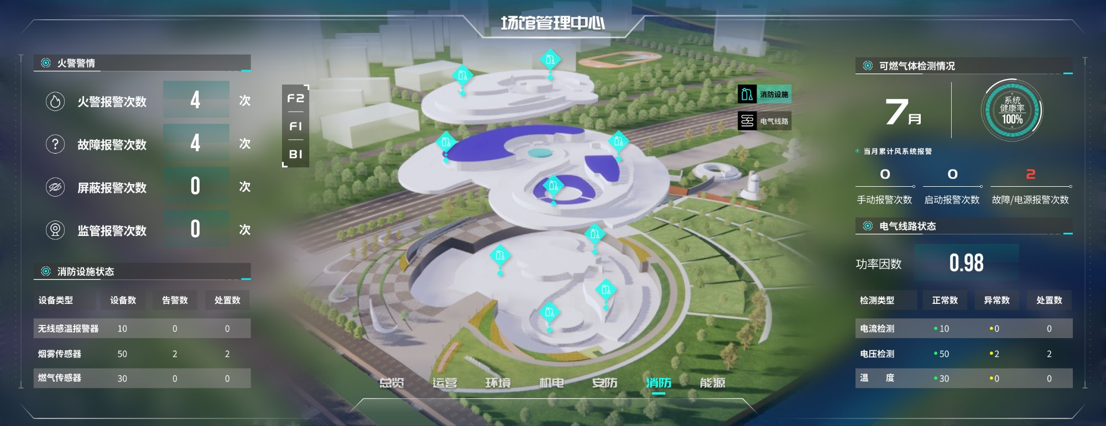

能源 — 用电用水趋势与碳排放追踪
左右对称展示耗电量和用水量的历史趋势、当月总量与环比同比数据，底部的碳排放模块关联了减排指标。
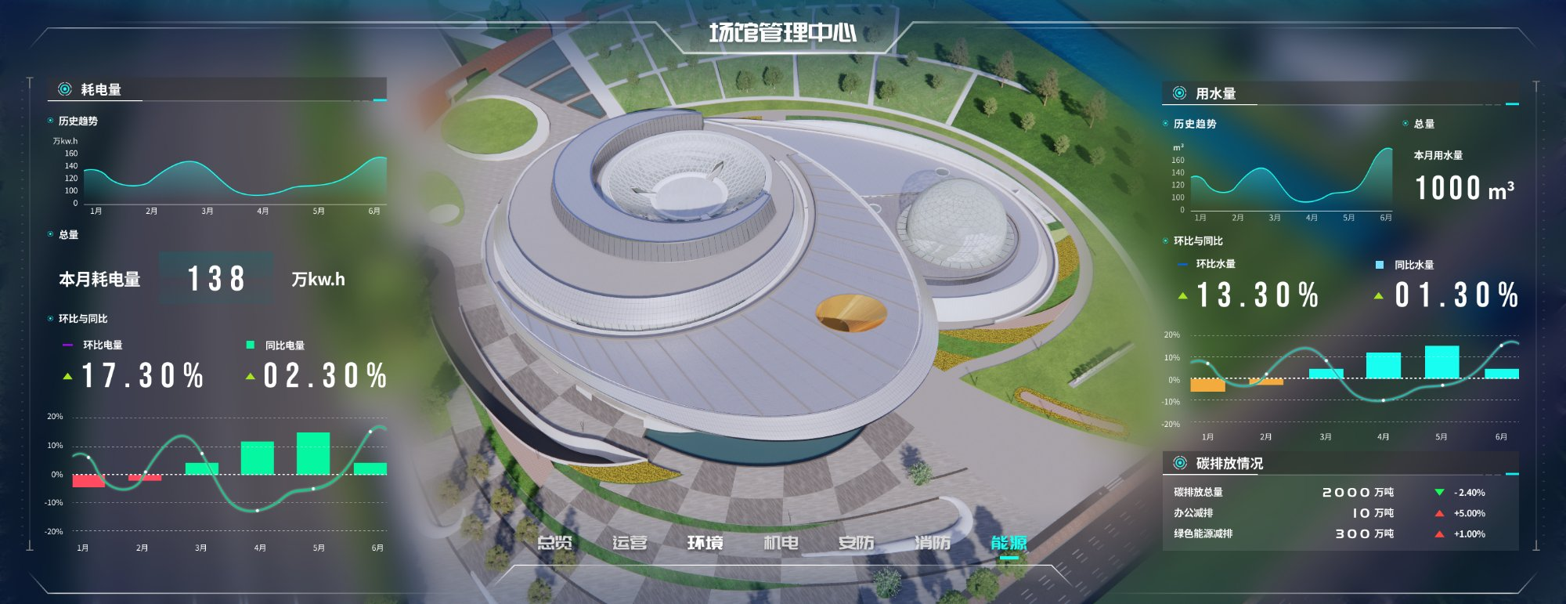

移动端 — 大屏的延伸，从监控到处置
除了大屏端，我还设计了配套的移动端应用。大屏负责全局展示和实时监控，移动端则承担异常推送和现场处置的角色，两者共同构成一个完整的监控响应闭环。

场馆总览与数据查看
移动端同样保留了场馆总览功能：月度客流趋势、分馆拥挤度、影院票务、投诉分析等核心数据可以在手机上随时查看。信息结构针对小屏幕做了重新组织，从大屏的左右对称布局调整为纵向卡片式排列。
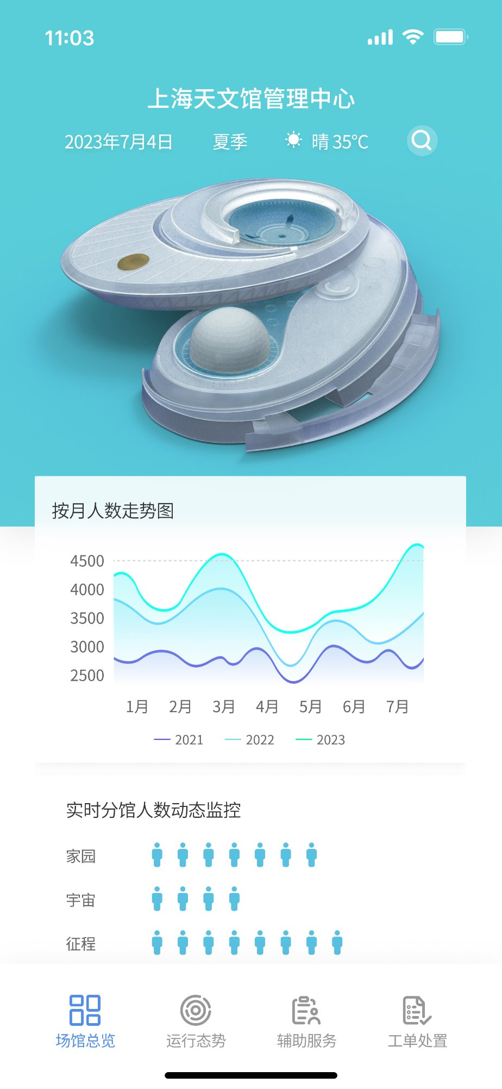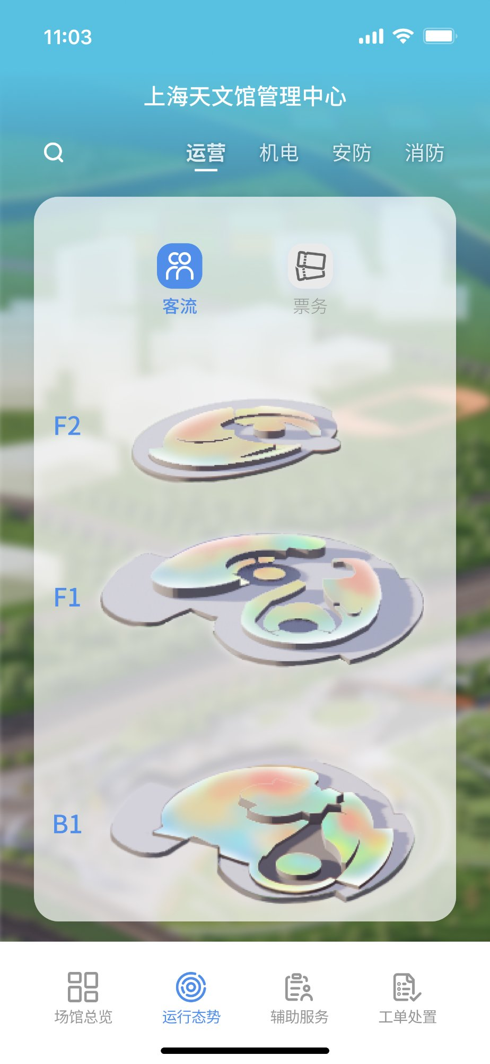

异常推送与处置流程
当系统检测到异常（如某区域拥挤超过阈值），移动端会收到实时推送通知。管理人员点击通知后可以看到：异常发生的具体位置（在 3D 模型上标红）、事件详情列表（时间、地点、事件、处理状态），以及系统生成的处理方案建议。确认处理后，状态会同步更新到大屏端。
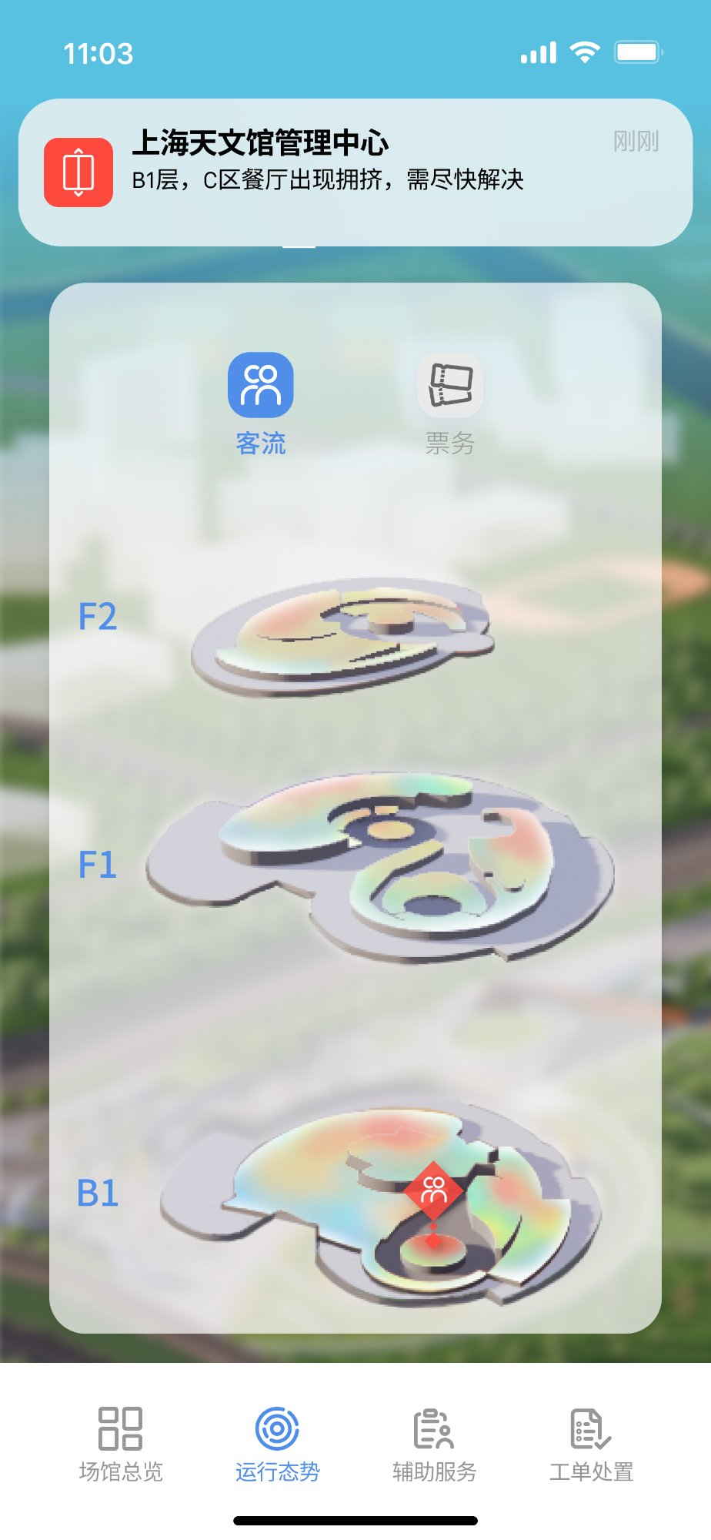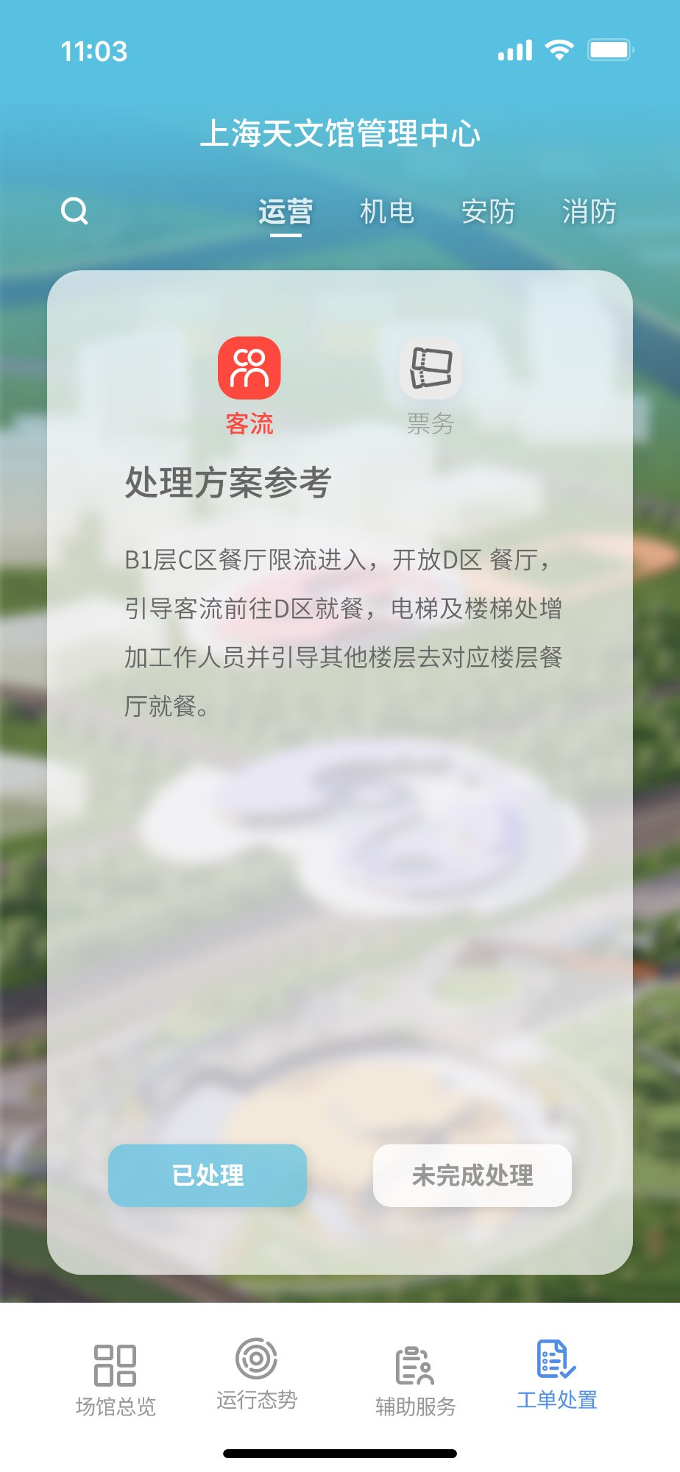

Shanghai Astronomy Museum
Venue Management Dashboard
UI/UX Design · Portfolio Case Study


Overview Dashboard — Venue Management Center
The museum’s operational data was spread across 7 separate systems. This project was about bringing it all into one spatially-anchored interface where problems could be spotted at a glance.

Background
The Shanghai Astronomy Museum is one of China’s largest and most-visited science museums, with multiple exhibition halls, theaters, and public facilities spread across a large campus.
The management team needed a centralized way to monitor visitor flow, building systems, security, and energy usage—all from a single large-format display in the control room.

My Role
Role: UI/UX Designer
Year: 2023
I designed the entire system end-to-end: the large-screen dashboard with 7 functional modules, plus a companion mobile app for alert response and on-the-go data access.

Design Thinking

Anchoring data to physical space with a 3D model
The museum spans three floors (B1, F1, F2), with cameras, fire sensors, and HVAC units distributed across all of them. A flat map can’t express floor relationships and spatial positions simultaneously. The 3D model, paired with a floor-switching control, ties each data point to its physical location—making it immediately clear where an issue is in the building.

Matching each data type to the right visualization
The 7 modules each deal with fundamentally different data: visitor trends, sensor readings, alarm events, equipment status, energy comparisons. Rather than applying one template across the board, I matched each to the visualization that fits best—line charts for trends, ring charts for proportions, color-coded tables for status, annotated points on the 3D model for spatial distribution.

Visual hierarchy for large-screen viewing
The dashboard is viewed from several meters away—you can’t read it like a webpage. Key metrics (4,800 daily visitors, 1.38M kWh monthly electricity) need oversized typography and high contrast to register immediately. Secondary details like device logs and event tables recede with smaller type and muted colors. The dark background also required careful color calibration to keep charts legible.

Symmetrical layout for predictable scanning
On a large screen, the eye naturally goes to the center first, then out to the sides. A symmetrical layout leverages this: center is always the spatial view, sides are always data panels. Switching modules doesn’t require relearning the layout. The two sides also naturally separate data dimensions—electricity vs. water for Energy, device stats vs. personnel events for Security.

7 focused modules instead of one dense screen
Operations, environment, security, mechanical, fire, energy—these are fundamentally different domains with little overlap. Combining them on one screen would exceed readable limits. Seven modules, each focused on one dimension with a shared navigation bar, balance completeness against cognitive load. The Overview page serves as the consolidated entry point.

Module Walkthrough

Overview — Real-Time Operational Snapshot
The landing page aggregates the most critical KPIs: real-time and monthly visitor trends, sub-venue crowding with a congestion index, ticket sales, complaint tracking, and merchandise revenue. Weather and emergency protocol links at the top round out the full-picture view.


Operations — Multi-Dimensional Visitor Intelligence
The most data-rich module: real-time visitor flow, demographic breakdowns, reservations, equipment rentals, complaint analysis, and merchandise sales. A heat map overlaid on the 3D model shows crowd density across exhibition zones.


Environment — Zone-Level Conditions at a Glance
Air quality, noise, illumination, fresh air volume, temperature, and humidity—broken down by zone. Color-coded areas on the 3D model provide spatial orientation; oversized typography on the right highlights current readings and alert thresholds.


Security — Three Layers: Devices, Space, Personnel
Left panel: parking and electronic fence status. Center: camera and barrier gate locations on the 3D model. Right panel: patrol routes, anomaly events, and security staff allocation—structured as three progressive layers from devices to space to personnel.


Mechanical & Electrical — Five Systems, One View
Five building systems—water supply, ventilation, lighting, elevators, HVAC—listed by floor with operating, maintenance, and inspection status. Anomalies are highlighted in red for immediate identification.


Fire Safety — Alarm Stats Meets System Health
Left: fire alarm statistics and facility status. Right: combustible gas detection, ventilation alerts, and electrical circuit health. A gauge prominently displays the overall system health rate.


Energy — Consumption Trends and Carbon Tracking
Symmetrical layout with electricity on the left and water on the right, each showing trend charts, monthly totals, and MoM/YoY comparisons. A carbon emissions section at the bottom connects energy data to sustainability metrics.


Mobile Companion — From Monitoring to Response
Beyond the large-screen dashboard, I also designed a companion mobile app. The dashboard handles global display and real-time monitoring; the mobile app handles alert delivery and on-site response. Together, they form a complete monitoring-to-action loop.

Venue overview and data access
The mobile app retains key overview data: monthly visitor trends, sub-venue crowding levels, theater ticket sales, and complaint analysis—all accessible on the go. The information architecture was reorganized for the small screen, shifting from the dashboard’s symmetrical side-by-side layout to a vertical card-based flow.


Alert push and incident handling
When the system detects an anomaly (e.g., crowding exceeds a threshold in a specific zone), the mobile app delivers a real-time push notification. Tapping the alert shows: the exact location highlighted in red on the 3D model, an event log with timestamps and status, and a system-generated response recommendation. Once the operator confirms resolution, the status syncs back to the main dashboard.


