Rare alleles increase genome-wide in a hybrid zone

Youri Lammers

Introduction

Hybrid zones can provide valuable information on the genetics of different species, adaptation and speciation under identical environments (Hewitt 1988). Certain interesting patterns arise in hybrid zones, one of these is the ‘rare-allele phenomenon’, where a certain allele is found in higher frequencies in the hybrid zone compared to the parental populations (Barton et al. 1983, Barton et al. 1985, Woodruf 1989).

The cause for these rare alleles is reproductive isolation. Mutation-order speciation can produce different sets of alleles in populations under similar conditions (Nosil et al. 2011, Schluter 2009). The formed alleles can be beneficial for a certain population, but might cause reproductive isolation when combined in hybrids. Any gene variant that can increase the fitness of these hybrids will be favored in the hybrid zone. The frequency of such a gene variant, and any marker, even very rares ones, linked with it, will increase in the hybrid zone, thus resulting in rare alleles (Hoffmann et al. 1995, Schilthuizen et al. 1999, Schilthuizen et al. 2001).

In non model organisms it can be difficult to find speciation genes, linked regions that have distinct patterns, such as the rare allele phenomenon, can potentially simplify the search for these speciation genes by focusing the search on these patterns rather than genes themselves. Next-generation sequencing methods can be used to sequence and compare specimens from hybrid zones so that these rare alleles and speciation genes can be discovered.

The two Albinaria hippolyti subspecies A. h. aphrodite and A. h. holtzi live on Crete. These subspecies differ in morphology and have diverged DNA. Both subspecies meet along a 10km long narrow (20-260m wide) hybrid zone. For this hybrid zone it is known that several markers show the rare allele phenomenon (Schilthuizen & Lombaerts 1995). With next-generation sequencing large part of the Albinaria hippolyti genome can be scanned for the rare alleles and speciation genes.

Material and methods

Illumina sequencing and SNP detection

A total of 15 individuals were sampled from the A. h. aphrodite – A. h. holtzi hybrid zone (5 individuals for each parental population and 5 hybrid individuals). The samples were collected based on morphology. The QIAGEN DNeasy Blood & Tissue kit was used to extract DNA for each sample.

A reduced representation of the entire genome was created by digesting the genomes with MspI. From the digest +/- 250bp long fragments were selected for Illumina sequencing.

First one individual was sequenced on the Illumina GAIIx with both paired-end sequencing (2* 50bp long reads) and single-end sequencing (100bp long reads). With the CLC Genomics Workbench (version 4.5) these reads were de novo assembled into contigs (minimum size for a contig was set to a 100bp). This resulted in 425.424 contigs. This set of contigs was further filtered by coverage (minimum 20 reads) and length (less than 250bp, since that was the maximum length of the fragments that were sequenced), a final set of 103,176 contigs was obtained which would act as a reference sequence for the remaining 14 samples.

The remaining individuals were sequenced on an Illumina GAIIx machine with 100bp long single-end reads and were aligned against the reference sequence with the CLC Genomics Workbench. The contigs that were sequenced by all individuals were saved. This resulted in a set of 100,317 contigs with a total length of 13.88 x 10⁶bp, about 1% of the entire Albinaria genome.

The CLC Genetics Workbench was used to obtain SNPs for the 15 sequenced individuals. The settings used for the SNP detection were: SNPs were selected if they had a coverage between 20 and 1000 reads, matched the expected ploidy of 2 and if the called SNP was present in more than 1% of the reads.

The set of SNPs was filtered so that only the SNPs remained that appeared on contigs that were fully sequenced in all the individuals. A list of genotypes was created for the hybrid and parental samples based on the SNP frequencies that were found for each individual.

Based on the difference in allele frequencies between the SNP markers of the hybrid and parental populations the rare alleles where selected. A SNP marker was called a rare allele if the frequency difference between the hybrid and parental population was larger than 50%.

Mass SNP genotyping

801 live Albinaria hippolyti specimens were collected from 17 sample sites in Crete. The sampling sites where located along two transects through the hybrid zone, at each sampling site 13-86 live specimens were collected and several empty shells for morphological identification. Live specimens were stored in pure ethanol.

For each individual DNA was extracted by cutting a 1 mm³ section from the foot muscle and placing it in a 5% Sigma Chelex ® 100 solution. The solution was placed in a 100ºC water bath for 5 minutes and spun at 14,680 rpm for five minutes. The top 50μl was pipetted off and the DNA concentration was measured with a Nanodrop® ND-1000 Spectrophotometer. The DNA extracts were diluted with H₂O to obtain a 5 ng/μl solution.

For the Sequenom genotyping two sets of primers where required, PCR primers and extension primers. The software package MassARRAY Typer Assay Designer (version 4.0.0.2) was used to design both sets of primers for the selected markers. Because the Sequenom retrieves the genotype data based on a mass-spectrum analysis, primers that are similar in mass can cause miss-called genotypes. To avoid this, primers with a similar mass can be placed in different arrays, so that each array has a set of non interfering markers.

For each array the PCR reaction was run in a Biosystems GeneAmp® PCR 9700 machine. After amplification the phosphate groups were removed from 5’ end of the amplicons, thus preventing the products from ligating. The iPLEX extension reactions were run for each sample and salts that might influence the Sequenom run were removed from the samples with resin.

The samples were spotted on a 384 sample Sequenom chip with the Samsung – Sequenom NanodispenserS, along with calibration material for the Sequenom. The filled chip was placed in the Bruker – Sequenom Massarray Compact Analyzer, where the mass-spectrums were obtained for each sample.

Results from the sequenom were analyzed with Sequenom MassARRAY Typer – Typer Analyzer (version 4.0.22.67) software package. For every primer the sample genotypes were manually checked, and based on the mass-spectra, genotype calls were edited where necessary. All samples that had a primer failure rate higher than 50% were excluded from further analysis.

Statistics

The Sequenom genotypes were compared with the expected Illumina genotypes. The results were scored based on the number of Sequenom alleles that matched with the rare allele Illumina data. For each matching allele 50 points were scored (minimum of 0 points, for a homozygote sample with no matching alleles and a maximum of a 100 point in case of a homozygote sample with 2 matching alleles).

The statistics package R (version 2.13.1) was used to analyze the markers. For each marker 3 unpaired student T-tests (p < 0.05) were performed to compare the hybrid group with A. h. holtzi group, the hybrid group with the A. h. aphrodite group and the A. h. holtzi group with the A. h. aphrodite group. Each comparison was tested for significance. A strict Bonferroni correction (N = 104) was applied on the results from the multiple tests.

[hier gebleven] Results

The SNP detection based on the sequence assemblies of the 15 individuals produced a total of 36,897 SNP positions for the 100,317 contigs. The SNP markers with a rare allele frequency that was 50% higher in the hybrid samples then in the parental samples were selected as rare allele candidates, this produced 1,451 candidates. Graph 1 shows the number of SNPs found for the allele differences 50-100% between the hybrid and parental groups.

From the set of 1,451 rare allele markers, 57 markers were selected for Sequenom primer design. In order to avoid mass-spectronomy interference the markers were divided into two arrays, the first array contained 33 SNPs and second array 24 SNPs.

For 633 out of the 801 samples the Sequenom produced at least one array with reliable results, for each of these samples the number of rare alleles was determined for each marker by comparing the measured genotypes with the Illumina genotypes.

For the 57 markers tested, 52 markers gave the predicted genotypes. The remaining 5 markers either gave no results (for example due to a failing primer) or showed no variation throughout the samples. The 5 failing markers where removed from the dataset and not used for the statistical analysis.

Based shell morphology the 17 sampling sites where divided into three groups: A. h. aphrodite, A. h. holtzi and a hybrid group.

For each of the 52 markers the Sequenom results were compared between the 3 groups with an unpaired Student’s T-test and a strict Bonferroni correction was applied on the results. Out of the 52 markers, 37 markers (71%) showed a significant difference between the hybrid populations and the parental population. Table 1 shows the results for the statistical analysis. The obtained rare allele frequencies for the 52 markers are graphically displayed in graph 2.

Discussion

With the Sequenom SNP genotyping we managed to get usable SNP genotypes for 52 of the 57 tested markers. The 5 markers that failed either gave no genotypes or gave no variation. Primer failure (either failing PCR primers or extension primers) can explain the lack of genotypes found for some of the markers. Proper testing of primers can prevent these issues. However, due to time constraints this was not possible. Markers that resulted in no variation are probably caused by miscalled SNPs and rare alleles. A more thorough SNP analysis and inspection of the selected markers (coverage, based on the number of individuals, quality of the SNP bases) might prevent these miscalls from happening.

Only 633 out of the 801 analyzed samples produced at least one array of usable genotypes, for the remaining 168 samples the overall quality of the mass-spectra was too low to reliably predict genotypes. The cause for the low quality spectra is probably the DNA extraction method used, the Chelex extraction method is a relatively “dirty” extraction method, the lack of a high quality DNA extract could limit the PCRs and Sequenom genotyping. The Chelex method was picked over other methods such as the QIAGEN extraction method because it allows for faster extractions.

Because rare alleles are either located on or linked to speciation genes, looking for rare alleles can be a clever way to discover these speciation genes in non model organisms. Based on the obtained results we can calculate that for the 1% of the Albinaria hippolyti there are about a thousand potential rare alleles, this means that there must be several thousand rare alleles across the entire genome. Next-generation sequencing is powerful way to quickly scan a genome for these markers and thus making the search for speciation genes a lot less labor intensive.

A downside is that it might be difficult to find the linked gene or region for these rare alleles in non model organisms. One of the goals for this project was to come up with a list of speciation genes that were linked to the SNP markers, but lacking a well annotated reference genome made this impossible without additional research. When a decent reference is available the rare allele method is a viable and quick way to scan a genome for speciation genes.

References

- Barton, N. H., Halliday, R. B. & Hewitt, G. M. Rare electrophoretic variants in a hybrid zone. Heredity 50, 139-146 (1983).
- Barton, N. H. & Hewitt, G. M. 1985. Analysis of hybrid zones. Annu. Rev. Ecol. Syst. 16, 113-148 (1985).
- Hewitt, G.M. Hybrid zones – Natural laboratories for evolutionary studies. Tree, 3,158-167 (1988).
- Hoffmann, S. M. G. & Brown, W. M. The molecular mechanism underlying the ‘rare allele phenomenon’ in a subspecific hybrid zone of the California field mouse, Peromyscus californicus. J. Mol. Evol. 41, 1165-1169 (1995).
- Nosil, P. & Flaxman, S. M. Conditions for mutation-order speciation. Proc. R. Soc. Lond. B 278, 399-407 (2011).
- Schilthuizen, M. & Lombaerts, M. Life on the edge: a hybrid zone in Albinaria hippolyti (Gastropoda: Clausiliidae) from Crete. Biol. J. Linn. Soc. 54, 111-138 (1995).
- Schilthuizen, M., Hoekstra, R. F. & Gittenberger, E. Selective increase of a rare haplotype in a land snail hybrid zone. Proc. R. Soc. Lond. B 266, 2181-2185 (1999).
- Schilthuizen, M., Hoekstra, R. F. & Gittenberger, E. The ‘rare allele phenomenon’ in a ribosomal spacer. Mol. Ecol. 10, 1341-1345 (2001).
- Schluter, D. Evidence for ecological speciation and its alternative. Science 323, 737-741 (2009).
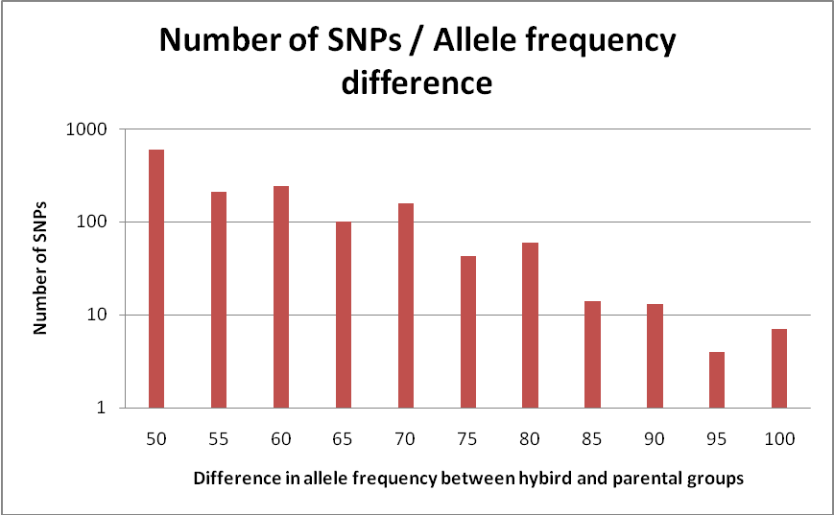
- Woodruff, D. S. Genetic anomalies associated with Cerion hybrid zones: the origin and maintenance of new electromorphic variants called hybrizymes. Biol. J. Linn. Soc. 36, 281-294 (1989).

Graph 1. The number of SNPs found for the allele difference between the hybrid and parental groups.

SNP | t-test hol-hyb after strict Bonferroni | t-test aph-hyb after strict Bonferroni | significant signal of rare allele increase?
10005 | 2,288E-14 | 2,288E-14 | yes
10275 | 0,105248 | 1,5236E-06 | no
1029 | 9,52848E-07 | 2,288E-14 | yes
10416 | 0,558792 | 0,00138112 | no
10450 | 0,00059332 | 6,18072E-09 | yes
1060 | 1,7472E-06 | 0,103012 | no
11319 | 1,07432E-05 | 2,288E-14 | yes
11319#2 | 1,61824E-08 | 2,288E-14 | yes
12711 | 1,25632E-05 | 4,93064E-08 | yes
12782 | 62,192 | 1,872E-11 | no
13006 | 1,42688E-05 | 2,288E-14 | yes
1301 | 12,2824 | 8,28672E-11 | no
14512 | 0,00188032 | 4,32224E-06 | yes
14640 | 2,288E-14 | 2,288E-14 | yes
17380 | 8,83584E-10 | 2,51056E-09 | yes
1980#2 | 2,288E-14 | 2,288E-14 | yes
20412 | 0,000119392 | 1,73264E-07 | yes
223035 | 2,288E-14 | 2,288E-14 | yes
223149 | 2,288E-14 | 2,288E-14 | yes
223308 | 2,288E-14 | 0,109616 | no
223308#2 | 9,43592E-14 | 9,46608E-14 | yes
223543 | 2,288E-14 | 2,288E-14 | yes
223543#2 | 5,17504E-14 | 2,288E-14 | yes
224209 | 2,288E-14 | 2,288E-14 | yes
224466 | 5,24992E-07 | 7,05432E-08 | yes
226085 | 4,12256E-07 | 2,4284E-11 | yes
226831 | 2,288E-14 | 2,288E-14 | yes
226890 | 8,65384 | 2,288E-14 | no
227824 | 2,288E-14 | 2,288E-14 | yes
228575 | 75,0984 | 1,12944 | no
231551 | 0,0572624 | 1,72952E-07 | no
231734 | 3,46216E-10 | 1,09824E-12 | yes
24389 | 5,15424 | 1,7992 | no
24674 | 6,49584E-13 | 3,95304E-13 | yes
255747 | 2,288E-14 | 2,288E-14 | yes
257820 | 2,7092E-11 | 2,288E-14 | yes
259590 | 4,49176E-14 | 2,288E-14 | yes
260898 | 3,64728E-09 | 8,20768E-05 | yes
261335 | 2,288E-14 | 2,288E-14 | yes
261335#2 | 2,36912E-12 | 2,288E-14 | yes
261613 | 93,7664 | 2,288E-14 | no
263777 | 1,76696E-05 | 6,35128E-07 | yes
265618 | 0,0279448 | 0,020488 | yes
266722 | 0,000473616 | 2,10496E-05 | yes
266722#2 | 2,288E-14 | 2,288E-14 | yes
267641 | 6,83592E-11 | 2,288E-14 | yes
267857 | 1,3936 | 0,230152 | no
267857#2 | 25,5008 | 20,332 | no
268553 | 41,4232 | 5,79384 | no
269155 | 2,53656E-05 | 6,60192E-06 | yes
270178 | 3,36752 | 0,0511264 | no
275664 | 7,2488E-13 | 2,288E-14 | yes

Table 1. The T-test results for the 52 markers tested

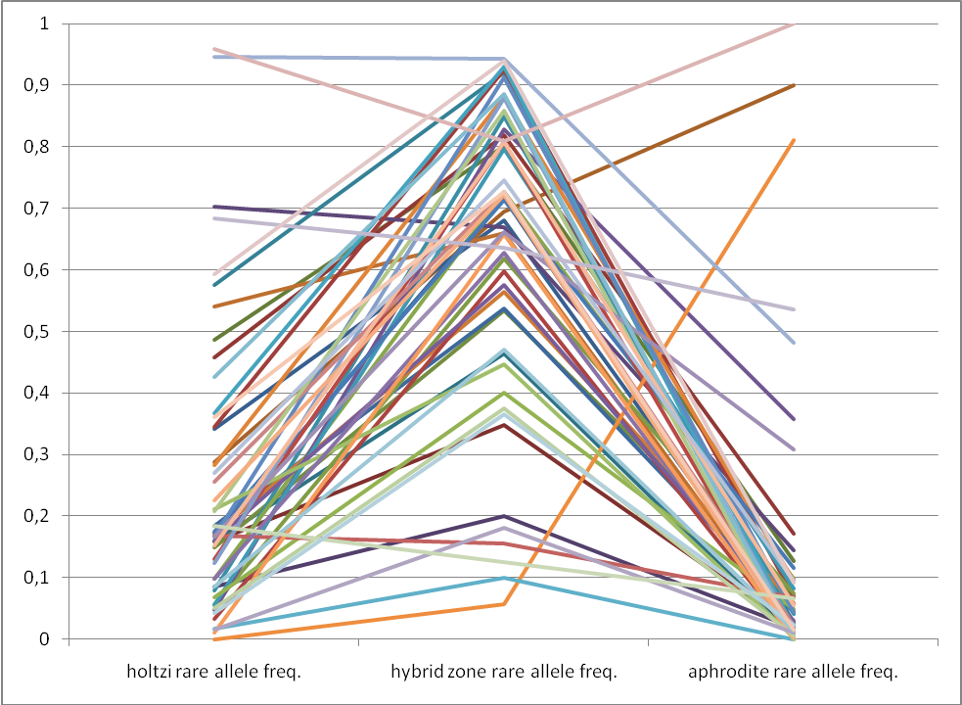
Graph 2. The rare allele frequencies for the 52 tested markers through the 3 groups

