Start:

Before executing the file “Server.py” configure the “configuration.ini” file.
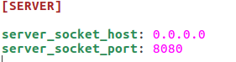

server_socket_host is set to “0.0.0.0” to automatically assign the server to its machine IP.

The received data from the requester have several restrictions:

Phone Number:
Must be at least four digits long and containing only numbers.

Text Message:
Accept everything but null value. In case you wanted to set the language detection to Auto, the message must be at least three letters long to be accepted.

Repetition Number:
Accept only integer numbers. The value must eight or below.
“Check code line 245 in the Server.py file to edit this condition”
Language:
If you chose to manually insert the language of the message. The text to speech API will enforce that language regardless of the message content. For example, a text message written in English, with “fr” in the language bar. Will result in the message being read in French accent , and not translated to French.
The language parameter can accept only the available languages by Google Translate.
If you want the language to be detected automatically, insert “auto” in the language field. However in this case your text message must be three letters long minimum in order for its language to be detected by the system.

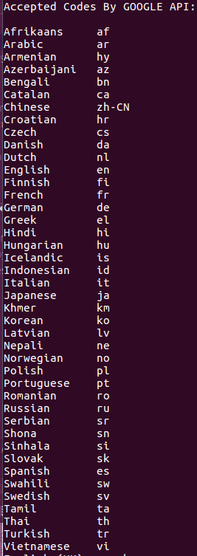

Google Translate API will be adding languages in the future, so if there is a newly supported language that is needed to be added. Edit the language code list in the file |(Server.py) by inserting the language name and code.

Media:

The media folder contains audio files that could be categorized as dynamic and static.
The dynamic WAV files are always being replaced by the message content.
Whenever a request is being accepted by the system, the text message is converted into speech, which is saved as an MP3 file in the media folder. Then converted to WAV file of 24000Hz sample rate using “sox”.
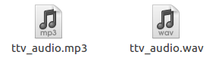

The file (ttv_audio.wav) will be the one played when the receiver answers the call.
The static WAV files are not to be moved or renamed.
-(gratitude_de.wav), (griatiude_en.wav), (gratitude_fr.wav):
Are played after the recipient has pressed one or two. The system will choose one depending on the language. Default is English.
-(options_de.wav), (options_en.wav), (options_fr.wav):
The options_xx.wav file is played after the message is fully played. “Please press 1 to confirm the message, press 2 to decline, or press 3 to repeat the message”
-(note.wav):
Tone played whenever the recipient presses a digit.
-(tone.wav):
Tone played after the message is played. It works as a break between the message and the options question audio file.
-(silence_0.6.wav):
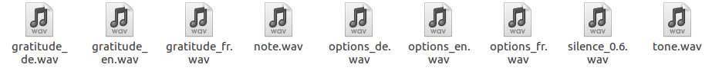
When the message is going to be played more than once. There will be a 0.6 silence in between.
Please note that the Pjsua (SIP library) requires the audio files to have these properties in order to be able to play them:
- Channels : 1
- Sample Rate : 24 KHz
- Precision : 16-bit
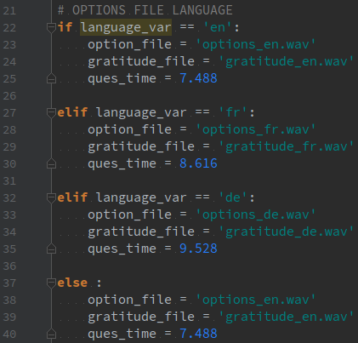
To modify the question option and replace media file, make sure to edit the (quest_time) variable with the new audio file duration.

