



**John Doe**

HAS SUCCESSFULLY COMPLETED

***AI PRIMER WORKSHOP***

ORGANIZED FOR ACME Corporation

DECEMBER 15 - 16, 2024

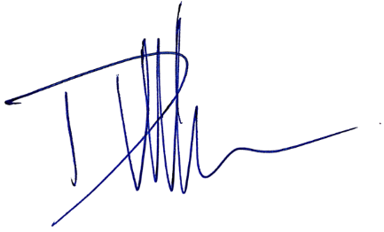 DOMINIQUE ROSE VAN-WINTHER

CEO & CHIEF AI EVANGELIST FINAL UPGRADE AI