



**Ally Farah**

HAS SUCCESSFULLY COMPLETED

***AI PRIMER WORKSHOP***

ORGANIZED FOR JEBSEN GROUP

AUGUST 7 – 8 , 2025

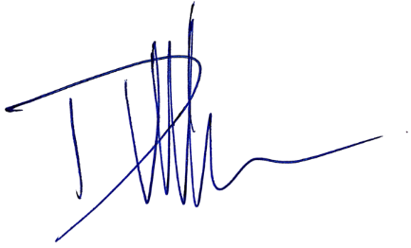 DOMINIQUE ROSE VAN-WINTHER

CEO & CHIEF AI EVANGELIST FINAL UPGRADE AI