**Current Trends in Software Engineering**

**SE4010**

Week 10 Lab

IT19132310

Hettiarachchi L.S

**Task 01**

Docker login

**Task 02**

Docker run nginx server

Edit index.html using interactive terminal

Delete the Docker container

**Task 03**

Clone git repository

Building Docker image

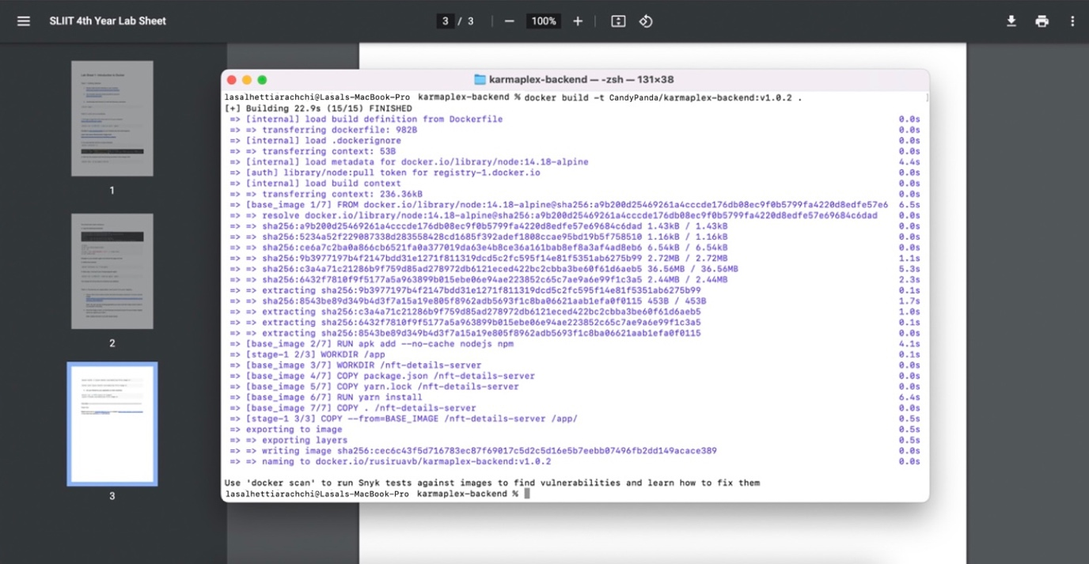

Push image to Docker Hub

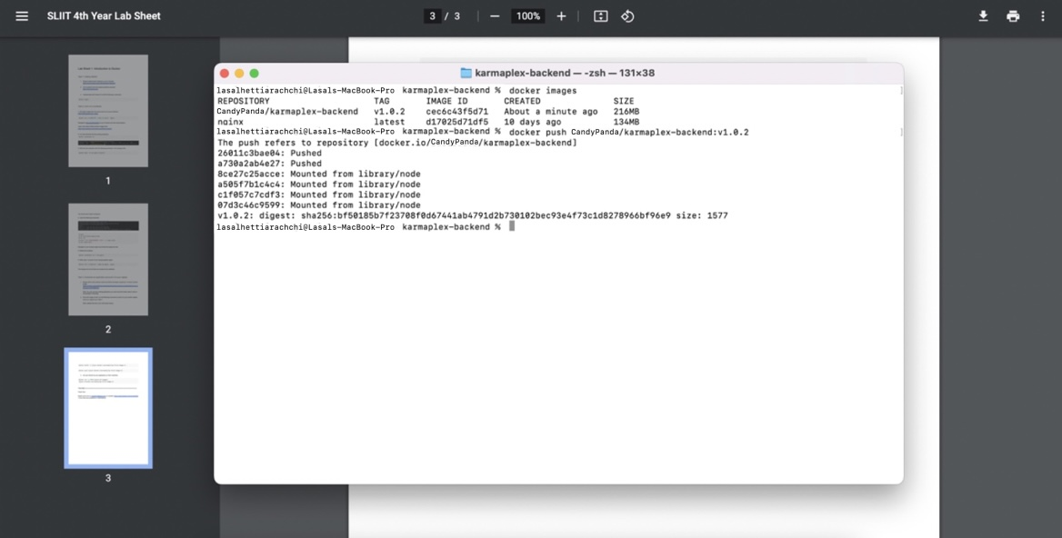

Run the pushed Docker container

