**Current Trends in Software Engineering**

**SE4010**

Week 11 Lab

IT19132310

Hettiarachchi L.S

# Task 01 – Create Kubernetes Cluster

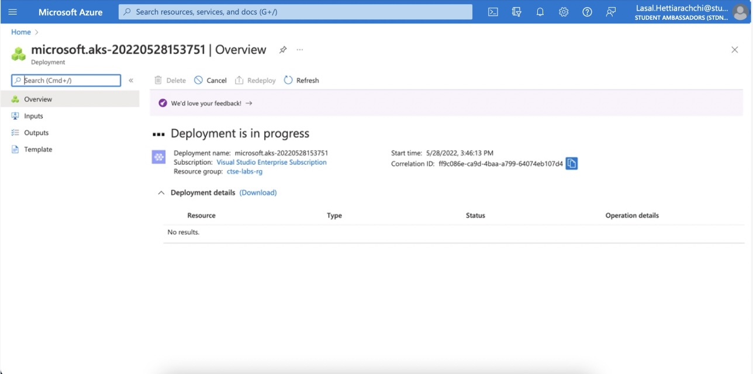

# Task 02 – Running a Po

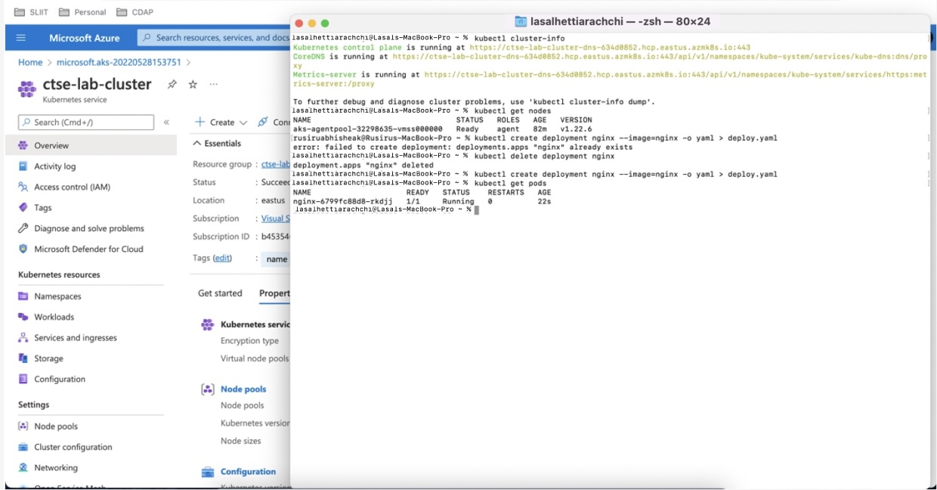

# Task 3 – Update the deployment

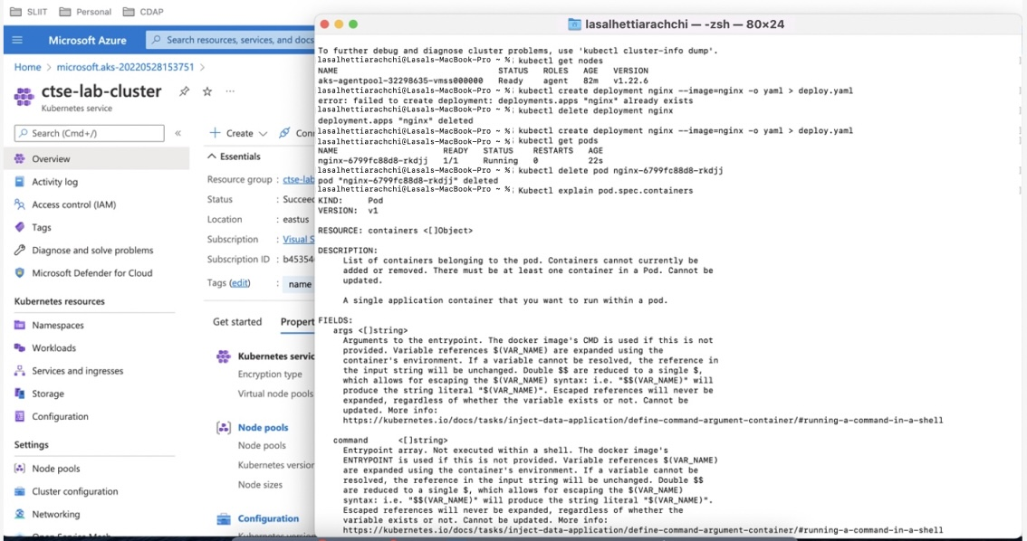

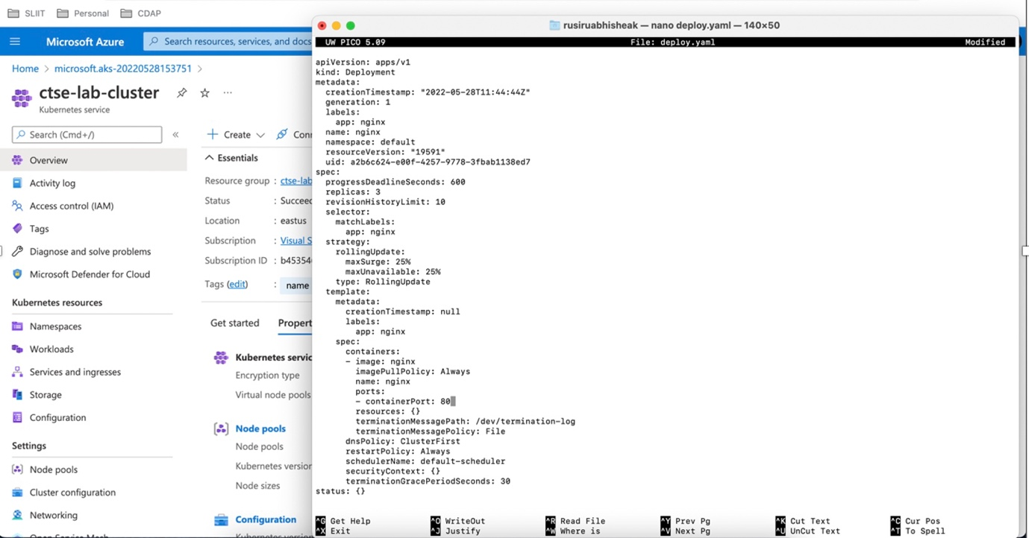

# Task 4 – Deploy as a service

