March 1, 2025

**WORK EXPERIENCE CERTIFICATE**

This is to certify that Ms. Rutika K. Sonawane (B.Arch) has been associated with our firm as an Architect and Project Manager. Our firm is engaged in a diverse range of commercial and hospitality projects.

In her role, Ms. Sonawane has consistently demonstrated punctuality, promptness, and proficiency in managing the responsibilities assigned to her. Her technical skills and professional conduct have contributed positively to the projects she has been involved in.

This certificate is issued to acknowledge her contributions to the firm from January 2023 to December 2024, during which her performance has been satisfactory and in line with our expectations.

Ms. Sonawane continues to remain affiliated with our firm and is currently involved in select ongoing projects.

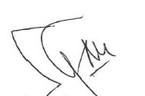

Suprio Ghosh

Malgrat Procurement Services Pvt Ltd.