7. Use (a) Linear Layout (b) Relative Layout and (c) Grid Layout or Table Layout

a. Linear Layout

activity.xml:

|  |
| --- |
| <?xml version="1.0" encoding="utf-8"?>  <LinearLayout xmlns:android="http://schemas.android.com/apk/res/android"  android:layout_width="match_parent"  android:layout_height="match_parent"  android:paddingLeft="16dp"  android:paddingRight="16dp"  android:orientation="vertical" >  <EditText  android:layout_width="match_parent"  android:layout_height="wrap_content"  android:hint="@string/app_name" />  <EditText  android:layout_width="match_parent"  android:layout_height="wrap_content"  android:hint="@string/app_name" />  <EditText  android:layout_width="match_parent"  android:layout_height="0dp"  android:layout_weight="1"  android:gravity="top"  android:hint="@string/app_name" />  <Button  android:layout_width="100dp"  android:layout_height="wrap_content"  android:layout_gravity="right"  android:text="@string/app_name" />  </LinearLayout> |

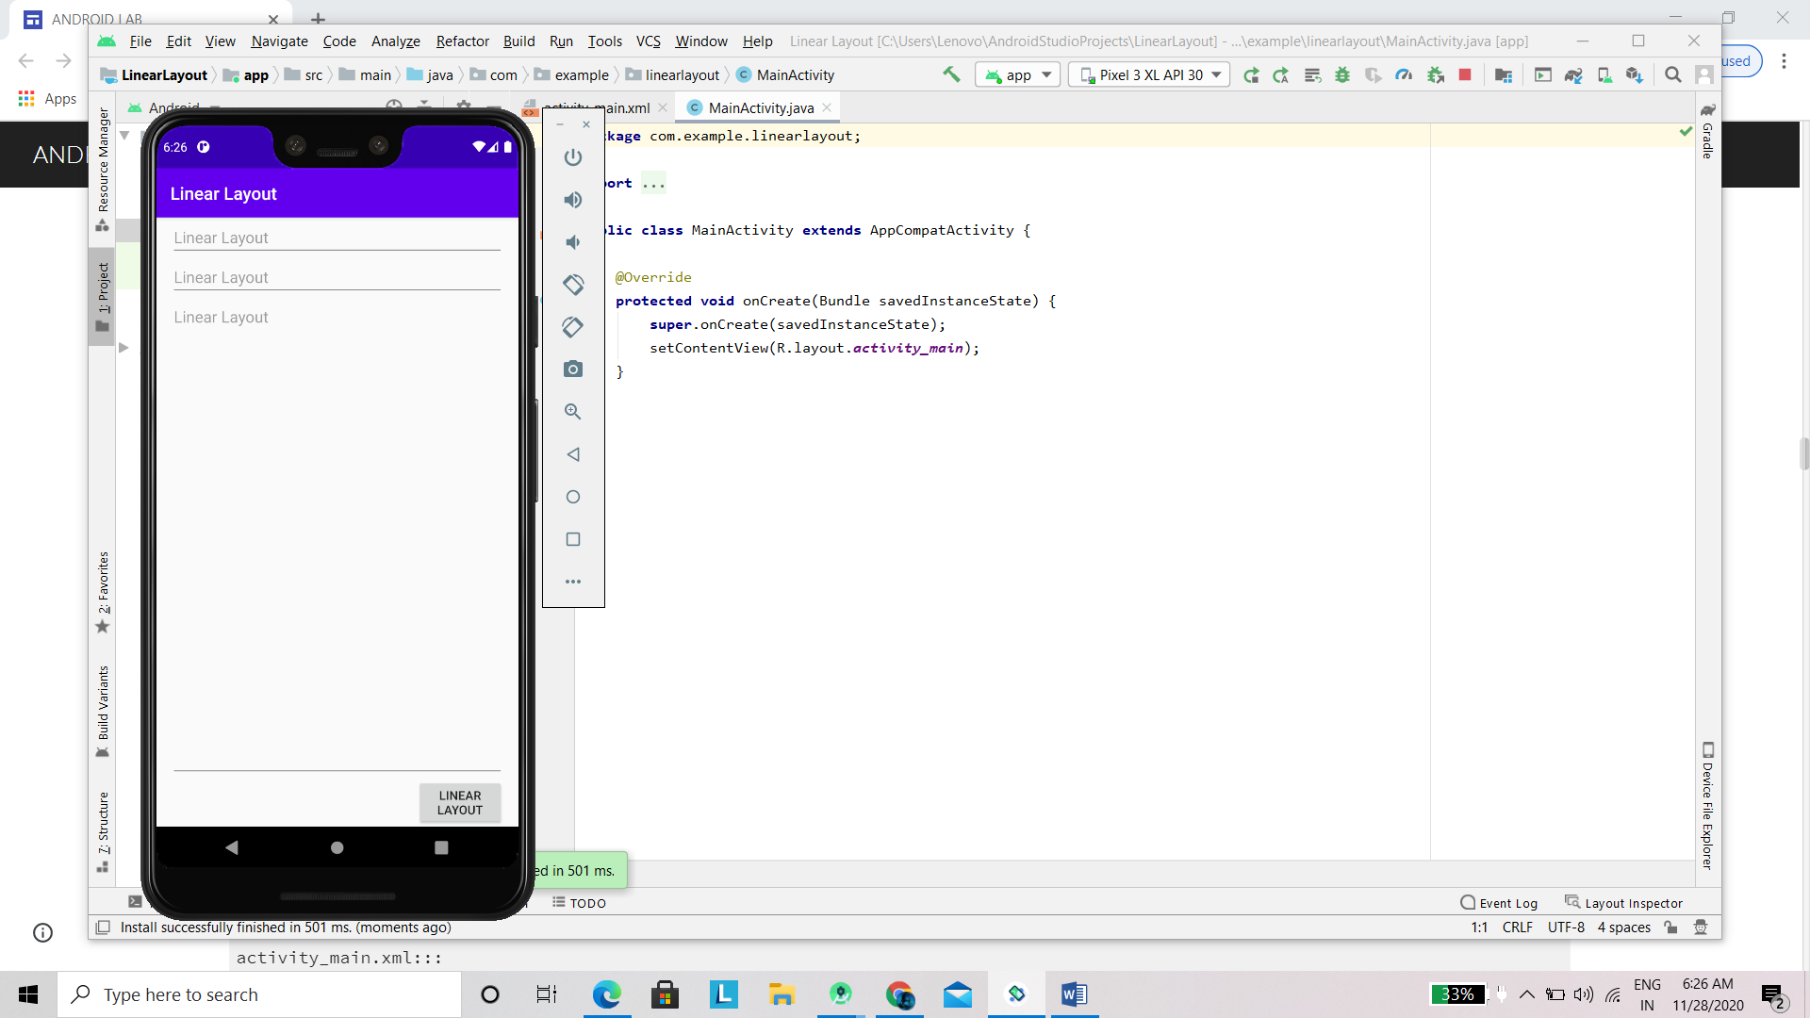

b.Relative Layout:

|  |
| --- |
| <?xml version="1.0" encoding="utf-8"?>  <RelativeLayout xmlns:android="http://schemas.android.com/apk/res/android"  android:layout_width="match_parent"  android:layout_height="match_parent"  android:paddingLeft="16dp"  android:paddingRight="16dp" >  <EditText  android:id="@+id/name"  android:layout_width="match_parent"  android:layout_height="wrap_content"  android:hint="@string/app_name" />  <Spinner  android:id="@+id/dates"  android:layout_width="0dp"  android:layout_height="wrap_content"  android:layout_below="@id/name"  android:layout_alignParentLeft="true"  android:layout_toLeftOf="@+id/times" />  <Spinner  android:id="@id/times"  android:layout_width="96dp"  android:layout_height="wrap_content"  android:layout_below="@id/name"  android:layout_alignParentRight="true" />  <Button  android:layout_width="96dp"  android:layout_height="wrap_content"  android:layout_below="@id/times"  android:layout_alignParentRight="true"  android:text="@string/app_name" />  </RelativeLayout> |

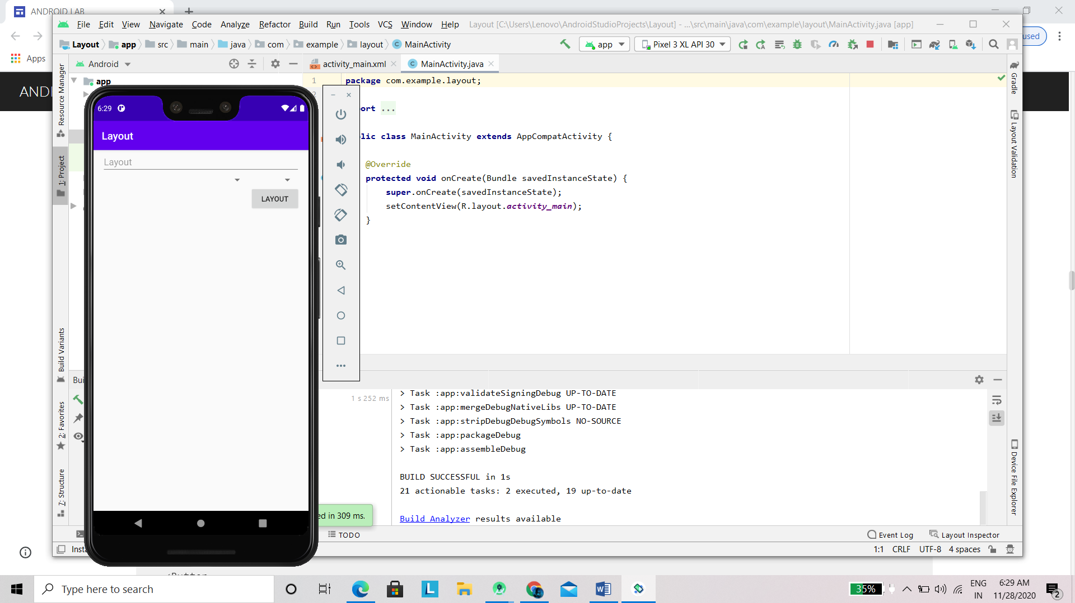

c. GridLayout

|  |
| --- |
| <GridLayout xmlns:android="http://schemas.android.com/apk/res/android"  xmlns:tools="http://schemas.android.com/tools"  android:id="@+id/GridLayout1"  android:layout_width="wrap_content"  android:layout_height="wrap_content"  android:columnCount="3"  android:rowCount="3"  android:orientation="horizontal"  tools:context="com.example.lab7c.MainActivity" >  <Space />  <Button  android:id="@+id/button1"  android:layout_gravity="left|top"  android:text="@string/app_name" />  <Button  android:id="@+id/button3"  android:layout_gravity="left|top"  android:text="@string/app_name" />  <Button  android:id="@+id/button2"  android:layout_column="0"  android:layout_gravity="left|top"  android:layout_row="0"  android:text="@string/app_name" />  <Button  android:id="@+id/button4"  android:layout_column="0"  android:layout_gravity="left|top"  android:layout_row="2"  android:text="@string/app_name" />  <Button  android:id="@+id/button5"  android:layout_column="1"  android:layout_row="2"  android:layout_columnSpan="2"  android:layout_gravity="fill"  android:text="@string/app_name" />  </GridLayout> |

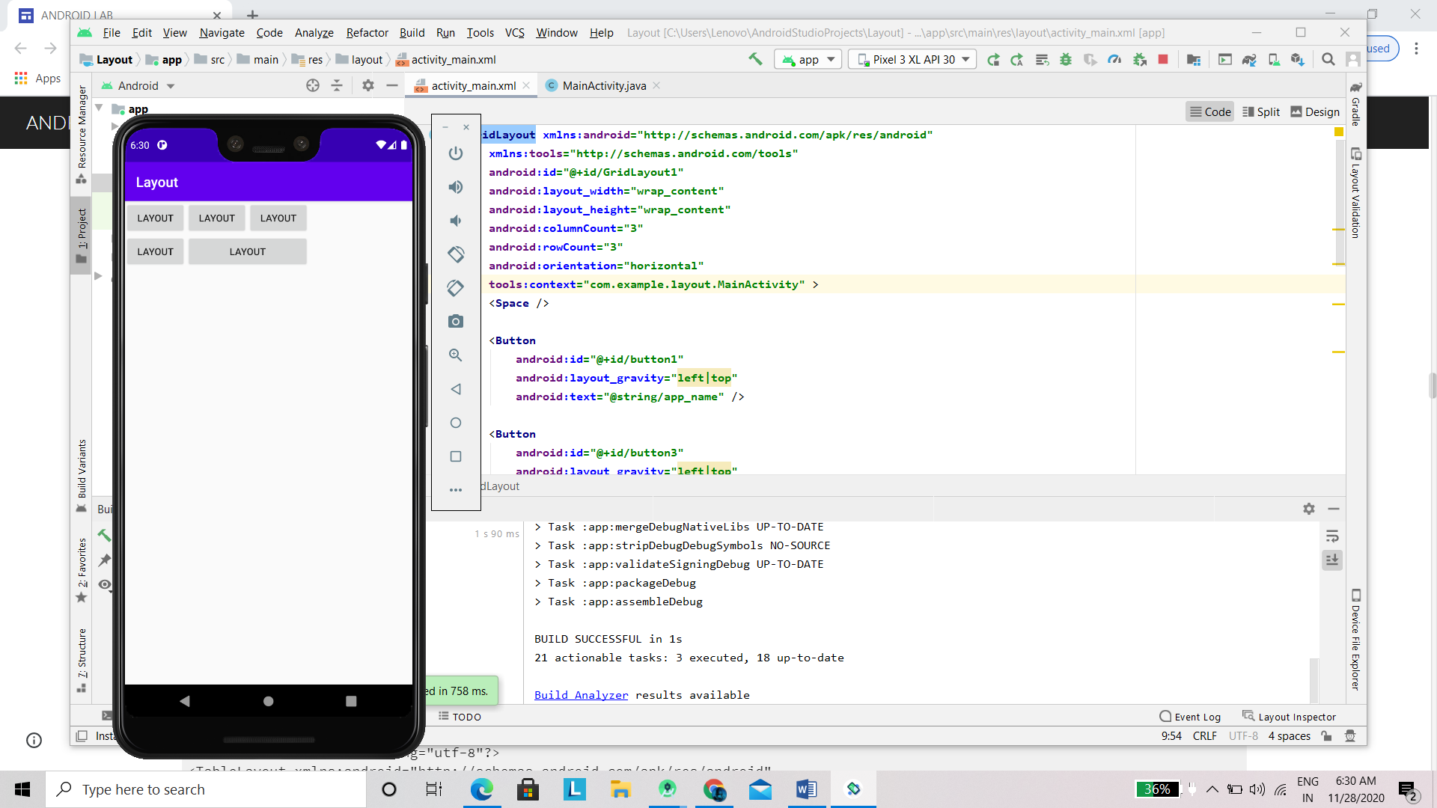

d. TableLayout

|  |
| --- |
| <?xml version="1.0" encoding="utf-8"?>  <TableLayout xmlns:android="http://schemas.android.com/apk/res/android"  android:layout_width="match_parent"  android:layout_height="match_parent"  android:stretchColumns="1">  <TableRow>  <TextView  android:text="@string/app_name"  android:padding="3dip" />  <TextView  android:text="@string/app_name"  android:gravity="right"  android:padding="3dip" />  </TableRow>  <TableRow>  <TextView  android:text="@string/app_name"  android:padding="3dip" />  <TextView  android:text="@string/app_name"  android:gravity="right"  android:padding="3dip" />  </TableRow>  </TableLayout> |

