**8. Create an application that uses the basic views of Android.**

**Activity_Main.xml:**

|  |
| --- |
| *<?***xml version="1.0" encoding="utf-8"***?>* <**LinearLayout xmlns:android="http://schemas.android.com/apk/res/android"  android:layout_width="fill_parent"  android:layout_height="fill_parent"  android:orientation="vertical"** >   <**TextView  android:id="@+id/textView"  android:layout_width="match_parent"  android:layout_height="wrap_content"  android:text="Hello Readers!!"** />   <**Button  android:id="@+id/buttonExample"  android:layout_width="match_parent"  android:layout_height="wrap_content"  android:text="Example Button"** />   <**CheckBox  android:id="@+id/checkBoxExample"  android:layout_width="match_parent"  android:layout_height="wrap_content"  android:text="CheckBox Example"** />   <**ToggleButton  android:id="@+id/toggleButtonExample"  android:layout_width="wrap_content"  android:layout_height="wrap_content"  android:text="ToggleButton Example"** />   <**RadioGroup  android:id="@+id/radioGroupExample"  android:layout_width="wrap_content"  android:layout_height="wrap_content"** >   <**RadioButton  android:id="@+id/radioBtton1"  android:layout_width="wrap_content"  android:layout_height="wrap_content"  android:checked="true"  android:text="RadioButton 1"** />   <**RadioButton  android:id="@+id/radioButton2"  android:layout_width="wrap_content"  android:layout_height="wrap_content"  android:text="RadioButton 2"** />   <**RadioButton  android:id="@+id/radioButton3"  android:layout_width="wrap_content"  android:layout_height="wrap_content"  android:text="RadioButton 3"** />  </**RadioGroup**>   <**ImageButton  android:id="@+id/imageButtonExample"  android:layout_width="match_parent"  android:layout_height="wrap_content"**/>  </**LinearLayout**> |

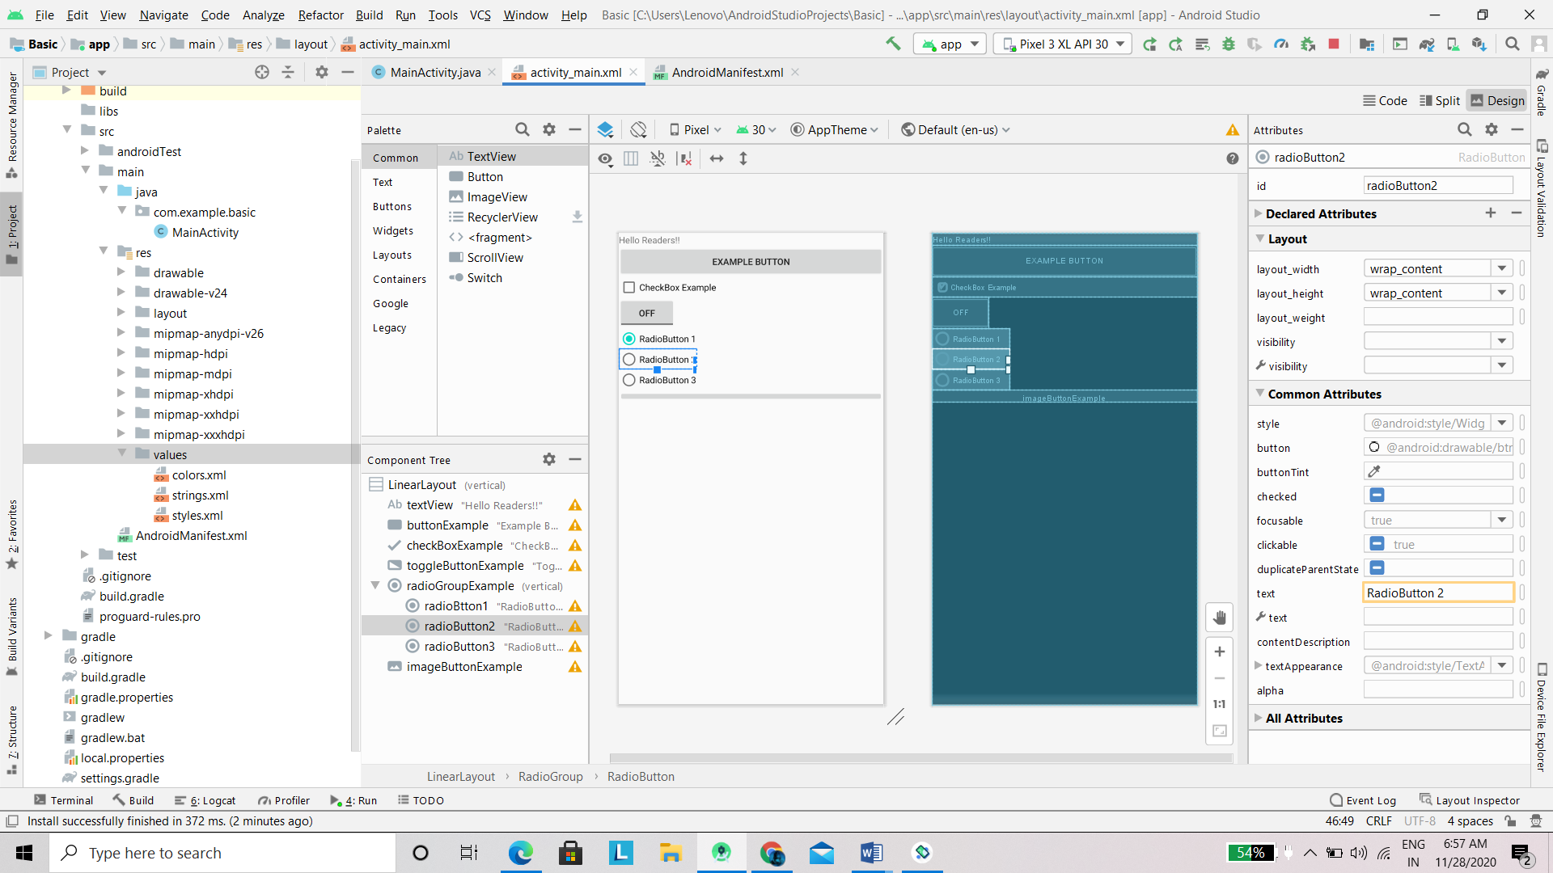

MainActivity.java:

|  |
| --- |
| **package** com.example.basic;  **import** androidx.appcompat.app.AppCompatActivity; **import** android.os.Bundle; **import** android.view.Menu; **import** android.view.View; **import** android.widget.Button; **import** android.widget.CheckBox; **import** android.widget.ImageButton; **import** android.widget.RadioButton; **import** android.widget.RadioGroup; **import** android.widget.RadioGroup.OnCheckedChangeListener; **import** android.widget.Toast; **import** android.widget.ToggleButton;  **import** android.os.Bundle;  **public class** MainActivity **extends** AppCompatActivity {   @Override  **protected void** onCreate(Bundle savedInstanceState) {  **super**.onCreate(savedInstanceState);  setContentView(R.layout.***activity_main***);  Button example = (Button) findViewById(R.id.***buttonExample***);  CheckBox exampleCheckBox = (CheckBox) findViewById(R.id.***checkBoxExample***);  RadioGroup exampleRadioGroup = (RadioGroup) findViewById(R.id.***radioGroupExample***);  ToggleButton exampletoggleButton = (ToggleButton) findViewById(R.id.***toggleButtonExample***);  ImageButton exampleImageButton = (ImageButton) findViewById(R.id.***imageButtonExample***);  example.setOnClickListener(**new** View.OnClickListener() {   @Override  **public void** onClick(View arg0) {  *//* ***TODO Auto-generated method stub*** Toast.*makeText*(MainActivity.**this**, **"Hey Button is pressed !!"**, Toast.***LENGTH_SHORT***).show();  *//ToastToDisplay("Hey Button is pressed!!");* }  });  exampleCheckBox.setOnClickListener(**new** View.OnClickListener() {  @Override  **public void** onClick(View v) {  *//* ***TODO Auto-generated method stub* if** (((CheckBox) v).isChecked()) {  *//ToastToDisplay("Check Box is checked");* Toast.*makeText*(MainActivity.**this**, **"Check Box is checked"**, Toast.***LENGTH_SHORT***).show();  } **else** {  *//ToastToDisplay("Check box is unchecked");* Toast.*makeText*(MainActivity.**this**, **"Check Box is unchecked"**, Toast.***LENGTH_SHORT***).show();  }  }  });  exampleRadioGroup  .setOnCheckedChangeListener(**new** OnCheckedChangeListener() {  @Override  **public void** onCheckedChanged(RadioGroup group, **int** checkedId) {  *//* ***TODO Auto-generated method stub*** RadioButton rb1 = (RadioButton) findViewById(R.id.***radioBtton1***);  RadioButton rb2 = (RadioButton) findViewById(R.id.***radioButton2***);  **if** (rb1.isChecked()) {  *//ToastToDisplay("Radio Button 1 is checked");* Toast.*makeText*(MainActivity.**this**, **"Radio Button 1 is checked"**, Toast.***LENGTH_SHORT***).show();  } **else if** (rb2.isChecked()) {  *//ToastToDisplay("Radio Button 2 is checked");* Toast.*makeText*(MainActivity.**this**, **"Radio Button 2 is checked"**, Toast.***LENGTH_SHORT***).show();  } **else** {  *//ToastToDisplay("Radio Button 3 is checked");* Toast.*makeText*(MainActivity.**this**, **"Radio Button 3 is checked"**, Toast.***LENGTH_SHORT***).show();  }  }  });  exampletoggleButton.setOnClickListener(**new** View.OnClickListener() {  @Override  **public void** onClick(View v) {  *//* ***TODO Auto-generated method stub* if** (((ToggleButton) v).isChecked()) {  *//ToastToDisplay("Toggle button is ON");* Toast.*makeText*(MainActivity.**this**, **"Toggle button is ON"**, Toast.***LENGTH_SHORT***).show();  } **else** {  *//oastToDisplay("Toggle Button is OFF");* Toast.*makeText*(MainActivity.**this**, **"Toggle button is OFF"**, Toast.***LENGTH_SHORT***).show();  }  }  });  exampleImageButton.setOnClickListener(**new** View.OnClickListener() {   @Override  **public void** onClick(View v) {  *//* ***TODO Auto-generated method stub*** *//ToastToDisplay("Image Button is pressed");* Toast.*makeText*(MainActivity.**this**, **"Image Button Is pressed"**, Toast.***LENGTH_SHORT***).show();  }  });  }  **private void** ToastToDisplay(String args) {  Toast.*makeText*(getBaseContext(), args, Toast.***LENGTH_SHORT***).show();  }  @Override  **public boolean** onCreateOptionsMenu(Menu menu) {  *// Inflate the menu; this adds items to the action bar if it is present.  //getMenuInflater().inflate(R.menu.main, menu);* **return true**;  } } |

Output:

