9. Develop an application that uses a menu with 3 options for dialing a number, opening a website and to send an SMS. On selecting an option, the appropriate action should be invoked using intents.

Activity_main.xml:

|  |
| --- |
| *<?***xml version="1.0" encoding="utf-8"***?>* <**LinearLayout  xmlns:android="http://schemas.android.com/apk/res/android"  xmlns:tools="http://schemas.android.com/tools"  android:id="@+id/activity_main"  android:orientation="vertical"  android:layout_width="match_parent"  android:layout_height="match_parent"   android:gravity="center_horizontal|center_vertical"  tools:context=".MainActivity"**>   <**EditText  android:id="@+id/et_phone_no"  android:hint="Enter Phone number"  android:inputType="phone"  android:layout_width="match_parent"  android:layout_height="wrap_content"**/>  <**EditText  android:id="@+id/et_message"  android:hint="Enter message"  android:inputType="textCapSentences|textMultiLine"  android:maxLength="2000"  android:maxLines="12"  android:layout_width="match_parent"  android:layout_height="wrap_content"**/>   <**Button  android:id="@+id/btn_send_message"  android:layout_gravity="center_horizontal"  android:text="Send Messange"  android:layout_width="wrap_content"  android:layout_height="wrap_content"**/>   <**Button  android:id="@+id/btn_dial"  android:layout_gravity="center_horizontal"  android:text="Dial"  android:layout_width="wrap_content"  android:layout_height="wrap_content"**/> </**LinearLayout**> |

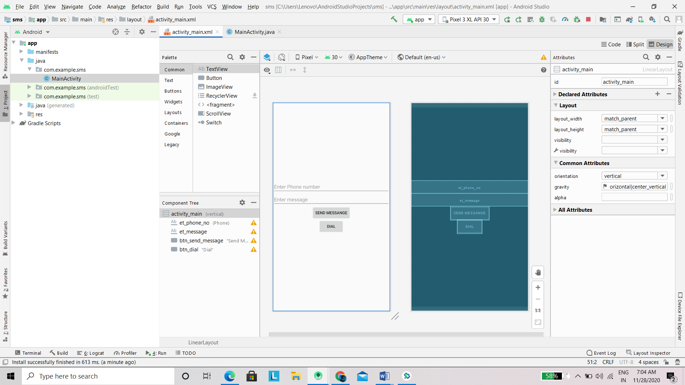

MainActivity.java:

|  |
| --- |
| **package** com.example.sms;  **import** androidx.appcompat.app.AppCompatActivity; **import** android.content.Intent; **import** android.net.Uri; **import** android.os.Bundle; **import** android.text.TextUtils; **import** android.view.View; **import** android.widget.Button; **import** android.widget.EditText; **import** android.widget.Toast;  **import** android.os.Bundle;  **public class** MainActivity **extends** AppCompatActivity {   @Override  **protected void** onCreate(Bundle savedInstanceState) {  **super**.onCreate(savedInstanceState);  setContentView(R.layout.***activity_main***);  Button mDialButton = (Button) findViewById(R.id.***btn_dial***);  **final** EditText mPhoneNoEt = (EditText) findViewById(R.id.***et_phone_no***);   mDialButton.setOnClickListener(**new** View.OnClickListener() {  @Override  **public void** onClick(View view) {  String phoneNo = mPhoneNoEt.getText().toString();  **if**(!TextUtils.*isEmpty*(phoneNo)) {  String dial = **"tel:"** + phoneNo;  startActivity(**new** Intent(Intent.***ACTION_DIAL***, Uri.*parse*(dial)));  }**else** {  Toast.*makeText*(MainActivity.**this**, **"Enter a phone number"**, Toast.***LENGTH_SHORT***).show();  }  }  });  Button sendMessageBtn = (Button) findViewById(R.id.***btn_send_message***);  **final** EditText messagetEt = (EditText) findViewById(R.id.***et_message***);  sendMessageBtn.setOnClickListener(**new** View.OnClickListener() {  @Override  **public void** onClick(View view) {  String message = messagetEt.getText().toString();  String phoneNo = mPhoneNoEt.getText().toString();  **if**(!TextUtils.*isEmpty*(message) && !TextUtils.*isEmpty*(phoneNo)) {  Intent smsIntent = **new** Intent(Intent.***ACTION_SENDTO***, Uri.*parse*(**"smsto:"** + phoneNo));  smsIntent.putExtra(**"sms_body"**, message);  startActivity(smsIntent);  }  }  });  } } |

Outputs: 