**Reminder!!**

All participants please take attention for here.

Before to do the questionnaire user testing game system, please play the game first and see the Game Design Document (GDD).

This game is a computer-based gaming. Please using laptop or PC to enjoy the game. Thank You.

Play the game

Step 1: Click the PixelAdventure-Release2.0 and open it.

Step 2: Click the Pixel Adventure and open it.

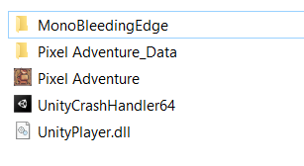

Click This

Step 3: Enjoy your game

Step 4: Finish the game and “shift + click” below link for give the user testing feedback

Questionnaire of User Testing Gaming System

<https://docs.google.com/forms/d/e/1FAIpQLScurUdXvwh2GRI3N2x-zExNeFODLzmmHYMvSLSj_eFZ4OV3Rg/viewform?usp=sf_link>

Step 5: Thank for your supporting me for playing game.