Robust, fast active spectral sensing via orthogonal temporal-frequency encoding
Introduction
Spectroscopic sensing has emerged as a cornerstone technology across diverse disciplines, finding critical utility in precision agriculture, environmental monitoring, and clinical diagnostics. However, achieving high-fidelity spectroscopy in real-world environments remains a significant challenge, primarily due to unpredictable ambient interference. Conventional dispersive spectrometers based on gratings or prisms are not only compromised by bulky form factors and high costs but also inherently constrained by the need for narrow entrance slits, which severely limits optical throughput. More critically, these systems indiscriminately accumulate total photon flux due to a lack of intrinsic mechanisms to decouple the target signal from background illumination. This mixes the target signal with ambient interference, causing spectral reconstruction to fail in real-world scenarios.
Computational spectroscopy has emerged as a promising pathway to overcome these physical limitations. However, existing paradigms remain constrained by an inherent trade-off between signal-to-noise ratio (SNR), acquisition speed, and spectral resolution. Snapshot approaches, such as filter arrays, achieve acquisition speed but inherently suffer from a spatial-spectral trade-off that limits their spectral resolution. Conversely, time-division multiplexing (TDM) approaches, ranging from tunable spectral filters to sequential active illumination, offer high spectral fidelity but rely on serial acquisition. This temporal sequentiality dictates that the total acquisition time scales linearly with the number of spectral channels ($T_{total}∝N$), rendering them ineffective for capturing transient dynamics. Ultimately, these computational frameworks lack an intrinsic encoding mechanism to effectively decouple the active signal from ambient interference. Consequently, they remain strictly bound to controlled lighting environments.
In this work, we propose orthogonal time-frequency encoding (OTFE) to address the challenge of retrieving the encoded spectral response amidst complex environmental lighting. Rather than attempting to disentangle mixed signals post-detection, our strategy ensures rigorous isolation by encoding each spectral basis function via a distinct orthogonal modulation kernel at the illumination source. This mechanism fundamentally shifts spectral acquisition from a serial time-domain sequence to a parallelized frequency-domain architecture. Consequently, it eliminates the need for sequential illumination, enabling the simultaneous reconstruction of all encoded spectral channels via a single-pixel detector in a single-shot acquisition.
The resulting demodulation process leverages orthogonality-based filtering, efficiently rejecting all ambient light and out-of-band interference that does not match the specific modulation frequencies. We demonstrate that this strategy enables accurate spectral reconstruction even under a SNR as low as $-$11.77 dB—a regime where conventional approaches fail. Furthermore, it achieves microsecond-level sensing with acquisition times as short as 250 μs. This work establishes a robust, fast and low-cost framework for spectral sensing in challenging environments.
Principle
Under the TDM architecture, spectral channels are activated sequentially according to a predefined timing sequence. The instantaneous intensity $y_{\text{TDM}}\left(t\right)$ received by the detector at any given time $t$ represents the superposition of the spectral signal from the single active channel within the current time slot and the ambient noise:
 | $$y_{\text{TDM}}\left(t\right)=\int_{λ_{1}}^{λ_{2}}{\sum_{k=1}^{K}{\left[P_{k}\left(λ\right)⋅\text{rect}\left(\frac{t-kτ}{τ}\right)\right]}}⋅R\left(λ\right)S\left(λ\right) dλ+I_{\text{noise}}\left(t\right)$$ | (1)
where $P_{k}\left(λ\right)$ denotes the spectral basis function of the $k$-th channel at the illumination source. $\text{rect}\left(⋅\right)$ represents the unit rectangular function, acting as a temporal gating operator that characterizes the serial scanning mechanism, where the $k$-th channel is active solely during its specific integration time $τ$. $R\left(λ\right)$ represents the reflectance or transmittance spectrum of the target, $S\left(λ\right)$ is the spectral responsivity of the detector, which characterizes overall efficiency of the optical-to-electrical conversion determined collectively by the photoelectric conversion efficiency and the transimpedance gain. And $I_{\text{noise}}\left(t\right)$ denotes the ambient light noise.
To transcend the serial constraints of TDM, we fundamentally alter the encoding mechanism for each spectral channel indexed by $k$ ($k=1, …, K$). Specifically, we substitute the binary temporal gating operator $\text{rect}\left(⋅\right)$ with a modulation kernel $m_{k}\left(t;f_{k}\right)$ uniquely assigned to that channel. This substitution eliminates the requirement for sequential time slots, allowing all channels to operate in parallel. The modulation kernel for the $k$-th channel is formulated as:
 | $$m_{k}\left(t;f_{k}\right)=a_{k,0}+a_{k,1}\cos\left(2πf_{k}t+φ_{k}\right)$$ | (2)
where $f_{k}$ is the distinct carrier frequency assigned to channel $k$. $a_{k,0}$ represents the DC bias required to ensure non-negative optical intensity. $a_{k,1}$ denotes the carrier amplitude, and $φ_{k}$ is the initial phase of the signal.
Upon simultaneous projection of all spectral channels modulated by their respective kernels, the detector integrates the total photon flux. The received OTFE signal $y_{\text{OTFE}}\left(t\right)$ is a composite waveform containing information from all$K$channels concurrently:
 | $$y_{\text{OTFE}}\left(t\right)=\sum_{k=1}^{K}{\underset{z_{k}}{\underbrace{\left[\int_{λ_{1}}^{λ_{2}}{P_{k}\left(λ\right)R\left(λ\right)S\left(λ\right)dλ} \right]}}}⋅m_{k}\left(t;f_{k}\right)+I_{\text{noise}}\left(t\right)$$ | (3)
Here, to simplify the physical interpretation, we define the scalar $z_{k}$ as the spectral projection value for the $k$-th channel. Substituting the modulation kernel into equation (3), the received signal $y_{\text{OTFE}}\left(t\right)$ can be reorganized into two distinct components:
 | $$y_{\text{OTFE}}\left(t\right)=\underset{\text{DC }\text{\&} \text{Noise component}}{\underbrace{\sum_{k=1}^{K}{z_{k}a_{k,0}}+I_{\text{noise}}\left(t\right)}}+\underset{\text{Signal }\text{c}\text{omponent}}{\underbrace{\sum_{k=1}^{K}{z_{k}a_{k,1}}\cos\left(2πf_{k}t+φ_{k}\right)}}$$ | (4)
The signal decomposition is achieved by mapping the time-domain observation into the frequency domain. Defining $F\{⋅\}$ as the continuous Fourier transform operator, the frequency-domain response $Y\left(f\right)$ is given by:
 | $$Y\left(f\right)=F\{y_{\text{OTFE}}\left(t\right)\}+\sum_{k=1}^{K}{\frac{1}{2}}z_{k}a_{k,1}\left[e^{jφ_{k}}δ\left(f-f_{k}\right)+e^{-jφ_{k}}δ\left(f+f_{k}\right)\right]$$ | (5)
where $δ\left(⋅\right)$ denotes the Dirac delta function. This formulation demonstrates the mechanism of noise rejection: as long as the modulation frequencies $\{f_{k}\}$ are designed to avoid the dominant bands of environmental noise and are mutually non-interfering, the projection value $z_{k}$ can be retrieved precisely by extracting the magnitudes at the corresponding carrier frequencies:
 | $$\left|Y\left(f_{k}\right)\right|=\frac{1}{2}z_{k}a_{k,1} ⇒ z_{k}=\frac{2\left|Y\left(f_{k}\right)\right|}{a_{k,1}}$$ | (6)
Once the projection values for all $K$ channels are retrieved, they are aggregated to form the measurement vector $z={\left[z_{1},z_{2},…,z_{K}\right]}^{T}$.To recover the spectrum $R\left(λ\right)$ of the target, we discretize the spectral range $\left[λ_{1},λ_{2}\right]$ into $N$ bands and model the measurement process as a system of linear equations:
 | $$z=Wr+e$$ | (7)
where $r∈R^{N}$ represents the ground truth (GT) spectrum, and $W∈R^{K×N}$ is the pre-calibrated system matrix determined by the source emission spectra and detector responsivity. The term $e$ accounts for the system noise and measurement residuals. Consequently, the spectral reconstruction is treated as an inverse problem. The estimated spectrum $\hat{r}$ is obtained by finding the solution that minimizes the reconstruction error:
 | $$\hat{r}=\underset{r}{argmin}{{\left\|z-Wr\right\|}_{2}^{2}}$$ | (8)
Experiment
To empirically validate the proposed OTFE framework, we develop a spectral sensing prototype. OTFE is methodologically agnostic to the specific light source, provided it supports high-speed temporal modulation and possesses spectral diversity. In this study, we select LEDs as the source due to their narrowband spectral diversity and MHz-level modulation bandwidth for efficient orthogonal encoding.
Correspondingly, the detection module is designed to match this high-frequency modulation capability. While standard 2D image sensors (CMOS/CCD) provide spatial resolution, their limited frame rates (typically < 100 fps) constitute a fundamental bottleneck for sampling the high-frequency carriers essential for OTFE’s noise rejection mechanism. We employ a high-bandwidth single-point detector. This configuration prioritizes temporal resolution and spectral precision, serving as a rigorous validation platform where the core encoding-decoding physics can be evaluated without the bandwidth limitations of conventional imagers.
To systematically evaluate the system's noise rejection capabilities, three distinct noise models are synthesized to simulate typical experimental scenarios: (i) additive white gaussian noise (AWGN) representing broadband thermal and detector noise; (ii) in-band interference (aggregated random narrowband signals) spectrally coincident with the system's modulation bandwidth; (iii) 100 Hz power-line flicker modeling ambient lighting artifacts. Figure 1(a) illustrates the temporal response under these conditions. Notably, due to the short acquisition window, the low-frequency flicker manifests as a significant baseline drift, whereas the in-band interference induces amplitude beating due to frequency mixing.
Figure 2b reveals a strong correlation between spectral reconstruction RMSE and demodulation error (defined in Supplementary Note 1), confirming that reconstruction fidelity hinges on carrier extraction accuracy. Notably, the 100 Hz flicker rapidly aligns with the AWGN baseline, demonstrating efficient out-of-band rejection. In contrast, in-band interference decays slowest. Since these disturbances spectrally coincide with the carrier signals, they bypass the orthogonal filtering process, thereby establishing the theoretical lower bound of reconstruction precision.
To simulate realistic environmental challenges, we introduced three representative structured interferences (defined in Supplementary Note 1): DC background light (simulating direct solar illumination); 20 kHz PWM noise (mimicking standard dimming protocols engineered to exceed the human audible threshold); and 100 kHz SMPS noise (modeling the switching ripples inherent to ubiquitous electronic power adapters).
Figure 2c depicts the time-domain response under an extreme SNR of -20 dB. Visually, the target signal is completely overwhelmed. The DC component imposes a massive baseline shift, while the high-energy PWM and SMPS oscillations bury the effective modulation, rendering the spectral information indistinguishable from the background interference in the time domain.
The quantitative reconstruction results in Figure 2d reveal a critical advantage of the OTFE framework. While random noise (AWGN) and in-band interference degrade performance linearly, the structured environmental noises exhibit negligible reconstruction error (RMSE≈10⁻²), remarkably remaining flat even at an SNR of $-$20 dB. This spectral immunity validates that the orthogonality of the basis functions allows the system to completely bypass these specific interference bands. By ensuring modulation frequencies do not overlap with known ambient interference, the system reliably retrieves data despite interference.
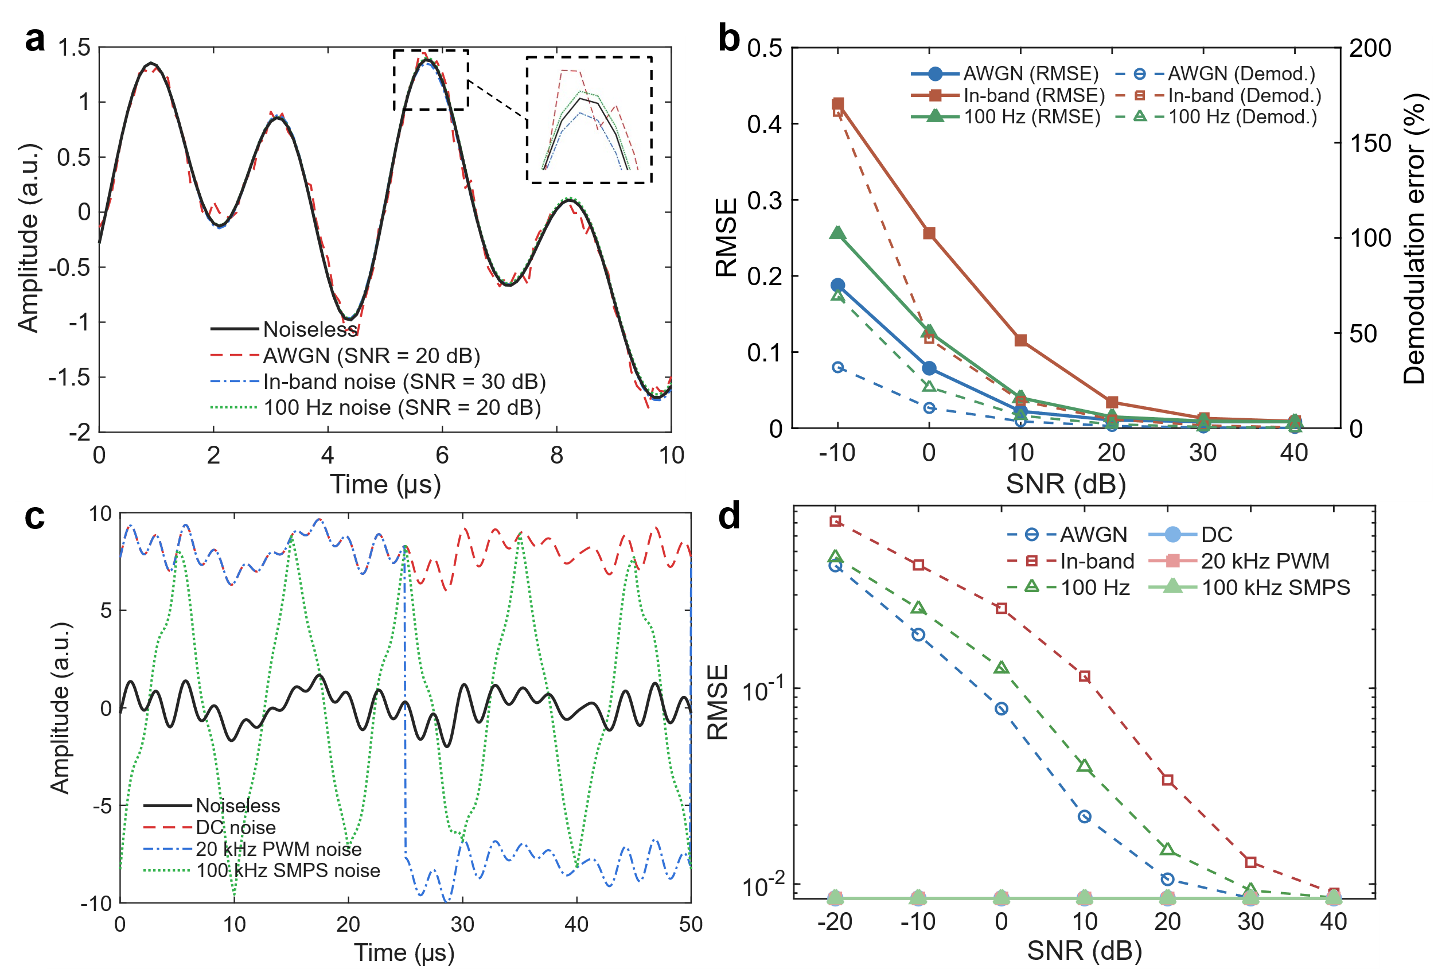
Figure 1. Simulation of noise rejection and robustness analysis. (a) Time-domain response of the modulated signal under AWGN, in-band interference, and 100 Hz flicker. (b) Reconstruction accuracy and demodulation error as a function of SNR. (c) Extreme interference scenarios (SNR = -20 dB) featuring ubiquitous environmental artifacts: DC background, 20 kHz PWM dimming, and 100 kHz SMPS ripple. (d) Comparative robustness analysis.
The experimental setup employs a Thorlabs PDA100A2 photodetector (11 MHz bandwidth) digitized by a RIGOL DS1202Z-E oscilloscope (200 MHz, 1 GSa/s) for high-fidelity acquisition. Modulation sequences are generated by a 72 MHz MCU. The system bandwidth is physically constrained by the switching characteristics of the PT4115 LED driver chip. Consequently, the maximum modulation frequency is strictly capped at 500 kHz to ensure signal integrity.
Within this operational bandwidth, the single-shot integration time was configured to $250 μs$. This temporal window is selected to accommodate the specific orthogonal frequency set designed for optimal spectral retrieval (detailed in Supplementary Note X). Figure 3 validates the reconstruction performance under this configuration. For broadband targets (Figure 3a), the system recovers the reflectance of the reflective colorchecker with an average RMSE of 0.0422. The results exhibit strong agreement across diverse textures—from the flat response of neutral grays to the complex curvature of biological tones. For narrowband evaluation (Figure 3b), the accurate reconstruction of 10 nm FWHM spectral peaks without significant broadening confirms robust resolving power even in microsecond-scale snapshots.
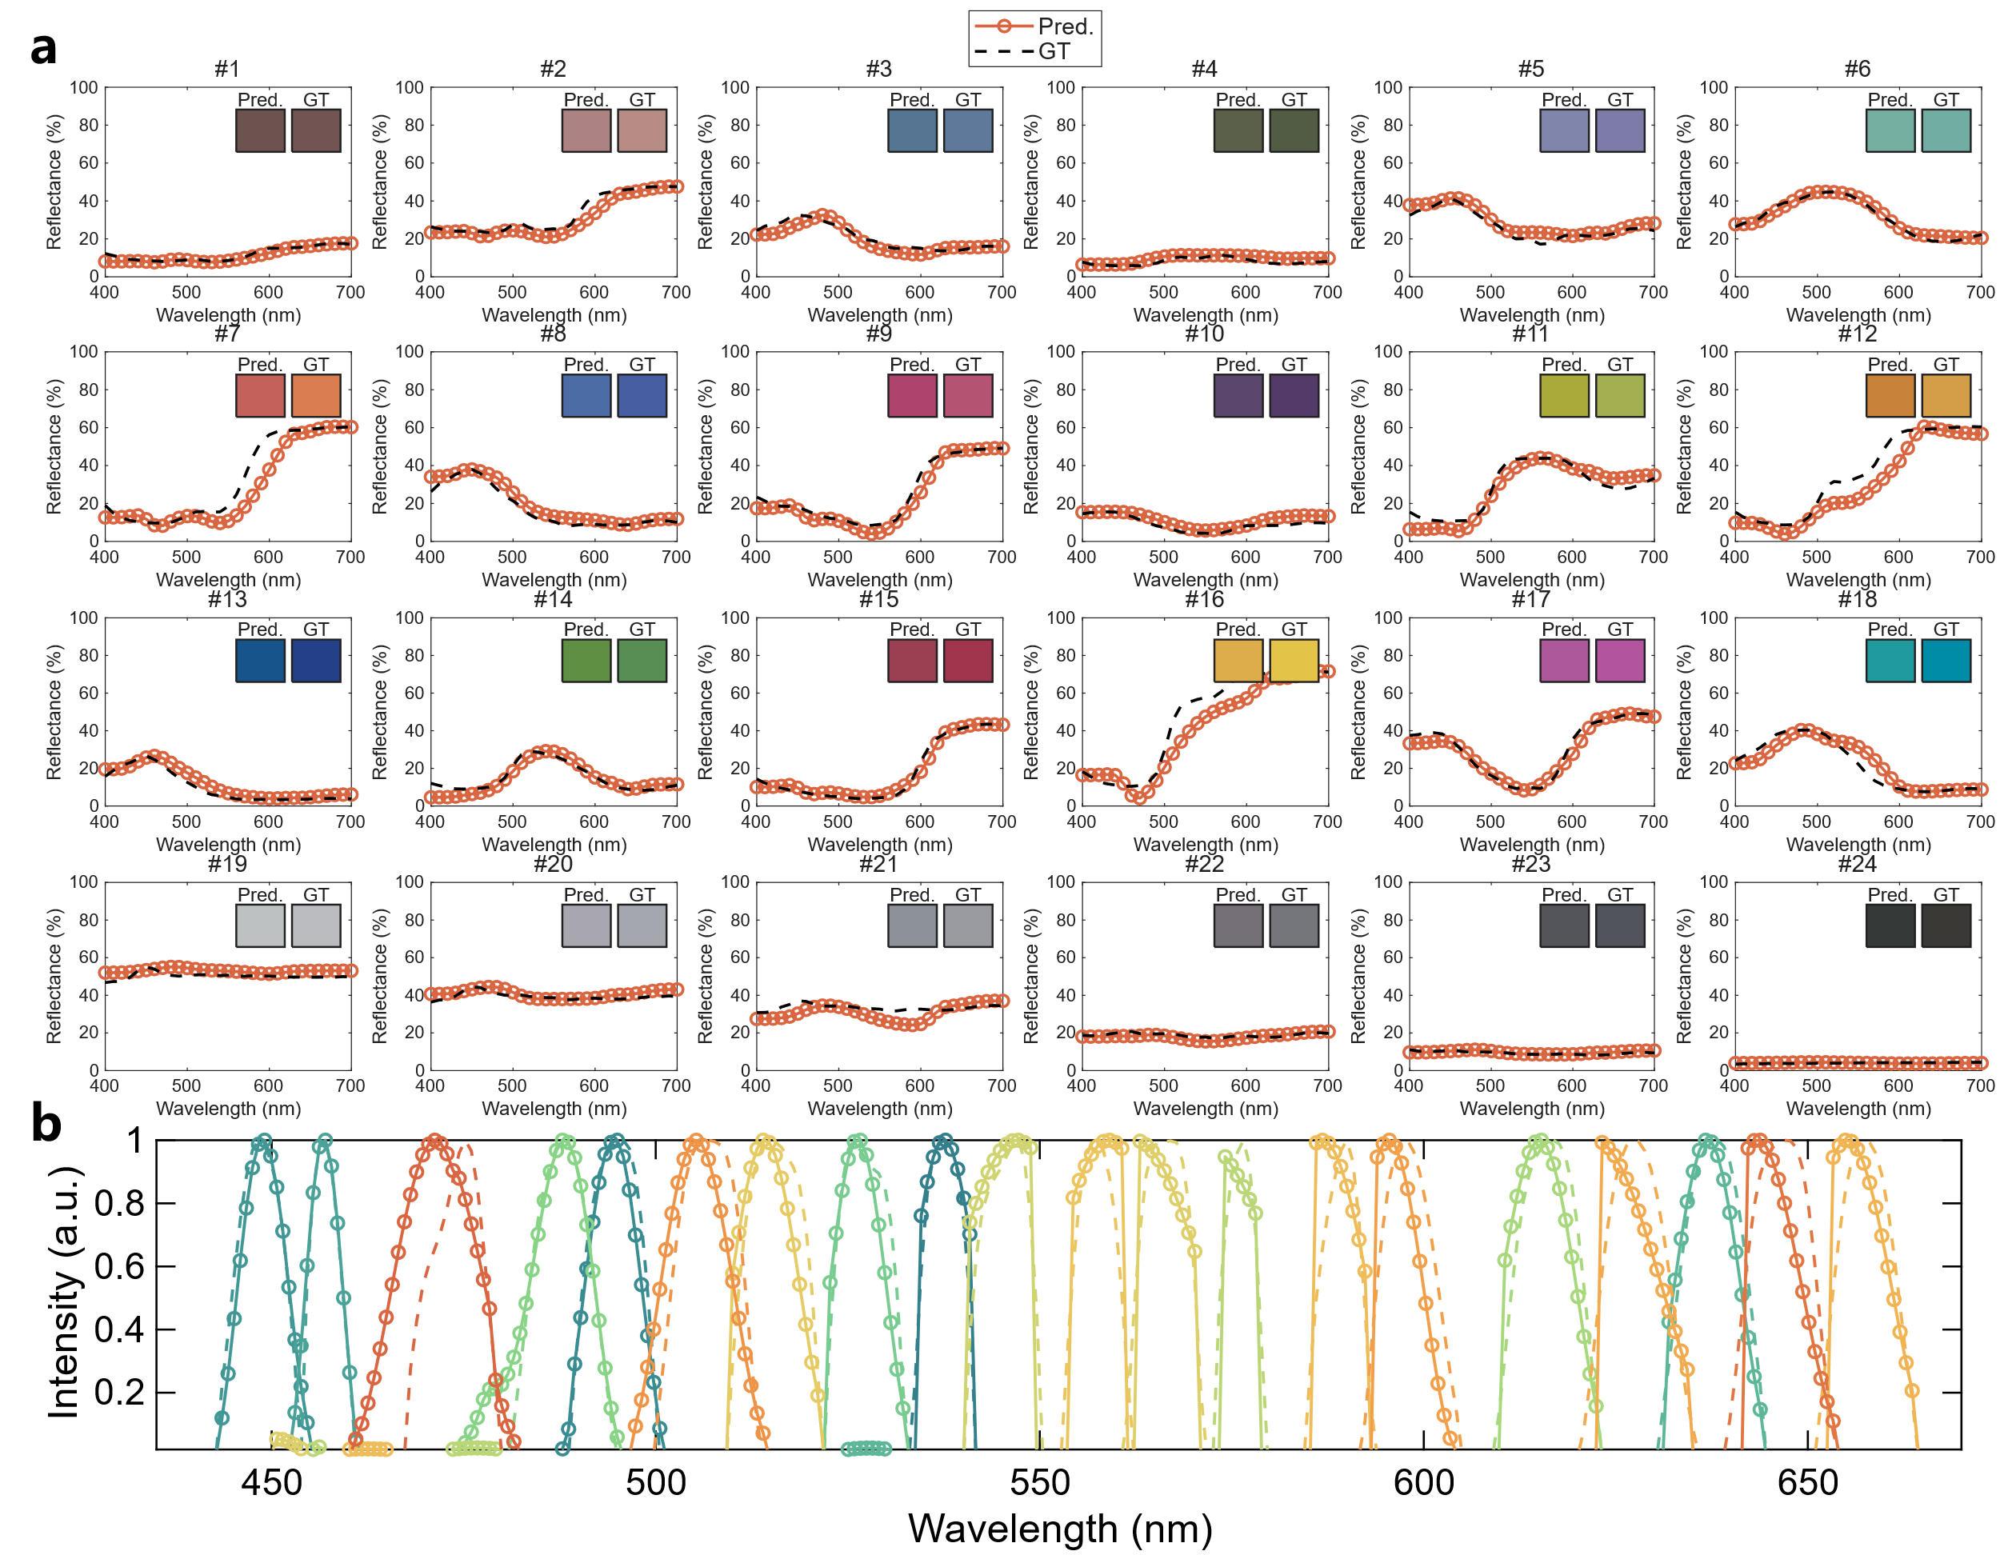
Figure 2. Experimental validation of high-speed spectral reconstruction ($T_{s}=250 μs$). (a) Reconstruction of surface reflectance for the 24 patches of the reflective colorchecker. Insets compare the sRGB rendered colors of the prediction (left) and ground truth (right). (b) Reconstruction of 10 nm FWHM narrowband spectra.

