Section 1: Spectral reconstruction based on projected gradient descent
While equation (8) in the main text describes the least-squares solution, solving the ill-posed inverse problem under physical constraints requires adaptive regularization to handle diverse spectral topologies. The $L_{1}$ norm is utilized to promote sparsity for recovering narrowband peaks, whereas the smoothness term exploits the inherent spectral continuity across adjacent bands to reconstruct broadband signatures; meanwhile, the $L_{2}$ norm acts as an energy constraint to ensure numerical stability. To solve this, we employ the projected gradient descent (PGD) algorithm to minimize the composite objective function subject to the box constraint $C=\{r∣0⪯r⪯1\}$:
$$J\left(r\right)=\min_{0⪯r⪯1}\left(\frac{1}{2}{\left\|z-Wr\right\|}_{2}^{2}+β_{1}{\left\|r\right\|}_{1}+\frac{β_{2}}{2}{\left\|r\right\|}_{2}^{2}+\frac{β_{3}}{2}{\left\|Dr\right\|}_{2}^{2}\right)$$
where $D∈R^{\left(N-1\right)×N}$ is the first-order difference matrix:
The gradient $∇J\left(r\right)$ is:
$$∇J\left(r\right)=W^{T}\left(Wr-z\right)+β_{1}\text{sgn}\left(r\right)+β_{2}r+β_{3}D^{T}Dr$$
The iterative update rule is given by:
$$r^{\left(k+1\right)}=\min\left(\max\left(0,r^{\left(k\right)}-α⋅∇J\left(r^{\left(k\right)}\right)\right),1\right)$$
Algorithm 1: PGD Spectral Reconstruction
Input: $z,W,D$, parameters $β_{1,2,3},α,K_{\text{max}},τ$.
Output: $\hat{r}$.
- Initialize: $r^{\left(0\right)}←0$,$k ←0$, $ϵ←∞$
- While $k<K_{\text{max}}$ and $ϵ> τ$ do:
- $g^{\left(k\right)}←W^{T}\left(Wr^{\left(k\right)}-z\right)+β_{1}\text{sgn}\left(r^{\left(k\right)}\right)+β_{2}r^{\left(k\right)}+β_{3}D^{T}Dr^{\left(k\right)}$
- $r^{\left(k+1\right)}←\min\left(\max\left(0,r^{\left(k\right)}-α⋅g^{\left(k\right)}\right),1\right)$
- $ϵ←\frac{{\left\|r^{\left(k+1\right)}-r^{\left(k\right)}\right\|}_{2}^{2} }{{\left\|r^{\left(k\right)}\right\|}_{2}^{2}}$
- $k ←k + 1$
- End While
- Return $·$

Section 2: Definition of noise types
To systematically evaluate the system's noise rejection capabilities, three noise models were synthesized to simulate general experimental scenarios, and three structured interference models were introduced to mimic realistic environmental artifacts.
In this study, these interferences are treated as additive noise. The actual observed signal $\hat{y}\left(t\right)$ received by the system is modeled as a linear superposition of the ideal signal $y\left(t\right)$ and the specific environmental noise $n\left(t\right)$ applied independently:
$$\hat{y}\left(t\right)=y\left(t\right)+n\left(t\right)$$
The mathematical formulations for the six noise types $n\left(t\right)$ are defined as follows:
1. Additive white gaussian noise (AWGN)
Simulates broadband thermal noise and detector shot noise.
$$I_{\text{AWGN}}\left(t\right)∼N\left(0,σ_{n}^{2}\right)$$
where $N\left(⋅\right)$ denotes the normal distribution is the standard deviation, controlling the noise power. $Σ_{n}$ is the standard deviation controlling the noise power.
2. In-band interference
Models aggregated random narrowband signals that spectrally coincide with the system's modulation bandwidth.
$$I_{\text{in-band}}\left(t\right)=\sum_{j=1}^{M}{A_{j}}\cos\left(2πf_{j}t+ϕ_{j}\right), \text{s.t. }f_{j}∈\left[f_{\text{min}},f_{\text{max}}\right]$$
where $M$ is the total number of interfering narrowband signals. $A_{j}$ is the amplitude of the $j$-th interference component. $f_{j}$ is the random frequency of the $j$-th component, constrained within the system's bandwidth $\left[f_{\text{min}},f_{\text{max}}\right]$. $ϕ_{j}$ is the random initial phase.
3. Power-line flicker (100 Hz)
Models the low-frequency intensity fluctuation caused by AC-driven artificial lighting.
$$I_{\text{flicker}}\left(t\right)=A_{\text{grid}}\sin\left(2πf_{\text{grid}}t+ϕ_{\text{grid}}\right)$$
where $A_{\text{grid}}$ represents the flicker amplitude. $f_{\text{grid}}$ is the power line frequency (fixed at 100 Hz for rectified 50 Hz mains). $ϕ_{\text{grid}}$ is the phase offset.
4. DC background
Simulates constant high-intensity ambient illumination, such as direct sunlight.
$$I_{\text{DC}}\left(t\right)=C_{\text{const}}$$
where $C_{\text{const}}$ is a time-invariant constant representing the static background photon flux.
5. PWM dimming noise (20 kHz)
20 kHz is the typical frequency for mainstream commercial LED drivers using PWM dimming. It is designed to avoid audible noise (< 20 kHz) while maintaining dimming efficiency. Rather than a simple square wave, it is modeled as an infinite sum of odd harmonics:
$$n_{\text{PWM}}\left(t\right)=A_{\text{PWM}}⋅\frac{4}{π}\sum_{m=1,3,5,…}^{∞}{\frac{1}{m}}\cos\left(2πmf_{\text{PWM}}t\right)$$
where $A_{\text{PWM}}$ represents the interference amplitude. $f_{\text{PWM}}=20\text{ kHz}$ is the fundamental dimming frequency. $m ∈\{1, 3, 5, …\}$ denotes the odd harmonic orders. $1/m$ is the amplitude decay coefficient for the $m$-th harmonic.
6. Switched-mode power supply (SMPS) noise (50 kHz)
Similarly, the switching ripple from power adapters is not a single tone but a complex waveform containing a fundamental frequency and a dense series of integer harmonics (both odd and even). It is modeled by the Fourier series:
$$n_{\text{SMPS}}\left(t\right)=A_{\text{SMPS}}\sum_{n=1}^{∞}{c_{n}}\cos\left(2πnf_{\text{SMPS}}t+ϕ_{n}\right)$$
where $f_{\text{SMPS}}$ is the switching frequency (typically 50 kHz or 100 kHz). $n ∈\{1, 2, 3, …\}$ denotes the integer harmonic orders. $c_{n}$ is the Fourier coefficient for the $n$-th harmonic (typically decaying as $1/n$ or $1/n^{2}$ depending on the waveform shape, e.g., sawtooth or triangle). $ϕ_{n}$ represents the random phase of each harmonic.

Section 3: Phase noise simulation
Beyond additive noise, phase instability in oscillator, typically arising from signal generators or phase-locked loops (PLLs), affects OTFE performance. The modulated signal with phase noise is modeled as:
$$s_{\text{noisy}}\left(t\right)=\sum_{k=1}^{K}{A_{k}}\cos\left(2πf_{k}t+ϕ_{k}+θ_{k}\left(t\right)\right)$$
where $θ_{k}\left(t\right)$ represents the phase jitter, modeled as a zero-mean Gaussian random process: $θ_{k}\left(t\right)∼N\left(0,σ_{ϕ}^{2}\right)$.
For a small phase deviation ($σ_{ϕ}≪1$ rad), using the small-angle approximation ($\cos{θ}≈1,\sin{θ}≈ θ$), the signal for the $k$-th channel can be expanded as:
$$s_{k}\left(t\right)=A_{k}\cos\left(2πf_{k}t+ϕ_{k}\right)\cos\left(θ_{k}\left(t\right)\right)-A_{k}\sin\left(2πf_{k}t+ϕ_{k}\right)\sin\left(θ_{k}\left(t\right)\right) \\ ≈\underset{\text{Ideal Carrier}}{\underbrace{A_{k}\cos\left(2πf_{k}t+ϕ_{k}\right)}}-\underset{\text{Interference}}{\underbrace{A_{k}θ_{k}\left(t\right)\sin\left(2πf_{k}t+ϕ_{k}\right)}}$$
This derivation reveals that phase noise introduces an orthogonal interference component modulated by the random process $θ_{k}\left(t\right)$. This results in spectral leakage (energy loss at the carrier frequency) and disrupts orthogonality, leading to inter-channel crosstalk.
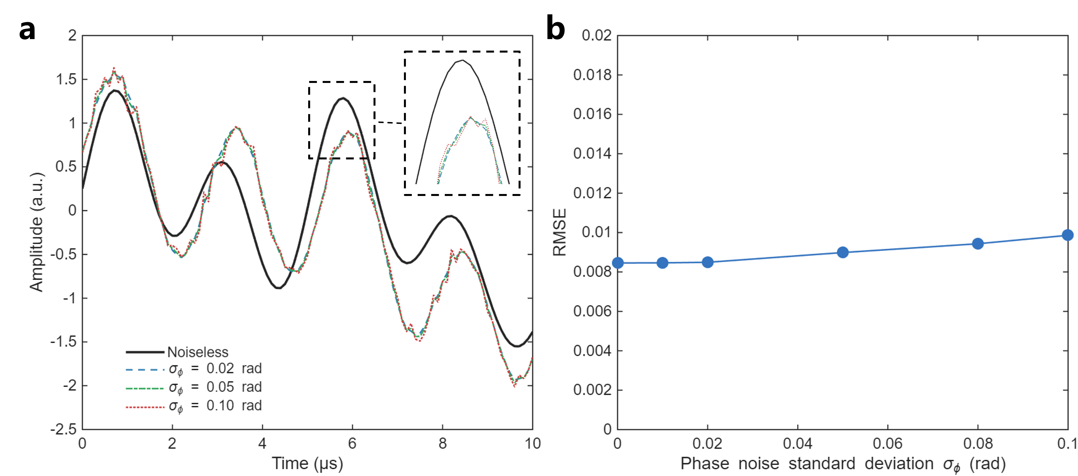
Figure S1. Simulation of OTFE robustness against phase noise. (a) Time-domain waveform response under varying phase noise intensities ($σ_{ϕ}=0∼0.1\text{ rad}$). The inset highlights that phase instability causes minor horizontal shifts in peak positions rather than amplitude distortion. (b) Spectral reconstruction RMSE as a function of phase noise standard deviation. The system demonstrates exceptional stability, with negligible error growth within the typical operating range of hardware oscillators ($σ_{ϕ}<0.01\text{ rad}$).
Figure S1 illustrates the system's response to phase noise with standard deviations $\sigma_\phi$ ranging from 0 to 0.1 rad. As shown in Figure S1(a), unlike additive noise which induces sharp amplitude spikes or "burrs," phase noise manifests primarily as minute horizontal timing jitters (time-axis deviations), while the overall signal envelope remains smooth and intact.
Figure S1(b) quantifies the robustness. The spectral reconstruction error (RMSE) exhibits a slow linear increase, rising only marginally from 0.0085 to $≈0.01$ even when $σ_{ϕ}$ reaches 0.1 rad ($≈{5.7}^{∘}$). Given that modern commercial signal generators typically maintain phase noise well below 0.01 rad, the system operates in the flat region of the error curve, rendering oscillator instability negligible for practical spectral reconstruction.
Section 4: Definition of demodulation error
Figure 2b illustrates the correlation between spectral reconstruction RMSE and demodulation error. We define the demodulation error $η_{\text{demod}}$ as the relative Euclidean distance between the estimated measurement vector $\hat{z}$ and the ground truth vector $z$:
$$η_{\text{demod}}=\frac{{\left\|\hat{z}-z\right\|}_{2}}{{\left\|z\right\|}_{2}}×100$$
This metric quantifies the efficiency of carrier extraction and noise rejection in the frequency domain.
Section 5: Spectral distribution of illumination sources
The system employs a discrete array of narrowband active illumination sources to span the visible spectrum. The spectral power distribution (SPD) of the $k$-th source, denoted as $P_{k}\left(λ\right)$, is modeled using a Gaussian approximation:
$$P_{k}\left(λ\right)≈P_{\text{peak},k}⋅\exp\left(-\frac{{\left(λ-λ_{c,k}\right)}^{2}}{2σ_{k}^{2}}\right)$$
where $λ_{c,k}$ represents the center wavelength, $σ_{k}$ determines the spectral bandwidth, and $P_{\text{peak},k}$ denotes the peak radiant intensity. These profiles form the basis vectors of the system matrix $W$ used in the forward model (Equation 7 in the main text).
Figure S2 characterizes the spectral properties of the 12 discrete sources utilized in the prototype. The left panel illustrates the normalized spectral profiles (amplitude scaled to [0, 1]). This visualization confirms that the sources are strategically spaced across the 400–700 nm range with minimal severe overlap, ensuring sufficient spectral diversity and conditionality for the reconstruction algorithm. The right panel displays the measured relative radiant flux of the sources under identical driving conditions. The variations in peak amplitude reflect the inherent differences in quantum efficiency and electro-optical conversion characteristics of different semiconductor materials across the spectrum. These intensity disparities are pre-calibrated and compensated for within the system matrix $W$.
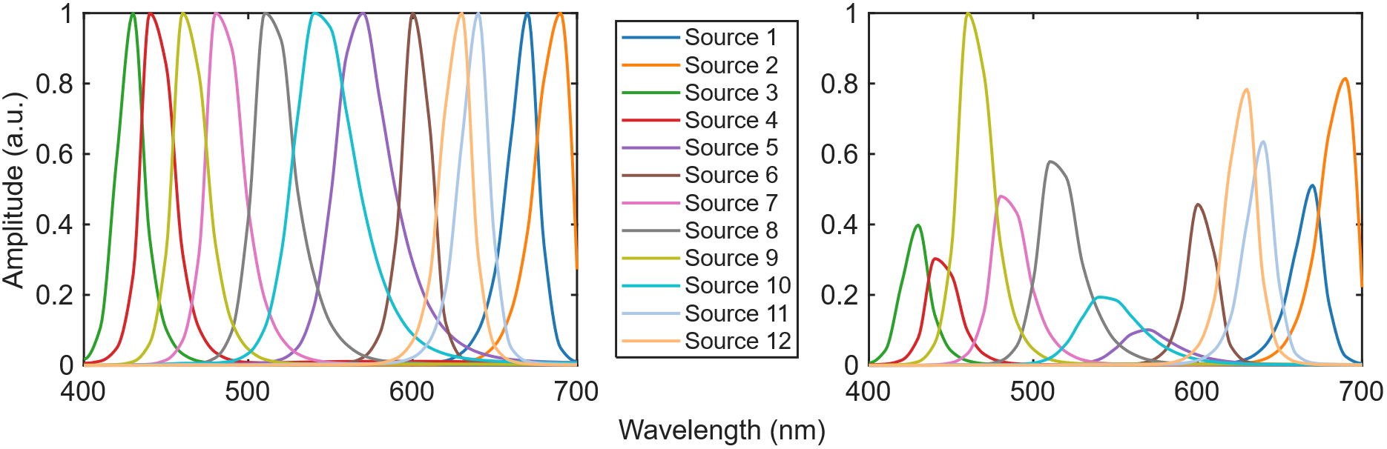
Figure S2. Spectral characterization of the illumination sources. (a) Normalized spectral profiles of the 12 channels. The sources exhibit narrowband characteristics with distinct center wavelengths distributed across the visible band (400–700 nm). (b) Actual relative intensity distribution. The plot reveals the native radiant flux variations among the sources, which are accounted for in the system calibration matrix to ensure accurate radiometric retrieval.
Section 6: Frequency set design and optimization
The selection of the modulation frequency set $H=\{f_{1},f_{2},…,f_{K}\}$ for the $K$ spectral channels is constrained by both signal processing principles and the physical limitations of hardware implementation. While ideal mathematical models assume pure sinusoidal modulation and perfectly linear system components, practical active sensing architectures face inherent non-idealities: to maximize energy efficiency and modulation bandwidth, driving circuits often utilize switching waveforms (e.g., PWM or stepped waves) rather than ideal analog sinusoids; furthermore, both the electro-optical transfer function of the sources and the responsivity of the detectors exhibit non-linear regions.
These factors introduce significant high-order harmonics and intermodulation distortion into the system. Therefore, to ensure high-fidelity demodulation within the OTFE framework, the frequency set design must strictly adhere to three physical constraints.
1. Spectral Separability Condition
$$\left|f_{i}-f_{j}\right|>Δf, ∀i≠j$$
Signal acquisition is inherently confined to a finite time window $T$, which is mathematically equivalent to multiplying the infinite signal $x\left(t\right)$ by a rectangular window function $\text{rect}\left(t/T\right)$. In the frequency domain, this results in the convolution of the original spectrum with a sinc function:
$$X_{T}\left(f\right)=X\left(f\right)*\left[T⋅\text{sinc}\left(πfT\right)\right]$$
This convolution broadens ideal spectral lines into lobes. If the frequency interval between adjacent channels is smaller than the Rayleigh bandwidth $Δf ≈1/T$, the main lobes will overlap severely, rendering the channels indistinguishable.
2. Harmonic Interference Avoidance
Due to switching modulation and source non-linearities, the $j$-th channel emits not only the fundamental carrier $f_{j}$ but also harmonics $2f_{j},3f_{j},⋯$. If the bandwidth extends beyond an octave ($f_{\text{max}}≥2f_{\text{min}}$), the frequency set must be optimized to ensure that no fundamental carrier coincides with any harmonic of another channel:
$$f_{j}≠n⋅f_{i}, ∀i≠j, n∈\{2,3,…,N_{\text{max}}\}$$
Alternatively, confining the set to a sub-octave band ($f_{\text{max}}<2f_{\text{min}}$) naturally places all second harmonics ($2f_{\text{min}}$) above the highest fundamental, eliminating this interference type entirely.
3. Intermodulation Distortion (IMD) Avoidance
The non-linear response of single-point detectors generates cross-products between co-existing signals. Expanding the quadratic response term yields sum and difference frequencies ($f_{i}±f_{j}$). To prevent these "phantom" frequencies from corrupting valid measurements, the set must satisfy:
$$\left|f_{i}±f_{j}\right|≠f_{k}, ∀i≠j≠k$$
6.2 Optimization strategies
Based on these criteria, we implemented two distinct frequency allocation strategies tailored to specific sensing requirements.
Strategy 1: Robust Acquisition (Sub-octave Planning)
For high-precision sensing in environments dominated by structured noise, we devised a strategy utilizing a 1000 $μ$s acquisition window. By selecting a high-frequency band of 380–490 kHz, the system adheres to the sub-octave rule ($490 < 2 ×380$), which inherently eliminates all harmonic interference and sum-frequency intermodulation within the signal band. The extended integration time refines the frequency resolution to $Δf=1\text{ kHz}$, allowing carriers to be precisely positioned to avoid low-frequency difference intermodulation ($\left|f_{i}-f_{j}\right|$) and external noise spikes. The resulting linear set is $H_{lin}=\{380,390,…,490\}$ kHz.
Strategy 2: High-Speed Acquisition (Greedy Algorithm)
To enable snapshot capture of transient dynamics, the acquisition window is reduced to 250 $μ$s, resulting in a coarser resolution of $Δf=4\text{ kHz}$. To accommodate 12 channels within this constraint, the system utilizes the full broadband spectrum (30–410 kHz). Since this range exceeds an octave ($f_{\text{max}}≥2f_{\text{min}}$), simple linear planning is insufficient. We employed a Greedy Algorithm to iteratively construct a frequency set that strictly satisfies all three design criteria—separability, harmonic avoidance, and IMD avoidance. The algorithm scans the spectrum and selects frequencies that do not conflict with the existing set, yielding the optimized set $H_{\text{opt}}=\{30,50,70,110,130,170,190,230,290,310,370,410\}$ kHz.

Section 7 硬件調制信號不幹淨帶來的誤差

Section 8: Definition of Signal-to-Noise Ratio in the Frequency Domain
To quantitatively assess the robustness of the orthogonal frequency encoding (OFE) framework, the signal-to-noise ratio (SNR) is defined in the frequency domain, consistent with our signal retrieval process. This definition accounts for practical hardware constraints and ensures a rigorous evaluation of the system’s noise rejection capabilities.
- Signal Power ($P_{\text{signal}}$)
In the experimental setup, the modulation signals generated by the hardware (e.g., LED drivers) are not ideal sinusoids and contain both even and odd harmonics. However, the spectral reconstruction algorithm exclusively extracts energy at the fundamental carrier frequencies $\{f_{k}\}$. Consequently, the signal power is defined as the sum of the squared magnitudes at these specific frequencies:
$$P_{\text{signal}}=\sum_{k=1}^{K}{{\left|Y\left(f_{k}\right)\right|}^{2}}$$
where $Y\left(f_{k}\right)$ represents the complex magnitude of the spectrum at carrier frequency $f_{k}$. All higher-order harmonics ($nf_{k}$ for $n≥2$) are excluded from $P_{\text{signal}}$ as they do not contribute to the spectral reconstruction.
- Noise Power ($P_{\text{noise}}$)
The noise power is defined as the total residual energy within the experimental bandwidth that could potentially interfere with the carrier extraction. To provide a conservative and precise assessment of external noise immunity, $P_{\text{noise}}$ is calculated by excluding the DC component, the fundamental carriers, and their associated higher-order harmonics:
$$P_{\text{noise}}= \sum_{f∈\left(0,\left.B\right]\right.,f∉{\left\{nf_{k}\right\}}_{n≥1}}{{\left|Y\left(f\right)\right|}^{2}}$$
where $B$ denotes the maximum frequency of interest is set to 500 kHz, determined by the physical modulation limits of the system. The direct current (DC) at 0 Hz, the fundamental carriers $\{f_{k}\}$, and all their higher-order harmonics $\{nf_{k} | n=2,3,…\}$ are strictly removed from the summation. By excluding harmonics from $P_{\text{noise}}$, we treat these deterministic hardware artifacts as systematic losses rather than stochastic noise. Consequently, $P_{\text{noise}}$ focuses on environmental disturbances such as SMPS switching ripples and PWM dimming artifacts.
- SNR Calculation
The SNR is expressed as the ratio of the fundamental carrier power to the total residual interference power within the sensing bandwidth:
$$\text{SNR}\left(\text{dB}\right)=\frac{P_{\text{signal}}}{P_{\text{noise}}}=10\log_{10}\left(\frac{\sum_{k=1}^{K}{{\left|Y\left(f_{k}\right)\right|}^{2}}}{\sum_{f∈\left(0,\left.B\right]\right.,f∉{\left\{nf_{k}\right\}}_{n≥1}}{{\left|Y\left(f\right)\right|}^{2}}}\right)$$
This frequency-domain definition provides a conservative estimate of the system's performance. By treating harmonic distortions as a form of self-interference and excluding them from the signal power, we ensure that the reported SNR (e.g., -11.77 dB) accurately reflects the framework's ability to recover high-fidelity spectral information from a heavily submerged signal. This approach maintains strict consistency between the SNR calculation and the actual physical mechanism of spectral retrieval.

