Frequency encoded computational spectral sensing
Yijia Zeng¹, Zhi Zhang¹, Quanzhou Long¹, Zijian Lin¹, Tingbiao Guo^{1,}*, Sailing He^{1,}*
1 Centre for Optical and Electromagnetic Research, National Engineering Research Center for Optical Instruments, College of Optical Science and Engineering, Zhejiang University, Hangzhou, Zhejiang, China
2 Department of Electromagnetic Engineering, School of Electrical Engineering, Royal Institute of Technology, Stockholm S-10044, Sweden
*Corresponding authors: sailing@kth.se and tbguo@zju.edu.cn

Abstract
High-fidelity spectroscopy in real-world environments is severely limited by unpredictable ambient interference and the inherent trade-off between acquisition speed and signal-to-noise ratio (SNR). Conventional time-division multiplexing (TDM) approaches often fail as they lack intrinsic mechanisms to decouple target signals from background illumination. Here, we propose orthogonal frequency encoding (OFE), a robust framework that shifts spectral acquisition from serial scanning to a parallelized frequency-domain architecture. By encoding each spectral channel with a distinct orthogonal frequency kernel, it allocates carriers to frequency gaps to evade structured environmental noise. As a proof of concept, we use a programmable LED array to demonstrate single-shot spectral reconstruction based on this framework. The system exhibits immunity to high-energy interference, maintaining high reconstruction fidelity (RMSE ≈ 0.0261) under an SNR of
-11.77 dB. This work establishes a fast, low-cost strategy for spectral sensing in challenging environments.
Introduction
Spectroscopic sensing stands as an essential technology across diverse disciplines, finding critical utility in precision agriculture, environmental monitoring, and clinical diagnostics. However, achieving high-fidelity spectroscopy in real-world environments remains a significant challenge due to unpredictable ambient interference. Conventional dispersive spectrometers based on gratings or prisms are not only compromised by bulky form factors and high costs but also inherently constrained by the need for narrow entrance slits, which limits optical throughput. Moreover, these systems indiscriminately accumulate total photon flux due to a lack of intrinsic mechanisms to decouple the target signal from background illumination. This mixes the target signal with ambient interference, causing spectral reconstruction to fail in real-world scenarios.
Computational spectroscopy offers a promising pathway to overcome these physical limitations. Existing schemes remain constrained by an inherent trade-off between signal-to-noise ratio (SNR), acquisition speed, and spectral resolution. Snapshot approaches, such as filter arrays, achieve high acquisition speed but suffer from a spatial-spectral trade-off that limits their spectral resolution. Conversely, TDM methods rely on sequential scanning, trading off temporal resolution for spectral accuracy. This sequentiality dictates that the total acquisition time scales linearly with the number of spectral channels ($T_{total}∝N$), rendering them ineffective for capturing high-speed dynamics. These computational frameworks remain bound to controlled lighting environments due to their lack of an intrinsic encoding mechanism to effectively decouple the active signal from ambient interference.
In this work, we propose a robust framework for spectral sensing in challenging environments, termed orthogonal frequency encoding (OFE). Unlike standard lock-in detection or post-detection unmixing strategies, this scheme ensures isolation by encoding each spectral basis function via a distinct orthogonal frequency kernel, enabling the simultaneous reconstruction of all encoded spectral channels via a detector in a single-shot acquisition. We employ a low-cost, programmable LED array as a demonstration of this framework. The results demonstrate that this strategy enables high- fidelity spectral reconstruction at an SNR of -11.77 dB. Furthermore, it achieves fast sensing with acquisition times as short as 250 μs. This work establishes a robust, fast and low-cost framework for spectral sensing in challenging environments.
Principle
Under the TDM scheme, spectral channels are activated sequentially according to a predefined timing sequence. The instantaneous intensity $y_{\text{TDM}}\left(t\right)$ received by the detector at any given time $t$ represents the superposition of the spectral signal from the single channel within the current time slot and the ambient noise:
 | $$y_{\text{TDM}}\left(t\right)=\int_{λ_{1}}^{λ_{2}}{\sum_{k=1}^{K}{\left[P_{k}\left(λ\right)⋅\text{rect}\left(\frac{t-kτ}{τ}\right)\right]}}⋅R\left(λ\right)S\left(λ\right)dλ+I_{\text{noise}}\left(t\right)$$ | (1)
where $P_{k}\left(λ\right)$ denotes the spectral basis function of the $k$-th channel for the spectral sensing system. $\text{rect}\left(⋅\right)$ represents the unit rectangular function, acting as a temporal gating operator that characterizes the serial scanning mechanism, where the $k$-th channel is active solely during its specific integration time $τ$. $R\left(λ\right)$ represents the reflectance or transmittance spectrum of the target, $S\left(λ\right)$ denotes the detector's spectral responsivity, encompassing both photoelectric conversion efficiency and transimpedance gain. And $I_{\text{noise}}\left(t\right)$ denotes the ambient light noise.
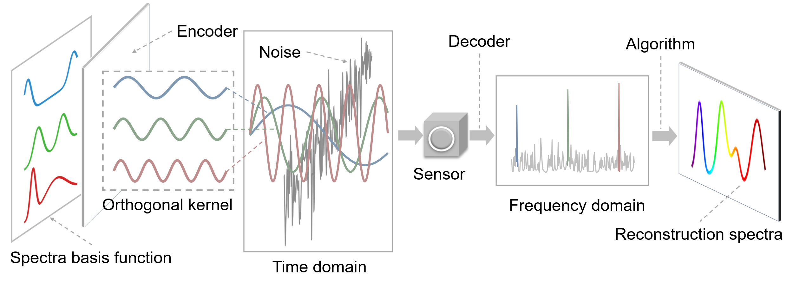
Figure 1. OFE schematic diagram.
In orthogonal frequency encoding scheme, we substitute the binary temporal gating operator $\text{rect}\left(⋅\right)$ with a modulation kernel $m_{k}\left(t;f_{k}\right)$ uniquely assigned to that channel. This substitution eliminates the requirement for sequential time slots, allowing all channels to operate in parallel. The modulation kernel for the $k$-th channel is formulated as:
 | $$m_{k}\left(t;f_{k}\right)=a_{k,0}+a_{k,1}\cos\left(2πf_{k}t+φ_{k}\right)$$ | (2)
where $f_{k}$ is the distinct carrier frequency assigned to channel $k$. $a_{k,0}$ represents the direct current (DC) bias required to ensure non-negative optical intensity. $a_{k,1}$ denotes the carrier amplitude, and $φ_{k}$ is the initial phase of the signal.
Upon simultaneous projection of all spectral channels modulated by their respective kernels, the detector integrates the total photon flux. The received OFE signal $y_{\text{OFE}}\left(t\right)$ is a composite waveform containing information from all $K$channels concurrently:
 | $$y_{\text{OFE}}\left(t\right)=\sum_{k=1}^{K}{\underset{z_{k}}{\underbrace{\left[\int_{λ_{1}}^{λ_{2}}{P_{k}\left(λ\right)R\left(λ\right)S\left(λ\right)dλ} \right]}}}⋅m_{k}\left(t;f_{k}\right)+I_{\text{noise}}\left(t\right)$$ | (3)
To simplify the physical interpretation, we define the scalar $z_{k}$ as the spectral projection value for the $k$-th channel. Substituting the modulation kernel into equation (3), the received signal $y_{\text{OFE}}\left(t\right)$ can be reorganized into two distinct components:
 | $$y_{\text{OFE}}\left(t\right)=\underset{\text{DC }\text{\&} \text{Noise component}}{\underbrace{\sum_{k=1}^{K}{z_{k}a_{k,0}}+I_{\text{noise}}\left(t\right)}}+\underset{\text{Signal }\text{c}\text{omponent}}{\underbrace{\sum_{k=1}^{K}{z_{k}a_{k,1}}\cos\left(2πf_{k}t+φ_{k}\right)}}$$ | (4)
<10-2
The signal decomposition is achieved by mapping the time-domain observation into the frequency domain. Defining $F\{⋅\}$ as the continuous Fourier transform operator, the frequency-domain response $Y\left(f\right)$ is given by:
 | $$Y\left(f\right)=F\{I_{\text{noise}}\left(t\right)\}+\sum_{k=1}^{K}{\frac{1}{2}}z_{k}a_{k,1}\left[e^{jφ_{k}}δ\left(f-f_{k}\right)+e^{-jφ_{k}}δ\left(f+f_{k}\right)\right]$$ | (5)
where $δ\left(⋅\right)$ denotes the Dirac delta function. This formulation demonstrates the mechanism of noise rejection: if the modulation frequencies $\{f_{k}\}$ are designed to avoid the dominant bands of environmental noise without mutual interference, the projection value $z_{k}$ is retrieved by extracting the magnitudes at the corresponding carrier frequencies:
 | $$\left|Y\left(f_{k}\right)\right|=\frac{1}{2}z_{k}a_{k,1}⇒z_{k}=\frac{2\left|Y\left(f_{k}\right)\right|}{a_{k,1}}$$ | (6)
TS=≈≈
Once the projection values for all $K$ channels are retrieved, they are aggregated to form the measurement vector $z={\left[z_{1},z_{2},…,z_{K}\right]}^{\text{T}}$. To recover the spectrum $R\left(λ\right)$ of the target, we discretize the spectral range $\left[λ_{1},λ_{2}\right]$ into $N$ bands and model the measurement process as a system of linear equations:
 | $$z=Wr+e$$ | (7)
where $r∈R^{N}$ represents the ground truth (GT) spectrum, and $W∈R^{K×N}$ is the pre-calibrated system matrix determined by spectral sensing system. The term $e$ accounts for the system noise and measurement residuals. Consequently, the spectral reconstruction is treated as an inverse problem. The estimated spectrum $\hat{r}$ is obtained by finding the solution that minimizes the reconstruction error:
 | $$\hat{r}=\underset{r}{arg min}{{\left\|z-Wr\right\|}_{2}^{2}}$$ | (8)
Experiment

To validate the above principle and to evaluate the system's noise rejection capabilities, we conduct simulation studies comparing the proposed orthogonal frequency encoding (OFE) approach with conventional time division multiplexing (TDM). The simulations are performed under additive white gaussian noise (AWGN). Detailed definitions of the AWGN model, the formulation of the demodulation error, the specific frequency assignments for both the OFE and TDM signals, and the theoretical derivation of the 10 kHz frequency spacing threshold are provided in Supplement 1.
Figure 2. Simulation of noise rejection mechanisms and quantitative analysis. (a) Time-domain signal comparison. OFE exhibits a continuously varying composite waveform characteristic of parallel frequency multiplexing, whereas TDM presents discrete, sequential step-like features. The inset highlights the superimposition of additive white Gaussian noise (AWGN, SNR = 25 dB) on both signals. (b) Quantitative analysis of reconstruction accuracy under AWGN. The results indicate that TDM is significantly more susceptible to AWGN degradation, while OFE maintains a consistently lower root-mean-square error (RMSE) and demodulation error across the evaluated SNR range. (c) Simulated time-domain waveforms for OFE under different frequency spacings (Δf = 1 kHz, 5 kHz, and 10 kHz). (d) Evaluation of RMSE versus SNR across different frequency spacings. When the frequency spacing is selected at 10 kHz—exceeding the minimum threshold required by the OFE framework—the system achieves robust noise immunity, maintaining a consistently low reconstruction error regardless of SNR degradation.
Figure 2(a) illustrates the time-domain waveforms of both schemes under noiseless and noisy conditions. The OFE signal exhibits a continuously varying composite waveform arising from the superposition of multiple sinusoidal carriers modulated simultaneously, whereas the TDM signal presents a discrete, step-like profile corresponding to sequential activation of individual LEDs. When AWGN at SNR = 25 dB is superimposed (inset), the OFE waveform retains its oscillatory structure with only moderate perturbation, while the TDM signal whose amplitude within each time slot is essentially a constant becomes heavily corrupted, as the noise amplitude is comparable to the signal level in each slot.
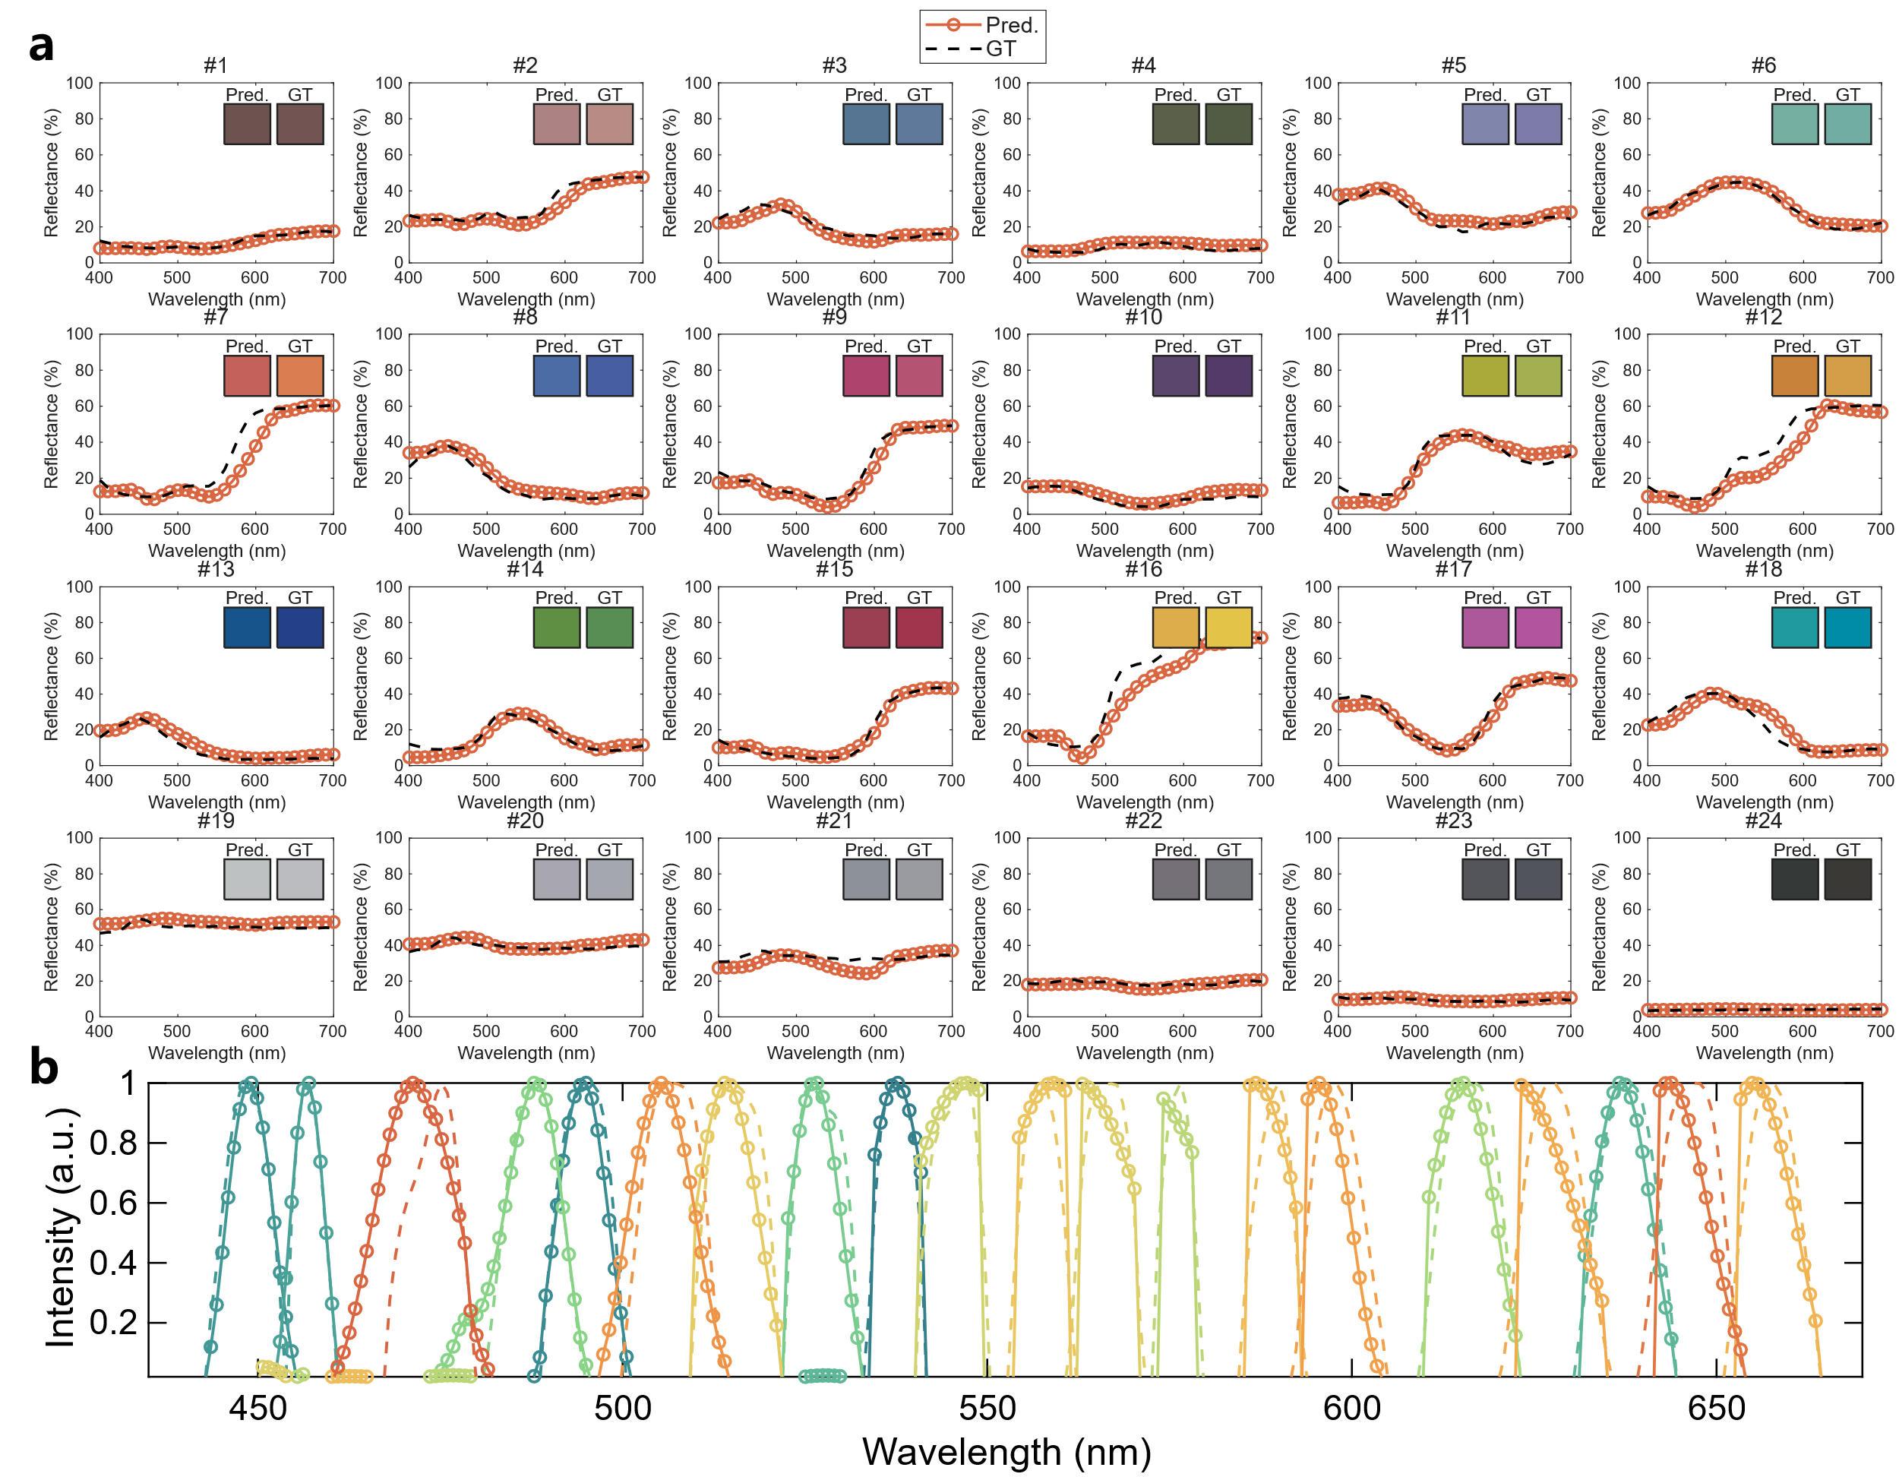
Figure 3. Experimental validation of high-speed, single-shot spectral reconstruction (TS= 250 μs). (a) High-fidelity reconstruction of surface reflectance for the 24 patches of the reflective colorchecker. Open circle markers denote the OFE reconstruction (Pred.), plotted against the ground truth reference (GT, black dashed lines). Despite the rapid 250 μs acquisition window, the system achieves an average RMSE of 0.0422. Insets visualize the sRGB color rendering of the predicted versus GT spectra. (b) Resolution capability demonstration using 10 nm FWHM narrowband peaks. Open-circle markers indicate the discrete spectral points of the reconstructed profiles, compared against the GT (dashed lines). The accurate reconstruction of these sharp spectral features confirms that the OFE framework effectively decouples acquisition speed from spectral resolution, avoiding the signal broadening artifacts typically associated with high-speed computational sensing.
This qualitative observation is quantified in Fig. 2(b), which plots the spectral reconstruction RMSE (left axis) and the demodulation error (right axis) as functions of input SNR. Across the entire evaluated range from −10 dB to 40 dB, OFE consistently achieves lower RMSE and demodulation error than TDM by a near-constant factor. This can be understood from the processing gain inherent to frequency-domain demodulation: in OFE, the coherent correlation detection effectively integrates over all N samples of the acquisition window for every channel, whereas in TDM each channel is confined to a time slot containing only N/K samples, where K denotes the number of LEDs. The resulting noise variance ratio is K, yielding a demodulation error ratio of √K ≈ 3.5 for K = 12 channels, consistent with the observed separation between the two curves.
Beyond broadband AWGN, a distinct noise concern in practical OFE systems is narrowband interference from ambient sources whose spectral content falls near the modulation carriers. To investigate this, we simulate multi-tone interference at frequencies offset from the OFE carriers by Δf = 1, 5, and 10 kHz, respectively. As shown in Fig. 2(c), the time-domain waveforms under Δf = 1 kHz exhibit pronounced beating patterns, indicating strong spectral leakage into the demodulation bins, while larger offsets produce progressively less visible distortion. Figure 2(d) presents the corresponding RMSE as a function of SNR. At Δf = 1 kHz, the OFE reconstruction error remains elevated and comparable to or worse than TDM, because the interfering tones fall within the mainlobe of the DFT bins centered on each carrier, rendering the frequency-domain separation ineffective. At Δf = 5 kHz the situation improves substantially, particularly at moderate-to-high SNR, as the interference migrates toward the sidelobe region. At Δf = 10 kHz — exceeding the minimum guard-band threshold dictated by the frequency resolution 1/T of the acquisition window — the OFE system restores its full noise immunity, maintaining a consistently low RMSE that is nearly independent of the interference level. These results establish a practical design guideline: the minimum carrier spacing in OFE must satisfy Δf ≥ 1/T with sufficient margin to ensure that ambient narrowband interference does not compromise reconstruction fidelity.ΔΔ
Figure 4. Experimental robustness evaluation under harsh electromagnetic interference (50 kHz SMPS noise, TS= 1000 μs). (a) Time-domain signal under high-SNR conditions (23.11 dB). This baseline measurement displays the modulated OFE carriers with minimal environmental interference, providing a reference for high-fidelity signal acquisition. (b) Time-domain signal under a low SNR of
-11.77 dB. In this scenario, the target signal is substantially masked by high-energy, structured environmental noise. (c) Frequency-domain representation of the OFE signal. The discrete peaks (marked by red triangles) between 380 kHz and 490 kHz correspond to the orthogonal frequency carriers, illustrating the sparse and localized nature of the encoded spectral information. (d) Frequency-domain interference analysis. The plot reveals a clear separation between the high-energy environmental noise concentrated at low frequencies and the designated "Signal area" at higher frequencies. This separation is fundamental to the system's ability to extract spectral data from a noisy background. (e) RMSE vs. SNR curve. A distinct robustness plateau is observed where reconstruction fidelity remains invariant (RMSE ≈ 0.03) despite a 30 dB drop in SNR. Performance breakdown occurs only when the SNR breaches the threshold of ≈ -12 dB, where noise harmonics begin to overwhelm the signal carriers. (f) Reconstructed transmittance spectra across varying noise levels. Despite the extreme interference shown in (b), the reconstructed curves (dashed lines) for SNRs ranging from 23.11 dB down to -11.77 dB show high alignment with the reference spectrum (solid black line), confirming the framework's reliability in challenging environments.

-
TS=

We first assess the system's resolving capability under controlled lighting conditions. Figure 3a presents the spectral reconstruction of a standard reflective colorchecker. Despite the rapid 250 μs snapshot acquisition, the system retrieves the broadband reflectance profiles with high fidelity, achieving an average root mean square error (RMSE) of 0.0422. The system’s capability to resolve fine spectral features is evidenced in Figure 3b. The accurate reconstruction of 10 nm FWHM narrowband peaks confirms that the OFE framework alleviates the inherent trade-off between acquisition speed and spectral resolution. By shifting from time-serial acquisition to frequency-multiplexed encoding, the system circumvents the artificial spectral widening typically caused by under-sampling or noise-reduction smoothing in high-speed computational sensing.
To evaluate the operational limits of the OFE framework, we subject the system to an electromagnetic environment dominated by high-energy switching noise (centered at 50 kHz). This interference, characteristic of common power electronics, specifically switched-mode power adapters, solid-state lighting drivers, and electronic ballasts, found extensively in modern daily infrastructure, presents a challenge due to its dense series of high-energy harmonics. The challenging signal conditions of this environment are visualized in Figure 4b. To ensure sufficient integration and frequency resolution under such interference, the acquisition window is extended to 1000 μs, and the specific selection of the modulation frequency set refers to Hopt, as detailed in Supplement 1.
Under an SNR of -11.77 dB, the target signal is overwhelmed by the intense switching ripples. In this regime, the minute modulation features are indistinguishable from the large interference baseline, rendering conventional time-domain integration or DC-coupled detection schemes ineffective. The frequency-domain analysis in Figure 4c-d demonstrates the mechanism of OFE’s immunity. While the noise harmonics possess amplitudes significantly higher than the signal carriers, the system exploits the discrete nature of interference by interleaving modulation carriers within vacant spectral gaps, thereby ensuring strict frequency-domain orthogonality that allows for high-fidelity signal recovery amidst high-power noise harmonics.

Figure 4e quantifies this resilience, revealing a distinct robustness plateau here reconstruction fidelity remains virtually invariant (RMSE ≈ 0.03) despite a 30 dB degradation in SNR. The performance breakdown occurs when the SNR breaches the threshold of approximately -12 dB. As shown in Figure 4f, at the SNR of -11.77 dB, the reconstructed spectrum retains its characteristic shape with an RMSE of 0.0261.
Figure 5. Trade-off of the OFE framework under a fixed hardware bandwidth of 500 kHz. The bottom axis represents the number of spectral channels K, while the top axis displays the corresponding minimum frequency spacing Δf required to maintain orthogonality among all carriers within the available bandwidth. The blue curve (left axis) shows the simulated spectral reconstruction RMSE as a function of K, evaluated on the open dataset “CAVE” ; reconstruction fidelity improves rapidly with increasing K and saturates beyond approximately 15 channels. The red curve (right axis, logarithmic scale) indicates the theoretical lower bound on acquisition time, governed by the time–frequency uncertainty relation T = 1/Δf: accommodating more channels necessitates a smaller Δf and thus a longer integration window. The two markers at K = 12 denote the actual operating configurations of the prototype: the green star corresponds to the speed-optimized experiment (T = 250 μs, Fig. 3), and the orange diamond corresponds to the noise-robust experiment (T = 1000 μs, Fig. 4). Both points lie above the theoretical bound, as practical deployment requires additional spectral margin to ensure robust carrier separation and interference avoidance.
To systematically characterize the design space of the OFE framework, we analyze the trade-off among three coupled parameters: the number of spectral channels K, the minimum carrier frequency spacing Δf, and the acquisition time T. For a given hardware modulation bandwidth Bhw, accommodating K orthogonal carriers requires a minimum frequency spacing of Δf = Bhw/(2K), while the time–frequency uncertainty relation dictates that T ≥ 1/Δf. Consequently, increasing the number of channels demands a proportionally longer acquisition window. Figure 5 quantifies this trade-off for our prototype (Bhw = 500 kHz). The simulated reconstruction RMSE decreases rapidly as K increases from 4 to approximately 15 and subsequently saturates, indicating diminishing returns from additional channels. Meanwhile, the theoretical minimum acquisition time grows linearly with K. The two experimental configurations demonstrated in this work — the speed-optimized setup (Strategy 2, T = 250 μs, Fig. 3) and the noise-robust setup (Strategy 1, T = 1000 μs, Fig. 4) — both operate at K = 12, which lies near the onset of the RMSE saturation plateau. The difference in their acquisition times reflects a deliberate design choice: Strategy 2 distributes carriers across the full available bandwidth to minimize T, whereas Strategy 1 concentrates carriers in a narrow high-frequency band to avoid interference harmonics, requiring a finer frequency resolution and hence a longer integration window. This analysis confirms that the current 12-channel configuration achieves near-optimal reconstruction fidelity while preserving significant headroom for future channel expansion within the existing hardware bandwidth.
Conclusion and discussion
In this work, we propose OFE to resolve the speed-SNR trade-off inherent in conventional TDM. By shifting from serial scanning to parallelized frequency-domain encoding, the system achieves single-shot spectral reconstruction in 250 $\text{μ}\text{s}$. Crucially, unlike standard lock-in techniques, OFE employs a strategic frequency allocation scheme that exploits the spectral gaps of structured environmental noise. This mechanism ensures robust retrieval (RMSE $≈$ 0.0261) even under harsh interference with an SNR of -11.77 dB (at a 1000 $\text{μs}$ sampling time), effectively immunizing the system against common artifacts like PWM dimming and SMPS ripples.
However, the performance boundaries of OFE are strictly dictated by hardware constraints rather than the encoding strategy itself. The acquisition speed $T$ is governed by the time-frequency uncertainty principle, $T ≈1/Δf$. While our prototype is limited to 250 $\text{μs}$ by the 500 kHz bandwidth of LED drivers, the framework holds immense potential for ultrafast spectroscopy. By transitioning to high-speed laser diodes modulated at hundreds of megahertz or even gigahertz, the system can theoretically scale to nanosecond-level acquisition times, allowing for a dramatic increase in the number of spectral channels without compromising temporal resolution.
To extend the system's capabilities, the OFE architecture offers versatile scalability across spectral, spatial, and functional dimensions. First, the spectral range is not confined to the visible band; by incorporating appropriate sources and detectors, the framework can be readily expanded to the ultraviolet or infrared regions, enabling molecular fingerprinting in complex environments. Second, coupling OFE with event cameras (capable of microsecond-level temporal resolution) or SPAD arrays (achieving picosecond to nanosecond-level precision) facilitates hyperspectral imaging. Finally, the active nature of OFE opens new possibilities for real-time adaptive sensing. Unlike passive spectrometers, the illumination patterns in OFE can be dynamically optimized based on initial measurements to maximize the reconstruction fidelity for specific spectral features, establishing a closed-loop framework for intelligent optical sensing.

