Supplement: Robust computational spectral sensing via orthogonal frequency encoding
Yijia Zeng¹, Zhi Zhang¹, Quanzhou Long¹, Yafan Jin¹, Zijian Lin¹, Feng Zhou ¹, Tingbiao Guo^{1,2,}*, Sailing He^{1,2,}*
1 Centre for Optical and Electromagnetic Research, National Engineering Research Center for Optical Instruments, College of Optical Science and Engineering, Zhejiang University, Hangzhou, Zhejiang, China
2 Institute of Fundamental and Transdisciplinary Research, Zhejiang University, Hangzhou, Zhejiang, China
3 Department of Electromagnetic Engineering, School of Electrical Engineering, Royal Institute of Technology, Stockholm S-10044, Sweden
*Corresponding authors: sailing@kth.se and tbguo@zju.edu.cn

Section 1: Spectral reconstruction based on projected gradient descent
While equation (8) in the main text describes the least-squares solution, solving the ill-posed inverse problem under physical constraints requires adaptive regularization to handle diverse spectral topologies. The $L_{1}$ norm is utilized to promote sparsity for recovering narrowband peaks, whereas the smoothness term exploits the inherent spectral continuity across adjacent bands to reconstruct broadband signatures; meanwhile, the $L_{2}$ norm acts as an energy constraint to ensure numerical stability. To solve this, we employ the projected gradient descent (PGD) algorithm to minimize the composite objective function subject to the box constraint $C=\{r∣0⪯r⪯1\}$:
$$J\left(r\right)=\min_{0⪯r⪯1}\left(\frac{1}{2}{\left\|z-Wr\right\|}_{2}^{2}+β_{1}{\left\|r\right\|}_{1}+\frac{β_{2}}{2}{\left\|r\right\|}_{2}^{2}+\frac{β_{3}}{2}{\left\|Dr\right\|}_{2}^{2}\right)$$
where $D∈R^{\left(N-1\right)×N}$ is the first-order difference matrix:
The gradient $∇J\left(r\right)$ is:
$$∇J\left(r\right)=W^{T}\left(Wr-z\right)+β_{1}\text{sgn}\left(r\right)+β_{2}r+β_{3}D^{T}Dr$$
The iterative update rule is given by:
$$r^{\left(k+1\right)}=\min\left(\max\left(0,r^{\left(k\right)}-α⋅∇J\left(r^{\left(k\right)}\right)\right),1\right)$$
Algorithm S1: PGD spectral reconstruction
Input: $z,W,D$, parameters $β_{1,2,3},α,K_{\text{max}},τ$.
Output: $\hat{r}$.
- Initialize: $r^{\left(0\right)}←0$,$k ←0$, $ϵ←∞$
- While $k<K_{\text{max}}$ and $ϵ> τ$ do:
- $g^{\left(k\right)}←W^{T}\left(Wr^{\left(k\right)}-z\right)+β_{1}\text{sgn}\left(r^{\left(k\right)}\right)+β_{2}r^{\left(k\right)}+β_{3}D^{T}Dr^{\left(k\right)}$
- $r^{\left(k+1\right)}←\min\left(\max\left(0,r^{\left(k\right)}-α⋅g^{\left(k\right)}\right),1\right)$
- $ϵ←\frac{{\left\|r^{\left(k+1\right)}-r^{\left(k\right)}\right\|}_{2}^{2} }{{\left\|r^{\left(k\right)}\right\|}_{2}^{2}}$
- $k ←k + 1$
- End While
- Return $·$
In the experimental implementations, for broadband continuous targets (e.g., the 24-patch colorchecker), the regularization weights are empirically set to $β_{1}=0$, $β_{2}=0.05$, and $β_{3}=1$. For narrowband filters, the sparsity prior is activated with $β_{1}=0.1$, while $β_{2}$ and $β_{3}$ are set to 0. The step size $α$ is $0.001$.
Section 2: Modulation frequency set selection criteria
Unlike the proposed OFE framework, the conventional time division multiplexing (TDM) scheme requires no complex frequency-domain constraints. In our simulation, TDM utilizes no modulation frequency; instead, it simply divides the 100 μs acquisition window into 12 sequential time slots (≈ 8.33 μs each) of constant DC signal. For the OFE system, which operates over the identical 100 μs acquisition window regardless of its specific frequency configuration, let $\{f_{1},f_{2},…,f_{K}\}$ denote the set of modulation frequencies for the $K$ spectral basis functions. The selection of this frequency set is constrained by both non-ideal hardware characteristics and fundamental signal processing principles. Specifically, it must adhere to the following three physical constraints:
- Spectral separability condition
 | $$\left|f_{i}-f_{j}\right|>Δf, ∀i≠j$$ | (1)
The signal integration performed by the detector is confined to a finite time window $T$. This process is equivalent to multiplying the infinitely long original signal $x\left(t\right)$ by a rectangular window function $\text{rect}\left(t/T\right)$ of width $T$:
 | $$x_{T}\left(t\right)=x\left(t\right)⋅\text{rect}\left(\frac{t}{T}\right)$$ | (2)
Assuming the original signal is a single-frequency cosine wave $x\left(t\right)=\cos\left(2πf_{0}t\right)$ (whose spectrum is the impulse function $δ\left(f-f_{0}\right)$), the spectrum $X_{T}\left(f\right)$ of the truncated signal can broaden into a sinc function morphology:
 | $$X_{T}\left(f\right)=X\left(f\right)*F\left[\text{rect}\left(\frac{t}{T}\right)\right]=X\left(f\right)*\left[T⋅\text{sinc}\left(πfT\right)\right]$$ | (3)
The derivation above demonstrates that the ideally sharp impulse spectral line broadens due to spectral leakage. The main lobe width of the sinc function (i.e., the Rayleigh bandwidth) directly determines the system's frequency resolving capability.
- Harmonic interference avoidance condition
Due to the hardware limitations discussed above, the $j$-th channel signal contains not only the fundamental frequency $f_{j}$ but also higher-order harmonics such as $2f_{j}$, $3f_{j}$, etc. There are two strategies to avoid harmonic interference: sub-octave design and specific frequency avoidance. If the frequency set satisfies the condition that the maximum frequency $f_{\text{max}}$ is less than twice the minimum frequency $f_{\text{min}}$:
 | $$f_{\text{max}}<2⋅f_{\text{min}}$$ | (4)
Then, the second harmonic of the lowest frequency signal ($2f_{\text{min}}$) will reside above the highest frequency signal ($f_{\text{max}}$). In this sub-octave strategy, the entire fundamental frequency band is free of harmonic interference. However, if the system bandwidth is restricted or the number of channels is large, resulting in $f_{\text{max}}≥2f_{\text{min}}$, the following constraint must be enforced to ensure that no fundamental frequency coincides with the harmonics of other channels:
 | $$f_{j}≠n⋅f_{i}, ∀i≠j, n∈\{2,3,…,N_{\text{max}}\}$$ | (5)
where $N_{\text{max}}$ is the highest harmonic order limited by the effective bandwidth $f_{\text{bw}}$ of the system.
- Intermodulation interference avoidance
 | $$\left|f_{i}-f_{j}\right|≠f_{k}, ∀i≠j≠k$$ | (6)
Assuming the output response $I_{\text{sensor}}\left(t\right)$ of the sensor contains a quadratic non-linear term:
 | $$I_{\text{sensor}}\left(t\right)∝{\left(\sum_{k=1}^{K}{E_{k}\left(t\right)}\right)}^{2}$$ | (7)
where $E_{k}\left(t\right)=E_{0k}\cos\left(2πf_{k}t\right)$ is the equivalent signal component of the $k$-th modulation kernel. Expanding the squared term yields:
 | $$I_{\text{sensor}}\left(t\right)∝\sum_{k=1}^{K}{E_{0k}^{2}}\cos^{2}\left(2πf_{k}t\right)+\sum_{i≠j}{E_{0i}E_{0j}}\cos\left(2πf_{i}t\right)\cos\left(2πf_{j}t\right)$$ | (8)
The cross-term can be expanded as:
 | $$\cos\left(2πf_{i}t\right)\cos\left(2πf_{j}t\right)=\frac{1}{2}\left[\cos\left(2π\left(f_{i}+f_{j}\right)t\right)+\cos\left(2π\left(f_{i}-f_{j}\right)t\right)\right]$$ | (9)
This equation reveals that hardware non-linearities inevitably generate sum and difference frequency interferences. While sub-octave strategies inherently exclude sum-frequencies from the operational band, difference-frequencies—and both components in wider-band systems—can still cause contamination. If any combination frequency coincides with a target demodulation frequency $f_{k}$, an uncalibratable interference term corrupts the measured amplitude:
 | $${\hat{A}}_{k}=A_{k}+ν⋅A_{i}A_{j}$$ | (10)
Here, $ν$ represents the intermodulation coefficient and $A_{i}A_{j}$ denotes the mixing contribution, which introduces non-linear distortion that fundamentally degrades spectral reconstruction.
Section 3: Frequency selection strategies
To eliminate spectral leakage caused by non-integer period truncation, the system satisfies the coherent sampling condition, requiring all modulation frequencies $f_{k}$ to be integer multiples of the frequency resolution $Δf$:
 | $$f_{k}=M⋅Δf, M∈Z^{+}$$ | (11)
Guided by this fundamental constraint, we formulate two theoretical frequency selection strategies catering to different system bandwidth capacities and computational priorities.
1. Strategy 1: Linear planning based on sub-octave rules
Under the sub-octave constraint ($f_{\text{max}}<2⋅f_{\text{min}}$) second and higher-order harmonics of any channel inherently fall outside the effective signal band $\left[f_{\text{min}},f_{\text{max}}\right]$ condition eliminates the need for complex combinatorial optimization; orthogonality is guaranteed simply by spacing the frequencies linearly according to Eq. (11).
2. Strategy 2: Broadband optimization via greedy algorithm
When the system bandwidth is wide ($f_{\text{max}}≥2⋅f_{\text{min}}$), frequency selection becomes a multi-constraint combinatorial optimization problem. We design a greedy algorithm (Algorithm S2) as follows:
Algorithm S2: Greedy optimization for modulation frequency selection
Input：Lower bound $f_{\text{min}}$, upper bound $f_{\text{max}}$, resolution $Δf$, channel count $K$
Output：Frequency set $H=\{f_{1},f_{2},…,f_{K}\}$
1： $H←∅$
2： for $f = f_{min}$ to $f_{max}$ step $Δf$ do
3： if $∀f∈H$，the candidate $f$ satisfies:
4： $\left|f_{i}-f_{j}\right|>Δf$
5： $f≠n⋅f_{i}$，$∀n∈Z_{≥2}$
6： $\left|f-f_{i}\right|≠f_{j}$，$∀f∈H$
7： $f+f_{i}≠f_{j}$，$∀f∈H$
8： then
9： $H←H∪\left\{f\right\}$
10： if $\left|H\right|=K$ then return $H$
11： end for
12： return $H$
In this study, the practical hardware imposes a physical modulation bandwidth limit of 500 kHz. To evaluate the orthogonal frequency encoding (OFE) framework under this constraint, we apply the above frequency selection strategies across our numerical simulations and physical experiments.
Simulation setup (Strategy 1): The objective of the numerical simulation is to demonstrate the advantage of the OFE framework over conventional TDM in terms of noise rejection. We apply Strategy 1 as a representative interference-free configuration. By setting the lower bound $f_{\text{min}}=380$ kHz and the frequency spacing $Δf = 10$ kHz, we establish the following 12-channel frequency set $H_{\text{sub}}$ (in kHz):
 | $$H_{\text{sub}}=\{380,390,400,410,420,430,440,450,460,470,480,490\}$$ | (12)
Experimental setup (Strategies 1 and 2): The deployment of these strategies in hardware is dictated by the environmental constraints. As demonstrated in Figure 3 of the main text, Strategy 2 ($H_{\text{opt}}$) is utilized in pristine environments to maximize acquisition speed ($T_{s}=250$s). Conversely, as detailed in Figure 4, the system dynamically switches to Strategy 1 ($H_{\text{sub}}$) under 50 kHz SMPS interference. This shifts the carriers to a high-frequency safe harbor (380–490 kHz), sacrificing acquisition speed ($T_{s}=1000$s) to actively evade deterministic low-frequency harmonics. The optimal 12-channel broadband set $H_{\text{opt}}$ (in kHz) generated and experimentally verified is:
 | $$H_{\text{opt}}=\{30,50,70,110,130,170,190,230,290,310,370,410\}$$ | (13)
Section 4: Additive white gaussian noise (AWGN) model
In this study, noise interferences are treated as additive noise. The actual observed signal $\hat{y}\left(t\right)$ received by the system is modeled as a linear superposition of the ideal signal $y\left(t\right)$ and the specific environmental noise $n\left(t\right)$ applied independently:
 | $$\hat{y}\left(t\right)=y\left(t\right)+n\left(t\right)$$ | (14)
where $y\left(t\right)$ is the noiseless signal (OFE or TDM) and $n\left(t\right)∼N\left(0,σ_{n}^{2}\right)$ is independent and identically distributed Gaussian white noise. The noise variance is determined by a prescribed signal-to-noise ratio (SNR) in decibels:
$$σ_{n}^{2}=\frac{P_{s}}{{10}^{{SNR}_{\text{dB}}/10}}$$
where $P_{s}$ is the signal power of the noiseless OFE waveform, computed as the temporal variance of the composite sinusoidal signal. The same noise power $σ_{n}^{2}$ and the same random realization are applied to both the OFE and TDM signals.
Section 5: Phase noise simulation
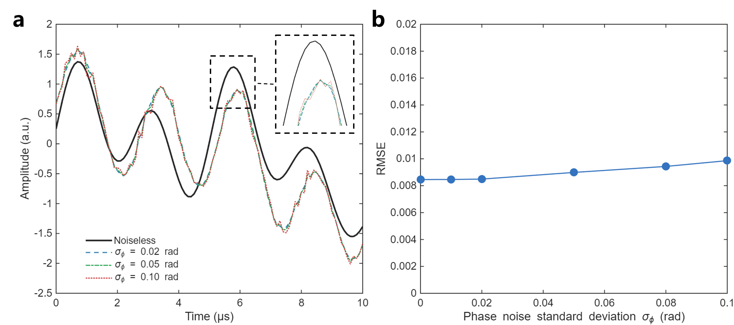
Figure S1. Simulation of OTE robustness against phase noise. (a) Time-domain waveform response under varying phase noise intensities ($σ_{ϕ}=0∼0.1\text{ rad}$). The inset highlights that phase instability causes minor horizontal shifts in peak positions rather than amplitude distortion. (b) Spectral reconstruction RMSE as a function of phase noise standard deviation. The system demonstrates exceptional stability, with negligible error growth within the typical operating range of hardware oscillators ($σ_{ϕ}<0.01\text{ rad}$).
Beyond additive noise, phase instability in oscillator, typically arising from signal generators or phase-locked loops (PLLs), affects OFE performance. The modulated signal with phase noise is modeled as:
$$s_{\text{noisy}}\left(t\right)=\sum_{k=1}^{K}{A_{k}}\cos\left(2πf_{k}t+ϕ_{k}+θ_{k}\left(t\right)\right)$$
where $θ_{k}\left(t\right)$ represents the phase jitter, modeled as a zero-mean Gaussian random process: $θ_{k}\left(t\right)∼N\left(0,σ_{ϕ}^{2}\right)$.
For a small phase deviation ($σ_{ϕ}≪1$ rad), using the small-angle approximation ($\cos{θ}≈1,\sin{θ}≈ θ$), the signal for the $k$-th channel can be expanded as:
$$s_{k}\left(t\right)=A_{k}\cos\left(2πf_{k}t+ϕ_{k}\right)\cos\left(θ_{k}\left(t\right)\right)-A_{k}\sin\left(2πf_{k}t+ϕ_{k}\right)\sin\left(θ_{k}\left(t\right)\right) \\ ≈\underset{\text{Ideal Carrier}}{\underbrace{A_{k}\cos\left(2πf_{k}t+ϕ_{k}\right)}}-\underset{\text{Interference}}{\underbrace{A_{k}θ_{k}\left(t\right)\sin\left(2πf_{k}t+ϕ_{k}\right)}}$$
This derivation reveals that phase noise introduces an orthogonal interference component modulated by the random process $θ_{k}\left(t\right)$. This results in spectral leakage (energy loss at the carrier frequency) and disrupts orthogonality, leading to inter-channel crosstalk.
Figure S1 illustrates the system's response to phase noise with standard deviations $σ_{ϕ}$ ranging from 0 to 0.1 rad. As shown in Figure S1(a), unlike additive noise which induces sharp amplitude spikes or "burrs," phase noise manifests primarily as minute horizontal timing jitters (time-axis deviations), while the overall signal envelope remains smooth and intact.
Figure S1(b) quantifies the robustness. The spectral reconstruction error (RMSE) exhibits a slow linear increase, rising only marginally from 0.0085 to $≈0.01$ even when $σ_{ϕ}$ reaches 0.1 rad ($≈{5.7}^{∘}$). Given that modern commercial signal generators typically maintain phase noise well below 0.01 rad, the system operates in the flat region of the error curve, rendering oscillator instability negligible for practical spectral reconstruction.
Section 6: Spectral distribution of LED array
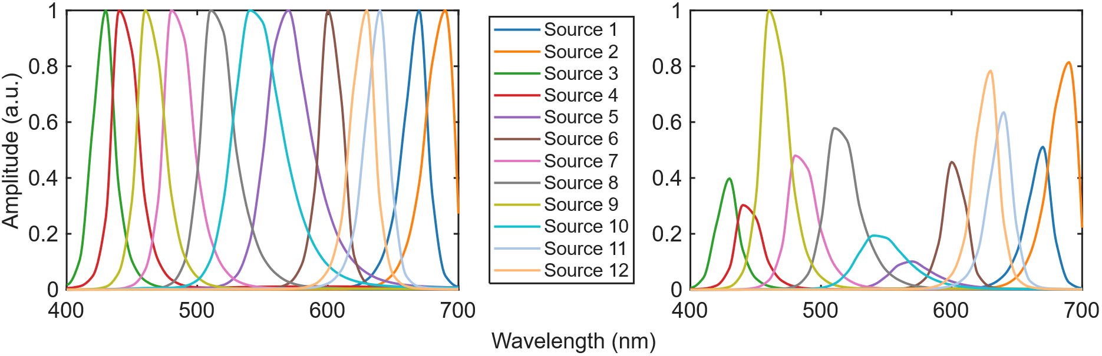
Figure S2. Spectral characterization of the illumination sources. (a) Normalized spectral profiles of the 12 channels. The sources exhibit narrowband characteristics with distinct center wavelengths distributed across the visible band (400–700 nm). (b) Actual relative intensity distribution. The plot reveals the native radiant flux variations among the sources, which are accounted for in the system calibration matrix to ensure accurate radiometric retrieval.
Figure S2 characterizes the spectral properties of the 12 discrete LEDs utilized in the prototype. The left panel illustrates the normalized spectral profiles (amplitude scaled to [0, 1]). The right panel displays the measured relative radiant flux of the sources under identical driving conditions. The variations in peak amplitude reflect the inherent differences in quantum efficiency and electro-optical conversion characteristics of different semiconductor materials across the spectrum. These intensity disparities are pre-calibrated and compensated for within the system matrix $W$.
Section 7: Photograph of the physical experimental setup
The optical receiver employs a photodiode (PDA100A2, Thorlabs) with an 11 MHz bandwidth. The time-domain composite waveforms are digitized utilizing a high-speed oscilloscope (DS1202Z-E, RIGOL) featuring a 200 MHz analog bandwidth and a 1 GSa/s real-time sampling rate. The baseband modulation sequences are synthesized by a microcontroller unit (MCU, STM32F103C8T6, 72 MHz core clock). However, the ultimate system modulation bandwidth is strictly bottlenecked by the switching characteristics of the constant-current LED driver ICs (PT4115). Consequently, the maximum operational modulation frequency is physically bounded at 500 kHz. This hardware limitation dictates the frequency selection upper bounds ($B=500 kHz$) discussed in Section 3.
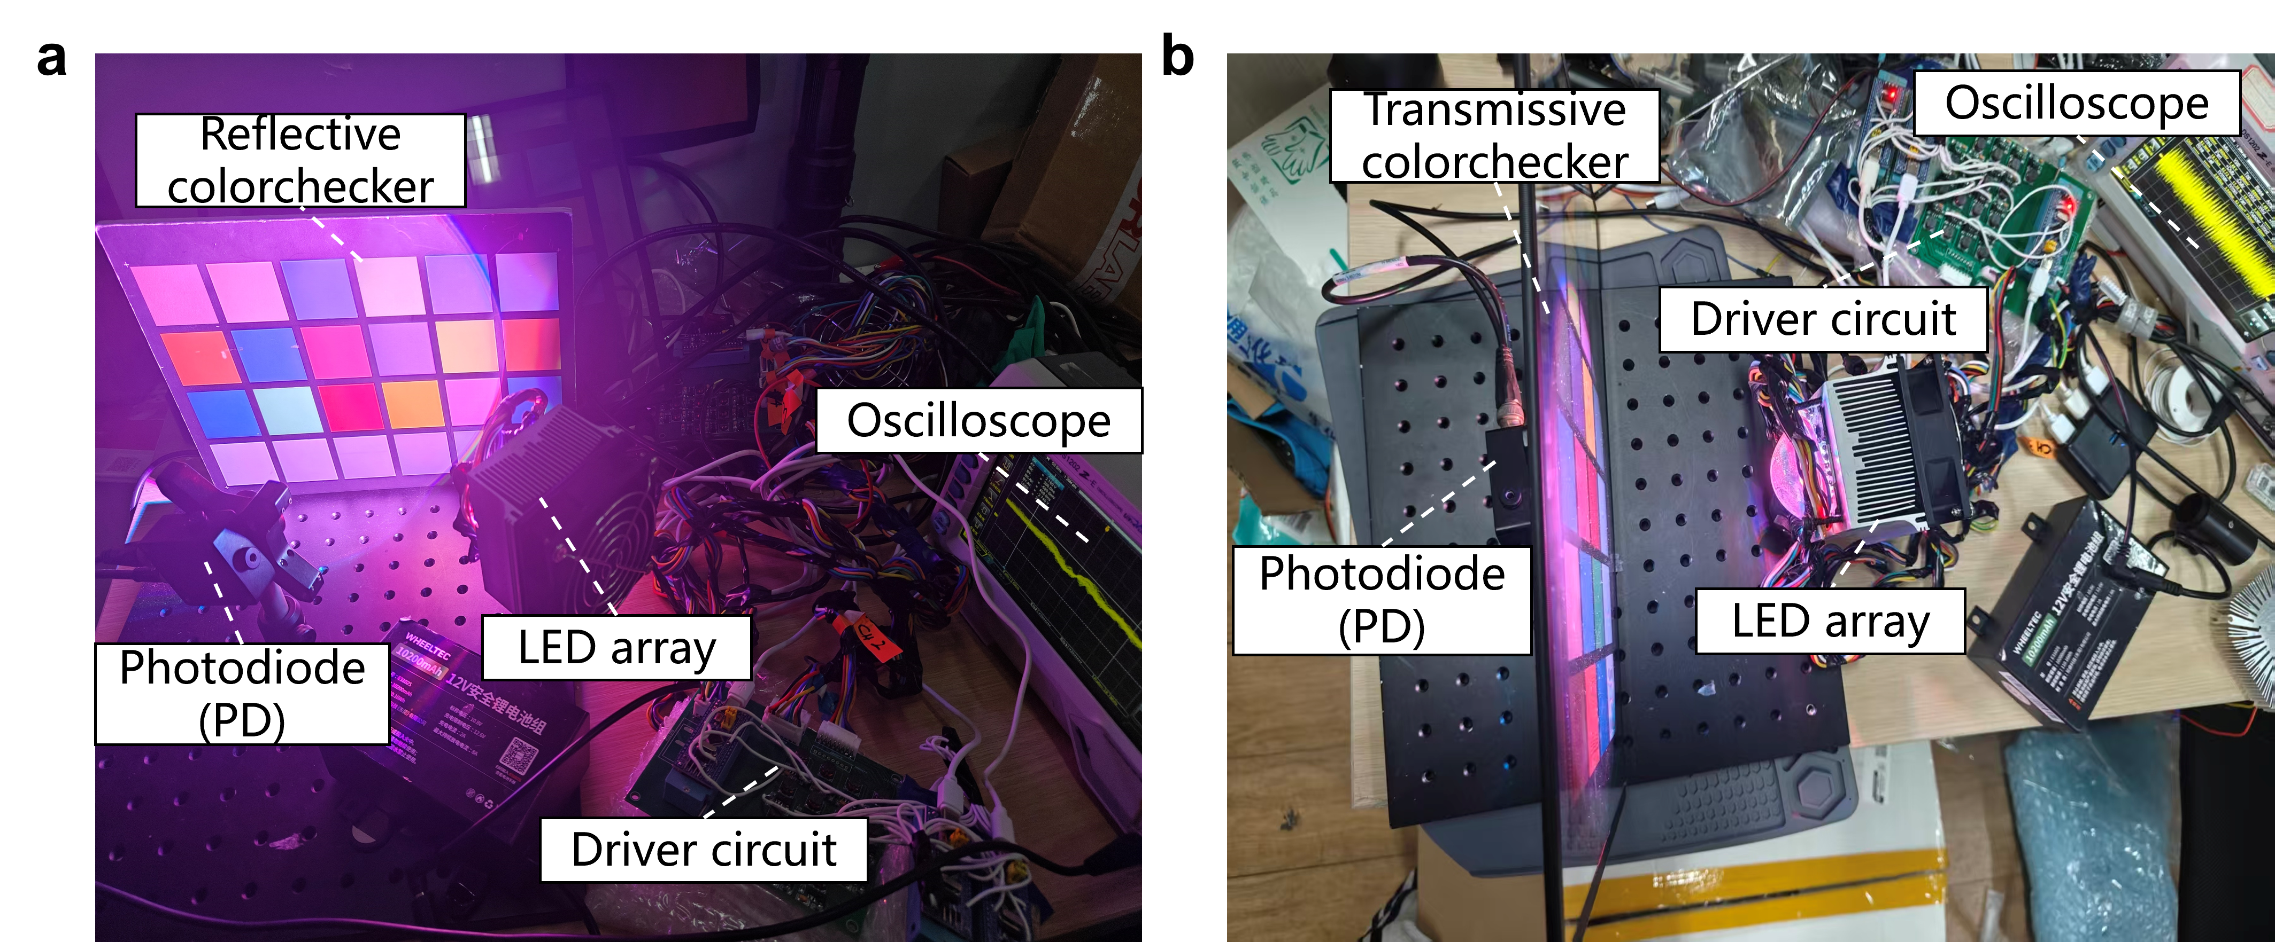Figure S3. Photographs of the reconfigurable physical optoelectronic prototype. (a) The reflective modality configured for macroscopic broadband targets (as evaluated in Main Text Fig. 3b), depicting the customized LED array illuminating a standard 24-patch reflective colorcchecker, with the reflected photons captured by the photodiode (PD). (b) The transmissive modality configured for edge-case stress testing (as evaluated in Main Text Fig. 4), incorporating a transmissive colorchecker. Both optical paths are governed by a customized driver circuit, with the time-domain composite signals acquired via a high-speed oscilloscope.
Section 8: Definition of signal-to-noise ratio (SNR) in the frequency domain
To quantitatively assess the robustness of the orthogonal frequency encoding (OFE) framework, the signal-to-noise ratio (SNR) is defined in the frequency domain, consistent with our signal retrieval process. This definition accounts for practical hardware constraints and ensures a rigorous evaluation of the system’s noise rejection capabilities.
- Signal Power ($P_{\text{signal}}$)
In the experimental setup, the modulation signals generated by the hardware (e.g., LED drivers) are not ideal sinusoids and contain both even and odd harmonics. However, the spectral reconstruction algorithm exclusively extracts energy at the fundamental carrier frequencies $\{f_{k}\}$. Consequently, the signal power is defined as the sum of the squared magnitudes at these specific frequencies:
$$P_{\text{signal}}=\sum_{k=1}^{K}{{\left|Y\left(f_{k}\right)\right|}^{2}}$$
where $Y\left(f_{k}\right)$ represents the complex magnitude of the spectrum at carrier frequency $f_{k}$. All higher-order harmonics ($nf_{k}$ for $n≥2$) are excluded from $P_{\text{signal}}$ as they do not contribute to the spectral reconstruction.
- Noise Power ($P_{\text{noise}}$)
The noise power is defined as the total residual energy within the experimental bandwidth that could potentially interfere with the carrier extraction. To provide a conservative and precise assessment of external noise immunity, $P_{\text{noise}}$ is calculated by excluding the DC component, the fundamental carriers, and their associated higher-order harmonics:
$$P_{\text{noise}}= \sum_{f∈\left(0,\left.B\right]\right.,f∉{\left\{nf_{k}\right\}}_{n≥1}}{{\left|Y\left(f\right)\right|}^{2}}$$
where $B$ denotes the maximum frequency of interest is set to 500 kHz, determined by the physical modulation limits of the system. The direct current (DC) at 0 Hz, the fundamental carriers $\{f_{k}\}$, and all their higher-order harmonics $\{nf_{k} | n=2,3,…\}$ are strictly removed from the summation. By excluding harmonics from $P_{\text{noise}}$, we treat these deterministic hardware artifacts as systematic losses rather than stochastic noise. Consequently, $P_{\text{noise}}$ focuses on environmental disturbances such as SMPS switching ripples and PWM dimming artifacts.
- SNR Calculation
The SNR is expressed as the ratio of the fundamental carrier power to the total residual interference power within the sensing bandwidth:
$$\text{SNR}\left(\text{dB}\right)=\frac{P_{\text{signal}}}{P_{\text{noise}}}=10\log_{10}\left(\frac{\sum_{k=1}^{K}{{\left|Y\left(f_{k}\right)\right|}^{2}}}{\sum_{f∈\left(0,\left.B\right]\right.,f∉{\left\{nf_{k}\right\}}_{n≥1}}{{\left|Y\left(f\right)\right|}^{2}}}\right)$$
This frequency-domain definition provides a conservative estimate of the system's performance. By treating harmonic distortions as a form of self-interference and excluding them from the signal power, we ensure that the reported SNR (e.g., -11.77 dB) accurately reflects the framework's ability to recover high-fidelity spectral information from a heavily submerged signal. This approach maintains strict consistency between the SNR calculation and the actual physical mechanism of spectral retrieval.
Section 9: Empirical benchmarking of acquisition time and frequency strategies
To rigorously map the theoretical integration time ($T = 1/Δf$) to the physical hardware performance, we empirically benchmark the reconstruction error against varying sampling times. To ensure statistical robustness and generalization across diverse spectral profiles, the reported root-mean-square error (RMSE) represents the global average evaluated over 48 physical targets—encompassing all 24 patches from both the reflective and transmissive standard colorcheckers—for both Strategy 1 (sub-octave) and Strategy 2 (broadband greedy). The corresponding physical optoelectronic configurations utilized for these exhaustive measurements are photographically detailed in Section 7, Fig. S3.
Figure S4. Empirical integration time benchmark. The broadband greedy configuration (Strategy 2) leverages a wider spectral spacing, enabling rapid stabilization and convergence to the noise floor at $T_{s}=250 \text{μ}$s. Conversely, the dense, sub-octave configuration (Strategy 1) requires extended temporal integration to maintain mathematical orthogonality against hardware transients, converging at $T_{s}=1000 \text{μ}$s. This physical constraint dictates the specific parameter configurations utilized in the main text for pristine and harsh environments.

