Robust, fast active spectral sensing via orthogonal temporal-frequency encoding
Abstract
High-fidelity spectroscopy in real-world environments is severely limited by unpredictable ambient interference and the inherent trade-off between acquisition speed and signal-to-noise ratio (SNR). Conventional time-division multiplexing (TDM) approaches often fail as they lack intrinsic mechanisms to decouple target signals from background illumination. Here, we propose orthogonal time-frequency encoding (OTFE), a robust framework that shifts spectral acquisition from serial scanning to a parallelized frequency-domain architecture. By encoding each spectral channel with a distinct orthogonal modulation kernel, OTFE strategically allocates carriers to spectral gapsto effectively evade structured environmental noise. We demonstrate single-shot spectral reconstruction in just 250 μs using a single-point detector. The system exhibits exceptional immunity to high-energy interference—including PWM dimming and SMPS ripples—maintaining high reconstruction fidelity (RMSE ≈ 0.0261) even under an extreme SNR of -11.77 dB (with a 1000 μs acquisition window). This work establishes a fast, low-cost paradigm for active spectral sensing in challenging electromagnetic environments.
Introduction
Spectroscopic sensing stands as an essential technology across diverse disciplines, finding critical utility in precision agriculture, environmental monitoring, and clinical diagnostics. However, achieving high-fidelity spectroscopy in real-world environments remains a significant challenge, primarily due to unpredictable ambient interference. Conventional dispersive spectrometers based on gratings or prisms are not only compromised by bulky form factors and high costs but also inherently constrained by the need for narrow entrance slits, which severely limits optical throughput. More critically, these systems indiscriminately accumulate total photon flux due to a lack of intrinsic mechanisms to decouple the target signal from background illumination. This mixes the target signal with ambient interference, causing spectral reconstruction to fail in real-world scenarios.
Computational spectroscopy offers a promising pathway to overcome these physical limitations. However, existing paradigms remain constrained by an inherent trade-off between signal-to-noise ratio (SNR), acquisition speed, and spectral resolution. Snapshot approaches, such as filter arrays, achieve acquisition speed but inherently suffer from a spatial-spectral trade-off that limits their spectral resolution. Conversely, time-division multiplexing (TDM) approaches, ranging from tunable spectral filters to sequential active illumination, offer high spectral fidelity but rely on serial acquisition. This temporal sequentiality dictates that the total acquisition time scales linearly with the number of spectral channels ($T_{total}∝N$), rendering them ineffective for capturing transient dynamics. Ultimately, these computational frameworks lack an intrinsic encoding mechanism to effectively decouple the active signal from ambient interference. Consequently, they remain strictly bound to controlled lighting environments.
In this work, we propose a robust framework for spectral sensing in challenging environments, termed orthogonal time-frequency encoding (OTFE). Unlike standard lock-in detection, OTFE employs a strategic frequency allocation scheme that exploits the spectral gaps of environmental noise to evade structured interference. Unlike post-detection unmixing strategies, our approach ensures rigorous isolation by encoding each spectral basis function via a distinct orthogonal modulation kernel directly at the illumination source. This mechanism shifts spectral acquisition from a serial time-domain sequence to a parallelized frequency-domain architecture. Consequently, it obviates the need for sequential illumination, enabling the simultaneous reconstruction of all encoded spectral channels via a single-pixel detector in a single-shot acquisition.
The resulting demodulation process leverages orthogonality-based filtering, efficiently rejecting all ambient light and out-of-band interference that does not match the specific modulation frequencies. We demonstrate that this strategy enables accurate spectral reconstruction even under a SNR as low as $-$11.77 dB—a regime where conventional approaches fail. Furthermore, it achieves microsecond-level sensing with acquisition times as short as 250 μs. This work establishes a robust, fast and low-cost framework for spectral sensing in challenging environments.
Principle
Under the TDM architecture, spectral channels are activated sequentially according to a predefined timing sequence. The instantaneous intensity $y_{\text{TDM}}\left(t\right)$ received by the detector at any given time $t$ represents the superposition of the spectral signal from the single active channel within the current time slot and the ambient noise:
 | $$y_{\text{TDM}}\left(t\right)=\int_{λ_{1}}^{λ_{2}}{\sum_{k=1}^{K}{\left[P_{k}\left(λ\right)⋅\text{rect}\left(\frac{t-kτ}{τ}\right)\right]}}⋅R\left(λ\right)S\left(λ\right)dλ+I_{\text{noise}}\left(t\right)$$ | (1)
where $P_{k}\left(λ\right)$ denotes the spectral basis function of the $k$-th channel at the illumination source. $\text{rect}\left(⋅\right)$ represents the unit rectangular function, acting as a temporal gating operator that characterizes the serial scanning mechanism, where the $k$-th channel is active solely during its specific integration time $τ$. $R\left(λ\right)$ represents the reflectance or transmittance spectrum of the target, $S\left(λ\right)$ denotes the detector's spectral responsivity, encompassing both photoelectric conversion efficiency and transimpedance gain. And $I_{\text{noise}}\left(t\right)$ denotes the ambient light noise.
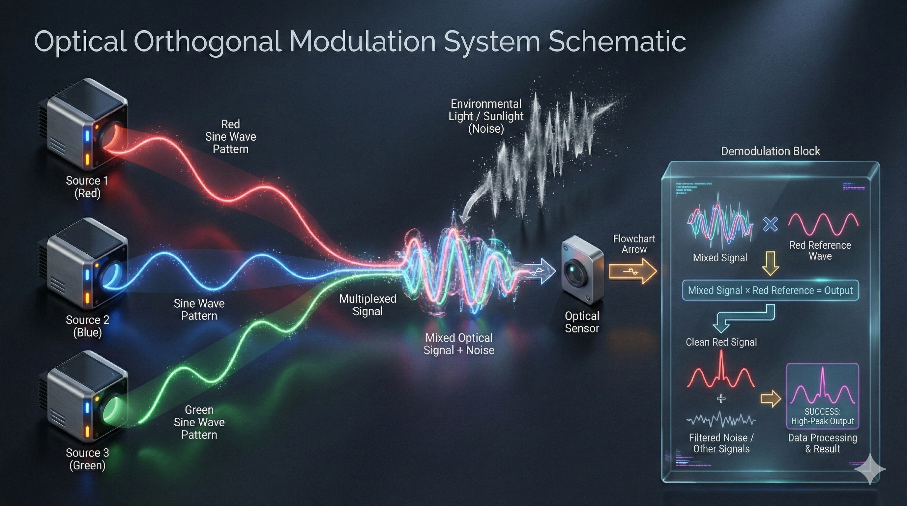
Figure 1. OTFE schematic diagram.

To transcend the serial constraints of TDM, we alter the encoding mechanism for each spectral channel indexed by $k$ ($k=1, …, K$). Specifically, we substitute the binary temporal gating operator $\text{rect}\left(⋅\right)$ with a modulation kernel $m_{k}\left(t;f_{k}\right)$ uniquely assigned to that channel. This substitution eliminates the requirement for sequential time slots, allowing all channels to operate in parallel. The modulation kernel for the $k$-th channel is formulated as:
 | $$m_{k}\left(t;f_{k}\right)=a_{k,0}+a_{k,1}\cos\left(2πf_{k}t+φ_{k}\right)$$ | (2)
where $f_{k}$ is the distinct carrier frequency assigned to channel $k$. $a_{k,0}$ represents the DC bias required to ensure non-negative optical intensity. $a_{k,1}$ denotes the carrier amplitude, and $φ_{k}$ is the initial phase of the signal.
Upon simultaneous projection of all spectral channels modulated by their respective kernels, the detector integrates the total photon flux. The received OTFE signal $y_{\text{OTFE}}\left(t\right)$ is a composite waveform containing information from all$K$channels concurrently:
 | $$y_{\text{OTFE}}\left(t\right)=\sum_{k=1}^{K}{\underset{z_{k}}{\underbrace{\left[\int_{λ_{1}}^{λ_{2}}{P_{k}\left(λ\right)R\left(λ\right)S\left(λ\right)dλ} \right]}}}⋅m_{k}\left(t;f_{k}\right)+I_{\text{noise}}\left(t\right)$$ | (3)
To simplify the physical interpretation, we define the scalar $z_{k}$ as the spectral projection value for the $k$-th channel. Substituting the modulation kernel into equation (3), the received signal $y_{\text{OTFE}}\left(t\right)$ can be reorganized into two distinct components:
 | $$y_{\text{OTFE}}\left(t\right)=\underset{\text{DC }\text{\&} \text{Noise component}}{\underbrace{\sum_{k=1}^{K}{z_{k}a_{k,0}}+I_{\text{noise}}\left(t\right)}}+\underset{\text{Signal }\text{c}\text{omponent}}{\underbrace{\sum_{k=1}^{K}{z_{k}a_{k,1}}\cos\left(2πf_{k}t+φ_{k}\right)}}$$ | (4)
The signal decomposition is achieved by mapping the time-domain observation into the frequency domain. Defining $F\{⋅\}$ as the continuous Fourier transform operator, the frequency-domain response $Y\left(f\right)$ is given by:
 | $$Y\left(f\right)=F\{y_{\text{OTFE}}\left(t\right)\}+\sum_{k=1}^{K}{\frac{1}{2}}z_{k}a_{k,1}\left[e^{jφ_{k}}δ\left(f-f_{k}\right)+e^{-jφ_{k}}δ\left(f+f_{k}\right)\right]$$ | (5)
where $δ\left(⋅\right)$ denotes the Dirac delta function. This formulation demonstrates the mechanism of noise rejection: as long as the modulation frequencies $\{f_{k}\}$ are designed to avoid the dominant bands of environmental noise and are mutually non-interfering, the projection value $z_{k}$ can be retrieved precisely by extracting the magnitudes at the corresponding carrier frequencies:
 | $$\left|Y\left(f_{k}\right)\right|=\frac{1}{2}z_{k}a_{k,1} ⇒ z_{k}=\frac{2\left|Y\left(f_{k}\right)\right|}{a_{k,1}}$$ | (6)
Once the projection values for all $K$ channels are retrieved, they are aggregated to form the measurement vector $z={\left[z_{1},z_{2},…,z_{K}\right]}^{T}$.To recover the spectrum $R\left(λ\right)$ of the target, we discretize the spectral range $\left[λ_{1},λ_{2}\right]$ into $N$ bands and model the measurement process as a system of linear equations:
 | $$z=Wr+e$$ | (7)
where $r∈R^{N}$ represents the ground truth (GT) spectrum, and $W∈R^{K×N}$ is the pre-calibrated system matrix determined by the source emission spectra and detector responsivity. The term $e$ accounts for the system noise and measurement residuals. Consequently, the spectral reconstruction is treated as an inverse problem. The estimated spectrum $\hat{r}$ is obtained by finding the solution that minimizes the reconstruction error:
 | $$\hat{r}=\underset{r}{arg min}{{\left\|z-Wr\right\|}_{2}^{2}}$$ | (8)
Experiment
To systematically evaluate the system's noise rejection capabilities, three distinct noise models are synthesized to simulate typical experimental scenarios: (i) additive white gaussian noise (AWGN) representing broadband thermal and detector noise; (ii) in-band interference (aggregated random narrowband signals) spectrally coincident with the system's modulation bandwidth; (iii) 100 Hz power-line flicker modeling ambient lighting artifacts. Figure 2(a) illustrates the temporal response under these conditions. Notably, due to the short acquisition window, the low-frequency flicker manifests as a significant baseline drift, whereas the in-band interference induces amplitude beating due to frequency mixing.
Figure 2b reveals a strong correlation between spectral reconstruction RMSE and demodulation error (defined in Supplementary Note 1), confirming that reconstruction fidelity hinges on carrier extraction accuracy. Notably, the 100 Hz flicker rapidly aligns with the AWGN baseline, demonstrating efficient out-of-band rejection. In contrast, in-band interference decays slowest. Since these disturbances spectrally coincide with the carrier signals, they bypass the orthogonal filtering process, thereby establishing the theoretical lower bound of reconstruction precision.
To simulate realistic environmental interference, we introduce three representative structured interferences (defined in Supplementary Note 1): DC background light (simulating direct solar illumination); 20 kHz PWM noise (mimicking standard dimming protocols engineered to exceed the human audible threshold); and 100 kHz SMPS noise (modeling the switching ripples inherent to common electronic power adapters). Figure 2c depicts the time-domain response under an extreme SNR of -20 dB. Visually, the target
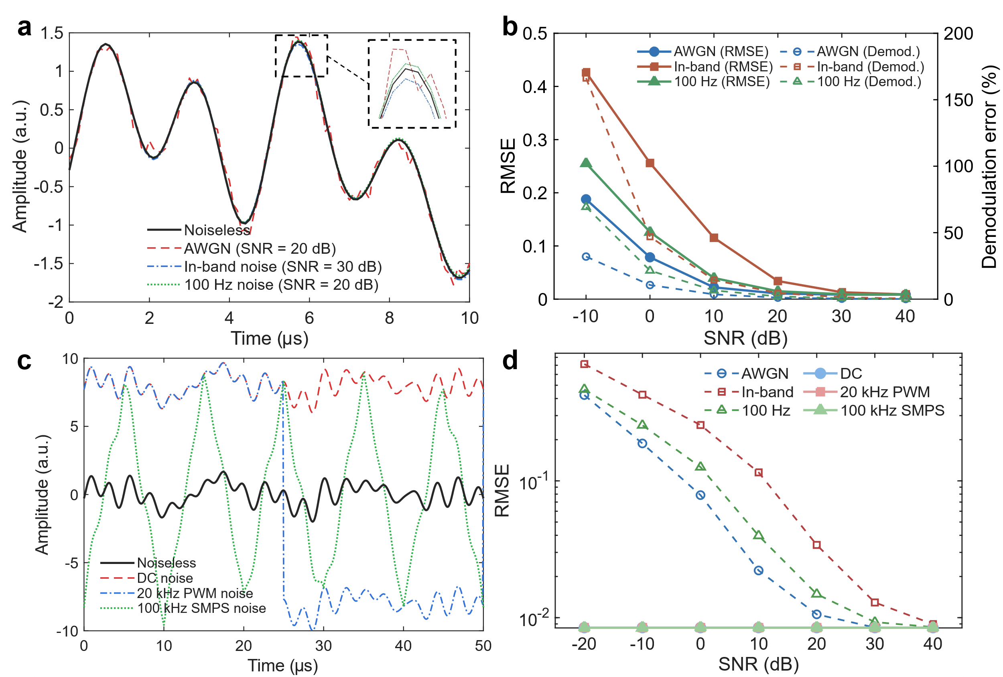
Figure 2. Simulation of noise rejection mechanisms and quantitative robustness analysis. (a) Time-domain response of the modulated signal under three distinct noise models. While 100 Hz flicker manifests as a baseline drift, in-band interference induces amplitude beating due to frequency mixing. (b) Correlation between spectral reconstruction accuracy (RMSE) and carrier demodulation error. The strong alignment confirms that reconstruction fidelity is fundamentally determined by the precision of carrier extraction. (c) Time-domain visualization of extreme interference scenarios (SNR = -20 dB). The target signal is effectively submerged by high-energy structured artifacts, including DC background, 20 kHz PWM dimming, and 100 kHz SMPS ripples. (d) Comparative robustness analysis. A key advantage of the OTFE framework is revealed: while performance degrades linearly with random noise (AWGN), the system exhibits a robustness plateau against structured environmental noises (DC, PWM, SMPS), maintaining a low reconstruction (RMSE ${<10}^{-2}$) even at an SNR of -20 dB.
The quantitative reconstruction results in Figure 2d reveal a critical advantage of the OTFE framework. While random noise and in-band interference degrade performance linearly, the structured environmental noises exhibit negligible reconstruction error (RMSE≈10⁻²), remarkably remaining flat even at an SNR of $-$20 dB. This spectral immunity validates that the orthogonality of the basis functions allows the system to completely bypass these specific interference bands. By confining modulation carriers to the spectral gaps distinct from environmental disturbances, the OTFE framework isolates the retrieval process against structured interference.
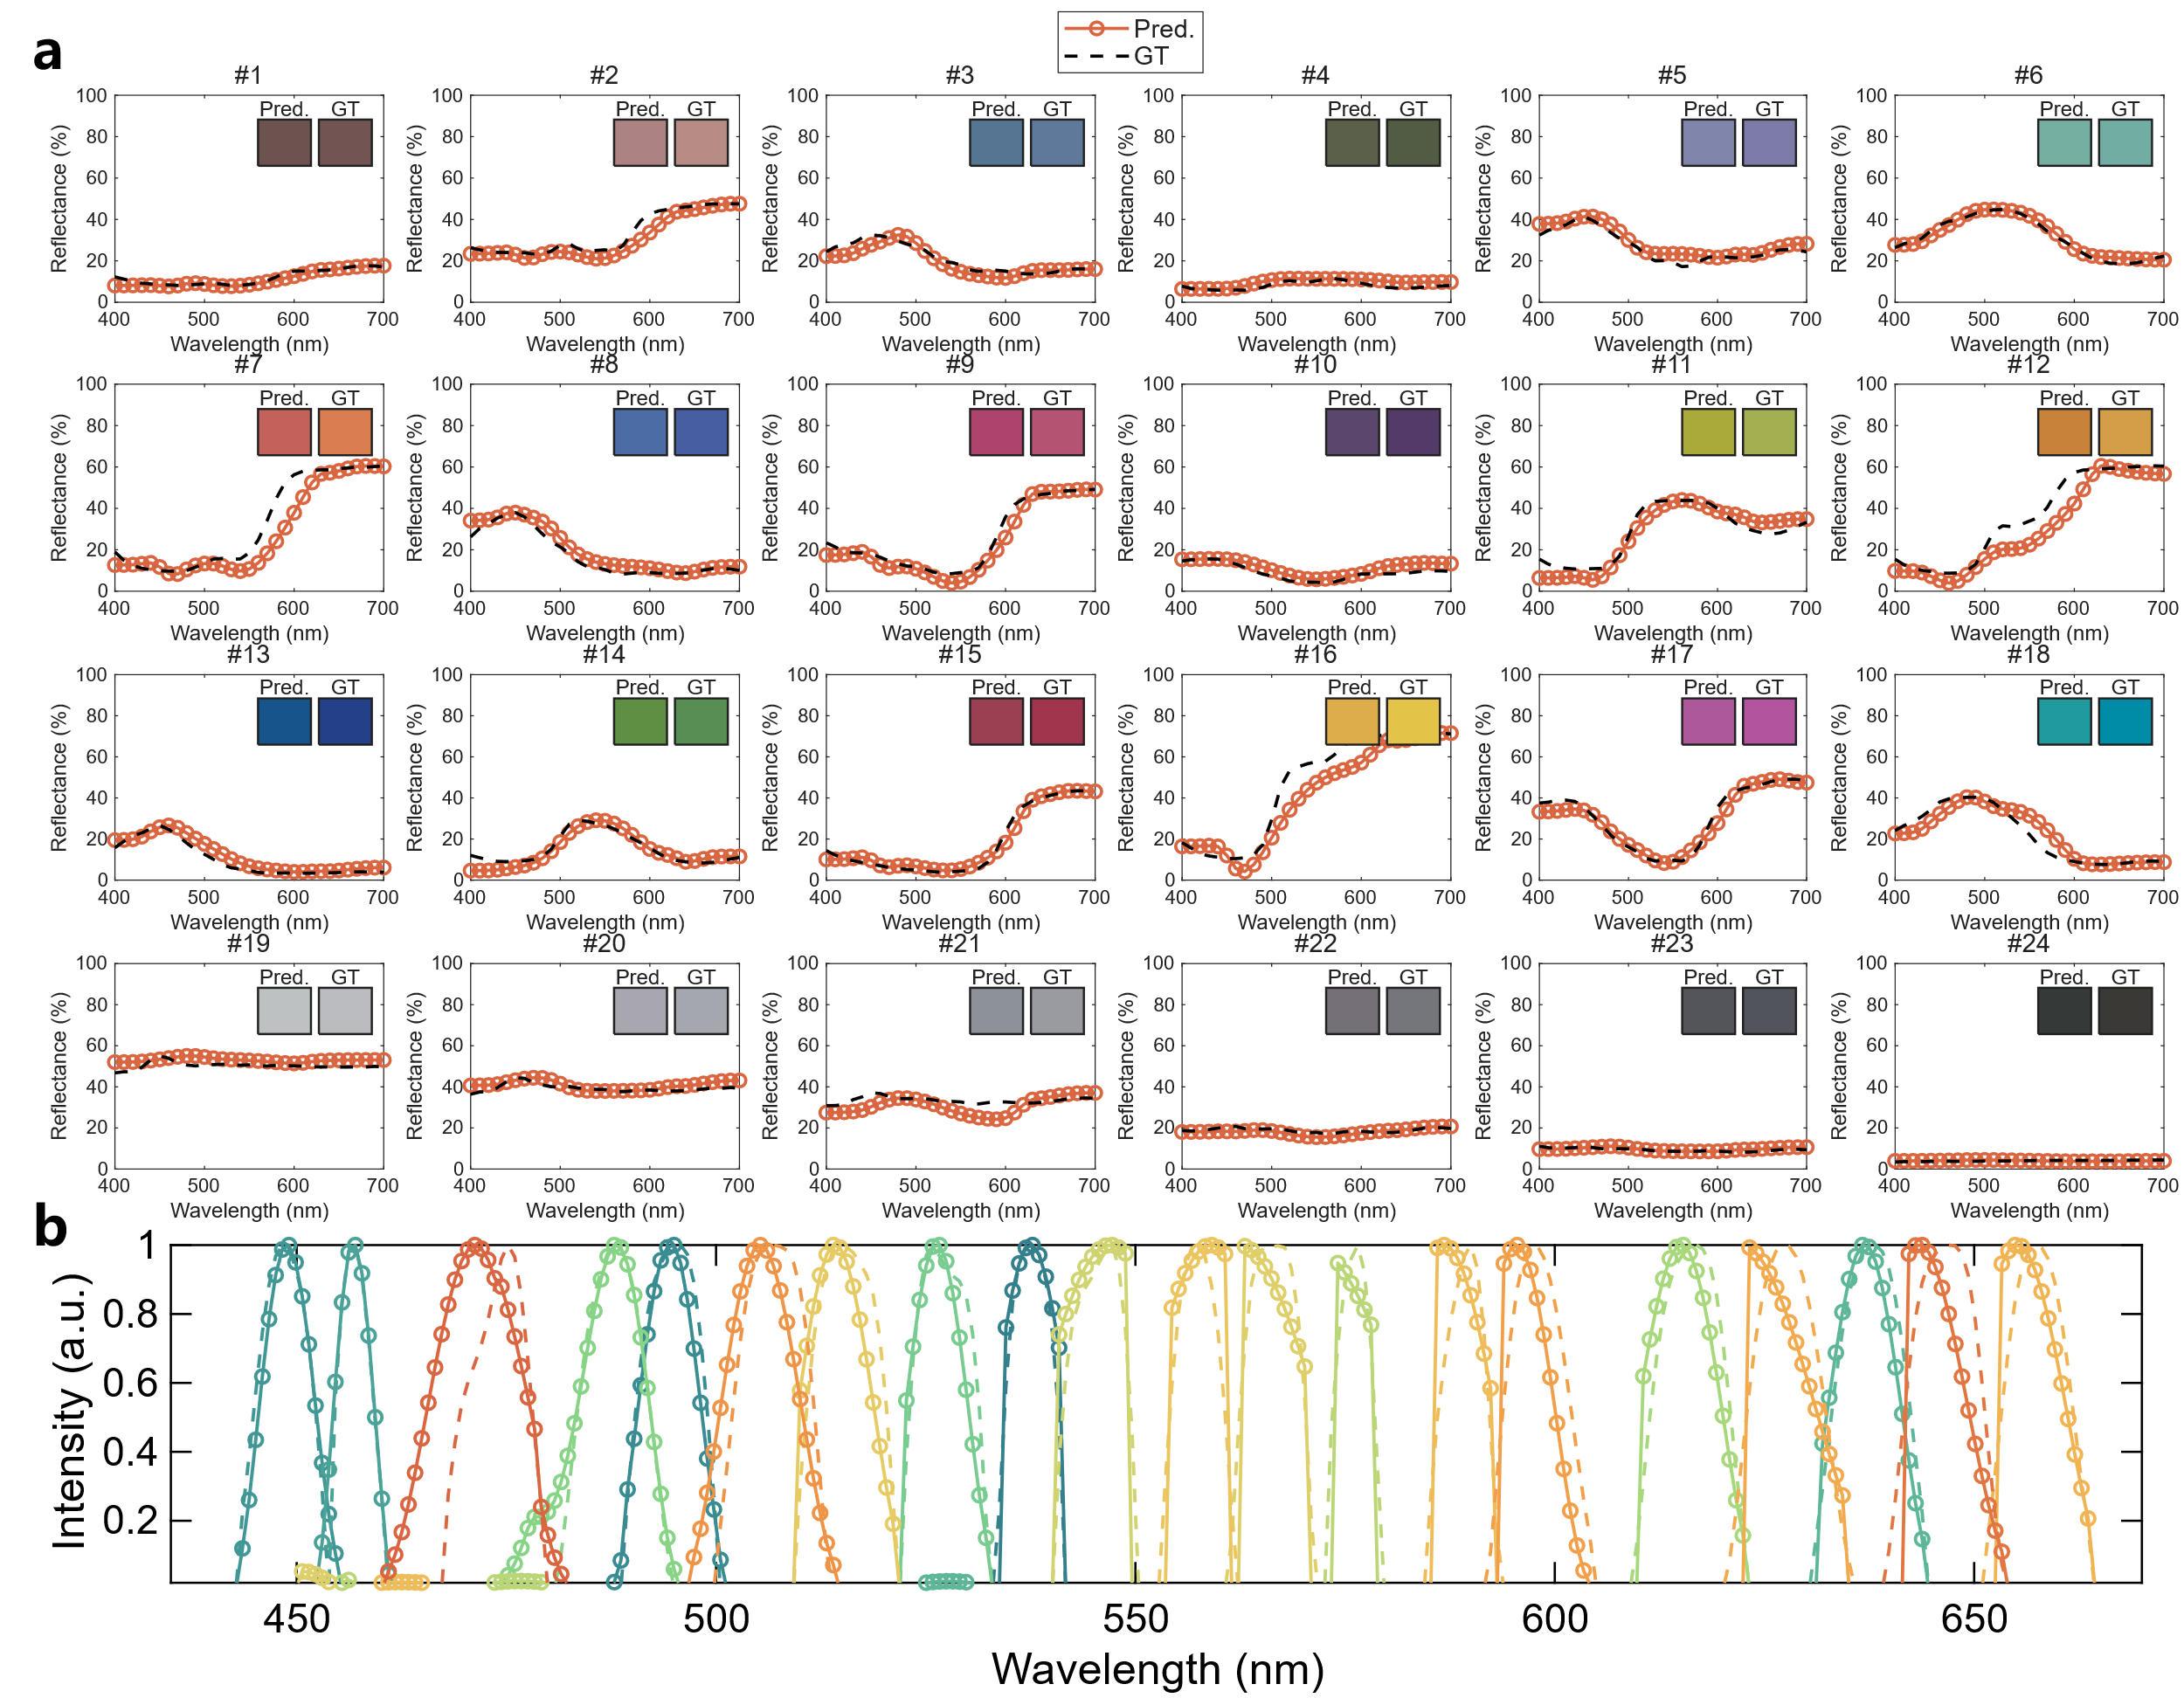
Figure 3. Experimental validation of high-speed, single-shot spectral reconstruction ($T_{S}=$ 250 μs). (a) High-fidelity reconstruction of surface reflectance for the 24 patches of the reflective colorchecker. Open circle markers denote the OTFE reconstruction (Pred.), plotted against the ground truth reference (GT, black dashed lines). Despite the rapid 250 μs acquisition window, the system achieves an average RMSE of 0.0422, showing high concordance with GT measurements across diverse spectral topologies. Insets visualize the sRGB color rendering of the predicted versus GT spectra. (b) Resolution capability demonstration using 10 nm FWHM narrowband peaks. Open-circle markers indicate the discrete spectral points of the reconstructed profiles, compared against the GT (dashed lines). The accurate reconstruction of these sharp spectral features confirms that the OTFE framework effectively decouples acquisition speed from spectral resolution, avoiding the signal broadening artifacts typically associated with high-speed computational sensing.
To empirically validate the OTFE framework, we develop a high-bandwidth spectral sensing prototype. The system employs narrowband LEDs as the active illumination source, selected for their MHz-level modulation capabilities essential for orthogonal frequency encoding. For detection, we utilize a high-speed single-point photodetector (Thorlabs PDA100A2, 11 MHz bandwidth) coupled with a 1 GSa/s digitizer (RIGOL DS1202Z-E). Unlike conventional hyperspectral imagers limited by low frame rates (<100 fps), this single-point architecture is strategically chosen to prioritize temporal resolution, enabling the evaluation of microsecond-scale spectral dynamics. While the current LED driver (PT4115) imposes a physical modulation bandwidth of 500 kHz, this constraint serves as a testbed for demonstrating spectral retrieval efficiency under limited hardware resources. Within this bandwidth, the system is configured for a single-shot acquisition window of 250 μs, a speed unattainable by traditional TDM approaches.
We first assess the system's resolving power under controlled lighting conditions. Figure 3a presents the spectral reconstruction of a standard reflective colorchecker. Despite the rapid 250 μs snapshot acquisition, the system retrieves the broadband reflectance profiles with high fidelity, achieving an average root mean square error (RMSE) of 0.0422. The results exhibit high concordance with GT measurements across diverse spectral topologies—ranging from the flat response of neutral grays to the complex, curvature-rich features of biological tones. Furthermore, the system’s ability to resolve fine spectral features is evidenced in Figure 3b. The accurate reconstruction of 10 nm FWHM narrowband peaks confirms that the OTFE framework decouples acquisition speed from spectral resolution, avoiding the signal broadening artifacts typically associated with high-speed computational sensing.
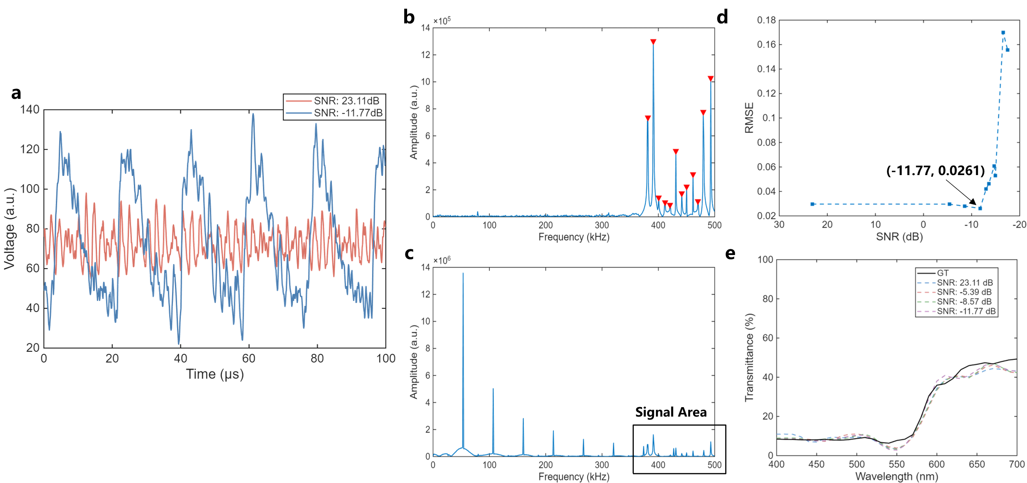
Figure 4. Experimental robustness evaluation under harsh electromagnetic interference (50 kHz SMPS noise, $T_{S}=$ 1000 μs). (a) Time-domain comparison showing the severity of the noise environment. At an SNR of -11.77 dB, the target signal is visually indistinguishable from the intense switching ripples. (b, c) Frequency-domain analysis revealing the spectral allocation strategy. The system mitigates interference through a two-tier approach: first, the modulation carriers (indicated by red triangles) are shifted to the higher frequency band (390–500 kHz) to bypass the dominant noise energy concentrated in the lower spectrum; second, within this target band, these carriers are precisely aligned into the spectral gaps of the residual interference to ensure rigorous orthogonality. (d) RMSE vs. SNR curve. A distinct robustness plateau is observed where reconstruction fidelity remains invariant (RMSE $≈$ 0.03) despite a 30 dB drop in SNR. Performance breakdown occurs only when the SNR breaches the critical threshold of $≈$-12 dB, where noise harmonics begin to overwhelm the signal carriers. (e) Spectral reconstruction at the extreme limit. Even at an SNR of -11.77 dB, the system successfully retrieves the characteristic spectral shape (RMSE = 0.0261), demonstrating utility in regimes where noise amplitude exceeds the signal by nearly fourfold.
To challenge the physical limits of the OTFE framework, we subject the system to a harsh electromagnetic environment dominated by high-energy switching noise (centered at 50 kHz). This interference, characteristic of common power electronics, specifically switched-mode power adapters, solid-state lighting drivers, and electronic ballasts, found extensively in modern daily infrastructure, presents a critical challenge due to its dense series of high-energy harmonics extending into the signal band (380 ~ 490 kHz).
The severity of this environment is visualized in the time-domain comparison in Figure 4a. To ensure sufficient integration and frequency resolution under such extreme interference, the acquisition window is extended to 1000 μs. Under a SNR of -11.77 dB, the target signal is overwhelmed by the intense switching ripples. In this regime, the minute modulation features are indistinguishable from the large interference baseline, rendering conventional time-domain integration or DC-coupled detection schemes futile. However, the frequency-domain analysis in Figure 4c demonstrates the mechanism of OTFE’s immunity. While the noise harmonics (red triangles) possess amplitudes significantly higher than the signal carriers, the system exploits the discrete nature of the interference by strategically allocating modulation carriers within the spectral silence windows between noise spikes. This strict frequency-domain orthogonality prevents spectral collision, allowing the system to selectively extract signal energy while rejecting high-power interference.
Figure 4d quantifies this resilience, revealing a distinct robustness plateau here reconstruction fidelity remains virtually invariant (RMSE ≈ 0.03) despite a 30 dB degradation in SNR. A sharp performance breakdown occurs only when the SNR breaches the critical threshold of approximately -12 dB. Notably, as shown in Figure 4e, even at the extreme limit of -11.77 dB, the reconstructed spectrum retains its characteristic shape with an RMSE of only 0.0261. This confirms that the OTFE framework delivers usable spectral data in regimes where the noise amplitude exceeds the signal by nearly fourfold.
Conclusion and discussion
In this work, we propose OTFE to resolve the speed-SNR trade-off inherent in conventional TDM. By shifting from serial scanning to parallelized frequency-domain encoding, the system achieves single-shot spectral reconstruction in 250 $\text{μ}\text{s}$. Crucially, unlike standard lock-in techniques, OTFE employs a strategic frequency allocation scheme that exploits the spectral gaps of structured environmental noise. This mechanism ensures robust retrieval (RMSE $≈$ 0.0261) even under harsh interference with an SNR of -11.77 dB (at a 1000 $\text{μs}$ sampling time), effectively immunizing the system against common artifacts like PWM dimming and SMPS ripples.
However, the performance boundaries of OTFE are strictly dictated by hardware constraints rather than the encoding strategy itself. The acquisition speed $T$ is governed by the time-frequency uncertainty principle, $T ≈1/Δf$. While our prototype is limited to 250 $\text{μs}$ by the 500 kHz bandwidth of LED drivers, the framework holds immense potential for ultrafast spectroscopy. By transitioning to high-speed laser diodes modulated at hundreds of megahertz or even gigahertz, the system can theoretically scale to nanosecond-level acquisition times, allowing for a dramatic increase in the number of spectral channels without compromising temporal resolution.
To extend the system's capabilities, the OTFE architecture offers versatile scalability across spectral, spatial, and functional dimensions. First, the spectral range is not confined to the visible band; by incorporating appropriate sources and detectors, the framework can be readily expanded to the ultraviolet or infrared regions, enabling molecular fingerprinting in complex environments. Second, coupling OTFE with event cameras (capable of microsecond-level temporal resolution) or SPAD arrays (achieving picosecond to nanosecond-level precision) facilitates hyperspectral imaging. Finally, the active nature of OTFE opens new possibilities for real-time adaptive sensing. Unlike passive spectrometers, the illumination patterns in OTFE can be dynamically optimized based on initial measurements to maximize the reconstruction fidelity for specific spectral features, establishing a closed-loop framework for intelligent optical sensing.

