To view the server, please follow the following steps.

1) Download Python 3.11 from https://www.python.org/downloads/
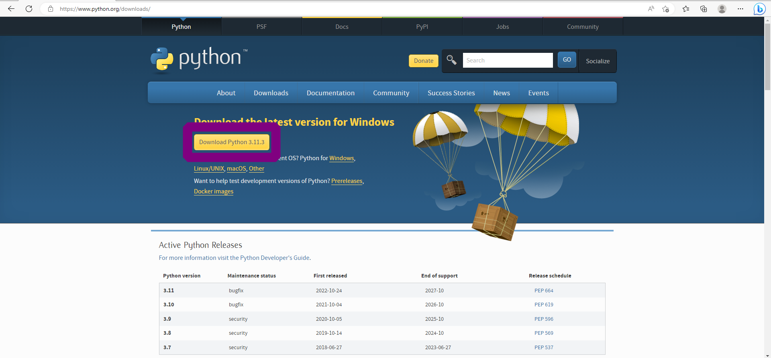
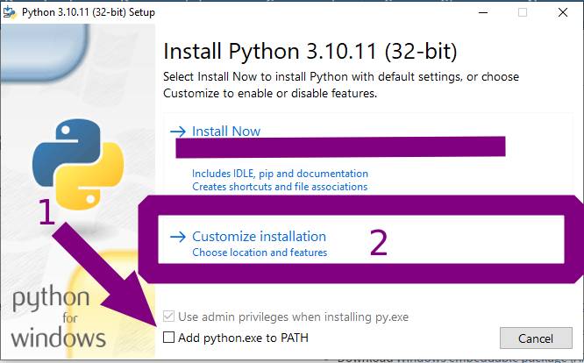
2) Install Python 3.11 and make sure to tick "Add python to environment variables".
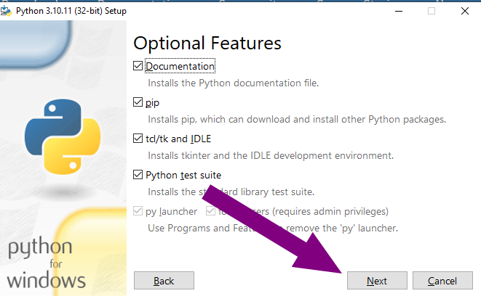
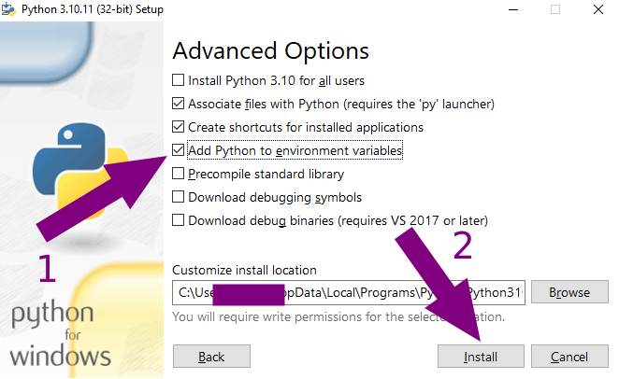
Make sure this is checked

Make sure this is checked too

3) Double click on the start_server.bat file. A command prompt will pop up that looks like this.

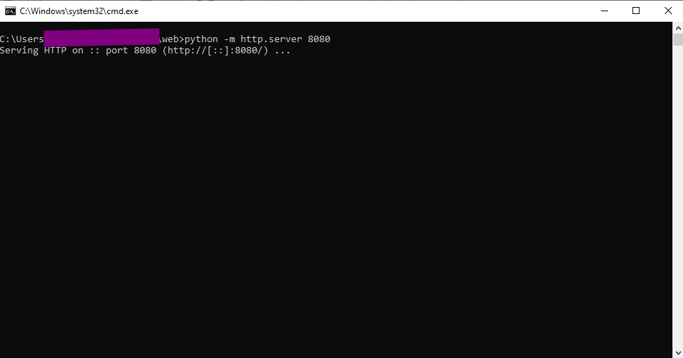
4) Go to localhost:8080 in your browser to view the website.

Note 1: The server will take a few seconds (depending on your internet speed) before it will download all the required assets and be displayed correctly.

Note 2: If the server failed to start, open up start_server.bat as a text file and change 8080 to some other 4-digits number and use the url localhost:<the 4-digits number you entered>.

Note 3: As responsive design is not 100% working, please zoom in/out until the page looks correct.

