**Database Fundamentals**

**Lab Sheet 1**

Type up your answers to the following questions and show to your lecturer when complete before the end of the lab session. Submit your work on Moodle (e.g. file name – B000XXXXXLab1.doc). All work must be uploaded the day before your next lab session. See Moodle for the upload link and submission deadline date & time. Note: no late submissions will be accepted. This lab sheet consists of 2 parts. Part A written questions and part B MySQL and SQL queries.

**Part A: Complete the following questions**

1. Write a short definition for the following terms:
   1. Data
   2. Persistent storage
   3. Database
   4. Databases Management System
   5. Database Systems
   6. SQL
2. Read up on the following DBMS’s, and write a short summary for each:
   1. MySQL
   2. MsAccess
   3. SQL Server
   4. Oracle 12c

Include in your summary - what company owns the DBMS, is it open source, is it popular (look for comparison between the different databases).

**Part B: Getting Started with MySQL**

1. **Open up workbench.**

Start/All Programs/MySQL/MySQL Workbench 5.? CE

Under SQL Developer select local instance MySQL.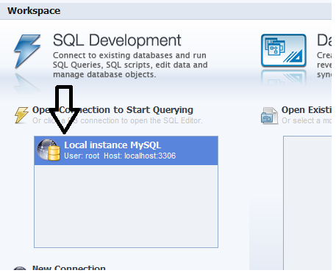

Once the SQL editor is open the databases already created in this instance of MySQL are listed on the left hand side under the heading of ‘schemas’.

On the left under ACTIONS select ‘add schema’ to create a new database. Call it **ITB**. (It may already have been created by a classmate in a previous lab. If so delete the database and recreate it). Apply the new schema and then Finish.

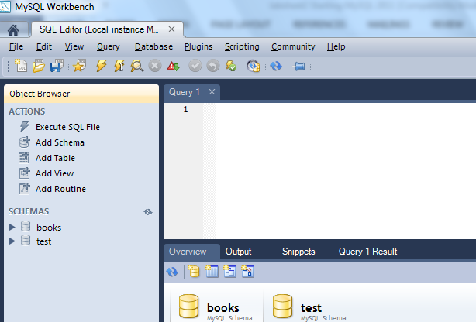

Update the schema list and double click ITB to make it the active schema (it should appear in bold). Click the ‘Add Table’ button to add a new table to the database. Call the table ‘student’.

Give the table three columns: student ID which is varchar(9), student name which is varchar(50), and student date of birth which is date. Set student ID to be the primary key.

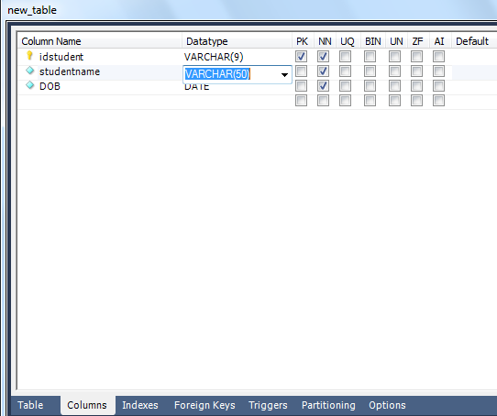

1. **MySQL Query Browser**

Next open up MySQL Query Browser. MySQL Query browser is a GUI tool for running SQL queries. Available schemas are listed.

Click the arrow to the left of the ITB schema you created above. You should see the student table listed.

In the query window at the top, type **describe student** and click the **execute** button. The main window shows the results of the query, i.e. the column definitions of the student table.

Note:

You may also run SQL statements stored in an external file (i.e. typed up in note pad or text pad) using file -> open script. SQL scripts are generally recorded in a file with an extension of .sql.

1. **SQL Queries**

Create the emp, dept and salgrade tables (tables used in lecture notes) from a script as explained below.

The script to create the tables can be found in a file called CreateTablesForMySQL.sql on studentshare\Laura Keyes\Semester 1 2016_2017\Database Fundamentals\Week 2 or on Moodle.

In MySQL Workbench, select file / open SQL script / CreateTablesForMySQL.sql

Don’t worry about understanding the code for now – we will cover that in later lectures.

Execute the code using the execute icon:  or select Query / Execute All. This will create the tables in the Database Server.

Remember, MySQLWorkBench is just a client tool, its NOT the database itself. Often when you make a change to the database, you cannot see the change in the GUI tool, you have to refresh its view (like refreshing a page on the web).

Refresh Schema

Press the refresh button. 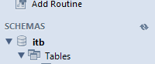

You should now see the three tables listed under itb / tables: emp, dept and salgrade.

Create SQL queries for each of the following. Write the queries one after the other in the editor. To run a query, highlight and then click execute. When done, all queries can be saved to a text file using file/save as or saved as a script file .sql.

1. Show details of all employees in the Employee table.
2. Display the employee number, name and job in the Employee table.
3. Display the department number that each employee works in.
4. Display the employee number, name and occupation for all employees employed as clerks.
5. Display the name and salary of employees earning more than $2850.