Visualisation Critique Assignment
Student Name | : Ricardo Zhen Wei CHEW
Student ID | : 104392756
Selected Dashboard | : Hospitalised injury rates

1. Introduction (150 words)
Overview & Purpose | The Hospitalised injury rates page of BITRE's road crash dashboard shows how many people per 100,000 population were admitted to hospital after a road crash from 2011 to 2021 (Bureau of Infrastructure and Transport Research Economics [BITRE], n.d.-a, n.d.-b). It lets users compare risk fairly across groups of different sizes and track progress towards the national target of at least 30% fewer serious injuries by 2030 (Infrastructure and Transport Ministers, 2021).
Intended Audience | Policymakers and road safety agencies are the main audience. They need headline trends and group comparisons to judge progress, but may have limited statistical training, so caveats such as series breaks must be visible on the charts. Researchers need definitions and data notes, which the Glossary provides. The public need plain, jargon-free labels.
Key User Questions | - How has the national hospitalised injury rate changed over time?  - Which age groups and sex face the highest injury risk?  - Are people living in remote areas at greater risk than those in major cities?

2. Data Processing and Governance (250 words)
Data Source & Processing | The dashboard combines custom Australian Institute of Health and Welfare hospital data (National Hospital Morbidity Database, coded in ICD-10-AM) with Australian Bureau of Statistics (ABS) population estimates (BITRE, n.d.-a). Cleaning counts inter-hospital transfers once and excludes deaths. The key transformation, normalising to rates per 100,000, reverses the story: Major Cities has the most injuries (26,355) but the lowest rate (142.1), while Remote has the fewest (1,114) but the highest (224.6). Grouping also shapes the view. Five ABS remoteness classes are merged into three, hiding Very Remote, and wide age bands such as 40–64 average away differences within them. Unknown values are excluded from subgroup rates.
Data Issues | First, the time series is broken. Victoria (from July 2012) and New South Wales (from June 2017) stopped counting patients treated only in emergency departments, so rates either side are not comparable (BITRE, n.d.-a). Second, there is representation bias. Intersex people are recorded under "unknown" sex, which is excluded from rates, so they are invisible in the sex comparison. Remoteness also reflects usual residence, not crash location (BITRE, n.d.-a); if misread, funding could target the wrong roads.
How Issues Are Addressed | Both issues are only partly addressed. Data are shown only as aggregates, which protects patient privacy. The trend chart's information icon urges caution when comparing over time, and the remoteness icon defines residence, but the cause of the breaks and the treatment of intersex people appear only on the Glossary page. Nothing warns that linking hospital and crash records gives serious injury estimates about 9% lower than hospital data alone (Austroads, 2023).

3. Visualisation Critique (500 words)
Visualisation 1 – Annual injury rate trend with series breaks
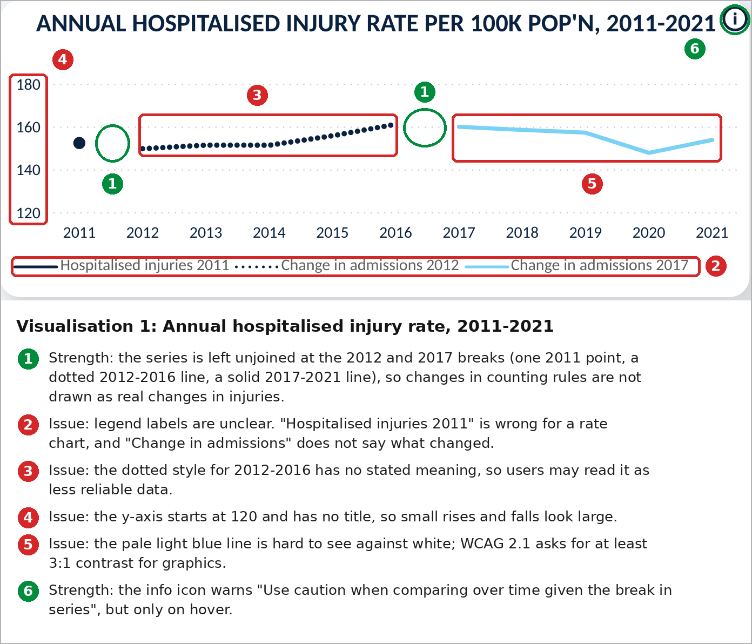  Note. Screenshot from the Hospitalised injury rates page of the dashboard (BITRE, n.d.-a), captured October 15, 2026. Numbered annotations have been added for explanation. | Design Principle / issue:  Honest representation of a broken series; line style, labelling, scale and colour contrast.
Evidence / observation:
The rate is drawn as three unconnected series: one 2011 point, a dotted 2012 - 2016 line and a light blue 2017 - 2021 line (annotation 1). The legend calls the first series "Hospitalised injuries 2011" although the chart shows rates, and "Change in admissions" does not say what changed (2). The y-axis starts at 120 with no title or break marker (4). The light blue line is pale against the white background (5).
Evaluation
Leaving gaps is a strength: guidance says not to join points across a break, even with a dotted line (Government Analysis Function, n.d.-b), so a change in counting rules is not shown as a real change in injuries. However, the same guidance warns that textured lines may be read as provisional data, and here the dotted style has no stated meaning (3). It also accepts a non-zero y-axis on line charts only when the break is made clear. With no break marker, the rise from 149.7 in 2012 to about 161 in 2016, roughly 7%, fills most of the plot and looks steep. The pale line is unlikely to meet the WCAG 2.1 minimum of 3:1 contrast for graphics (World Wide Web Consortium [W3C], 2018), making the latest period hardest to see. Because the cause of the breaks appears only on hover (6) and in the Glossary, the chart is honest but not self-explanatory.

Visualisation 2 – Injury rate by remoteness area
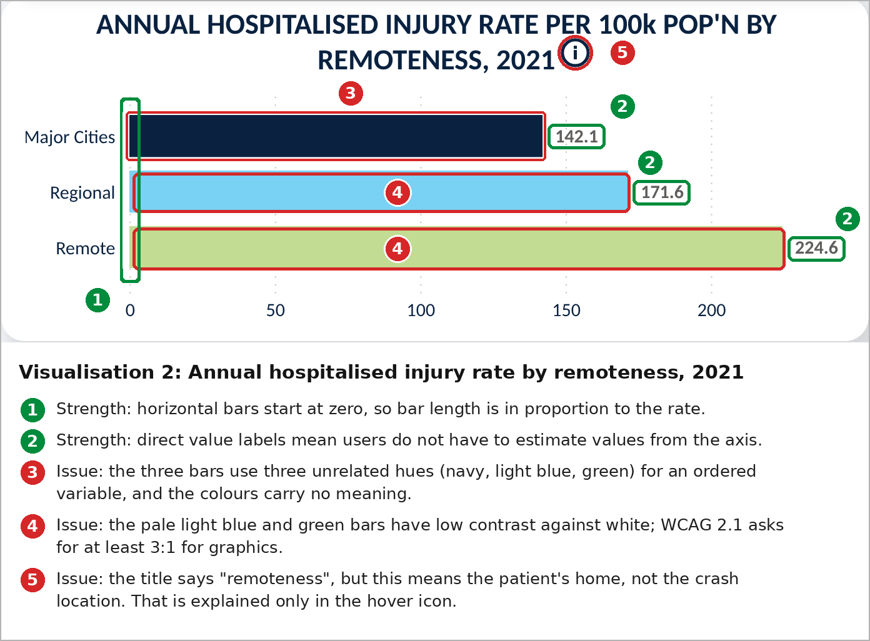  Note. Screenshot from the Hospitalised injury rates page of the dashboard (BITRE, n.d.-a), captured October 15, 2026. Numbered annotations have been added for explanation. | Design Principle / issue:  Visual encoding (length and colour) and accessibility.
Evidence / observation:
Horizontal bars start at zero, are ordered from Major Cities to Remote and carry direct value labels (1, 2). Each bar uses an unrelated hue: navy, light blue and green (3). The light blue and green bars are pale against the white background (4). The title says "remoteness", but only the info icon explains that this means usual residence (5).
Evaluation
Length on a common baseline is judged more accurately than other encodings (Cleveland & McGill, 1984), and bars should always start at zero (Government Analysis Function, n.d.-a), so users correctly see that the Remote rate is about 58% higher than Major Cities. Direct labels remove the need to estimate. However, hue suits unordered categories, while ordered attributes such as remoteness are better shown by luminance (Munzner, 2014); light-to-dark shades of one colour would reinforce the order (Government Analysis Function, 2026). Both pale bars are unlikely to meet the WCAG 3:1 contrast minimum for graphics (W3C, 2018). Titling the chart "by remoteness of residence" would stop users reading it as crash location, and a reference line at the national rate of 153.8 would show which areas sit above it.

4. Interaction and Usability (200 words)
Interactive feature | What does it do? | Evaluation
Feature 1: Filter (slicers) | Dropdowns for year, remoteness, sex and age group, with multi-select and a Reset button, filter the visuals on the page. | Effective. Users can answer targeted questions, such as rates for young males in remote areas, and Reset restores the default. The Year slicer sensibly leaves the 2011 - 2021 trend unchanged. Visuals update with a slight delay after each slicer change, which is noticeable but does not disrupt exploration.
Feature 2: Click graph to filter (cross-filtering) | Clicking a bar filters or highlights the other visuals (Microsoft, n.d.-a). Selecting Remote changed the headline rate to 224.6 and overlaid remote age-group rates on the national bars. | Partly effective. The overlay supports comparison, but the only cue is a bold label: slicers still read "All" and the headline title is unchanged, so users may mistake 224.6 for the national rate.
Feature 3: Tooltips and information icons | Hovering a data point shows its rate and population, and information icons explain the series breaks and remoteness definition. | Partly effective. Population context aids interpretation, but key caveats appear only on hover, which keyboard and screen reader users may struggle to reach. As a publish-to-web report, it cannot export data from visuals or offer a mobile layout (Microsoft, n.d.-b), limiting researchers and phone users.

5. Recommendations (200 words)
Recommendation | Issue addressed | Expected improvement
1. Replace the trend chart's legend labels and dotted style with one solid line style and a short on-chart note: "Series break: Victoria (2012) and NSW (2017) stopped counting emergency-only cases." | Unclear legend, unexplained dotted line and caveats hidden in hover and the Glossary. | Users understand the gaps without hovering, and the chart avoids dotted lines with no stated meaning (Government Analysis Function, n.d.-b).
2. Recolour the remoteness bars in light-to-dark shades of one colour with dark outlines, and retitle the chart "by remoteness of residence". | Unrelated hues for an ordered variable, pale low-contrast bars and the residence definition. | Colour reinforces the order from Major Cities to Remote, bars meet the 3:1 contrast minimum (Government Analysis Function, 2026; W3C, 2018), and users do not read it as crash location.
3. Show active selections in visual titles, for example "Remote areas, 2021", and add a national-rate reference line to the remoteness chart. | Click-to-filter changes values while slicers still read "All". | Users always know which group they are viewing and how it compares with the national rate.

AI Declaration
Claude (Anthropic) was used to review a draft of this report against the marking rubric and to propose cuts, rewording and general polishing. I assessed every suggestion myself, and any claim it added was verified against the cited source before I kept it.

References
Austroads. (2023). A national approach to measuring non-fatal crash outcomes stage 2: An Australian approach (Publication No. AP-R694-23). https://austroads.gov.au/publications/road-safety/ap-r694-23
Bureau of Infrastructure and Transport Research Economics. (n.d.-a). Hospitalised injuries from road crashes [Dashboard]. Microsoft Power BI. Retrieved October 15, 2026, from https://app.powerbi.com/view?r=eyJrIjoiZWQ0NTQ3ZDMtYWM1ZS00ZTNhLTlmZmMtZWY1MWFjOWNjODc5IiwidCI6ImFhMjFiNjQwLWJhYzItNDU2ZC04NTA1LWYyY2MwN2Y1MTc4NCJ9
Bureau of Infrastructure and Transport Research Economics. (n.d.-b). Hospitalised injuries from road crashes. Retrieved October 15, 2026, from https://www.bitre.gov.au/resource/road-safety/hospitalised-injury
Cleveland, W. S., & McGill, R. (1984). Graphical perception: Theory, experimentation, and application to the development of graphical methods. Journal of the American Statistical Association, 79(387), 531–554. https://doi.org/10.1080/01621459.1984.10478080
Government Analysis Function. (2026, February 12). Data visualisation: Colours. https://analysisfunction.civilservice.gov.uk/policy-store/data-visualisation-colours-in-charts/
Government Analysis Function. (n.d.-a). Bar charts [Introduction to data visualisation e-learning, Module 5]. Retrieved October 15, 2026, from https://analysisfunction.civilservice.gov.uk/support/communicating-analysis/introduction-to-data-visualisation-e-learning/module-5-bar-charts/
Government Analysis Function. (n.d.-b). Line charts [Introduction to data visualisation e-learning, Module 8]. Retrieved October 15, 2026, from https://analysisfunction.civilservice.gov.uk/support/communicating-analysis/introduction-to-data-visualisation-e-learning/module-8-line-charts/
Infrastructure and Transport Ministers. (2021). National road safety strategy 2021–30. Commonwealth of Australia. https://www.roadsafety.gov.au/sites/default/files/documents/National-Road-Safety-Strategy-2021-30.pdf
Microsoft. (n.d.-a). How visuals cross-filter each other in a Power BI report. Microsoft Learn. Retrieved October 15, 2026, from https://learn.microsoft.com/en-us/power-bi/explore-reports/end-user-interactions
Microsoft. (n.d.-b). Publish to web from Power BI. Microsoft Learn. Retrieved October 16, 2026, from https://learn.microsoft.com/en-us/power-bi/collaborate-share/service-publish-to-web
Munzner, T. (2014). Visualization analysis and design. CRC Press. https://doi.org/10.1201/b17511
World Wide Web Consortium. (2018). Web content accessibility guidelines (WCAG) 2.1. https://www.w3.org/TR/WCAG21/

