Visualisation Critique Assignment
Instruction: The text in blue is provided as guidance only. Please delete all blue instructional text and replace it with your own content when completing the report.
Student Name | :
Student ID | :
Selected Dashboard | : Hospitalised injuries

1. Introduction (150 words)
Overview & Purpose | This dashboard presents Australian hospitalised injuries from road crashes for 2021, reporting 39,505 cases and an average stay of five bed days. Its purpose is to let users explore how injuries vary over time, by age group, remoteness and road user type, supporting road safety monitoring and evidence-based policy (Microsoft Power BI, n.d.). Interactive filters let users refine results by year, remoteness, sex, age group, vehicle type and counterparty.
Intended Audience | The dashboard is intended for government policymakers, road safety researchers and health planners who need evidence to target interventions and allocate resources. It also suits journalists and the general public seeking accessible Hospitalised injuries from road crashes statistics.
Key User Questions | - Has the number of hospitalised injuries increased or decreased since 2011, and how did 2020 compare?  - Which age groups and road user types account for the most hospitalisations?  - Do injury numbers differ substantially between major cities, regional and remote areas?

2. Data Processing and Governance (250 words)
Data Source & Processing | The dashboard draws on hospital admissions data from the Australian Institute of Health and Welfare (AIHW), which (Bureau of Infrastructure and Transport Research Economics, 2023) packages into national, state and First Nations series for 2011–2021. A hospitalised injury is a confirmed admission after which the patient is discharged alive, so deaths are excluded. Hospital transfers are counted once. The records are aggregated into categories (year, remoteness, road user and vehicle type, sex, age group and counterparty). The dashboard then reports them as counts, rates and average bed days.
Data Issues | Comparability over time. The line chart is split into separate segments labelled “Change in admissions 2012” and “Change in admissions 2017”. This suggests breaks in how admissions are recorded, which makes year-to-year comparisons across those points unreliable.  Coverage and timeliness. The data lags publication by about two years, so it describes past rather than current conditions. It also covers only admitted patients, so non-fatal injuries treated outside hospital, and deaths, are missing. This understates the full road trauma burden. In addition, patients transferred several times may be counted as separate admissions in the source data, which risks inflating counts.
How Issues Are Addressed | The dashboard partly addresses these issues. Information icons, the glossary and the data dictionary define terms and scope. However, the reason for the series breaks is not explained on the main view, and the exclusion of deaths and non-admitted injuries is not visible alongside the headline figure of 39,505. Users could misread the charts as showing all road injuries or a continuous trend.

3. Visualisation Critique (500 words)
[Select 2 visualisations from the dashboard. Use screenshots as evidence where appropriate. Focus on analysis rather than describing everything shown.
• Evaluate chart type and how data is mapped to visual elements.
• Evaluate clarity and adherence to relevant visualisation design principles.
• Consider colour, labels, scales, visual encoding, potential distortion and ease of interpretation.]
Visualisation 1 – [Add a short descriptive title]
[Insert screenshot of the visualisation below (add annotations to highlight key features, issues or strength.)]  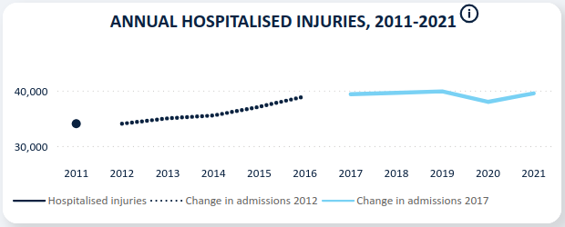 | Design Principal / issue:  A line chart suits a time trend, but the segmented lines, unclear legend and truncated y-axis undermine interpretation (Few, 2012; Tufte, 2001).
Evidence / observation:
The series is split into a single 2011 point, a dotted line (2012–2016) and a pale-blue line (2017–2021), with a visible gap between 2016 and 2017. The legend lists “Hospitalised injuries” as a solid dark line that never appears on the plot, plus “Change in admissions 2012” and “Change in admissions 2017”. The y-axis starts near 30,000 with only two labelled ticks, and there are no data labels. The 2020 dip is visible, but exact values cannot be read.
Evaluation
Mapping time to horizontal position and count to vertical position uses the most accurately perceived encoding (Cleveland & McGill, 1984). However, the gap and the changes in colour and line style break continuity. Users cannot tell whether the 2016–2017 difference is a real change or a recording change, and the legend terms are not explained at the point of use. The truncated axis is acceptable for lines, but it visually magnifies fluctuations. The 2020 dip of roughly 2,000 injuries looks dramatic (Cairo, 2016). The pale-blue segment also has weaker contrast on white than the navy used elsewhere. On the positive side, the chart is uncluttered and uses subtle gridlines.

Visualisation 2 – [Add a short descriptive title]
[Insert screenshot of the visualisation below (add annotations to highlight key features, issues or strength.)]  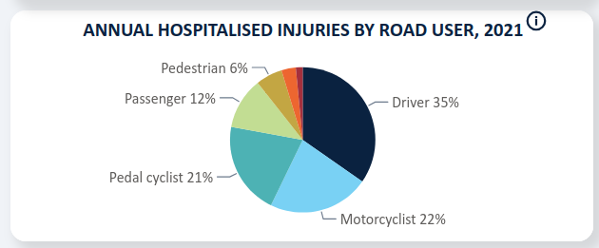 | Design Principal / issue:  A pie chart with too many categories, plus inconsistent labelling and colour use, reduces readability (Few, 2012; Knaflic, 2015).
Evidence / observation:
The chart has about eight slices. Labels show Driver 35%, Motorcyclist 22%, Pedal cyclist 21%, Passenger 12% and Pedestrian 6%. The three smallest slices (orange, red, maroon) have no labels. Each slice is a different hue, and only percentages are shown, not counts. The categories mix roles (driver, passenger) with road user types (pedestrian, pedal cyclist).
Evaluation
Pie charts encode values as angle and area, which people judge less accurately than length on a common scale (Cleveland & McGill, 1984). The 22% and 21% slices are almost indistinguishable, so ranking is difficult. Unlabelled slices leave the chart incomplete, and leader-line labels force the eye to move back and forth. The many hues carry no extra meaning and add visual noise (Knaflic, 2015). The overlapping categories also limit insight, because “Driver” does not show vehicle type. The chart does order slices clockwise from largest to smallest and quickly conveys that drivers make up about one-third of cases. A sorted horizontal bar chart with direct labels and counts would be easier to read and rank.

4. Interaction and Usability (200 words)
[Address the following points:
• Identify the main interactive features, such as filters, tooltips, zooming, highlighting or drill-down.
• Evaluate whether the interactivity supports the user's exploration and understanding of the data.]
Interactive feature | What does it do? | Evaluation
Feature 1: [e.g., filter, tooltip, zoom, highlighting, drill-down] | Briefly explain how the feature supports interaction with the data. | Does it effectively support the user's exploration and understanding? Explain why or why not.
Feature 2: [e.g., filter, tooltip, zoom, highlighting, drill-down] | Briefly explain how the feature supports interaction with the data. | Does it effectively support the user's exploration and understanding? Explain why or why not.
Feature 3: [e.g., filter, tooltip, zoom, highlighting, drill-down] | Briefly explain how the feature supports interaction with the data. | Does it effectively support the user's exploration and understanding? Explain why or why not.

5. Recommendations (200 words)
[Provide three specific and actionable recommendations. Each recommendation should be linked to a problem or weakness identified earlier in your critique.]
Recommendation | Issue addressed | Expected improvement
1. [Specific recommendation] | [Link to issue identified] | [How this improves the dashboard]
2. [Specific recommendation] | [Link to issue identified] | [How this improves the dashboard]
3. [Specific recommendation] | [Link to issue identified] | [How this improves the dashboard]

References
Microsoft power BI. (n.d.). App.Powerbi.Com. Retrieved October 15, 2026, from https://app.powerbi.com/view?r=eyJrIjoiZWQ0NTQ3ZDMtYWM1ZS00ZTNhLTlmZmMtZWY1MWFjOWNjODc5IiwidCI6ImFhMjFiNjQwLWJhYzItNDU2ZC04NTA1LWYyY2MwN2Y1MTc4NCJ9
Bureau of Infrastructure and Transport Research Economics. (2023). Hospitalised injury. Bureau of Infrastructure and Transport Research Economics. https://www.bitre.gov.au/resource/road-safety/hospitalised-injury
Cairo, A. (2016). The truthful art: Data, charts, and maps for communication. New Riders.

Cleveland, W. S., & McGill, R. (1984). Graphical perception: Theory, experimentation, and application to the development of graphical methods. Journal of the American Statistical Association, 79(387), 531–554. https://doi.org/10.1080/01621459.1984.10478080

Few, S. (2012). Show me the numbers: Designing tables and graphs to enlighten (2nd ed.). Analytics Press.

Knaflic, C. N. (2015). Storytelling with data: A data visualization guide for business professionals. Wiley.

Tufte, E. R. (2001). The visual display of quantitative information (2nd ed.). Graphics Press.

